**Working time, underemployment and overemployment: two different data sources with contradictory results[1]**

Martina Rengers, Federal Statistical Office FSO Germany, martina.rengers@destatis.de

**Abstract**

*According to microcensus results for 2015, well over 2.7 million employed people aged 15 to 74 years wanted to work more hours, while 1 million persons in employment wanted to work less. Based on Socio-Economic Panel results for the same reference year, the DIW Berlin found that just under 5.3 million employed people aged 18 to 64 years wanted to increase their working hours whereas 18.0 million wanted to reduce their hours of work.*

*The questionnaires of both surveys point out that an increase or reduction in working hours would involve correspondingly higher or lower earnings. What are the reasons for the completely different results? Can relevant key factors be identified for measuring working time and working-time preferences?*

**Keywords:** working time – working time preferences – measurement problems – household surveys

**1. Introduction**

According to microcensus results for 2015, over 2.7 million employed people aged 15 to 74 years wanted to work more hours (underemployed), while roughly 1 million persons in employment wanted to work less (overemployed). Underemployed people wanted to increase their weekly working time by an average of 11.3 hours, while those who were overemployed wanted to reduce it by 11.1 hours. Just under 91% of the people in employment did not want to change their weekly working time.

Based on Socio-Economic Panel (SOEP) results for the same reference year, the German Institute for Economic Research (DIW Berlin) found that just under 5.3 million employed people wanted to increase their working hours whereas approximately 18 million wanted to reduce their hours of work. On average, the underemployed wanted to work an extra 9 hours per week, while the overemployed wanted to reduce their working time by 7.8 hours. As shown by the results, more than 70% of the people in employment were dissatisfied with their working hours and wanted to change them.

The fact that an increase or reduction in working hours would involve correspondingly higher or lower earnings was pointed out to the respondents in both surveys. What are then the reasons for the different results? Are the wording, sequence and number of questions relevant key factors for measuring working time and working-time preferences?

The Federal Statistical Office investigated these questions together with DIW Berlin. This article provides a summary of the results obtained. The detailed study was published in the "Wirtschaft und Statistik" scientific journal (Rengers et al., 2017).

**2. Working time and working-time preferences**

The microcensus – including the labour force survey – is a representative household survey of official statistics (Federal Statistical Office, 2016). Using an established statistical random method, approximately 1% of the population is selected for the survey every year. A total of 691,000 members of 342,600 households were interviewed in 2015. Regarding most of the variables, there is a legal obligation to provide information.

The SOEP is a representative longitudinal survey of households which has been conducted on behalf of DIW Berlin since 1984 (Wagner et al., 2007). Currently, roughly 30,000 respondents in 11,000 households are interviewed in the survey. There is no obligation to provide information for the SOEP.

The type and the scope of questions about working time and working-time preferences differ largely between the microcensus and the SOEP. Fig. 1 and Fig. 2 show the relevant components of the questionnaires used in 2015.

**Figure 1. Questions about working time and working-time preferences in the 2015 microcensus**

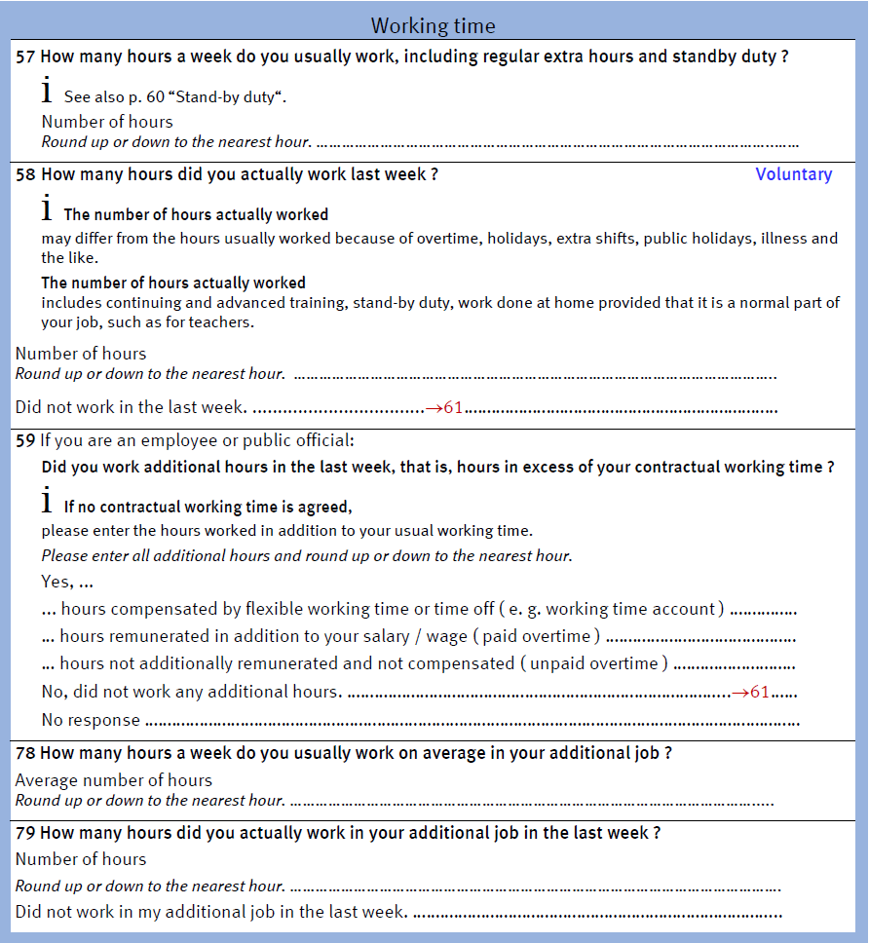

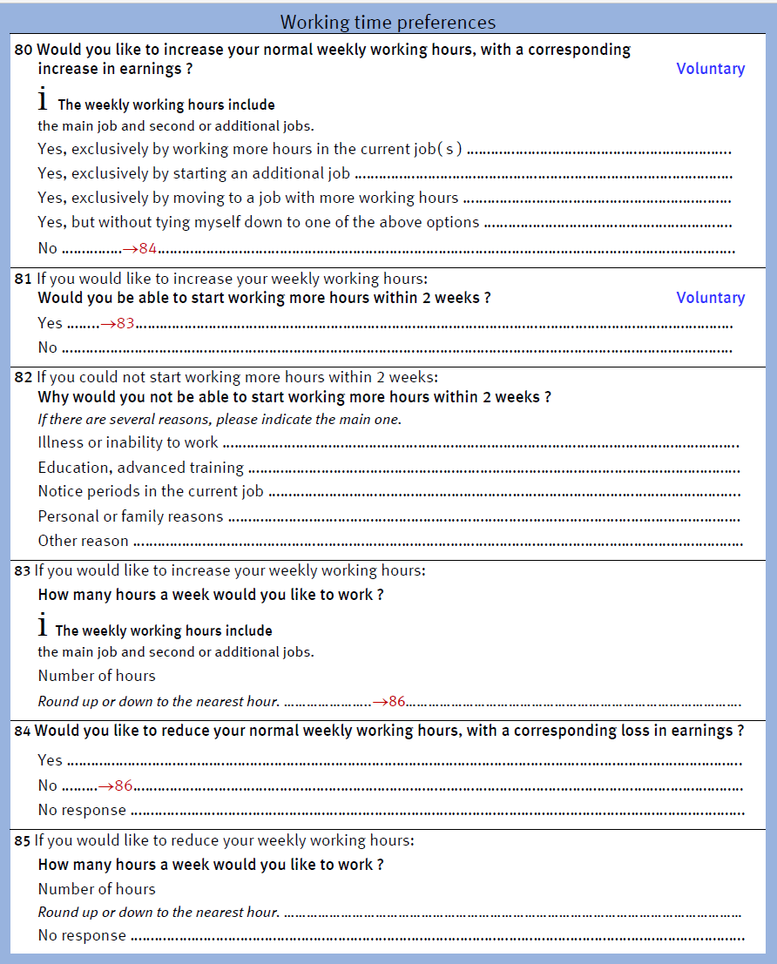



Source: Rengers et al., 2017, p. 16 (translated into English)

**Figure 2. Questions about working time and working-time preferences in the SOEP 2015**

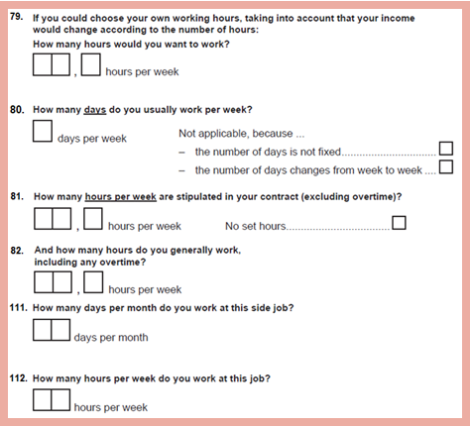

Source: Rengers et al., 2017, Fig. 4, p. 17 (translated into English)

**3. Comparison between the microcensus and the SOEP**

Based on the concept of time-related underemployment of the International Labour Organization (ILO), underemployment in the microcensus context refers to persons in employment who have a desire or preference to work more hours and would be available to work additional hours (Questions 80 and 81 in Fig. 1). In SOEP publications, however, the term ‘underemployment’ refers generally to all persons in employment who want to increase their working hours. The question of whether they would be able to start working additional hours within two weeks does not play a role.

Unlike the microcensus questionnaire, the SOEP questionnaire does not contain a preceding "Yes-No" filter question regarding the desire to work more hours. Instead, such a desire is indirectly identified by comparing the information on the preferred number of working hours with the number of hours generally worked (i.e. on average) (Questions 79 and 82 in Fig. 2). Persons in employment are considered underemployed in the SOEP if the desired number of weekly working hours is higher than the number of hours worked on average. The situation is just reverse regarding overemployed people. Here the number of hours generally worked is higher than the desired weekly working time.

In the microcensus questionnaire, the questions about overemployment are also preceded by a filter question before the preferred number of working hours is enquired in concrete terms (Questions 84 and 85 in Fig. 1). The filter question is intended to find out whether there really is a desire to reduce the working time. In 2015, however, answering this question was voluntary so that a "No response" category was added to the "Yes-No" options. It should be noted that the question about the desire to reduce the working time concerns only the employed people who have answered the "Yes-No" filter question about the desire to work more hours with "No" (for visualisation purposes, the filtering arrangements in Fig. 1 are highlighted in bright red, while they are printed in black in the original microcensus questionnaire).

To determine the extent to which the wording, sequence and number of questions impact the results of measuring working time and working time preferences, a uniform definition of underemployment has to be agreed initially. As the criterion of availability is not included in the SOEP, for uniform underemployment operationalisation purposes all people who wanted to increase their working hours were also covered in the microcensus, irrespective of whether they would be able to start working additional hours within two weeks.

In addition, other influencing factors, as far as possible, had to be filtered out in order to achieve approximately ceteris paribus conditions between the microcensus and the SOEP. To this end, additional adjustments were made to both surveys. For instance, evaluations were restricted to the age group of the 20 to 64 year olds in both surveys (see Rengers et al., 2017, p. 22 ff. for further adjustments).

However, the microcensus-SOEP adjustments did not result in a clear shift regarding the differences between the microcensus and the SOEP results. Despite the limited age range (people aged 20 to 64 years), the number of underemployed persons rose to 3.024 million in the microcensus because the availability criterion was not applied. With an unchanged operationalisation of overemployment, this declined to 901,000 persons (cf. Table 1). While underemployed people wanted to increase their weekly working time by an average of 11.1 hours, those who were overemployed wanted to reduce their working time by 10.5 hours. Just over 88% of the surveyed group of employed people did not want to change their weekly working hours.

**Table 1. Persons in employment by working time and working-time preferences 2015**



Source: Rengers et al., 2017, Table 3, p. 23 (translated into English)

In the SOEP, the data on underemployment and overemployment increased as the population typically covered only includes dependent employment. After the microcensus-SOEP adjustments, however, self-employed people were included, too. Table 1 shows that the number of underemployed people now amounts to 4.976 million, while that of overemployed persons totals 18.740 million. According to the SOEP, the underemployed want to work an extra 9 hours per week on average, while the overemployed want to reduce their working time by 8.3 hours. On the whole, nearly 72% would like to change their working hours.

**4. Analysis of causes**

There are many differences between the microcensus and the SOEP that cannot be described here in detail. Rengers et al. (2017) analysed a total of eight aspects which might be the causes of the clear differences in the results of working time and working-time preference measurements. Here is a summary of the most important results:

*4.1. Sequence of questions and recording of different working hours:*

The microcensus and the SOEP results differ markedly not only regarding the desired number of working hours but also the hours generally worked (i.e. on average). Table 1 shows that the average weekly working time is 36.2 hours (full-time: 41.5 hours) in the microcensus whereas the SOEP result amounts to 38.2 hours (full-time: 43.4 hours). This in turn can be a reason for the large discrepancies between the underemployment and overemployment results because these data were used directly for operationalisation in the SOEP. As the SOEP enquires not only the number of weekly hours generally worked, but also the contractually stipulated working time, Rengers et al. (2017) could also investigate the extent to which another working time concept would change the results of underemployment and overemployment.

Table 2 shows the different SOEP results of overemployment and underemployment calculations based on the differences between, on the one hand, the desired and the contractually stipulated working time and, on the other, the desired working time and the number of hours generally worked. The surveyed group of people only included persons in dependent employment. Taking the hours worked on average as a basis, more than 71% of this group wanted to change their working hours; the vast majority of 80% wanted to reduce their working time (17.2 million overemployed as compared to just under 4.6 million underemployed people). Taking the contractually agreed working hours as a basis, the desire to change their working time could be established for no more than just over 52% of the 28.7 million people in dependent employment who had answered all relevant questions (8.2 million overemployed and 6.8 million underemployed people). The ratio of overemployed to underemployed people in all persons in employment with working time discrepancies changed from 80:20 to 55:46.

**Table 2. Underemployment and overemployment calculations based on the contractually stipulated working time**



Source: Cf. Rengers et al., 2017, Table 8, p. 32 (translated into English)

Possibly, the information provided on different types of working hours depends on the sequence of questions. If the question about the contractually agreed working hours is put first and then followed by the question about the hours generally worked (i.e. on average), this may lead to an excessive number of hours worked because "overachievement" regarding the agreed working time is presumed to be socially desirable or at least commendable.

*4.2. Preceding filter question:*

A comparison of Fig. 1 with Fig. 2 reveals the different approaches to enquiring working time preferences in the microcensus and the SOEP. While the microcensus questionnaire includes preceding filter questions, the SOEP enquires the desired working hours right away. The respondents in the microcensus first have to answer a preceding filter question, namely a dichotomous "Yes-No" question as to whether they want to increase their working hours. Only then they are asked to indicate the concrete number of desired working hours. Only respondents who have answered the question of whether they would like to increase their working time with "No" are then asked whether they would like to reduce their working hours. Whether the microcensus results of underemployment and overemployment would be different if the sequence of the preceding filter questions changed – that is, if the question about a desired reduction in working hours preceded the question about an increase in working time – is however unclear. Another possible approach would be to include a single preceding and at the same time "neutral" filter question about the desire to change the working hours which, instead of "Yes-No" answer categories, would rather comprise variable values such as "Maintain" "Reduce" and "Increase".

Exactly this variant of a preceding filter question was used by DIW Berlin in its "Families in Germany (FiD)" survey. The FiD survey is an SOEP-compatible additional survey on a household longitudinal data basis. Since 2010, DIW Berlin has used this survey to obtain more information on families in Germany. Until 2014, the FiD survey included a filter question which preceded the questions about the desired working time. Respondents first had to indicate whether they wanted to maintain, reduce or increase their working hours. In 2014 the FiD survey was integrated into the SOEP and the wording of the SOEP questions used to enquire working time preferences. The respondents of the former FiD survey now had to answer the SOEP question about the desired working hours without a preceding filter question. Fig. 3 shows a comparison between the SOEP and the subsample of the FiD survey as well as the relevant changes in results. The average proportion of persons in employment who wanted to change their working hours increased from 32.6% in the FiD survey to 72% in the survey without preceding filter question for the same group of people.

Even though a one-to-one comparison of these results with the microcensus and its two separate filter questions is not possible, the assumption that the use or non-use of a preceding filter question might explain a large part of the differences in working time preferences identified in the SOEP and the microcensus has been substantiated.

**Figure 3. Impact of the filter question effects: comparison between SOEP and FiD**

|  |
| --- |
|  |

Source: Rengers et al., 2017, Fig. 1, p. 25 (translated into English)

*4.3. Explicit reference to changes in earnings:*

As is known from previous studies on recording the desire to work more hours in the microcensus, an explicit reference to an increase in earnings may lead to overcoverage of underemployed people. The analyses by Körner et al. (2013) and Rengers (2014) indicate that the wording "with a corresponding increase in earnings" encourages people to formulate a desire to work more hours. As of 2008, a phrase like that has been included in the microcensus questionnaire in the "Yes-No" filter question about the respondents' desire to increase their weekly working hours. In the years before, the question did not contain this phrase. After the change, the percentage of underemployed people in all persons in employment increased by roughly five percentage points (from 8.5% to 13.7% – especially for people employed full-time).

The extent to which, vice versa, an explicit reference to a corresponding decline in earnings in the question about the desire to reduce the working time would lead the respondents to be more cautious could however not be investigated. The question about a desired reduction in working hours was incorporated in the microcensus only in 2008 and has included an explicit reference to a corresponding loss in earnings right from the beginning.

Another issue which remains open concerns the impact an explicit reference to an "adjustment of earnings" could have in a single preceding and at the same time "neutral" filter question regarding the desire to change the working hours as compared to the cumulative effects of two separate and successive filter questions – one indicating an increase, the other a loss in earnings.

**5. References and further reading**

Körner, Thomas/Puch, Katharina/Rengers, Martina/Wingerter, Christian. Final report on the “Exploring possible strategies to quantify the effects of methodological breaks on the time series of the German Labour Force Survey and to apply back recalculation methods” project. 2013. Ref.: Grant agreement no. 10201.2011.001-2012.178.

Rengers, Martina/Bringmann, Julia/Holst, Elke. Arbeitszeiten und Arbeitszeitwünsche: Unterschiede zwischen Mikrozensus und SOEP. In: Wirtschaft und Statistik. 4/2017 issue, p. 11 ff. Available at: [www.destatis.de](http://www.destatis.de)

Rengers, Martina. Zeitreihenbrüche. Zeitreihenbrüche im Mikrozensus bei den Merkmalen zur Erwerbsbeteiligung. 8th user conference on "Research Based on the Microcensus", Mannheim, 11 and 12 November 2014. Available at: [www.gesis.org](http://www.gesis.org)

Statistisches Bundesamt. Mikrozensus 2015. Qualitätsbericht. Wiesbaden 2016. [Accessed on 19 January 2018]. Available at: [www.destatis.de](http://www.destatis.de)

Wagner, Gert G./Frick, Joachim R./Schupp, Jürgen. The German Socio-Economic Panel Study (SOEP) – Scope, Evolution and Enhancements. SOEP papers 1. Berlin 2007. Available at: [www.diw.de](http://www.diw.de)

1. This paper will also be published under the titel „Longer or shorter working hours? – Questions and answers in the microcensus and the SOEP“ in METHODS – APPROACHES – DEVELOPMENTS, Information of the German Federal Statistical Office, Issue 2/2018. Available at: www.destatis.de