Calendar effects in a monthly-based CATI survey
Antonio J. Rueda, National Statistics Institute of Spain, Antonio.rueda.clausell@ine.es
Abstract
In any CATI survey, at the beginning of the collecting period, the sampling units have a probability of being contacted. This probability depends on many different factors, but in any case, it decreases as the period goes on and the most difficult units remain without contact.
Since it is more difficult to contact these units, interviewers use less time to conduct interviews and have more time to make new telephone calls. As a consequence, the more difficult the contact is, the more attempts can be done. This gives them the possibility to make more contacts attempts per unit.
In this study we analyze the evolution of the probability of contact along the month in the Residents Travel Survey, and how it acts on the number of call attempts. On the one hand, the number of respondents increases because they are contacted at some point, although some of them refuse when they notice the large number of missed calls they receive. On the other hand, interviewers are discouraged when they make a lot of unproductive calls.
Knowing how the number of attempts impacts on the response rate, we can size the call center to avoid the discouragement of the interviewers as well as increase the final effective sample.
Keywords: CATI, data collection, paradata, response rate
1. Introduction
The Residents Travel Survey (Encuesta de Turismo de los Residentes, ETR) is a continuous survey with the main objective of providing monthly, quarterly and annual estimations of trips made by the resident population in Spain and the main characteristics such as destination, duration, reason, accommodation, means of transport, costs and sociodemographic characteristics of travelers, among others.
Each household is interviewed six times in 18 months (3 times every two months, leaves the sample other seven months and is interviewed again three other times, being interviewed the same month in two consecutive years). Each subsample is interviewed along the month, asking about trips from the two previous months: for instance, in January, we ask about trips from November and/or December. The interview is conducted by CATI method in all the waves, including the first one, but the last week of the month, units in the first wave that were not interviewed by CATI are derived to the CAPI method. For this reason, to reduce the amount of CAPI units, the first wave is given priority at the beginning of the CATI collection period.
A letter is sent a week before CATI beginning and another one (only for the first wave) a week before CAPI, and several other approaches are used to reduce non-response: increasing call attempts, priorize appointments made in previous contacts, daily cap on calls, time slices, among other good practices like interviewer training, monitoring, quality control, etc. In this paper, we are going to analyse the effect of some of them, and we will try to give some guidelines to improve the response rate. All the information given in this paper are related to the collection period of January 2018, referring to trips ending between November 1 and December 31.
2. Call attempts
The main goal of a call is getting in touch with the household, in order to conduct the interview or at least to fix an appointment if it is not possible to interview them.
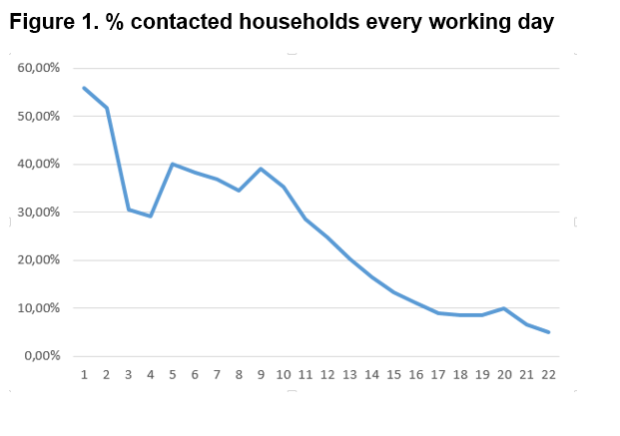
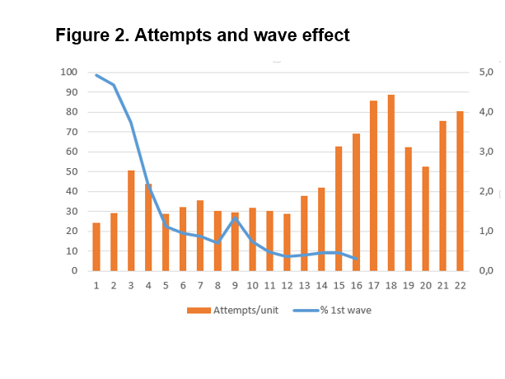
At the beginning of the collecting period, a relatively high percentage of the attempts result in a contacted household (figure 1). From the third working day, the percentage fall since some of the contacted units answer the questionnaire and some others postpone the interview to another day. Remaining units are more difficult to contact to. If a unit is contacted, might to fix an appointment later in the same day, or maybe the unit has busy telephone number, among other results; in both cases, we could make more than one attempt per unit during the day. Figure 2 shows the daily average number of attempts for units that are called each day. We can see that the third day, households are called more than twice (2.5 times in average terms), but this is because during those days we are mainly focusing on first wave units (75% of the third day attempts were done for units in first wave) and the remaining units in their first collaboration are quickly decreasing. We gradually introduce units in 2nd to 6th collaboration and for several days the percentage of contacts grows, and the number of average attempts stabilizes around 1.5 calls per unit (figures 1 and 2). Finishing the third week of the collection period, just when 1st wave is about to be derived to CAPI method, the number of attempts goes up getting the maximum in more than 4 calls. Obviously, if we keep the same number of interviewers with the same working hours, this parameter will be increasing until the end of the month. If this is not so, it is because we reduce the number of interviewers and their working hours.
Basically, we could say that, during the last 8 working days, a household is called 3-4 times along the day, morning, afternoon and evening, and more difficult units could be contacted at some moment.
As the number of interviewers affects to other variables, in the next sections we analyse the average work of an interviewer in one hour.
3. Contacts and response
In figure 3, the number of units who can be contacted by an interviewer in one hour is confronted to the number of attempts the interviewer can do in one hour.
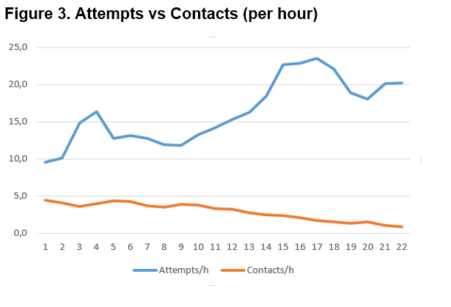
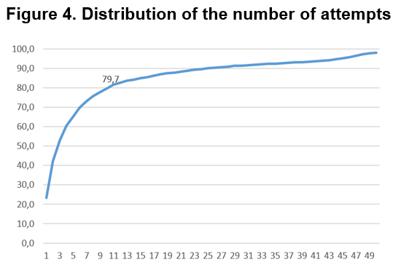
The number of contacts per hour uniformly decrease from 4.5 units the first day to less than 1 the last one. According to this, the number of attempts goes from almost 10 to 20, with a maximum of 23.5 the 17th day, when we derive the 1st wave to CAPI method. We can conclude that both parameters are correlated by the following fact: the more attempts are made per hour, the more units are called, so some additional units are contacted even when probability of contact is falling; moreover, contact decreasing produces more time without telephone conversations and interviewers can do more attempts.
We could think that it is a good idea to do more and more attempts, in order to increase contacted units, but, if we do so, respondent burden is increased, and they may be getting tired. Consequently, non-response arises.
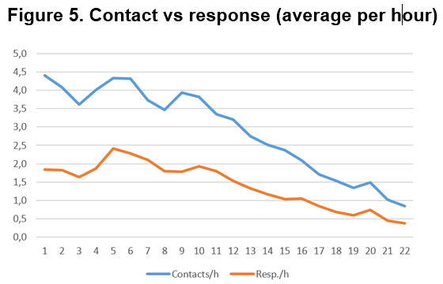
In the ETR, almost 80% of the sample units were called 10 times or less, and 10% had more than 25 attempts (figure 4). But only half of contacted people are respondents, and less than 1 household is interviewed by each interviewer in one hour, at the end of the month (figure 5).
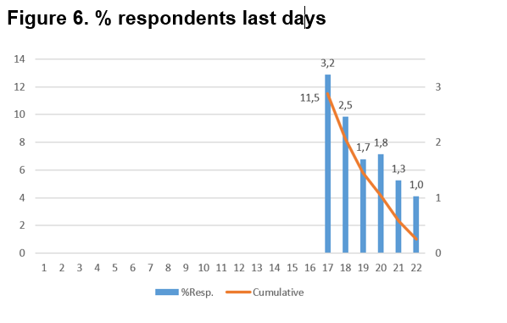
Is it convenient to go on doing attempts until the end of the collecting period? We have seen that contacts per hour fell, only half of them are interviewed, and a high proportion of the working time is unproductive. So, we could think it is better to stop data collection. Figure 6 shows that we get more than 11% of all respondents the last week of the month. It is remarkable that those days we are calling only people in their 2nd to 6th collaboration, so they supposedly were interviewed in a previous wave and this fact makes us conscious that contact is possible. They are the most difficult to be contacted, that is, the most interesting group for a travel survey, so the effort is worth it.
4. Calendar
Everything we were telling about until now impacts to another fact: the first day where a unit is called.
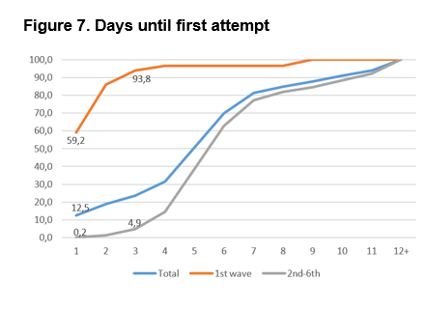
As 1st wave units are given priority for the first days’ attempts, almost 95% of them were called until day 3, but to reach the same percentage for the rest of the units, we have to be calling for two weeks (figure 7). It is true that units in 2nd to 6th wave theoretically represent 5/6 of the full sample (in fact, 4/5 due to the cumulated non-response for previous waves, mainly refusals and frame errors that are eliminated from the sample), but only 5% of these units were called the first 3 days, when focus was on 1st wave.
So, about 10% of January’s sample, basically from the 2nd to 6th wave, were not called the first two weeks and we have only two more weeks to try to contact them, as well as attending appointments from the others and making more attempts for the difficult units.
5. Concluding remarks and future work
The results provided in this paper show that the highest percentage of contacts are reached the first working week and about 50% of them result in respondent units. As the days go by, the contact rate decreases and the number of attempts per unit increases, giving more opportunities to contact them. It is clear that collection resources have to increase the first week and progressively to decrease from the third week in order to profit the behavioural schedule along the month. More studies are needed to find the optimal interviewer number and workload. We recently introduced CAWI collection for this survey, and additional analyse must be done to study the impact of multimode data collection on the most difficult units to be contacted.

6 References
AAPOR (2016). Standard definitions: Final dispositions of case codes and outcome rates for surveys. Retrieved from https://www.aapor.org/AAPOR_Main/media/publications/Standard-Definitions20169theditionfinal.pdf
De Leeuw/Hox/Dillman (2008) International Handbook of Survey Methodology.
INE (2015), Tourism Survey for Spanish Residents (ETR/FAMILITUR). Methods. Available at: http://www.ine.es/en/daco/daco42/etr/etr_metodologia_en.pdf

