A territorial model for
data collection implementation
Loredana De Gaetano, ISTAT, degaetan@istat
Angela Digrandi; ISTAT, digrandi@istat.it
Pasquale Papa, ISTAT, papa@istat.it
Abstract
The Italian National Statistical Institute (ISTAT) carries out the survey on the maritime transport of goods and passengers, as required by the Regulation (EU) No 1090/2010 of the European Parliament and of the Council.
The survey is a census as it refers to the final overall amount of the arrivals and departures recorded in Italian ports. It states, according to law, the obligation for all the agents, consignees and shippers operating in Italian ports to provide to ISTAT the main information on the travels of the relevant ships as well as on the quantity of goods and passengers transported.
In order to improve the quality of data collection, within the new ISTAT organizational structure, introduced during 2016, the Central Directorate for data collection was created, specifically dedicated to the design, organization, implementation and integration of the data collection activities.
Then a specific project assigned to a selected number of ISTAT territorial offices the new role of conducting data collection activities on the territory.
For the specific purposes of maritime transport survey, ISTAT territorial offices are entrusted with the tasks of updating the list of respondents and carrying out and monitoring data collection on the territory. In addition, according to this model a specific territorial office acquires the role to coordinate the conduction of data collection activity of all the other territorial offices.
The paper presents the case study of the ‘Campania and Basilicata’ territorial office that, starting from the survey editions 2017 and 2018, co-ordinates the activities of data collection, in collaboration with the ISTAT Section for the implementation of data collection from direct surveys (RDC) in the Central Directorate for data collection (DCRD). The analysis is aimed at presenting the improvements both in terms of process efficiency and quality of the results (response rates and timeliness) expected from the new data collection approach.
Keywords: data collection, maritime transport, process efficiency.

1. Introduction
During 2016 the Italian National Statistical Institute (Istat) launched a wide modernization programme whose main objective was to increase the supply and the quality of the information produced by improving the effectiveness and efficiency of the statistical processes. The new organizational set-up was based on centralization of all the support services, which were clearly separated from statistical production processes, in order to increase overall effectiveness and efficiency. The new set-up introduced a Directorate dedicated specifically to the design, organization, implementation and integration of the data collection (DC) activities, called Central Directorate for data collection. As the Central Directorate for data collection also the Istat’s Territorial offices (UUTT) were located in the new Department for data collection and development of methods and technologies for the production and dissemination of statistical information, so establishing the foundations for closer cooperation. The new organizational structure provides the following 8 offices located on Italian national territory: - Piemonte, Valle D’Aosta and Liguria RMB;- Lombardia RMC; - Veneto and Friuli Venezia Giulia RMD; - Emilia Romagna, Toscana and Umbria RME; - Marche, Abruzzo and Puglia RMF;- Lazio, Molise and Calabria RMG; - Campania and Basilicata RMH; - Sicilia and Sardegna RMI. Each territorial office may include one or more regional offices.
2. The role assumed by the Territorial offices in the new organizational setup
In the above mentioned framework Istat started a new project that assigned to territorial offices a central role, in carrying out several cross-cutting data collection activities on the territory. In particular, Istat territorial offices were entrusted with several tasks typical of centralized Data Collection offices: checking and updating the lists of companies involved in the surveys, carrying out and monitoring data collection on the territory, providing support and assistance to users. The new model assigns a specific role to one leader territorial office that carries out a coordination of the data collection activities for all the offices in the territory. The same lead office also maintains relations with the structure dedicated to managing the implementation of data collection at central level (office conducting data collection from direct surveys- RDC). The selection of the lead office is based on the experience accumulated in the specific subject area investigated. So, for the first time in Italy the activity of the Territorial offices in the field of data collection was not limited to the territory under its jurisdiction but is extended nationwide. During the start-up phase, the new management project for data collection on the territory is limited to a small number of activities: survey on Maritime transport, survey of Road accidents, Demographic statistics. At the conclusion of this opening phase, it is planned to extend it to other thematic sectors such as structural business statistics, tourism, environmental statistics. In order to better describe the new role of UUTT during the data collection phase it will be presented in the next paragraph the case study of the Territorial Office for Campania and Basilicata (RMH) that, starting from the survey edition 2018, co-ordinates the activities of data collection on Maritime Transport statistics, in collaboration with the Istat Section for the implementation of data collection from direct surveys (RDC) in the Central Directorate for data collection. During the start-up phase of the project, all the data collection activities taken over by the central structure were transferred to the territorial office through videoconferences and face-to-face meetings held at the headquarters in Rome. In particular, the transfer concerned the use of the tools used for data capturing (Tramar), for monitoring the DC, for the management of reminders, for assistance and support to respondents. Then they where entrusted with the main activities typical of the centralized data collection such as the task of updating the lists of respondents, carrying out and monitoring data collection on the territory, provide technical support for the correct filling out of the survey questionnaires, ensuring the consistency and quality of the data acquired. In fact the Territorial offices also carry out an activity of first level checking the information reported in the ISTAT TRAMAR models, compiled by the Maritime Agents, Forwarders, Recipients.
Since for the purposes of the survey it is foreseen a periodic sending of reminders for the transmission of monthly data to respondents, they will be contacted by relevant Istat Territorial Offices in order to collect updated contact information (i.e, phone and/or email addresses), useful to reach people authorized to carry out the operations of declaration of boarding and landing of goods and passengers. Lastly, Istat's territorial offices make a consistency check with the administrative data available at the Ministry of Infrastructures and Transport (named PMIS system - Port Management Information System), also with a view to activating the desired interoperability between the PMIS system and the ISTAT system for the automatic exchange of data of statistical interest.
3. A case study of process innovation: the role of Campania and Basilicata (RMH) Territorial Office in DC implementation for Maritime Transport survey
The reorganization of the data collection for maritime transport survey, that entrusted a coordination role to the Territorial office Campania and Basilicata, has determined the redesign of the flow of interventions to support respondents and of the checks of coverage and quality on information collected. Firstly, the redesign requested the revision of methods for monitoring the data collection trend by redefining the reports deducible from the dedicated web application (named Tramarint see Annex 1), that is both an application for monitoring the survey trend, and a collaboration tool between Territorial Offices and Maritime Agencies. It offers facilities to manage the exchanges of information between ISTAT and the Maritime Agencies, in particular for the requests of password for accreditation to the data capturing system, for the modifications of the delegation powers, for restoring questionnaires to be reinserted or modified. This last functionality allows, by operating on Tramarint back-office system, to support respondents for changes and restoration of previously entered questionnaires and which must be made accessible again to the Agency's completion. Tramarint is currently accessible only by the Territorial Office, to which it returns the views on the summaries of the inserted questionnaires and a summary of the compilation of the relevant questionnaire sections in relation to the specific characteristics of the ships surveyed, the goods moved, the passengers transported.
The Tramarint monitoring system, when its management was taken over by the Campania and Basilicata Territorial office, presented only partial reports. It was therefore necessary to expand the contents of the reports and designing and implementing a new layout in order to reconstruct the entire survey year for every single movement of ships arriving or departing. With the new display, the information refers to the whole registry of the marine agency and ship's marine data and in particular the ship code IMO (International Maritime Organization), a unique code assigned to the vessel when the keel was laid by the IHS Fairplay, ex-Lloyd's Register - Fairplay.
The monitoring activity is carried out on the basis of two archives: the first is TRAMAR, the ISTAT site which collects the flow of the data of the survey with ISTAT ownership, according to Regulation (EU) No. 1090/2010 prescriptions, the second consists of the ADES (Arrivals Departures Enhanced Statistics) archive, which is fed by the flow deriving from the compulsory administrative records for each arrival and departure of ships from/to any Italian port by the Shipper. The Recipient is the legal figure assuming all the responsibilities related to the various aspects of port security and tax declarations on goods and passengers transported, with an additional requirement for cruise ships to communicate the list of passengers to the Ministry of the Interior for national security purposes. The Statistical Archive ADES is transmitted to Istat by the Statistical Office of the Ministry itself that acquires the elementary data (single trip of each ship identified by a code that is called visit_id) in possession of the Port Authorities and available for large and medium-sized Italian ports through the PMIS Portal.
Currently, the ADES file is acquired by the Division for integration of administrative sources and registers of the Central Directorate of Data Collection, and integration of the registers is carried out monthly. The file is transferred to the production Division that carries out the linkage with the data recorded in the Istat data capturing system in order to verify the exact correspondence between the data contained in the two databases that should not differ in anything except the fact that ISTAT, on the basis of what is prescribed by Eurostat to all Member States, requires a set of variables that is wider than those required for the PMIS system. Therefore, the comparison between the two archives should return an empty file in case of exact correspondence between the arrival / departure communications sent to the Port authorities and the TRAMAR forms. The condition is rarely verified, although the respondents are the same maritime agencies that feed both flows. All the complexity associated with the identification of ships and agencies to be subject to reminder or quality control mainly concerns the enucleation of the following cases: alleged duplication, compilation of only one of the two types of travel (arrival only or departure only), excess of declarations of empty vessels in cabotage movements for which it is presumed that the ship is unlikely to arrive or depart effectively empty. It follows the need for a continuous exchange between the National Coordination Office and all the local offices, concerning the issue of the various territorial completeness checks of ships operating between the same ports of origin and destination. In such situations, very frequently it is necessary to determine both the correspondence of the number of journeys and the correspondence in the definition of the type of ships and, as previously mentioned, the truthful correspondence of the indication of "empty ship". For this reason, in order to support information exchanges the Campania and Basilicata Territorial Office deemed it essential to activate a specific collaboration web area using the opportunity offered by the Istat Intranet. In addition to the need for frequent exchanges between the various territorial offices of the files monitored and the results, it allows to discuss any changes found by Istat territorial referents before requesting the Maritime Agency to formally communicate the changes. Only after the opportune exchanges of information between the territorial offices and the Istat lead office of Campania and Basilicata the formal communication channel is activated. The collaboration area is also used to share on the territory the survey administrative documentation among all the actors involved in all the phases of the survey, notably between ISTAT and the maritime agencies. Example of this documentation are the informative letter to start the survey, the monthly alerts and the quarterly and annual reminders. The collaboration area also has the function of interchanging external source documents such as ministerial circulars, initiatives by trade associations such as “Federagenti” and “Assoporti”, as well as lists and possible modifications of the territorial articulation of the Port Authorities and of the Port System Authorities, introduced by a recent legislation on port services in Italy.
Figure 1. Sharing information area among Territorial offices.
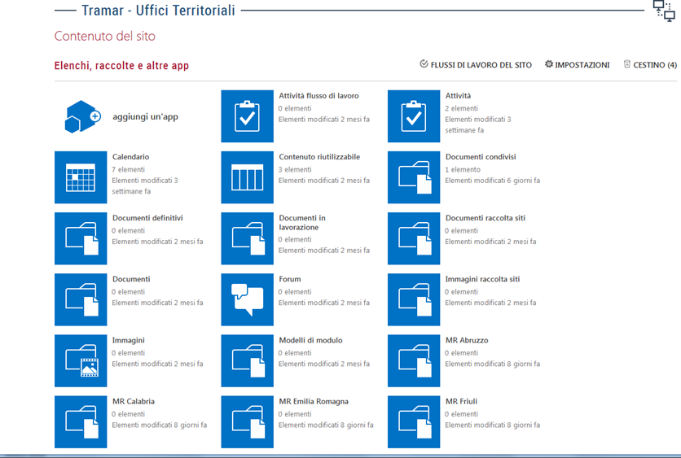
4. Results and final considerations
The case study concerning the involvement of the Campania and Basilicata Territorial Office in the DC implementation introduces an innovative way of managing data collection, that is characterized by a distributed throughout the territory approach, opposed to the standard model which provides for a centralized approach. The new mode has the main objective of streamlining the investigation procedures by adopting a standardized approach to data collection, in order to increase the overall efficiency of the process. The case study of the Campania and Basilicata Territorial office also demonstrated the active role of the UUTT in the DC activities as a national reference, not limited to the sphere of the single office. In fact the first results point out the capacity of a Territorial office to assume the role of leadership in the management of the DC activities, of coordinating the activities of other offices / territorial entities as well as the role of reference to the central structures that deal with the management of the collection. A first phase involves initial critical issues related to the consistent use of resources of the Central Data Collection Directorate, due to the rigidity of the existing management systems; the difficulty of extending the harmonization and rationalization objectives typical of data collection on the territory and the tendency to "mix" thematic and non-thematic topics. In the experience of maritime transport survey, the Campania and Basilicata office also demonstrated the ability to manage links with any intermediate bodies involved (other than ISTAT). The first results obtained showed a strong rationalization of the collection process with deep revisions of the modalities of relations with the agencies involved in the survey, in the roles of the external and internal actors involved and in the checks on the data made during the DC phase. The case study considered, moreover, represents a prototype model that can be of reference for the application in other research contexts and it may also be extended to other statistical surveys in the future.

Annex 1. Data collection procedure of the Istat survey on maritime transport
The data collection procedure is accessible by connecting to the secure site https://indata.istat.it/tramar and registering on first access. To receive the login credentials (username and password) to the Tramar service it is necessary to fill in a form containing the information related to the subject to be accredited and to the possible third party that he delegates to send the data. The user is in fact associated with the maritime agency, which can delegate a third party (for example a forwarder) to the sending of data through Tramar service. In the event that there is a person performing this task for several shipping agencies, the form must be completed for each agency; this subject will therefore be in possession of as many users as there are agencies that he represents in the use of the Tramar service. The form must then be filled in by entering the data relating to the shipping agency and the lower section (the person in charge) the data relating to the shipper / company in charge of sending the data via the electronic service. Tramar, if present.
A1. Use of the web procedure
In occasion of first access the respondent has to connect to the website https://indata.istat.it/tramar (the site is protected with SSL protocol that guarantees its authenticity and the protection of transmitted data). In the registration procedure the respondent must: 1) enter the user code and initial password contained in the e-mail sent by Istat; 2) enter the personal password. 3) press the Confirm key. The personal password, known only by the respondent, replaces the temporary one (not valid for the procedure). On the Web page these functions are also available: 1) Survey: a brief illustration of the Survey; 2) Instructions: guide to completing the questionnaire with any updates; 3) Contacts: contains the e-mail address and telephone numbers for contacts with the toll-free number and the contact person for the survey and data collection. These functions can be accessed independently of the registration procedure. Once the registration procedure is completed, the respondent is enabled and can immediately proceed with the filling in using the Questionnaire button.
A2. Web questionnaire
Inside the initial page relative to the Questionnaire entry is displayed a first part containing the personal data related to the user, previously provided to Istat. These are not directly editable, except for the field relative to the email address to which the respondent wants to receive the return receipt of the electronic form. To insert a new declaration, the user must enter by typing or using the appropriate calendar key, the date of arrival / departure of the ship subject to the declaration. The user cannot enter a date later than the day the form was filled. Alternatively, if the user wants to upload a file without inserting individual declarations, he/she can proceed with uploading via ‘Upload templates’ from files that can be found on the right side of the calendar. The files to be accepted by the system must comply with the specifications, available in the ‘Instructions and communications section’. The third part of the initial screen relates to the summaries of the inserted declarations or uploaded files.

Figure 2. Initial page of the web questionnaire.
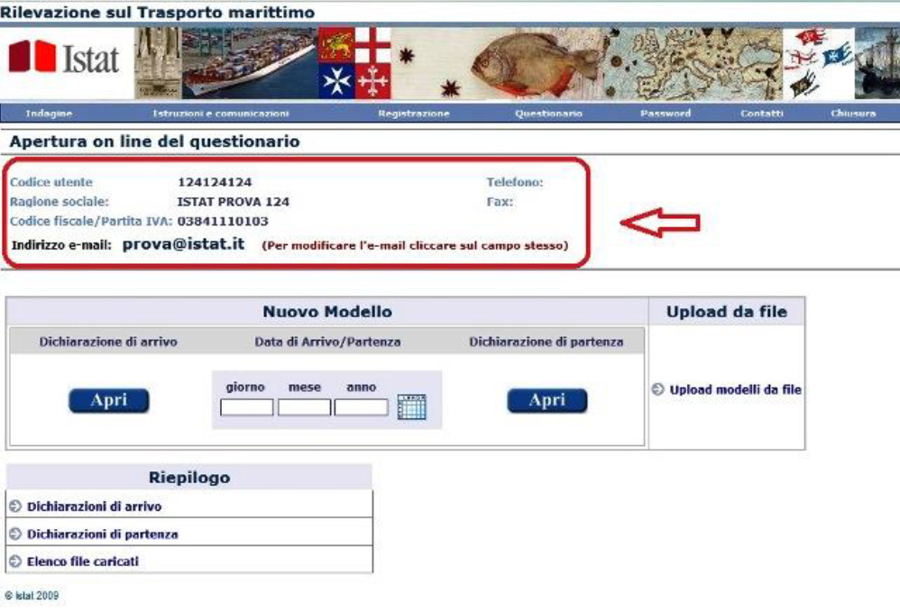
From January 2018, it is requested to insert the Visit_ID issued by the Port Authorities in place of the field "name Shipowner". The Visit_ID is a "unique national ship stop code" consisting of 13 characters: a) the first 5 characters identify the port according to the UNECE code; b) the following 2 identify the year; c) the remaining 6 represent a progressive number corresponding to the ship stop. In case an incorrect Visit_ID is inserted, which does not respect these characteristics, a warning window will open which will guide in solving the error. Typing the IMO (International Maritime Organization) number the user will automatically obtain all the characteristics related to the ship. In the event that only some of the characteristics of the ship are different, the important thing is that the type of ship, the net tonnage and the gross tonnage are correct. Once completed the compilation of the electronic questionnaire, the user will proceed with the next phase of checking and sending, through the appropriate screen. The checks carried out in this way are not to be considered exhaustive, since they mainly concern checks on the quantities of goods by port of origin / destination. Once the checks have been completed, the user must proceed by verifying, and possibly modifying, the e-mail address to which he/she wishes to receive a return receipt stating that the declaration has been sent correctly. This will only happen if the user authorizes the sending by the appropriate check box. After making the final dispatch, it will no longer be possible for the user to modify the declaration of arrival / departure entered. It will instead be possible to save a copy of the form in PDF format on the user's computer.
5. References
Bruinooge G. (2012) Counting the Dutch, The Future of the Virtual Census in the Netherlands Presentation at the seminar Counting the 7 Billion 24 February 2012.
Citro, C.F., From multiple modes for surveys to multiple data sources for estimates, Survey Methodology, December 2014, Vol. 40, No. 2, pp. 137-161, Statistics Canada, Catalogue No. 12-001-X .
Istat (2017), Mapping delle attività della DCRD nell’ambito dello schema concettuale di riferimento internazionale GSBPM. Delibera D16 49 DIRM2017, Unece Statistics wiki. Generic Statistical Business Process Model – GSBPM. http://www1.unece.org/stat/platform/display/metis/The+Generic+Statistical+Business+Process+Model.
Radermacher W. (2015), Statistics 4.0, Opening speech NTTS 2015.
Regulation (EU) No 1090/2010 of the European Parliament and of the Council of 24 November 2010 amending Directive 2009/42/EC on statistical returns in respect of carriage of goods and passengers by sea Text with EEA relevance.
Signore M. (2017) GSBPM and other international standards MedStat training on GSBPM, Istat - Rome (2017-07). Available at https://statswiki.unece.org/display/GSBPM/GSBPM+Training+Materials.

Contributors: L. De Gaetano paragraphs 2, 4, Annex 1; A. Digrandi paragraph 3; P. Papa paragraph 1.
Persons performing ship recommendation activities, assisting the master in respect of local authorities or third parties, receiving or delivering goods, embarking and disembarking passengers, acquiring freight, concluding transport contracts for goods and passengers with release of the relative documents, as well as any other activity for the protection of the interests assigned to him.

