Maintaining good response rates while changing survey techniques: the case of the Italian Quarterly Business Survey on Job Vacancies and Hours Worked
Diego Chianella, ISTAT, chianella@ISTAT.it
Giuliano Latini, ISTAT, latini@ISTAT.it
Annalisa Lucarelli, ISTAT, anlucare@ISTAT.it
Emilia Matera, ISTAT, ematera@ISTAT.it
Marina Sorrentino, ISTAT, mrsorren@ISTAT.it

Abstract
Response rates in Italian business surveys range from 30-40% in structural more complex ones to a maximum of around 85% in few monthly panel surveys.
The Italian Quarterly Business Survey on Job Vacancies and Hours Worked had always had response rates in the higher range of this interval (often around 65-70%). This was achieved through a mixed mode survey technique (CATI for around 70% of respondents and CAWI, or Computer Assisted Web Interview, for the remaining 30%), carefully timed and addressed email reminders and daily interaction with the sample enterprises by survey experts.
Changes in the laws concerning the interactions between enterprises and public administration and financial constraints made it impossible to continue using the CATI technique after 2016 and required the switch to a unique response mode, CAWI.
This change posed serious risks of a fall in response rates.
A series of measures were taken to avoid this outcome.
In particular, email and certified email reminders were intensified, increased resources were dedicated to responses to emails, certified emails and phone calls by sample enterprises so as to improve their already good timeliness and accuracy.
Furthermore, starting from the survey for the II quarter 2017, telephone reminders carried out by an external provider have been introduced, where the telephone operators can also support the enterprises on the questionnaires requests, access to the relevant website and filling in of the online form.
The results in terms of response rates have so far been encouraging.
Keywords: business survey; response rate; survey technique; CATI; CAWI.

1. Introduction and short description of the survey
The purpose of the quarterly ISTAT survey on Job Vacancies and Hours Worked (in the following, VELA) is to contribute to monitor the dynamics of the labour market (see Baldi et al., 2011, and Bellisai et al., 2013). Hours worked measure the amount of work effectively employed by enterprises and are used in the calculation of indicators such as hourly wages and labour costs (in particular, in the EU Labour Cost Index) and hourly productivity. Job vacancies are included among the PEEIs (Principal European Economic Indicators) on the labour market, for their role as leading indicator of employment dynamics.
The survey contributes to produce the statistics required by three EU Regulations: hours worked for short-term statistics (Regulation No. 1165/98) and as denominator for the Labour Cost Index (Regulation No. 450/2003); and job vacancies for Regulation No. 453/2008.
To these aim, the VELA survey measures employees’ stocks and flows, job vacancies, hours worked and paid but not worked, hours of short-time working allowance.
The survey population includes all Italian private enterprises with less than 500 employees in Nace Rev. 2 sections B to S (excluding O). The largest enterprises are excluded (apart from few exceptions, considered by VELA as belonging to take all strata) because they are all included in the panel of another ISTAT survey that collects data also on the same variables with a monthly frequency.
The VELA sample includes around 26.000 enterprises and it is drawn randomly on the basis of an allocation in strata defined through economic activity, size and geographical area. It is rotated by one third each year, for the first quarter of the year wave.
Up until the fourth quarter of 2016, VELA used a mixed mode data collection, combining CATI (Computer Assisted Telephone Interviewing), CAWI (Computer Assisted Web Interviewing) and a residual possibility to send the filled in questionnaire to ISTAT by certified email. Costs considerations and changes in the laws governing the communications between private individuals and enterprises, on the one hand, and public administration bodies, on the other, led to a switch to only CAWI since the first quarter of 2017. This change risked to produce a remarkable fall in response rates, due to the fact that enterprises were no more reminded of the need to respond to the survey or helped in doing so by the CATI phone interviewers. A number of measures were introduced to avoid this risk.
In the following, the patterns of response rates in the last year of the mixed mode data collection technique and the first year of reliance on CAWI only are analysed, together with the measures implemented to boost response rates from the point of view of the Istat unit responsible for the production of statistical outputs.

2. Impact on response rates of a change in the data collection techniques
As mentioned above, until the fourth quarter of 2016, the VELA survey was conducted using a mixed mode survey technique combining CATI and CAWI (and, for a small share of responses, certified email).
The CATI data collection, which made use of a questionnaire including a comprehensive set of consistency checks, contributed to ensure that sample enterprises were reminded of the need to respond and encouraged to fill in the questionnaire. Furthermore, the phone interviewers helped the respondents in supplying coherent data. The CAWI data collection cannot rely on the contribution of the phone interviewers and restricts the range of consistency checks that can be proposed to the respondent enterprises. However, it allows more flexibility to the respondents in choosing when to fill in and transmit the questionnaire. Moreover, it implies great financial savings for the institution running the survey, compared to the CATI technique.
The VELA CAWI questionnaire is included in a Portal where each enterprise belonging to one or more ISTAT surveys can find all the questionnaires it is asked to fill in.
Each quarter, at the opening of the VELA data collection, ISTAT sends to all sample enterprises a certified email that formally announces or reminds the enterprise of its inclusion in the sample, and describes the purpose of the survey, the rules governing it and the response modes. A deadline is indicated for the response, at 37 days after the end of the reference quarter. However, late respondents are allowed. Moreover, enterprises have an obligation to respond each quarter, but penalties are only foreseen for the non-response of units with at least 250 employees.
The time frame for the enterprises’ responses derives from the deadlines for data transmission in the EU Regulations. In particular, job vacancy statistics are to be delivered to Eurostat within 45 and 70 days after the end of the reference quarter. Hours worked for the short term statistics Regulation need to be transmitted to Eurostat within 90 days after the end of the reference quarter. The Labour Cost index is requested by 70 days after the end of the reference quarter, which means that hours worked produced also on the basis of VELA need to be made available to the unit producing this indicator within 60 days after the end of the reference quarter. Finally, hours worked are used also by the ISTAT National Account division, in the production of quarterly hours worked indicators. Also to this aim, hours worked based also on VELA need to be made available within 60 days after the end of the reference quarter.
Since April 2016, a wide ranging reorganization of ISTAT has centralized most of the functions connected to carrying out and monitoring data collection in a purposely created directorate. As a consequence, the responsibility for these parts of the VELA survey has been gradually moved to the data collection directorate. The list of tasks carried out for VELA within this directorate includes, in particular: the sending of certified emails at the beginning of the data collection; the monitoring of response rates; the sending of reminders by email and certified email; the contacts with and monitoring of external providers of support services; the reply to emails (certified or not) sent by enterprises when they do not refer to the VELA questionnaire contents.
ISTAT business surveys’ responses rates depend, among other factors, on the questionnaire complexity, data collection techniques, reference population and sample structure. They are lower for complex structural surveys, in particular when involving small and medium enterprises (around 35% in 2015 in the survey on enterprises with less than 100 job holders carried out to comply with the structural business statistics EU Regulations, No. 295/2008 and 446/2014). However, even with similarly complex questionnaires, surveys on larger enterprises can reach higher response rates (around 74% in 2015 in the survey on enterprises with at least 100 job holders carried out to comply with the same Regulation). Moreover, the response rates are generally higher for surveys with simpler questionnaires and panel samples: on average in 2017, they were equal to 86% for the monthly survey on turnover and orders and to 87% for the monthly survey on industrial production. In all these cases, the data collection mode is CAWI.
As mentioned above, starting from the first quarter of 2017, the VELA survey was conducted with a unique CAWI response mode. This change was reflected in the response rates, which declined from 2016 to 2017 (see Table 1).

Table 1. Response rate by quarter – Years 2016-2017 (percentage)
 | I | II | III | IV
2016 | 68.0 | 71.7 | 68.2 | 71.6
2017 | 64.7 | 66.8 | 66.8 | 65.6
Source: ISTAT

Table 2. Number of respondents by quarter and mode – Years 2016-2017
 | 2016 |  |  |  |  | 2017
 | Web | Cati | Sent by certified email | Total |  | Web
I | 7,845 | 9,369 | 90 | 17,304 |  | 16,479
II | 7,363 | 10,491 | 202 | 18,056 |  | 16,899
III | 7,853 | 8,298 | 735 | 16,886 |  | 16,818
IV | 8,806 | 8,249 | 518 | 17,573 |  | 16,384
Source: ISTAT
However, the fall was much lower than expected, due the series of measures that were taken to contain it.
In particular, regular reminders by email and certified email were sent, in dates defined in agreement between the relevant data collection units and the unit responsible for the production of the statistical outputs. Furthermore, from the second quarter of 2017, the VELA survey has also begun to avail itself of the support of phone reminders carried out by an external provider of outbound services. This service extends also to helping the sample enterprises in understanding and filling in the questionnaire on the dedicated ISTAT website. Particular attention was paid to the training of these phone operators.
The effect of email and certified email reminders can be seen clearly in Figure 1, where the time series of daily responses for the questionnaire of the first quarter of 2017 is represented together with the dates of the reminders. An increase in the number of daily responses can be observed after each of these reminders.

Figure 1. Q1-2017 Respondents and reminders
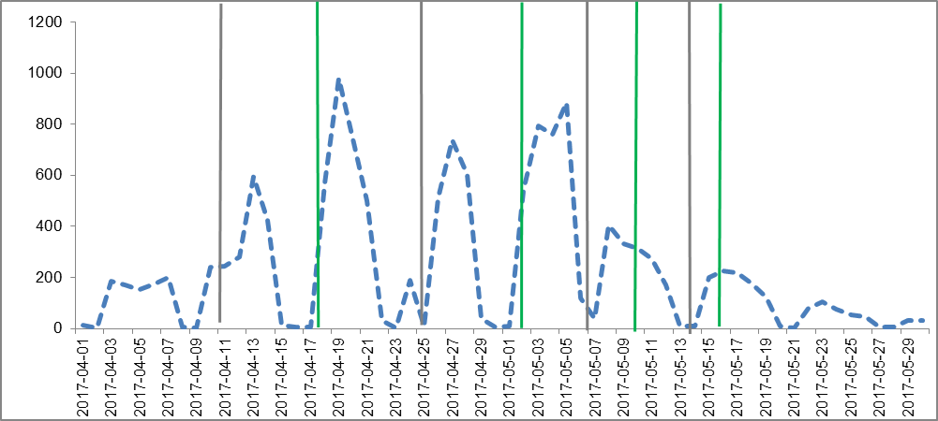
Source: ISTAT
Grey line: Certified email reminders; green line: email reminders.
Certified email reminders sent on 12 and 26 April; email reminders sent on 19 April.
The impact of the addition of phone reminders is shown in Figures 2 to 4, where a clear correlation (on average, equal to 0.91) appears between the series of daily number of responses and phone reminders. The effectiveness of phone reminders has also allowed to reduce in these three quarters the number of email and certified email ones, which however have still proven useful.
Figure 2. Q2-2017 Respondents and reminders
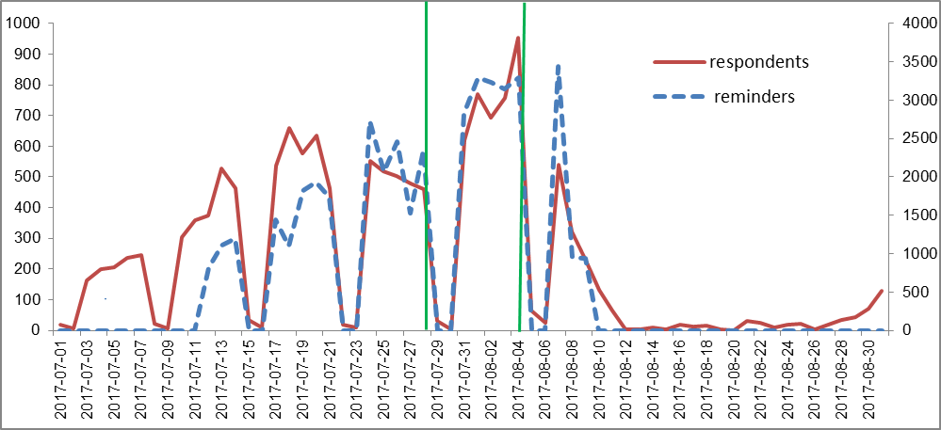
Source: ISTAT
Green line: email reminders, sent on 28 July,and 4 August.

Figure 3. Q3-2017 Respondents and reminders
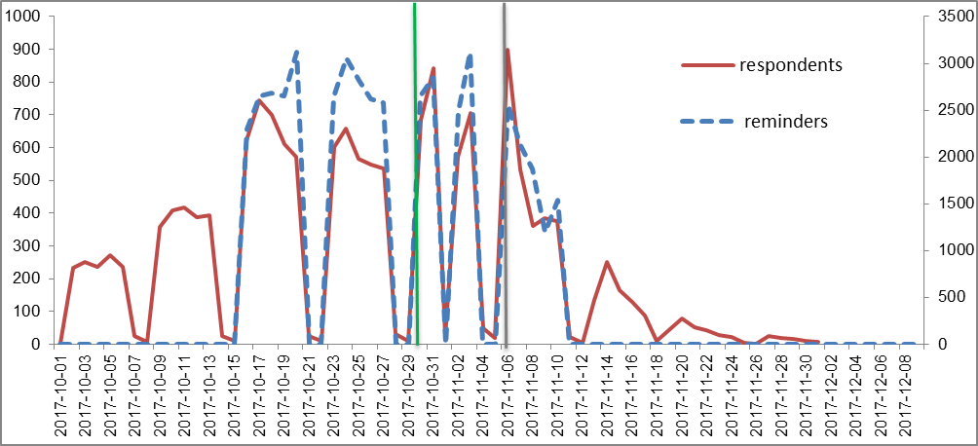
Source: ISTAT
Grey line: Certified email reminders; green line: email reminders.
Certified email reminders sent on 6 November; email reminders sent on 30 October.

Figure 4. Q4-2017 Respondents and reminders
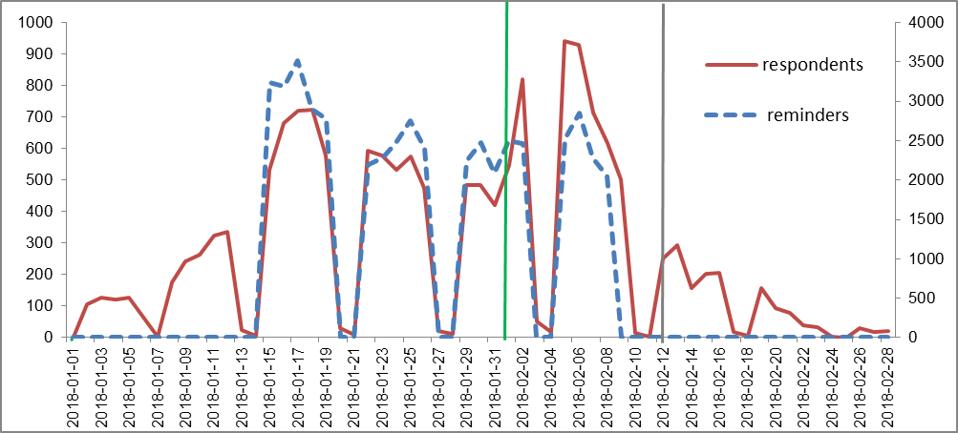
Source: ISTAT
Gray line: Certified email reminders; green line: email reminders.
Certified email reminders sent on 12 February; email reminders sent on 1 February.

3. Further measures to boost response rates
The phone reminders external supplier’s work is daily monitored by the relevant data collection unit, supported, if and when useful, by the unit responsible for the production of the statistical outputs. The synergy between the two units is crucial to achieving the results.
Furthermore, much attention has been paid to allow the sample enterprises various means to ask questions and support, through direct or indirect contacts with ISTAT. In particular, they can use certified or normal emails and phone calls to a toll-free number. Normal emails can be addressed directly to ISTAT or to an external provider of inbound services. The same external provider manages the toll-free number, while certified emails arrive directly to ISTAT. If an issue pertaining to the specific contents of the VELA questionnaire arrives to the inbound services external provider, this request is forwarded to the unit responsible for the production of the statistical outputs (and it is called “ticket” in the following). All other issues are addressed by the relevant data collection unit (in the case of certified emails) or the external provider (in the case of emails and phone calls arriving directly to it).
In Table 3, only communications related to the specific contents of the VELA questionnaire and to which a response is supplied by the unit responsible for the production of the statistical outputs are considered.

Table 3. Communication flows with sample enterprises managed by the unit responsible for the production of the statistical outputs - Years 2016-2017
 | Email - Received |  |  |  | Email - Sent |  |  |  | Tickets |  |  |  | Certified email - Received
 | 2016 | 2017 | 2017-2016 (%) |  | 2016 | 2017 | 2017-2016 (%) |  | 2016 | 2017 | 2017-2016 (%) |  | 2016 | 2017 | 2017-2016 (%)
I | 371 | 738 | 98.9 |  | 90 | 248 | 175.6 |  | 14 | 192 | 1271.4 |  | 967 | 1,250 | 29.3
II | 291 | 87 | -70.1 |  | 361 | 263 | -27.1 |  | 226 | 299 | 32.3 |  | 2,053 | 257 | -87.5
III | 79 | 27 | -65.8 |  | 53 | 184 | 247.2 |  | 291 | 186 | -36.1 |  | 1,790 | 52 | -97.1
IV | 786 | 133 | -83.1 |  | 147 | 125 | -15.0 |  | 262 | 121 | -53.8 |  | 2,185 | 45 | -97.9
TOT | 1527 | 985 | -35.5 |  | 651 | 820 | 26.0 |  | 793 | 798 | 0.6 |  | 6,995 | 1,604 | -77.1
Source: ISTAT
The figures show that the amount of these communications is substantial and takes place through all the available channels. Between 2016 and 2017 there has been an increase by 26.0% of the replies by email (attributable to the rise in the first and third quarters). On the other hand, the number of tickets has remained almost constant in the two years (the first quarter 2016 very low figure is due to the fact that at the time sample enterprises were just beginning to use that channel). The substantial decrease in the number of received certified emails (-77.1% year-on-year) is due to the fact that, as mentioned above, up until the end of 2016 sample enterprises could use this channel to send filled in questionnaires, while this possibility was no more available starting from the first quarter 2017.

4. Concluding remarks
In this paper, the patterns of response rates to the quarterly ISTAT survey on Job Vacancies and Hours Worked have been analysed, with a comparison between the last year of mixed mode (CATI and CAWI) data collection technique and the first year of reliance on CAWI only, from the point of view of the Istat unit responsible for the production of statistical outputs.
The measures taken to compensate for the end of the CATI technique, that range from certified and normal email reminders, to phone reminders and the availability to the sample enterprises of a varied set of closely monitored communication channels with ISTAT, have been shown to be important tools towards the aim to contain a possible fall in response rates.
The results highlight the great relevance of the synergy between the units responsible for data collection and the production of statistical outputs. In fact, a close cooperation has allowed to respond timely and effectively to the arising situations, for example adapting the schedule of normal and certified email reminders to the actual response patterns in each quarter.

5. References
Baldi C., Bellisai D., Ceccato F., Pacini S., Serbassi L., Sorrentino M. and Tuzi D. (2011), The System of Short Term Business Statistics on Labour in Italy. The Challenges of Data Integration. Available at: http://www.ine.es/e/essnetdi_ws2011/ppts/Baldi_et_al.pdf.
Bellisai D., Binci S., Gigante S., Libratore A., Serbassi L. and Sorrentino M. (2013), Verso la modernizzazione della produzione delle statistiche congiunturali sull’input di lavoro: il processo di integrazione tra la rilevazione mensile sulle grandi imprese e quella trimestrale sui posti vacanti e le ore lavorate, Istat, Working Papers, n. 11
Schwarz G. (2013), Response Rate in European Business Tendency Surveys, Organisation for Economic Co-operation and Development, Final Report of the task force on survey quality’s work group on response rates.

