EBALUA: BUILDING A NEW APPLICATION TO ASSIST QUALITY ASSESSMENT OF STATISTICS IN EUSTAT
Enrique Morán Aláez, Basque Statistics Institute - Eustat, Enrique-Moran@eustat.eus
María Victoria García Olea, Basque Statistics Institute - Eustat, Marivi-Garcia@eustat.eus
Abstract
“EBALUA”, the Basque word for “Assess”, is the provisional brand name of a new application that the Basque Statistics Institute-Eustat is currently building in order to assist the statistical staff to assess the quality of statistics produced inside the Basque Statistics Organization.

Assessment is seen in Eustat as an internal reflection that the responsible for the statistics makes with his/her team about the quality of them so that some improvements for the new cycle can be introduced.

The application provides the entire set of tools that the statistics team need to conduct the assessment, the questionnaires to fill in –based on the DESAP form developed by Statistics of Lithuania-, the assessment report, the access to the data base with previous assessments,..., following the assessment protocol adopted by Eustat.

The application is developed on the Internet because it is open to the Basque Statistical Organization, which includes Eustat and the statistical staff from the Basque Government Departments, in case this staff is part of a statistics team under Eustat’s responsibility.

EBALUA is integrated in the information system of Eustat so that it can take several programming data from it: the names of the statistics and of the team members, e-mail addresses, planned dates of the assessment, and so on.

EBALUA communicates the start and the end of the assessment process to the survey team and other people, such as the heads of the departments involved and Eustat’s managers, sending messages and the assessments reports.

EBALUA will store all the information in an Oracle data base and produce statistical reports of the assessment process, duration, delays and main features, giving a precise idea of the spreading of the culture of quality assessment in Eustat.
Keywords: Quality assessment, statistics team, assessment application, improvement, integration
1. Background
The Basque Statistics Institute – Eustat conducted a self-assessment first in 2006 and then in 2010, following the EFQM model as a quality management tool.
The EFQM model is based on a "framework of processes and procedures used to ensure that the organisation fulfils all tasks required to achieve its objectives". The processes map concept is introduced to identify the different processes in an organisation and their connections, so that this enables to obtain a global vision of the organisation.
Eustat develops its own Processes Map which includes, as the main process, the statistical production process with all its production phases, stages and tasks and a final phase referred to as the Assessment.
Although Eustat was aware of the importance of assessing quality in statistical production before, it was only in 2012 when a detailed and systematic approach was introduced in the organisation.
2. The assessment process
As the whole statistics process, the final phase of the quality assessment is planned as a task by the process team, under the leadership of the team head, and inside Eustat. The project was considered and treated by the organisation as strategic.
Assessment is defined as an output of a deep reflection about the survey, made by the statistics team, headed by its leader. It is not an external control but rather a self-evaluation of the way to improve each one of the phases and tasks of the survey.
Eustat has developed and approved an assessment protocol that has to be used as a guide for carrying out the assessment taking into account its main features, some of them outlined below.
Who makes the assessment? Assessment is the responsibility of the survey team as said before. The main burden falls directly on the Survey Manager, who is the responsible for filling in the questionnaire, with the assistance of those team partners needed for each of the sections of the questionnaire. The Survey Manager must inform the Heads of the Departments involved in the survey when the process begins.
In this context the survey team is the group of people from different Departments who take part in some of the phases of the survey. Given the size of Eustat, there is just one responsible person assigned permanently to each statistics, the Survey Manager. Other people dedicate part of their time, depending on the specific statistical tasks, their participation in other surveys and the size of the Department they belong to. For instance, the Dissemination and Marketing and the Methodology Departments are quite small so their staff has to participate in several surveys.
How the assessment is done? The DESAP – Development of a Self-Assessment Programme – questionnaire developed by the Lithuanian Statistical Institute for Eurostat was chosen as the assessment tool, considering it helps reviewing and rethinking all the survey stages and tasks and gives special attention to Eurostat quality dimensions. There are two versions, DESAP_E, a full questionnaire, and DESAP_C, a shortened questionnaire. The full questionnaire covers all the phases of a survey, starting with the reasons of carrying out the operation itself, and including the analysis of Eurostat quality criteria. The shortened questionnaire concentrates on assessing Eurostat quality criteria.
It is established that the full questionnaire will be used the first time the assessment is carried out for all statistics. Then, statistics differ depending on their frequency. The full questionnaire will also be used once every 5 years for yearly statistics. All other years, short questionnaires will be used instead. For less frequent statistics the full questionnaire will be applied every time they might be evaluated.
Finally, Eustat developed a template for a standard assessment report, which has been designed so it is easy to consult for team members or Heads of Departments involved in the survey. It can also be consulted by the Eustat managers.
The final report includes a list of the improvements for each section of the DESAP. Furthermore, it should also detail any ideas, conclusions and proposals for the next edition of the survey or for gradual introduction over the following 5 years. This report is reviewed by the corresponding Head of the Department, who should approve the proposal about how to carry out the improvements.
It is important to mention that only the assessment report is sent to people other than the survey team, such as the Heads of the Departments with some of their people in the team and Eustat Management.
3. EBALUA: the assessment application
During five years, the assessment process in Eustat has been using Excel as the means to fill in the questionnaire, because the DESAP had a macro which allowed this task, but unfortunately this macro failed to work in the new releases of the Microsoft Office suite.
On the other hand, all the communications needed were done by e-mail in a manual way and the DESAP questionnaires and the assessment reports were stored in separated survey files.
So, Eustat decided to build an application which assist the statistical staff and provide the entire set of tools needed to conduct the assessment: information on the dates of the assessment and the members of the survey team, the questionnaires to fill in, the assessment report, communications, the data base to store everything, the access to previous assessments, etc., following the assessment protocol adopted by Eustat.
As Eustat plans its yearly activity, EBALUA is integrated in the information system of Eustat so that it can take several programming data from it: the names and codes of the statistics to assess, the names, ID and e-mail addresses of the team members, planned dates of the assessment, and so on.
The application is developed on the Internet and open to the Basque Statistical Organization, which includes the statistical units of the Basque Government Departments along with Eustat. It is not unusual that the members of the survey team belong to different Departments so the intranet is the more adequate means to share information and tasks.
EBALUA presents the DESAP questionnaire in a manner that is common in Eustat activity; it looks like any other web questionnaire of the Eustat surveys and shares the framework developed for them, called “Canal Web” (web channel).
EBALUA informs about the dates of the assessment so it can be controlled by the survey managers, and sends automated messages to the team members, the heads of the departments involved in the process and Eustat managers, according to the assessment protocol, to communicate the start and the end of the evaluation and the final reports.
EBALUA will store all the information of the questionnaires and the reports in an Oracle data base and will load the main features of the statistics assessed, such as the type, if they have a sample, if they are based on administrative registers, etc. with the idea to allow analysis and improve the assessment process itself.
4. Improvement of the assessment process
EBALUA will produce statistical reports about the assessment process, such as the number of assessments by several characteristics of the survey, the duration of the process, the delays compared to the planned dates, etc.

Figure 1. Assessments by type of statistics
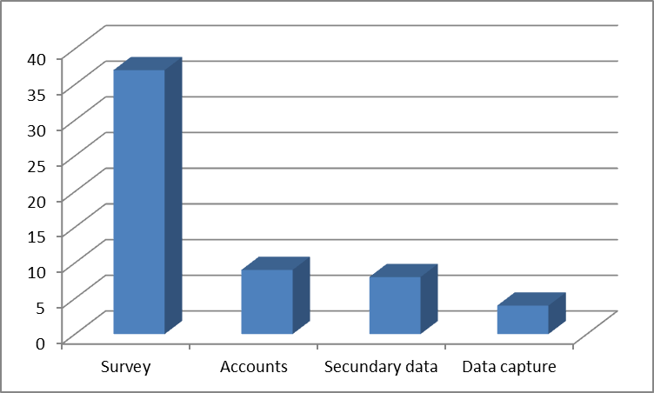
Source: Own elaboration
Additional work is needed to prepare analysis of the DESAP questionnaire which helps to improve the assessment process by comparing how things are done by different survey teams and in several types of statistics. It is important to answer questions such as: is it better to concentrate the assessment period in a week after the dissemination of the results or to split it up along with the stages of the survey process? Should other persons not directly involved in the survey be part of the assessment team?
Any ideas about this analysis will be welcome.

