**Workshop on Implementing Efficiencies and Quality of Output**

**Setting up a competences system at Istat**

*Istat, Human Resources Department*

*Antonio Ottaiano (*[*ottaiano@istat.it)*](mailto:ottaiano@istat.it))*, Pietro Scalisi (*[*scalisi@istat.it)*](mailto:scalisi@istat.it))*, Patrizio Di Nicola (*[*dinicola@istat.it*](mailto:dinicola@istat.it)*)*

What does a Human Resources Department in order to effectively accomplish its function? Which information about its personnel does it need to define adequate development policies and programs?

In this paper we will go through this; not from a theoretical, rather from a practical point of view, presenting the activities that Istat is carrying out accordingly to the modernisation process, with the aim of implementing a Competence system for its personnel.

**1. Introduction**

Last year the Italian National Institute of Statistics undertook a modernisation programme, innovating both the production system and the organisational structure and moving from a silos model to a matrix one.

Within the framework of this modernisation process, new roles and new competences are required to achieve Institute’s objectives.

In fact, the new production system introduces some challenging issues:

* An output oriented approach both in terms of a wider statistical production and in terms of accuracy of analysis;
* The need of strengthening quality standards and innovating technical and administrative services to support the statistical production system;
* The demand of new competences in activities programming and monitoring and in negotiation;
* The need of strengthening the managerial skills required to make the new matrix model work;
* The need of supporting processes with analytical reports.

On these bases, the modernisation programme represents a chance for Istat to state its expectations with respect to knowledge, skills, behaviour that its personnel will have to either acquire or develop in order to contribute to get Institute’s objectives.

Setting up a competence system at Istat goes towards this direction.

A competence system, seen as a set of knowledge, skills, and attitudes represents a common basis and a shared tool through which Istat can effectively manage the professional capabilities of its personnel, and it’s at the same time the basis on which to build development paths considering skills and attitude of individuals.

So, if we look at competences as the capability of carrying out the assigned tasks consistently with the continuous improvement principles, the organisation has, consequently, to be able to set up working contexts in which staff professional background (knowledge, skills, experiences, relationships…) is supported and fostered.

The competence system so becomes the cornerstone of an integrated human resources management model, around which all processes related to the human resources cycle turn.

In the human resources cycle, all aspects related to staff management are part of a common vision and contribute to achieve the organisation’s objectives. In such a vision, managing by competences turns to be a key factor of the organisational strategies.

So, providing Istat with a competence system means to affect significantly the whole human resources cycle:

* Recruiting: the competence system helps to define the competence profiles expected for each role, making the selection process transparent and consistent with the actual needs of the organisation;
* External mobility: the competence system supports the Institute in defining policies related to the acquisition/provision of competences from/to other organisations;
* Internal mobility: the system – thanks to comparative analysis among expected, practised and not practised competences – gives the organisation the opportunity to re-allocate resources in a more effective and efficient way;
* Training: the system makes it available a framework in order to build training paths more directly connected to the working processes, also fostering development processes based on an informal learning approach;
* Career development: a competence system can represent a shared platform, facilitating the dialogue between the organisation and its personnel about career development paths; it can also support evaluation tools.

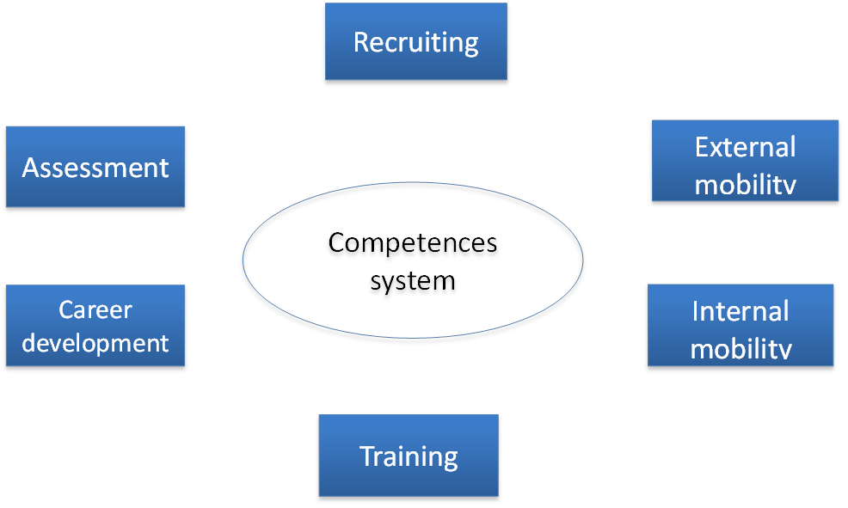

**2. The state of art at Istat**

Now, Istat hasn’t developed yet a competence system in the terms above illustrated.

However, some initiatives are being implemented, aiming at defining a picture about the competences our personnel have and the competences they practise in their work.

The objective, of course, is to find the gaps to fill in, to define human resources management policies and set the basis for a development process of Istat staff.

To do that, we must answer to some key questions: who are we? How do we work in the new organisational structure? Which competences do we have? And which of them, and at what extent, do we use? How can we find the gap? How are we assessed?

To get the answers to our questions we are developing a fact-finding pattern, made of different tiles, although sharing the same scope, each of them being part of the same mosaic.

They can be summed up through the steps in the following table.

Table 1: Fact-finding pattern at Istat

|  |  |  |
| --- | --- | --- |
|  | **Question** | **Answer** |
| 1 | What do we do during our working day? Which occupations are practised within our Institute? | Survey on occupations |
| 2 | Which knowledge and which technical skills are required to achieve our objectives? | Building a technical competences data base |
| 3 | Which organisational competences do we act in our work to use and share our knowledge? | Survey on acted organisational competences (OAC-PA methodology) |
| 4 | Which processes have been designed and implemented due to the modernisation process? Which competences do these new processes need? Which are the competence gaps we must face now? | Mapping working processes and expected competences and measuring the gaps |
| 5 | How is our work assessed? Which competences shall we either enhance or develop from the start? | 360° feedback for managers |

**3. The survey on occupation**

The competence system framework is based primarily on the description of what the personnel do. The renewed way to work in Istat, due to the modernisation process, requires knowledge of the new work activities and of the occupations carried out by the employees.

Classifying occupation is a very difficult task because, unlike other variables, the aim is to re-conduct an infinite universe of items to a finite number of codes. At Istat an official classification of Occupation has been defined, CP2011, which is inspired to an international one (ISCO08). This classification is based on the so-called criterion of competence, meaning the ability to carry out the tasks of a specific occupation, considered from two points of view: the level and the specialisation of this competence. Focusing on the daily working activities allows to code own occupation easily.

The survey on occupation, carried out by Istat for the implementation of the competence system, has been based on this assumption. The data collection started inviting personnel to codify own occupation focusing on the main working activities. The respondents described their tasks and then could use different search engine to find the best code for their work.

The results have been very interesting: more than eighty occupations have been detected by the staff. These are concentred in three *intellectual* major groups: the Professionals (II m.g.), the Technicians (III m.g.) and the Clerical support workers (IV m.g.).

The link with the classification of occupations (CP2011) will allow knowing, from a general point of view, the professional profiles of each occupation, what they do and the skills required to carry out their tasks.

**4. Building a technical competences data base**

Istat is currently working at the development of a job-specific competences register, aiming at classifying each employee’s capability and at measuring their level of mastery.

The first step has been the building of a skill classification by input of thematic experts. They have collected a large range of technical capabilities, knowledge and expertise - not only statistical ones – needed to work in a national institute of statistics. The experts have provided six thematic areas: statistics, information technology, administrative, communication, organization and foreign languages. Each area is subdivided into several subareas and each subarea provides a list of individual competencies. Overall, the classification consists of 29 subareas and 276 skills. It provides also a self-assessment scale of the mastery level structured in five modes: 0- none, 1- limited, 2-discreet, 3- advanced, 4- expert.

This classification system has been submitted to Istat staff, to collect all the skills owned by the personnel, both acted and not acted. After the first collection, the database has been closed to examine the feedbacks and the skills reported as missing.

The updated version of the data base will be opened to the personnel as soon as possible. All employees will be asked to fill in their new profile and self-evaluate the level of mastery of their skills.

The cognitive contribution of this operation could serve several practical purposes for different categories of users. For example, it will serve to:

* return to the management the existing skills profiles of staff;
* set up staffing plans;
* valuate mobility requests and orientate the job placement;
* identify training needs;
* select experts for cooperation projects;
* select internal teachers for training courses;
* select experts for international task forces;
* …

**5. Survey OAC-PA on acted organisational competences**

Which organisational competences do we act in our work to use and share our knowledge? The survey on acted organisational competences tries to answer this question.

In Italy, the so called OAC approach (Organisation, Learning and Skills) has been implemented in a large survey on public administration. Istat resumed this survey and tested it on a small part of his staff to verify the validity of the questionnaire and adapt it to its own reality. As soon as ready, the final questionnaire will be addressed to all Istat employees.

The survey will verify the Institute's ability to manage the knowledge and learning of its employees by organizational practices defined as "high performance work organizations". These practices - as team working, focus groups, mentoring, tutoring and so on - have a great importance in the knowledge-based economy.

In summary, the questionnaire focuses on the relationship between acted skills and work context, organizational policies, training strategies, real labor development processes and widespread learning forms.

The survey reports will provide benchmarking information for each direction, relating to organizational aspects, knowledge management and acted skills analysis.

**6. Mapping working processes and expected competences**

A survey is about to start aiming at defining working processes and competences required according to a bottom-up approach. This is the most important *tile* to insert in the competence system framework. It represents the benchmark to be considered in recognizing the skill gaps. So, mapping working processes and recognizing which competences new processes need is a basic task that must be done with great clarity and accuracy.

Concretely, Istat intends to organize focus groups with thematic experts and managers to describe the working processes implemented due to the modernisation and the skills expected to carry them out. This challenging and delicate phase will take a long time, but its implementation is strategic because it will allow comparing the three sets of skills: owned, acted and expected.

The figure below shows the three gaps that may arise in an organization:

Figure 1: The three main gaps related to the organizational skills

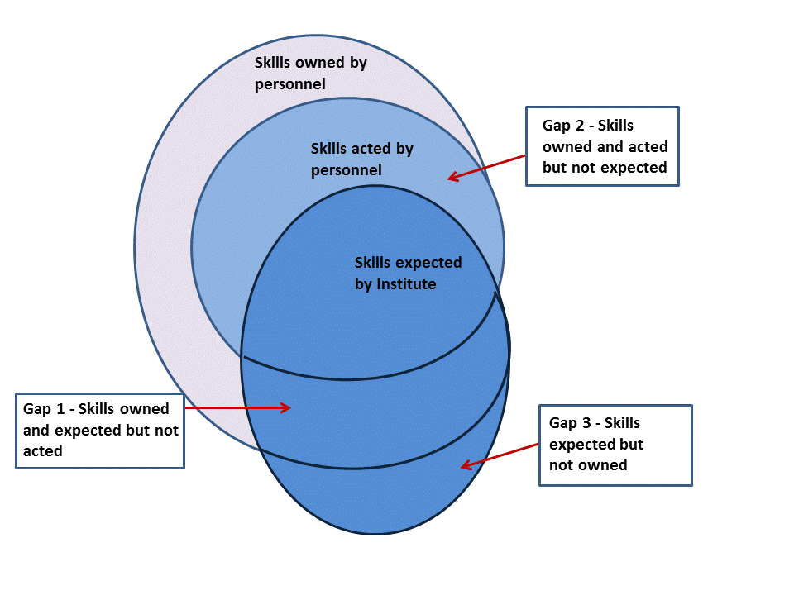

Many skill gaps may be detected in an organization. In the first case, the staff owns the skills expected, but it doesn’t act them. In the second case, the staff acts not expected skills while in the third case the staff doesn’t own the skills expected.

The main competences system purpose is to identify all the skill gaps present in an organization and to define human resources management policies able to fill in them.

**7. The 360° feedback analysis**

Setting a competence system gives also the opportunity to have a sound basis on which to build an evaluation system. That is, once an organisation has defined the competences it expects from its employees, it can also check whether such competences are actually held or not, if they are practised and how, which the gaps are.

At Istat, we have launched a self-assessment project addressed to Istat management, the 360°feedback analysis, based on a questionnaire (self)evaluating their competences.

The aim is to support managers in reflecting on their own individual effectiveness by adopting a “global feedback approach”, which makes it possible to compare feedbacks from the managers chief, peers, and employees with a self-assessment of the manager him/herself. This provides the manager with a picture of his/her features, strengths and weaknesses, and of the actions required to improve his/her way of acting within the organization.

Figure 2: 360°feedback approach



The entire process is based on the filling in of a questionnaire about the competences assumed as relevant for managers, referred to five different dimensions: I one; I – you; I – others, I – environment; I – vision.

For each dimension two or three key competences were identified as the ones to be (self)evaluated through some questions (around one hundred). The questionnaire is filled in on-line and anonymously. The feedback providers are requested to answer along a scale of frequency: never, seldom, sometimes, often, and always. Each of the about sixty managers involved is assessed by his/her chief; 3-5 peers; 3-15 co-workers.

The choice of the feedback providers is a crucial step of the process: all managers had to choose their feedback providers among people with which managers had work relations in the past. The choice can be made either by managers themselves or by a third part, i.e. the Human resources management department. Both alternatives come with pros and cons.

Communication is decisive for the process to be successful: all actors involved in the initiative are informed using different communication tools, starting from the HR staff, that has already attended a project start up seminar, during which information was provided to all about the aims, the methodology, the tools, the expected results of the project.

A webinar was organized to inform and, more, motivate managers and their feedback providers about the importance of the project. The webinar gave the opportunity to go through the aims and all the steps of the methodology, and also to focus on the importance of organizational competences with respect to the role of the management.

At the end of the process, each manager will receive a gap analysis report, in order to compare his/her self-assessment with the assessments of the feedback providers. The report will be deepened at an individual stage with an external consultant, a coach, who will support the participant to focus on strengths as well as on the improvement areas. Starting from that, manager and coach will define an action plan to develop those competences which need to be strengthened.

Also, the Institute will receive a final report, in which the feedbacks will be described in an aggregated way, giving a picture of areas of improvement of its management and of the training needs on which to work to organize competences development paths.

**8. Conclusions**

The management of human resources is a key element of any modern statistical office and statistical system.

The development of human resources is part of and must go along with the modernisation of the statistical production and services, and needs to have an active role in the corporate strategy and planning. This means that to promote change within organisations and to encourage innovation of processes and products a new human resources management approach is required, based on the definition and development of staff competences profiles.

Istat, because of modernisation, is currently working at the development of a competences system. The aim is to set up a very detailed informative system on personnel, on which all activities related to the human resources management cycle (attracting and retaining people, training and skills development, motivation, knowledge management, work environment and mobility etc.) must be based.

Setting up a competences system at Istat is a work in progress: some steps have been taken, others are still missing. The framework of the final mosaic is clear and first tiles have been placed, but many other have to be laid.