Revision Policy and Revision Analysis in Short-term Statistics at Istat: Recent Developments in Standardization and Communication Innovations
M. Giovanna Piras, Istat – National Accounts, piras@istat.it
Donatella Tuzi, Istat - Social Statistics and Population Census, tuzi@istat.it
Abstract
During the last two years the Italian National Institute of Statistics (Istat) intensively worked in the design and the establishment of a common framework in the revision policy and the revision analysis across different domains of short-term statistics. The primary objective was the set-up of a shared framework for internal governance of the quality in data and underlying processes and the development of an easily accessible platform where information on practices and measures of revisions is made available to stakeholders. At this aim, a mandate was given to a Working Group whose members were chosen from different structures of the Italian NSI: methodologists, statisticians, experts in IT and in communication, quality managers. The main achievement of the Working Group has been the setting of a dedicated section in the Istat website where, beside outlining the protocol on policy, analysis and dissemination of revisions - the different tools and related measures of revisions based on “revision triangles” are provided. Currently this new environment has been fully developed for three short-term production lines: Monthly Industrial Production, Quarterly National Accounts, Quarterly Labour Costs statistics. In the next future, it will be extended to cover all the short-term statistics, implying the overcoming of heterogeneous and extremely fragmented practices, towards a wider transparency and accountability of the released statistics. The purpose of this paper is threefold: presenting the main established protocol on revision policy, analysis and dissemination of revisions of short- term statistics; describing main input/output of a generalized tool for storing indicators and calculating revision indicators; identifying communication tools (calendar of revisions, release of vintage series, dissemination of the revision triangles, etc.).
Keywords: Revision Policy, quality indicators, revision triangles, standardization, transparency

1. Introduction
The theme of data revisions, regarding their amplitude and main determinants, is recently attracting an increasing attention by the large community of users due to the significant impact on their activities coming from the difficult understanding of the actual state of the economy. Indeed data revisions, even more under limited information on the underlying drivers, affect the prompt assessment by Central Banks of the main macroeconomic trends and the ensuing pressures on inflation as well as on the conditions for financial stability. Also the ability of Governments in drafting fiscal plans and in selecting the policy actions risks to be influenced by recurrent and sizeable revisions in statistics concerning the main economic aggregates. International organizations would largely benefit, in their country monitoring, from a sound and accountable statistical picture. In the same vein, statistical surprises due to revisions weigh on the country assessment by financial market operators, with possible bias on their portfolio decisions; the business and household confidence may be significantly affected by the additional uncertainty caused by data revisions, especially in GDP growth, as they are largely commented in mass media.
In this context a pivotal requirement to enhance the public value of the official statistics is the dissemination of transparent information on revision policies and the related analysis. In particular, the latter represents a key diagnostic tool to test and improve data quality. Indeed, it allows monitoring the evolution and assessing the origin of revisions based on a set of statistical indicators that summarize the main features of the revision process since the first and up to the final estimates.
The revision analysis provides a valuable contribution to the NSIs’ commitment to meet the demand for transparency of the data production providing information for a proper reading of the estimates released at each step along the revision process. In this respect, the revision analysis plays a key role on both the producer and user side to better understand the possible signal coming from new information that becomes available over time following the first estimates of economic data, and to separate the role of the pure noise components affecting the data production (Piras 2015).
2. General framework
During the last two years Istat intensively worked in designing and establishing a common background for revision policy and analysis across short-term statistics production processes. At this aim, a mandate was given to a transversal Working Group (WG) whose members were chosen from different structures of the Italian NSI: methodologists, statisticians, experts in IT and in communication, quality managers. The primary objective was to set-up a standardized framework for internal governance of data quality based on the outline of a shared model of practices on revision and related methods for analysis. Secondly, the development of an easily accessible platform where the harmonized information on practices and measures of revisions could be drawn by stakeholders.
According to the European Statistics Code of Practice, the Quality Assurance Framework of the European Statistical System (QAF) and the ESS Guidelines on Revision Policy for PEEIs, starting from mid-2017, Istat committed to guarantee the respect of the most common principles on practices, analysis and release of data and metadata on revisions on a regular basis. This includes: the preannouncement of revisions in a release calendar; the dissemination of out of calendar revisions due to unexpected errors; the classification of each published data as preliminary or final; the explanation of causes of revisions; the dissemination of both qualitative (revision analysis) and quantitative (revision measures) information on revisions.
An initial overview on the short-term production processes that introduce regular revisions to published data brought to the identification of twenty-one surveys ranging in seven thematic areas (table 1) for which the dissemination of data and metadata on revisions is relevant. Only cases with occasional or yet not defined revision strategies have been excluded. Fifty-eight of the statistics compiled by the selected surveys can, actually, be submitted to revision analysis.
At the basis of a standardized dissemination of the required information, for each short-term survey introducing revisions, currently Istat releases a Revision Form (figure 1) that reports metadata on the revision policy adopted for raw and, whereas produced, calendar and/or seasonally adjusted data and a list of the reasons explaining routine and major revisions. A calendar of the complete cycle of routine revisions is included. It is illustrated through a chart that, for each release of data, highlights revised data classified by frequency of revision. This chart has the appearance of a symmetric triangle (figure 2). Further metadata on revision policy are regularly included in the periodic press releases, in a dedicated section named "Revisions". In the cases of major revisions the communication on reasons of revisions is given in a "Information note" accompanying the press release.
In order to get an essential insight on the quality of the data and of the production methodology and process, revisions must be measured: 1) to reveal potential sources of systematic data anomalies and identify areas of data collection and compilation process which should be improved (data producers); 2) for the evaluation of revision impact on the overall data quality (data users).
For both needs, the measurement of revisions must necessarily be based on summary statistics: a wide set of descriptive statistics, statistical tests and econometric frameworks are available, allowing more or less in-depth analysis. A description of the methodological choices adopted so far is presented in paragraph 2, while paragraph 3 highlights on the IT solutions aimed at establishing an automatic relationship between the main dissemination processes (data and revision measures and metadata updating). Paragraph 4 finally describes the divulgation strategy.
Table 1. List of Surveys/production processes in charge for revision analysis
Topic | Survey/production processes | N. of statistics for revision analysis
Labour and wages | Quarterly labour cost indicators for all size enterprises, Monthly labour indicators for large enterprises, Quarterly indicators on job vacancies and hours worked, Quarterly indicators on employment and unemployment. | 14
Industry and construction | Monthly industrial production, Monthly production in constructions, Monthly industrial turnover and orders, Quarterly building permits indicators. | 12
Services | Monthly retail trade, Tourism indicators, Quarterly turnover in services. | 5
Consumer and business confidence | Monthly consumer and business confidence indicators. | 6
Prices | Monthly consumer prices Quarterly house prices, Monthly industrial producer prices, Monthly costs for residential buildings, Quarterly agricultural product prices | 6
External trade | Monthly foreign trade and industrial import prices, Quarterly exports of Italian regions | 4
National Accounts | Quarterly National accounts and Quarterly non-financial National accounts | 11
TOTAL | 21 | 58

Figure 1. The Revision form: an example from the Industrial Production Index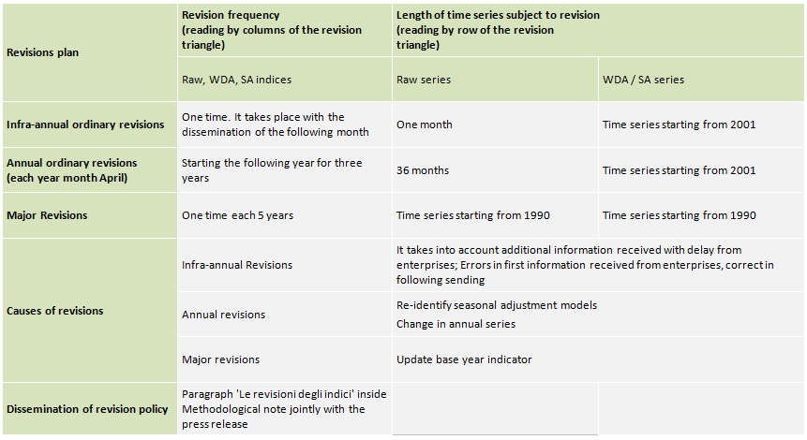
Figure 2. Outline of an ordinary process of revision: the case of the Monthly Industrial production Survey
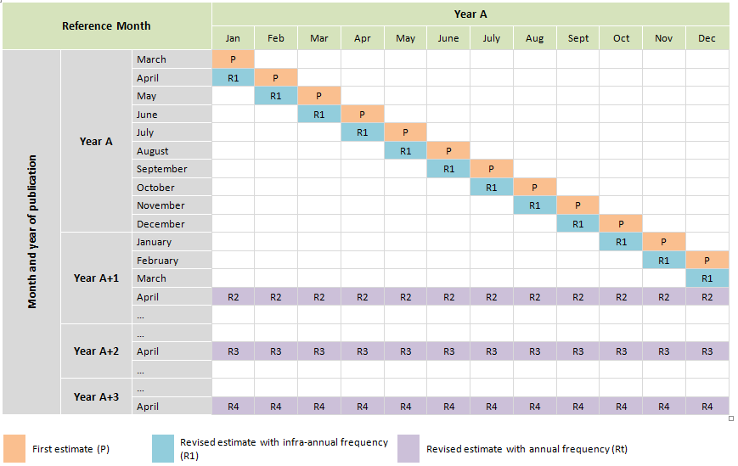

2. Revision Analysis: methodology and definition of standard measures
Consistently with the principle of clarity, for the main short-term indicators Istat publishes real-time databases in which different versions of data released over time are collected in tabular form. The rows of this form contains the time series released on a certain date (vintages); accordingly, by column the story of the released estimates of a given indicator is shown, starting from the first and up to the last available release. This way of organizing vintages (triangles) allows the monitoring of the process of change of a given observation along time until its final version.
A “revision” is defined as any change in the value of a statistic released to the public. Let define P_{t} the Preliminary estimate for a generic statistic referred to time t and L_{t} the related Later estimate. The measure of revision can be written as R_{t}=L_{t}-P_{t}. Revision analysis aims at highlighting the characteristics of R_{t} according to a double vision: considering external users’ needs, mainly interested in the overall data quality (accuracy, reliability and stability) of published data and producers’ needs, more oriented at the supervision of the statistical compilation process in order to control for potential sources of systematic data anomalies.
Having in mind triangles (figure 2), in practice R_{t} are calculated comparing data lying on fixed diagonals (P is in the first diagonal and L₁ is in the second one). In Istat practice, while the triangles report indices, levels or ratios (data published on Istat data warehouse) revisions are calculated on growth rates, more easy and readable measures of the short-term economic evolution. Normally year-on-year growth rates are considered for raw data (RAW) and calendar adjusted data (CA), while quarter-on-quarter or month-on-month growth rates are used for seasonally adjusted data (SA). Once revisions have been calculated, they are subsequently organized in time series and each occurrence of the time series represents the specific revision for the estimate on time t.
Revision analysis may be calculated on RAW data in which case the focus is on the peculiarities of the data production process; if CA data are considered the updating of the calendar factors is the additional aspect to be detected; finally in SA data the seasonal factors updating is the further component to investigate.
For each short-term indicator, in order to finalize revisions’ detection a first step is fixing P_{t} and L_{t} depending on the particularities of the revision policy (both of RAW, CA and SA data) and the relevance of each revision occurrence. Examining the cases listed in table 1, and trying to be parsimonious in the information produced, the following standard was outlined:
Table 2. Standard revision’s measures
Type of data | Measure of revision
R and CA | L₁-P, L_{1y}-P
SA | L₁-P, L_{1y}-P, L_{2y}-P, L_{3y}-P
Case of QNA | P-Flash, L₁-P, L_{1y}-P, L_{1y}-P, L_{2y}-P, L_{3y}-P

P=first estimate L₁=revised estimate with infra-annual frequency; L_{ty}=revised estimate with annual frequency;

Flash=GDP flash estimate t+30 days to the reference period

In almost all the analysed cases, the revision policy calculated on L₁-P (SA data) is a relevant measure particularly for users, interested in gathering elements about the robustness of the first estimates. A second important revision occurs after one year when more extensive changes are introduced in the information at the basis of the production processes. Further interesting revisions are those occurring at y+1, y+2 and y+3, whose comparison is useful to get an indication of the SA data convergence process. In Istat practice, ARIMA models, filters, outliers and calendar regressors used for SA are re-identified once a year (commonly in the occasion of the release of the first month/quarter of the year) and the respective parameters and factors re-estimated every time new or revised data become available (partial concurrent adjustment). When models are not re-specified, this practice implies that L₁ differs from P mainly because of the RAW data revision, while the updating of the seasonal factors due to the availability of a new observation and a revised one have a less significant impact. This is not the case of short or particularly volatile time series, or in cases of sudden changes in the trend, when additional information in the time series may imply important changes in the seasonal factors. In order to understand the cause of a revision in SA data, L₁-P has to be read together with the same measure calculated on RAW data. Because calendar factors are less sensible to the availability of new information in the time series, CA data revisions analysis is normally used as an alternative to RAW data revisions analysis, particularly when calendar effects are significant in the target time series.
Once defined, R_{t} must be synthetized using appropriate statistical measures aimed at highlighting the different characteristics of the revision process in a given revision interval. A total of 23 summary statistics have been considered for revision analysis, classified in 4 categories, each focusing on a particular aspect: 1) size of revisions; 2) direction of revisions; 3) variability of revisions; 4) effect of revisions on signs of growth rates. Table 3 reports the complete list of the summary statistics chosen. In the whole comprehensive list, a sub-set of 7 indicators has been selected as „basic measures”, those outlined in bolt, to be presented for a quick and easy understanding of the information.
Table 3. Summary statistics for revision analysis
Characteristic of the revisions | Statistical Measure
Size | Mean absolute revision (MAR), Mean squared revision, Median absolute revision, Relative MAR
Direction | Mean revision (MR), Standard deviation of revision, Statistical significance of MR (t-statistic), Critical values of t statistic for significance of MR (0.1/0.05/0.01), Statistical significance of MR, Median revision, Skewness of revision, % of positive revisions, % of negative revisions, % of zero revisions
Variability | Standard deviation of revision, Maximum revision, Minimum revision, Range of revision, Range that 90% of revisions lies within the interval of the percentile of the distribution of revisions, Quartile deviation
Effect on signs of variation rates | Percentage of observations where the sign of later estimate and the sign of earlier estimate are the same; Percentage of observations where both later and preliminary estimate have a positive growth rate if compared to the estimate of the previous time occurrence; Percentage of observations where both later and preliminary estimate have a negative growth rate if compared to the estimate of the previous time occurrence
3. The IT solution
In Istat website time series of the main short-term indicators can be downloaded from I.Stat. This database is complete on the statistics released but doesn’t systematically maintain vintages on-line. The WG has identified an efficient IT-solution that, in parallel with the release of a new data on I.Stat, is able to acquire in real-time the last issued information and update the revision triangle, calculate revisions and produce summary statistics and outputs to be published in a dedicated web page.
The solution was found in Micro Strategy Visual Analytics, a Business Intelligence IT-product exploited in its capability to connect various sources of data, integrate them in a multidimensional model, realize complex statistical calculation, allow visual analysis of data and production of multichannel output (web, pdf, xls etc.). In practice, this IT infrastructure connected with I.Stat acquires in real time the last published time series (indices, rates, ratios, levels) and then computes related growth rates. With this last time series a collection of vintages is firstly updated (historicalization), time series of revisions extracted and summarized through the calculation of the statistical measures listed above. These summary statistics are finally presented in an extensive and a synthetic format, through tables and graphs.
Figure 3 – The IT infrastructure*
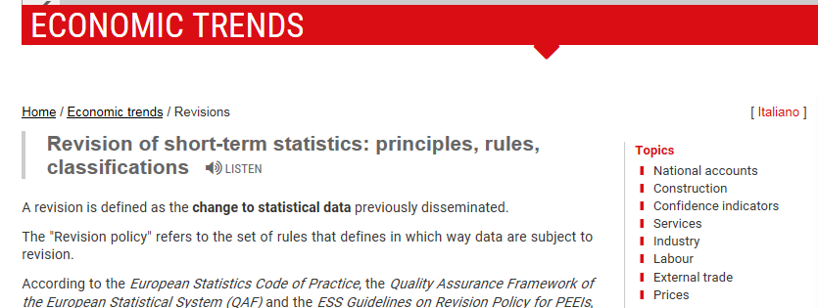
Calculation of statistical measures
Report doc, web
Calculation of growth rates
Indices, levels, rates, ratios
Data extraction
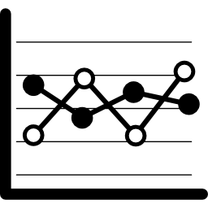
p-on-p growth rates
Historicalization of information

* This chart is an extraction from the work of A. Fiore, F. Billi and A. Virgillito: “L’infrastruttura tecnologica per il calcolo degli indicatori sulle revisioni” (Istat, 2017).
4. Release of the revision tools and analysis
A new dedicated section on Istat webside is available on the new information framework on revision policy and analysis. In this new page, metadata and data are organically presented under the section “Revisions” of the web page “Economic Trends” (http://www4.istat.it/en/economic-trends/revisions) that collects, organizes and provides information on the short-term economic indicators produced at Istat. An opening section, firstly introduces on principles, rules and classifications of revisions. A list of all the indicators subjected to revisions follows. For each indicator, beside the “Revision Form” (figure 1) describing the specific revision policy, the calendar of revisions is illustrated. For each indicator, the analysis of revisions is based on the presentation of revisions triangles that, accordingly to relevance concerns, refer to RAW, CA and/or SA data. Beside the triangles, a complete list of statistics on the revision process for each of the R_{t} listed in table 2 are reported. Finally, a more easily readable section synthetizes the main revision measures through a graphs accompanied by a reduced selection of statistical measures.
Links to each thematic section in the web page on Revisions are available in I.Stat (beside the specific data release), in the periodic press release where, in almost all the cases, a specific section called “revisions” reports some simple revision measures for the main aggregates. Further links are going to be included in SIQual the “Information system on quality of statistical production processes”.
4. Concluding remarks
In view of the increasing demand for statistics timely reporting on main economic developments (flash-estimates, provisional data etc.), providing a clear and standardized body of information about the revision policy and analysis becomes a strategic tool to enhance the regular control for the quality of flash data. In parallel, providing a prompt analysis of main determinants, nature and characteristics of revisions promotes confidence among users about the released data.
During the last two years Istat worked in the establishment of a common framework in revision policy and analysis. As a result, a shared framework has been set-up for the internal governance of the quality control of in the released statistics and the development of an easily accessible platform where information on practices and measures of revisions can be drawn by stakeholders.
Several improvements in the presentation of metadata and revision analysis tools can still be done, although with the caution that increasing the mass of information entails the risk to cause noise and confusion among the external users
References
Istat (2010), L’analisi delle revisioni delle informazioni statistiche congiunturali. Available at: https://www.istat.it/it/files/2011/01/approfondimenti_analisi_revisioni.pdf.
Istat (2017), Seminar „La politica di revisione degli indicatori congiunturali in Istat: novità e innovazione”. Rome, 26 June. Available at: https://www.istat.it/201387.
McKenzie R. and Gamba M. (2008), Interpreting the results of Revision Analyses: Recommended Summary Statistics. Contribution to the OECD/Eurostat Task Force on “Performing Revisions Analysis for Sub-Annual Economic Statistics. Available at: https://www.oecd.org/dataoecd/47/18/40315546.pdf.
Jens Mehrhoff (2008) Sources of Revisions of Seasonally Adjusted Real Time Data, Paper prepared for the Meeting of the OECD Short-term Economic Statistics Working Party (STESWP) in Paris, 23-24 June 2008.
Piras M. G. (2015), Revision Analysis of Italian Quarterly National Accounts, Istat Working Paper, n.17 2015.

Document by the European Statistical System Commettee (2011), available on the web: http://ec.europa.eu/KS-32-11-955-EN.PDF.
Document by the European Statistical System (2015), available on the web: http://ec.europa.eu/eurostat/documents/ESS-QAF-V1-2final.pdf.
Document by Eurostat (2013), available on the web: http://ec.europa.eu/KS-RA-13-016-EN.PDF.
Revision policy is the set of rules that defines how data are subject to revision (revision frequency, lenght of time series subject to revsion).
Quantifying and decomposing the two sources of error in seasonally adjusted data is actually an extensively debated question (see for example Mehrhoff, J. 2008). In particular, for users of seasonally adjusted real time data it is important to know the extent of revisions for economic analysis and forecast and how to take these into account. Several techniques can be used to perform this disaggregation and this is an improvement that will certainly be considered in the future work in the field of revision analysis at Istat.
Formulas can be found in: Istat (2010);; McKenzie and Gamba (2008).

