Understanding the effect of the global economy on the balance of payments
Caroline Bo, Statistics Denmark, cbo@dst.dk
Anette Morgils Hertz, Statistics Denmark, ahz@dst.dk
Abstract

Increasing our focus on large companies’ production setups has been of great importance to heighten the quality of measuring global activities affecting the Danish economy. Two global production setups – merchanting and processing – are central. During 2014 when the BPM6 was being implemented, we found that there was significant underreporting of these types of activities. Hence, we were not catching the full scale of global activities by Danish companies affecting the Danish economy. We decided to start validating data on the largest cases, i.e. the Danish companies, expected to have most global production. By validating data on the largest companies on an ongoing basis, we now believe to have a trustworthy indication of how our large companies affect our balance of payments. In this paper we will describe how we came to validate merchanting and processing data in a validation across statistical domains as well as include a description of the practical approach to this work.
Keywords: economic globalisation, Danish balance of payments, indicators of global production

1. Introduction
In September 2014, the balance of payments was compiled according to new international guidelines, as the new Balance of Payments Manual and International Investment Position Manual 6th edition, (BPM6) was implemented. With that, focus on economic globalisation was increased. As a consequence, more data on globalisation activities was to be reported, including information on processing activities abroad. The additional data made it possible to do a more direct comparison of data across statistical domains. With the implementation of BPM6, National Accounts detected inconsistencies between statistics on how globalisation activities were recorded, and concluded that there was a need for further analysis of how these activities are reported to Statistics Denmark. Consequently, in 2015 Statistics Denmark conducted a comprehensive analysis of data reported by some of the largest Danish companies.
One of the key elements of the analysis was to account for the companies' total operating revenue. By compiling a number of variables from different statistics, it was attempted to decompose the companies’ total revenue in domestic and foreign sales. The analysis showed underreporting of globalisation activities. It mainly concerned goods that do not cross the Danish border, which are part of the goods account of the balance of payments. Also, processing services and trade in intellectual property rights were underreported. As a consequence, the balance of payments was revised in October 2016, which meant an upward adjustment for the period 2005 to 2015, cf. Figure 1.
Figure 1. The current account balance before and after the revision
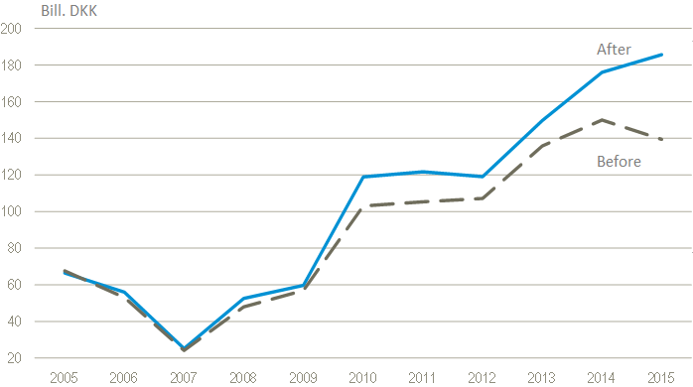
Source: Thomsen and Winther (2016)
The analysis taught us that multinational companies tend not to include all their foreign activities when reporting to Statistics Denmark. Intra-group trade is often disregarded. Moreover, multinational companies typically find it difficult to distinguish between ‘own goods’ and ‘commercial commodities for resale’ as required by the statistics. Viewed from the corporate (group) point of view, all goods produced by subsidiaries are typically regarded as ‘own goods’. Statistically, goods purchased and resold without further processing are ‘commercial commodities for resale’. Thus, the analysis made clear that actions had to be taken to ensure quality of the indicators that measure economic globalisation. Also, since the largest companies make up the lion’s share of the activity focus has to be put here.
Thus, to make sure that data reported by the companies is adequate we need to make some changes. First, we need to change our production processes at Statistics Denmark. The analysis showed that we need to analyse data for the largest companies in depth more systematically, which includes looking at data across statistical domains. By doing that we may be able to detect flaws and misunderstandings in reported data that otherwise may look correct when looking at it isolated within one statistics.
Secondly, we have to improve our communication with the companies. We need to make sure that they understand what they have to provide data on and thus be clearer on what the statistical concepts cover. Also, we need to clarify how certain variables and concepts are related to each other. Hence, a more direct contact with the companies is needed to understand their business models so we are able to guide them when reporting to us – this includes getting a better understanding of how business variables are related to statistical variables.
To ensure the quality of the balance of payments we have initiated several measures at External Economy at Statistics Denmark. It entails changes to our validation processes, our organisational structure as well as our collaboration with other statistical domains. More focus is put on the largest companies and their reporting of global production activities – especially merchanting and processing activities.

2. Understanding our indicators of global production
Around a sixth of Danish goods exports take place outside Danish borders. This export should by definition be included in the balance of payments. Danish exports outside Danish borders can take two forms – Merchanting which covers commercial commodities for resale or Processing which covers goods sold abroad after processing abroad.
Merchanting is a common practice in the international organisation of production carried out by multinational corporations. The example in Figure 2 demonstrates a Danish parent company purchasing products from their Chinese foreign affiliate. The products are sold unaltered to an American customer, and subsequently sent directly from China to the US, never crossing Danish borders. The profit earned by the Danish parent company (the selling price received in America minus the acquisition price paid for the goods in China) is included in Denmark’s balance of payments, recorded as merchanting products exported to the US.
Figure 2. Merchanting – ‘goods for resale’
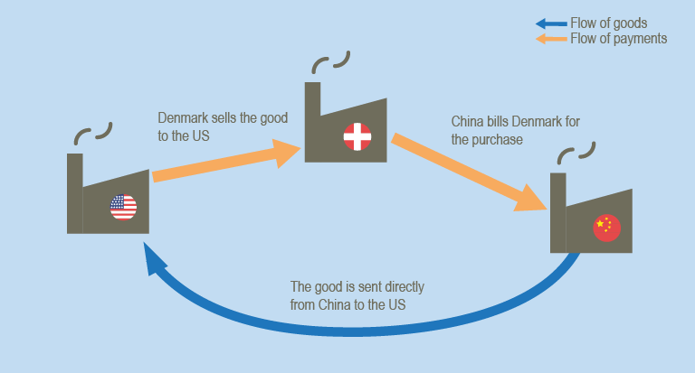
Source: Bo et al. (2018)
Processing is another way by which multinational corporations organise their production. It is when Danish businesses let companies abroad manage the manufacturing process of goods that the Danish businesses deliver (and own). Relating this to the previous example, if the Danish parent company chooses not to purchase the processed goods from their Chinese subsidiary (as shown in Figure 2), but instead chooses to enter a contractual agreement with their subsidiary concerning the processing of goods owned by the Danish company, this would be recorded as a purchase of processing services. Consequently, the same flow of goods will appear differently in statistical records, depending on who owns the goods at the time they are processed.
The example in Figure 3 shows a processing set-up in which a Danish business owns the products throughout a large part of the global value chain. In this example, the Danish parent company purchases goods in both Denmark and Vietnam to be produced in China. The parent company pays the Chinese subsidiary for the aforementioned processing services. As such, the parent company owns the goods throughout the entire production process and sells them first as finished goods to the American customer.
Figure 3. Processing
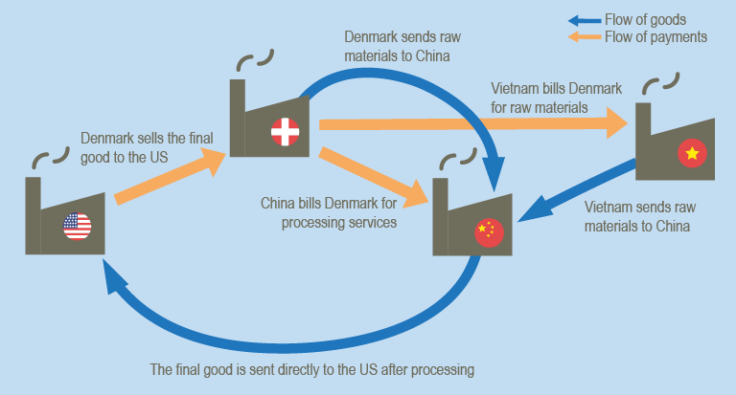
Source: Bo et al. (2018)
The payment for processing in the given example is recorded in the statistics for international trade in services as an import of a processing service. This service category covers both payroll and any supplementary purchasing of raw materials undertaken by the foreign business in relation to the further processing of the Danish goods. The goods purchased by the Danish parent company in Denmark and sent to China are recorded in the statistics for international trade in goods as exports. However, as Danish ownership remains constant and no change to a non-resident occurs, this movement of goods will not be classified as an export in the balance of payments. On the contrary, the goods purchased in Vietnam are not recorded in the statistics for international trade in goods as exports, but are included in the balance of payments as imported goods, due to the change from Vietnamese to Danish ownership. After processing, the products are sold to the US having never crossed Danish borders. The sale of goods abroad after being processed abroad is recorded as an export in the balance of payments: it is statistically irrelevant whether the goods are processed by a subsidiary or a third party.

3. Validation
In order to ensure good quality of the aforementioned indicators of global production – merchanting and processing – we have developed several consistency checks across statistical domains. Not only do we believe to have reached better quality on the indicators, these checks also ensure consistency between the involved statistics.
3.1. Involved statistics
The following statistics are included in the consistency checks:
- International Trade in Goods Statistics (ITGS)
  - Flows of goods to/from processing
  - Total imports and exports (with change of ownership)
- International trade in services survey and balance of payments (ITSS)
  - Manufacturing services
  - Materials bought abroad intended for processing abroad
  - Goods sold abroad after processing abroad
  - Merchanting, gross flows
  - Total imports and exports
- Business accounts (SBS)
  - Total turnover
  - Turnover own goods
- Manufacturers' sales (PRODCOM)
  - Total turnover
  - Sales of own goods
  - Commercial goods (resale) turnover
- Industrial turnover (STS)
  - Export turnover (own goods)
  - Domestic turnover (own goods)
3.2. Consistency check 1
In check 1, total revenue is decomposed in domestic and foreign sales.

The total turnover consists of the combined sale of goods and services domestically as well as abroad.
Discrepancies found in this check is most often due to wrong reporting of merchanting sales and/or goods sold abroad after processing. There is a general underreporting of Danish owned goods that do not cross the Danish border. It is especially common for Danish multinationals as inter-group transactions are poorly reported.

3.3. Consistency check 2
Check 2 examines whether there is consistency in reported data on goods for resale.
Commercial (resale) turnover (PRODCOM)
Merchanting exports (gross) (ITSS)
This consistency check is an indicator of size, as well as a check to ensure consistency between statistics. When it is confirmed that a Danish company has merchanting activities we would expect them to report it as commercial (resale) turnover for the statistics Industrial turnover. Since the commercial (resale) turnover also includes domestic resale, the merchanting sale should not exceed the reported figures for commercial (resale) turnover.
3.4. Consistency check 3
Check 3 examines whether there is consistency in reported data on sale of own goods.

If the Danish company is within the industrial sector, reported sale of own goods should be the sum of regular exports crossing the Danish border, as well as goods sold abroad after processing abroad and domestic turnover. Hence, this consistency check helps identify the level of goods sold abroad after processing abroad, as well as ensures consistency between the involved statistics.
3.5. Practical approach
In the office of External economy at Statistics Denmark we have identified 15 Danish company groups that we deem critical to the quality of the balance of payments. We have created a team of key account managers that are responsible for these company groups. Hence, the key account managers perform the before mentioned checks on data reported by these companies. Moreover, they are in close contact with the companies; so that we are informed in case their production setup changes. On top of the consistency checks we keep a close eye on the companies’ monthly reports to the two statistics International trade in goods and International trade in services, especially the parts where there are definitional differences between the balance of payments manual and the manuals for the individual statistics.

4. Additional measures
We keep looking for ways to increase the quality of the balance of payments. The balance of payments consists of the current account, the capital account and the financial account. The central bank of Denmark is responsible for the income part of the current account, as well as the capital account, and the financial account. When it comes to the large Danish companies the value added for the subsidiaries could theoretically be reported to both the central bank and Statistics Denmark. Against this background, we are now working closer with the central bank than previously to make sure that the large Danish companies report consistently.
In addition, Statistics Denmark has by 2018 established a large cases unit at house level. The unit will among other things function as a point of entry to Statistics Denmark for the largest Danish companies. External Economy works closely with this unit and provides specialist knowledge within the field of foreign trade. The unit will have close contact with the companies and will seek to make sure that the companies report consistently to Statistics Denmark across statistical domains.

5. Conclusion
By implementing consistency checks across statistical domains we have increased the quality of the two indicators measuring international activities undertaken by Danish companies – merchanting and processing. We are now able to better control for underreporting. Also, we are able to offer a closer contact with Statistics Denmark via the key account managers. Thereby helping companies understand what data we are looking for and why we are looking for it – including helping them distinguish between merchanting and processing. With the implementation of these initiatives, changes in the companies’ production setups should be caught faster. As a result, we believe we have a better indication of how much our large companies affect the Danish balance of payments.

6. References
Bo, C., Burman, S., Winther, C. and Rørmose Jensen, P. (2018), How big are Danish exports and who are our main trading partners?, Statistics Denmark, DST Analysis, No. 4, March.
Thomsen, A. and Winther, C. (2016), Implementation of the new guidelines concerning processing activities in Denmark – consistency problems detected, Statistics Denmark, Meeting of the Group of Experts on National Accounts, Geneva, 17 - 20 May 2016.

This section is based on the analysis How big are Danish exports and who are our main trading partners? published by Statistics Denmark in March 2018.

