Reduction of response burden by utilising extensively register data and modelling: Cases from new EU data needs in agricultural statistics
Pasi Mattila
Natural Resources Institute Finland, Finland, pasi.mattila@luke.fi
Johanna Laiho-Kauranne
Natural Resources Institute Finland, Finland, johanna.laiho-kauranne@luke.fi
Esa Katajamäki
Natural Resources Institute Finland, Finland, esa.katajamaki@luke.fi

Abstract
In ESS statistics, the use of administrative data is supported, which is also emphasized in the ESS Strategy for Agricultural Statistics for 2020 and beyond. Natural Resources Institute Finland (Luke) has a long experience of using administrative registers as a source for statistics. However, when new data needs are expressed or the administrative data develops, new possibilities arise. Our objective is to replace survey data in forthcoming farm surveys with register data, and to develop required survey estimation procedures. We examine and demonstrate the recent advances accomplished in the usability of the agricultural registers data and other data sources to reduce both the response burden and direct data collection from the farms.
The general objective is to provide statistical information on the greening of the agricultural production. Our case study investigates possibilities for a broader analysis of crop rotation based on the IACS parcel data including the new geospatial parcel data obtained from the farmers through farm subsidy administration from the year 2015 onwards.
Common advantages of the use of registers are the total coverage of farms, reduction of survey costs and the avoidance of misinterpretations by farmers when answering the questionnaires which is a significant factor in the case of the crop rotation variable.

Keywords: response burden, auxiliary information, register data

1. Introduction
Administrative and other registers contain data that may be useful when compiling statistics. Common advantages of agricultural register use are the almost total coverage of farms and the avoidance of misinterpretations by farmers when answering questionnaires. Developed techniques of data transfer and processing offer new possibilites for the utilization of registers. In this paper we have experimented and investigated some new ways of register use for statistics production. In ESS statistics, the use of administrative data is supported, which is also emphasized in the ESS Strategy for Agricultural Statistics for 2020 and beyond.
Natural Resources Institute Finland (Luke) has a long experience of using administrative registers as a source for statistics. However, when new data needs are expressed or the administrative data develops, we aim to investigate intensified utilisation of auxiliary data. Our objective is to replace survey data in forthcoming farm surveys increasingly with register data, and to develop required survey estimation procedures. We examine and demonstrate the recent advances accomplished in the usability of the agricultural registers data to reduce both the response burden and direct data collection from the farms. The general objective is to provide statistical information on the greening of the agricultural production, where crop rotation is a significant factor (Keskitalo ym. 2012). Our case study investigates possibilities for a broader analysis of crop rotation based on the IACS parcel data including the new geospatial parcel data obtained from the farmers through farm subsidy administration from the year 2015 onwards. Use of land parcel register data enables detailed definition of the area that is included and removes thus errors arising from misinterpretations by farmers when answering the questionnaires.
2. Crop rotation and analysis of field parcel data
Crop rotation was surveyed in the ESS Survey of Agricultural Production Methods (SAPM) in 2010, and in the Farm Structure Survey (FSS) of 2016. In the SAPM, it was difficult to find a clear definition for crop rotation that would be easy to transform into a simple and unambiguous question of a farm survey. As an alternative for farm surveys, the field parcel register of the Integrated Administration and Control System (IACS) was considered a potential source of information on crop rotation on individual farms that could be used also in the FSS of 2016.
The IACS field parcel data is obtained from the Finnish Agency for Rural Affairs (Mavi), and has been used as a source of annual cultivated area of crops for crop statistics and for FSS. However, the cultivation history of individual parcels has not been investigated in this connection. In our project, data available to help track cultivation history of a parcel over several years was screened. Specifically the use of the new geospatial data collected from farmers by the farm subsidy administration available from the year 2015 on was checked out (Figure 1). An example of the use of geospatial data is shown in Figure 2.

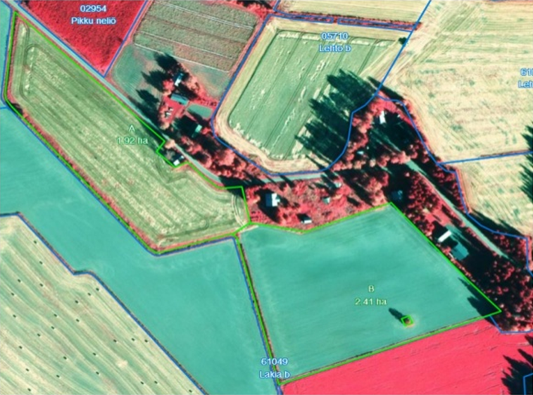
Figure 1. Sections of individual crops within a field parcel can be drawn with a computer in the web service for the application of subsidies (Finnish Agency for Rural Affairs (Mavi)).

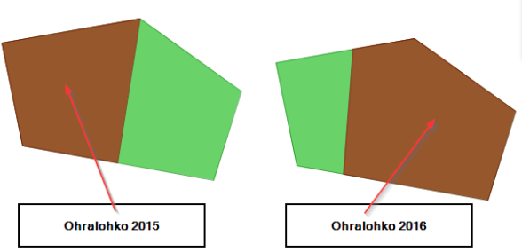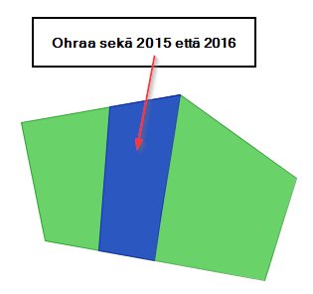
Barley 2015
Barley 2016

Barley 2015 and 2016:
The intersection of 2015 and 2016
Figure 2. Example of an area that has the same crop in two consecutive years.

At the first stage, register data was compared with the crop rotation data collected in the SAPM in the year 2010, whereby a calculation procedure was developed and the usefulness of the data was evaluated. At the second stage, register data from the year 2016 was used in the calculation of the corresponding variable for FSS 2016.
In the analysis, cultivation was considered monoculture, if same crop was grown on the same location for three consecutive years. For the SAPM, these years were 2008–2010 and for the FSS 2016 they were 2014–2016. Only those crop species were taken into account, that are considered to have negative effects when grown continuously. These crops included cereals, potato, sugar beet, oil seed crops, pulses, vegetables and strawberry.
When applying for agricultural subsidies, farmers must indicate the location of their field parcels and the location of individual crops within the parcels. In recent years, almost all farmers have adopted the possibility of drawing the location of their crops electronically on the internet service offered by the Finnish Agency for Rural Affairs. In 2016, about 90% percent of Finnish farmers used the internet service for the application of subsidies.
The geospatial data of crop location indicates the area within the parcel in question where same crop was grown in two consecutive years. To extend the scrutiny to a third consecutive year when the same crop has been grown on the same parcel, an intersection is formed of the intersection of the first two years and the same crop's location of the third year. This new intersection indicates the area where the same crop has been grown in all three consecutive years.
Process of the determination of monoculture area:
1. Parcels that have only one and the same crop on the whole parcel in the first two years.
a) Parcels that have only one and the same aforementioned crop on the whole area also in the third year. → Monoculture area = The whole area of the parcel
b) Parcels that have the same aforementioned crop in the third year too, but with at least one additional crop. → Monoculture area = The area of the third year
2. Parcels that have the same crop in the first two years with at least one other crop in one of the two years.
a) Parcels that have only one and the same aforementioned crop on the whole area in the third year, too. → Monoculture area = Smaller of the areas of the first two years
b) Parcels that have the same aforementioned crop in the third year too, but with at least one additional crop. → Geospatial analysis for the last year's crop location and the crop's location of the year when several crops were grown on the parcel in question.
3. Parcels that have the same crop in the first two years with at least one other crop in both of the two years.
a) Parcels that have only one and the same aforementioned crop on the whole area in the third year, too. → Geospatial analysis: Intersection of the first two years is the area of the same crop for all three years.
b) Parcels that have the same aforementioned crop in the third year too, but with at least one additional crop. → Geospatial analysis for the last year's crop location and the intersection of the first two years.
In Table 1 the process is represented in the cases of varying combinations of the number of crops.
Table 1. Determination of the area with the same crop in three consecutive years (monoculture area) of a field parcel. Total area of the parcel is assumed unchanged during the three years.
Number of crops within a field parcel in the three years |  |  |  | Area with the same crop in the three years
Y1 | Y2 | Y3
1 | 1 | 1 |  | Whole parcel
1 | 1 | >1 |  | A of Y3
1 | >1 | 1 |  | A of Y2
1 | >1 | >1 |  | Intersection of the A:s of Y2 and Y3
>1 | 1 | 1 |  | A of Y1
>1 | 1 | >1 |  | Intersection of the A:s of Y1 and Y3
>1 | >1 | 1 |  | Intersection of the A:s of Y1 and Y2
>1 | >1 | >1 |  | Intersection of the A:s of Y1, Y2 and Y3

Mass analysis of geospatial data is yet to be developed. So far, the respective phases of the data analysis (2b and 3) have been replaced with the assumption that half of the potential monoculture area has actually been under monoculture. In the cases where the area of a crop within the same parcel has varied less than 5% during the period of three consecutive years, the location of the crop is assumed having been constant and the whole area is considered monoculture. The cases where the analysis of geospatial data is necessary represent only a minor portion (18%) of the total area under monoculture and, therefore, they do not have a significant effect on the total area (Table 2). Comparison of crop areas between the years 2014 and 2015 must in any case be carried out by using the a-prior assumptions, because there are very few farms that have geospatial data for the year 2014.
Results below indicate that with the inclusion of temporary grassland, monoculture area calculated from IACS data is close to that obtained from the SAPM (Table 2). However, in the calculation of monoculture area for the FSS 2016, both permanent and temporary grassland were excluded, because they were not considered to have a negative effect when grown in monoculture.

Table 2. Monoculture area of the SAPM sample farms calculated from IACS field parcel data compared with the monoculture area of SAPM survey
 | # farms with monoculture area according to IACS | Total monoculture area, ha
 |  | IACS field parcel data | SAPM
Temporary grassland
- not included | 4 533 | 73 557 | 96 843
- included | 5 801 | 125 831 | 121 698

5. Conclusions
In the future, the developed calculation method will be used in the production of crop rotation characteristics for farm statistics. Besides the analysis of monoculture area, it is possible to use the method and the geospatial data of field parcels for a broader analysis of crop rotation by tracking any defined sequence of different crops. The potential enhancement in the use of geospatial data may enable the execution of the analysis using solely the geospatial data that indicates the location of individual crop species within field parcels.
6. References
Commission Regulation No 715/2014 of 26 June 2014 amending Annex III to Regulation (EC) No 1166/2008 of the European Parliament and of the Council on farm structure surveys and the survey on agricultural production methods, as regards the list of characteristics to be collected in the farm structure survey 2016.
European Commission (2015): Strategy for agricultural statistics for 2020 and beyond, European Commission, Directorate E: Sectoral and regional statistics. Directorate E: Sectoral and regional statistics. Unit E-1: Agriculture and fisheries.
Keskitalo, M., Hakala, K., Huusela-Veistola, E., Jalli, H., Jalli, M., Jauhiainen, L., Känkänen, H., 2012. Diversification of crop production through crop rotations. In: Mäkelä, P., Stoddard, F.L. (Eds.), ESA12 Abstracts, 12th Congress of the European Society for Agronomy. ESA, Helsinki, pp. 172–173. https://helda.helsinki.fi/handle/10138/36048 [3.6.2012].
Mattila, P., Vuorisalo, S., Kuoppa-aho, M. & Katajamäki, E. (2017) Reduction of response burden by replacing survey questions with register data: Cases of crop rotation, non-regular non-family labour, and number of pigs, sheep and goats. Unpublished Technical Project Report. Natural Resources Institute Finland.
Regulation No 378/2014 of the European Parliament and of the Council of 3 April 2014 amending Regulation (EC) No 1166/2008 as regards the financial framework for the period 2014-2018.
Luke Statistical WebServices on Agricultral, Forestry , Fishery and Bioeconomy statistics: http://stat.luke.fi/en/

