Quality Assurance and the GSBPM Adoption at INEGI, Mexico
Eduardo Jallath, INEGI, ejallath@inegi.org.mx
Enrique Ordaz, INEGI, enrique.ordaz@inegi.org.mx
Gloria M. Rubio, INEGI, gmrubio@inegi.org.mx

Abstract
At the end of 2014, INEGI introduced new institutional and technical measures for strengthening data quality, as part of the Quality Assurance Norm (QAN). The Norm outlines a general framework for quality assurance, establishes assessment requirements and defines institutional arrangements. The QAN implementation will involve several phases over the medium and long term. The initial implementation phase comprised the quality framework definition, a pilot self-assessment exercise, and priority setting. More recently, the quality assurance reform has been intertwined with the gradual adoption of the General Statistical Business Process Model (GSBPM).
Keywords: quality assurance reform, quality framework, quality assessment, General Statistical Business Process Model
1. Introduction
At the end of 2014, INEGI introduced new regulatory, institutional and technical measures, as part of a quality assurance reform. The approval of the Statistical and Geographical Information Quality Assurance Norm by the Governing Board sparked several actions aimed at institutionalizing quality assurance. Among these actions, the Norm entrusted a Senior Management Committee with the task of coordinating quality assurance. This paper presents the progress to date in implementing the QAN. Specifically, it focuses on the adoption of the Generic Statistical Business Process Model (GSBPM), as part of the quality assurance reform. The paper is organized as follows. The next section describes the initial implementation phase. Section 3 presents the rationale and adaptation of the GSBPM to the Mexican context. The final section examines lessons learned and challenges ahead.
2. Quality Assurance Reform: Initial Implementation
2.1 Defining INEGI Quality Assurance Framework
The QAN initial implementation phase concentrated primarily on defining INEGI quality assurance framework. Specifically, the Quality Assurance Committee adopted a quality assurance policy based on the Generic UN National Quality Assurance Framework (NQAF). The policy incorporates a set of guiding principles for developing, producing and disseminating statistical and geographical data. These principles are aimed at promoting an enabling institutional environment, as well as strengthening processes and products (see Figure 1).

Figure 1. INEGI Quality Policy
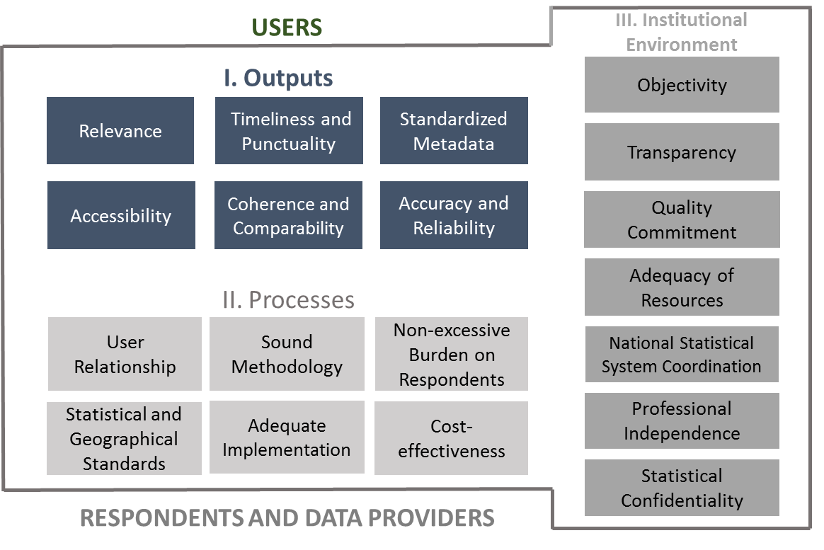
Source: INEGI, 2015b.
Hence, INEGI quality policy fosters an institutional environment based on objectivity, transparency, quality commitment, adequacy of resources, professional independence, statistical confidentiality, as well as, coordination of the National Statistical and Geographical System (SNIEG). At the process level, it promotes the use of sound methodologies, international or nationally agreed standards, and adequate implementation processes. Moreover, it includes the principles of solid relationships with information users, non-excessive burden on respondents, and cost-effectiveness.
Finally, at the output level, INEGI quality policy aims at producing statistics and geographical data that is relevant, accurate, reliable, coherent, and comparable over time and across regions. Furthermore, these data should be timely, readily accessible by users and include standardized metadata.
2.2 Setting Priorities for Quality Assurance
The Quality Assurance Committee is also in charge of approving an annual plan, outlining the objectives, strategies and priority actions. In 2016, this plan was aligned to the SNIEG long-term goals, which in turn are centred around the quality principles. As shown in Figure 2, the first phase of the quality assurance reform implementation is directed towards process standardization, systematic quality assessment and improvement management.

Figure 2. INEGI Objectives, Strategies and Targets for Quality Assurance
Objective 1:  Establishing quality controls in standardized and fully-documented processes (based on the GSBPM). | Medium-term targets (2019):  - 80% of INEGI key programs have fully-documented, standardized processes with quality controls.  - INEGI has a strengthened cost monitoring system
Strategies:
  - Processes standardization and documentation.
  - Quality controls definition and cost monitoring.

Objective 2:  Assessing statistical products quality in a systematic way. | Medium-term targets (2019):  - 85% of INEGI key programs have a quality assessment tool approved by the Committee.  - 85% of INEGI key programs report quality indicators, approved by the Committee, as part of their metadata.
Strategies:
2.1. Elaboration of quality indicators and reports.
2.2. Assessment tools design.
2.2. Application of assessment tools and techniques.

Objective 3:  Developing protocols for documenting and measuring the impact of improvements actions. | Medium-term goals (2019):  - 80% of INEGI key programs follow protocols for planning, documenting, consulting and/or assessing improvement actions.
Strategies:
3.1. Definition and application of protocols.
3.2. Implementation of improvements.
3.3. Quality assurance training and awareness campaign.
Source: INEGI, 2016.
3. Quality Assurance Reform and GSBPM Adoption
INEGI operates hundreds of different statistical and geographical programs. This complexity posed a major challenge for implementing the QAN in a cost-effective way. As a result, the quality assurance reform was complemented with a process standardization initiative based on the adoption of the Generic Statistical Business Process Model (GSBPM).
As indicated by UNECE High-Level Group for the Modernisation of Statistical Production and Services (HLG), “the GSBPM describes and defines the set of business processes needed to produce official statistics. It provides a standard framework and harmonised terminology to help statistical organizations to modernise their statistical production processes, as well as to share methods and components. The GSBPM can also be used for integrating data and metadata standards, as a template for process documentation, for harmonizing statistical computing infrastructures, and to provide a framework for process quality assessment and improvement.”
In 2017, INEGI adapted the GSBPM to the country context and developed the Statistical and Geographical Business Process Model (MPEG). The model will be first implemented at the phase level. A set of evidences for each phase have been identified and will be monitored regularly to assess the progress in process standardization, as well as in the QAN implementation. Evidences will be also useful to verify the adoption of international best practices. The MPEG adoption is supported by the development of appropriate regulations; a communication strategy and training activities.
4. Moving forward
The quality assurance reform faces many challenges, including the following:
- Continuous buy-in and commitment from senior management.
- Showing concrete short-term gains from standardization.
- Effective institution-wide communication on the reform goals and progress.
- Gradual scaling up to the SNIEG.
- Exploiting synergies with other initiatives, including data management and enterprise architecture.
Some of the lessons learned so far point to the need of strong leadership; massive reach out activities for all staff levels, and intensive technical assistance and follow up.
5. References
INEGI (2015a), Norma para el Aseguramiento de la Calidad de la Información Estadística y Geográfica del Instituto Nacional de Estadística y Geografía, Dirección General de Integración, Análisis e Investigación. México.
INEGI (2015b), Marco para el aseguramiento de la calidad de la información estadística y geográfica del Instituto Nacional de Estadística y Geografía, Comité de Aseguramiento de la Calidad. México.
INEGI (2015c), Política de Calidad Institucional, Comité de Aseguramiento de la Calidad. México.
INEGI (2016), Programa Anual de Aseguramiento de la Calidad Institucional 2017. México.
INEGI (2017), Modelo del Proceso Estadístico y Geográfico (MPEG). Sistema Nacional de Información Estadística y Geográfica. Versión 1.0, 28 de abril de 2017. México.

The Quality Assurance Committee is integrated by the managing directors and led by INEGI President. It is in charge of defining a quality management system, including quality standards, measurement tools, reporting requirements and feedback mechanisms. Moreover, the Committee is aimed at promoting quality assurance through technical advice and training.
The 2016 - 2040 SNIEG strategic objectives are: i) consolidating a coordinated, independent, transparent and objective SNIEG; ii) developing capacities for the data ecosystem; iii) ensuring the relevance and timeliness of statistical and geographical information; iv) producing accurate, reliable, consistent and comparable statistics and geo-spatial data, and v) ensuring data accessibility.
According to the Mexican Statistical Law, a set of key statistical and geographical programs, called Información de Interés Nacional, should be produced and disseminated following the guiding principles defined by the Law, and other regulations approved by INEGI Governing Board. These data may be produced by INEGI and other SNIEG members.
The GSBPM comprises eight phases of the statistical business process: i) Specify Needs; ii) Design; iii) Build; iv) Collect; v) Process; vi) Analyse; vii) Disseminate, and viii) Evaluate. In addition, there are sub-processes within each phase and several over-arching processes that apply throughout the eight phases. For more information, see https://statswiki.unece.org/display/GSBPM/GSBPM+v5.0

