Importance of Implementing EFQM Model for Official Statistics Institutes: PCBS Experience
Daliah Shahin
dshaheen@pcbs.gov.ps
Palestinian Central Bureau of Statistics (PCBS)
Abstract
This paper demonstrates how PCBS worked hard to fulfill the requirements of the certificate of “Committed to Excellent-C2E” delivered by EFQM, as a part of its efforts to develop comprehensive framework for the management of its operations according to international standards, this has been done to compete globally, and improve performance. The contribution of the paper is to explore an overview of EFQM model and the concept (EFQM model standards, Fundamental Concepts and RADAR Logic) and to highlight the concept of Excellence, Importance of applying EFQM model and the approach followed. It will also show the advantages and benefits of applying EFQM model such as: Comprehensive framework for improvement, improvement of quality, optimizing resources and it will explain difficulties and challenges faced PCBS in applying EFQM model. In addition to that, there is an overview of self-assessment process has been implemented in accordance with the European EFQM Excellence Model, it had been successfully conducted based on the principles and standards of excellence derived from the European Model and its evaluation-by RADAR. Throughout this process, the current situation of PCBS was diagnosed in comparison with standards of excellence to identify gaps and determine aspects of opportunities as way to develop PCBS and its methodologies in order to achieve PCBS mission and goals; we will show the projects resulted from the self- assessment as opportunities for improvement. Finally, the paper shows PCBS intention and its future steps towards continuing the way to achieve higher levels of excellence and sustainability.
Keywords: EFQM, Radar Logic, Committed to Excellent-C2E, Self-assessment.
Introduction
Excellence is about doing your best and developing culture of excellence by nurturing a culture of excellence in the organization, you open the path to success ,and improve performances and achieve outstanding results. The organizations should always be looking for opportunities to improve, where the EFQM Excellence Model provides a framework that encourages the cooperation and innovation that we need to ensure achieving this goal.
Since the establishment of PCBS in 1993, it has shown continued commitment to its internal development management systems to continue moving towards the highest possible levels of performance according to the best practices.
PCBS started the preparation of implementing EFQM model since 2014. The goal was to establish an institutional framework. PCBS reviewed relevant literature on the subject of quality management systems, examined the experiences of similar institutions which applied this model to benefit from their experiences. PCBS has reviewed the specifications of the model as well as contracted a local expert to help enabling the model's requirements. During 2015-2016, PCBS identified necessary documents needed to apply the model.
PCBS in the second quarter of 2017 passed the external evaluation successfully and received the Committed to Excellent certificate (C2E).
PCBS main reasons for adopting the idea of applying the model
There are many reasons encouraged PCBS to apply the model:
PCBS has applied the model of excellence as it is one of the most important models adopted worldwide as well as the following reasons:
- Improving the quality of performance of the institutions.
- Enhancing the capacities to implement modern and sustainable management concepts with the lowest cost and highest quality.
- Ensuring best development of human resources and encouraging creativity.
To achieve this, PCBS conducted several study visits to many countries in the field of quality and institutional performance such as Sweden, which prompted PCBS to implement requirements. In addition there was many recommendations of more than a technical assistance missions such as (the light peer review mission in 2012) to apply the model because of its impact in improving the overall performance of PCBS.
On the other hand, applying the model is in line with the vision and strategy of PCBS that focus on continuous development.

The concept of Excellence & EFQM Model
European Foundation for Quality Management EFQM: Is a non-prescriptive framework for enterprise management systems, helping to understand their key strengths and potential gaps, and provides a framework that promotes collaboration and innovation necessary to achieve the objectives of the enterprise, to guarantee a comprehensive framework for managing the operations and to compare them with the international standards.
The model contains three integrated components:
- Fundamental Concepts: Eight core values or key management principles that drive sustainable success.
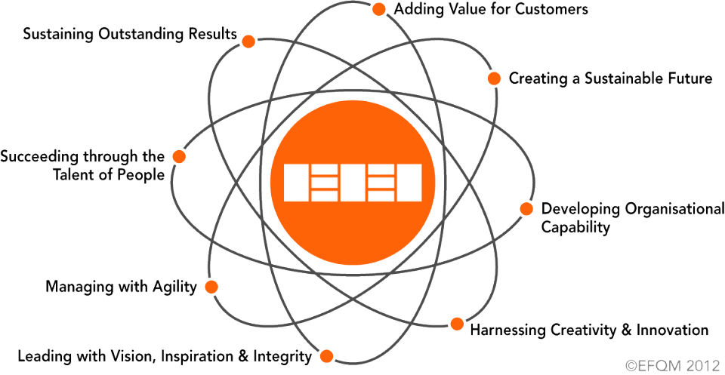
2-The EFQM Excellence model: allows managers/leaders to understand the cause and effect relationships between what their organization does and the results it achieves.
The EFQM Excellence Model is based on nine criteria, separated into five "enablers" and four "results" as shown in the following figure:
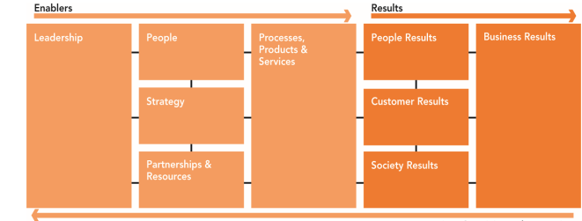
Within each sub-criterion there are indicative points, many of which are related to the basic concepts of excellence.
3-The RADAR logic: The RADAR logic is a dynamic assessment framework and a powerful management tool that provides a structured approach to questioning the performance of an organization which can help to lead change and manage improvement projects in an organization.
The RADAR logic is a continuous improvement cycle used by EFQM, derived from the Deming Process )PDCA cycle).
  - Determining the Results aimed at as part of the strategy.
  - Planning and developing a set of Approaches to deliver the required results now and in the future.
  - Deploying the approaches in a systematic way to ensure implementation.
  - Assessing and Refining the deployed approaches based on monitoring and analysis of the results achieved and ongoing learning.
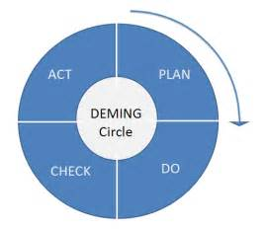
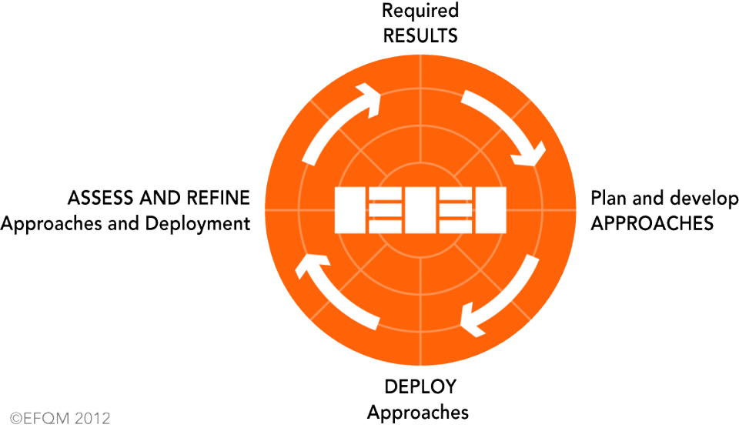
When an organization is assessed using a radar matrix, each of the nine criteria has a special weight, to calculate the final score given, 50% of the scores are allocated to the enablers and 50% of them are allocated to the results, which ensures the institution's ability to sustain its performance in the future.
When assessing Enablers, we look at the approaches adopted, how they have been deployed and how the organization assesses and refines its efficiency and effectiveness over time, when assessing Results, we first look at their Relevance to the organization's strategy and how useful they are in reviewing progress against these key objectives.
The Benefits from Applying EFQM model
- Creating comprehensive framework for improvement, spreading the culture of continuous improvement, sustaining excellence, enhancing leadership skills and encouraging employees to innovate.
- Optimizing resources by focusing on strategically important projects.
- Roadmap for enhancing motivation for improvement.
- Improving competitiveness by focusing on what matters.
- Top management commitment to quality and to continuous organizational development which helps to develop the performance of the institution.
The approach followed by PCBS to build the model (EFQM Excellence)
The approach followed in implementation involves three stages:
1. Preparatory stage
Work and preparation for this stage began between 2013 and 2014,at this stage, a team was selected in cooperation with a contracted local expert to help in gaining basic understanding of the model and its requirements in addition to three specialized courses were held on the model (Excellence Journey, Excellence Leaders and Assessor training) and overview of the work of PCBS was taken including its vision, mission and strategy, a lot of efforts and hard work have been done to increase the employees awareness of the model through distributing a brochure on the European Excellence Model.
2. Self-assessment stage and opportunities for improvement
Self-assessment lays the foundation for organizations to engage in systemic, integrative identification of organizational strengths and areas that need improvement in the organization. Accordingly, these organizations formulate programs and strategic plans for improvement. The model provides a basis for integrating and assimilating balanced processes of organizational development at the behavioral as well as the organizational-task levels. The process has been successfully conducted in November 2014, based on the European Model and its evaluation-radar RADAR. Throughout this process, the current situation of PCBS was diagnostic in comparison with standards of excellence to identify gaps and determine aspects of opportunities as way to develop PCBS and its methodologies in order to achieve PCBS' mission and goals.
Main Strength points and Opportunities for improvement which have been identified by self-assessment:
Strength Points
- The leaders of PCBS have a clear vision of building a distinctive institution capable of international competitiveness
- PCBS works in accordance with a strategic plan prepared in coordination with partners, and consultation with users in abidance to PCBS Strategy through "users and producers dialogue".
- PCBS invests a lot in the infrastructure to perform its mission and achieve its vision.
- PCBS has work systems and many procedures covering the both statistical and administrative aspects of work.
Opportunities for improvement
- There is a clear methodology for the implementation of the strategic plan through annual planning; however, it does not include a systematic follow up to evaluate the analytical overview of the strategic plan and results in terms of performance indicators and measuring the achievement of strategic goals.
- To develop and implement information systems objectives that contribute to achieving the overall goals of PCBS strategy such as computerization of administrative procedures.
- To review and assess the project life cycle and to use certified and proven project life cycle worldwide.
The selection of the projects aims to improve key support management functions necessary to lay down a solid foundation for core strategic development and future growth of PCBS.
Through the self-assessment conducted in cooperation with a national expert, PCBS identified and prioritized 3 improvement projects, based on several criteria:
- Ease of implementation availability of material and human resources.
- Duration of project implementation.
- The impact of the project and its importance on PCBS work and strategic objectives.
Improvement project: The improvement projects selected from among the many projects in PCBS have been selected according to priorities and highest values, the improvement projects and their opportunities for improvement were completed through the formation of task forces following up on the implementation of these projects. This was done between mid-2015 and mid-2016 the following is an explanation of the improvement projects.
1. Pilot key performance indicators project/national strategy and achievement of quality objective.
2. Generic Statistical Business Process Model (GSBPM).
3. Automation of administrative procedures (e-PCBS).
After the selection of projects, a team was selected for each improvement project, which prepares documents for each project according to the requirements of the European Excellence Model and holds workshops for all employees to increase their knowledge about the model of excellence in addition to knowing benefits of implementing it.
The following is a brief description of the objectives and results of each project:
Pilot key performance indicators project:
Objective: PCBS makes decisions depending on many measurement indicators using different data sources. PCBS plans to link these different data sources to a central database to enable measurement of processing at indicators levels.
Result: PCBS has been able to facilitate, monitor and evaluate results, where the central database was successfully created and it became available to produce periodic monitoring reports.
Generic Statistical Business Process Model (GSBPM):
Objective: PCBS aims at producing high quality statistics to meet users' needs, this comes through harmonizing standard terminologies and processes within the project life cycle, GSBPM represents a flexible tool to describe and define a set of necessary processes in producing official statistics. GSBPM provides more arranged simplified and consistent stages of a project life cycle, by which a statistical project would be organized and managed.
Result: The model Implemented in all PCBS survey during 2017 and it will be possible to mapping the quality indicators to the quality dimensions.
Automation of administrative procedures (e-PCBS):
Objective: PCBS depends on large number of administrative and technical procedures that require substantial time for completion. Automation of workflow should contribute to PCBS strategy of paperless office work environment and reengineering of current procedures.
Result: Where the objective of the project was the automation of 54% of the approved procedures and the reduction of time use by 73%, the project has achieved both targets.
3. Final assessment stage
Any organization can be recognized through an assessment based on the EFQM Excellence Model. EFQM assessment is a great way to motivate your people and encourage systematic improvement. It provides a focus for learning and training. External assessments can serve as milestones during a long-term program and demonstrate achievements to employees and users.
The output of an EFQM assessment is a number of strengths and opportunities to improve in the future, an EFQM assessment gives the management team a number of opportunities and how the organization chooses to solve them, where it depends on the strategic objectives and priorities of the organization. The external evaluation was implemented by the EFQM organization on May 11th 2017, and it included the improvement projects according to the radar logic. Finally, PCBS passed the external evaluation successfully and obtained the certificate (C2E).
Difficulties and challenges faced PCBS in applying EFQM model
1. Resistance to change, especially in the early beginning. It was important to overcome that by holding many meetings, workshops and seminars to explain the importance of change and the feasibility of applying the EFQM Excellence Model.
2. The obligation to conduct this process with a licensed external consultant entails a financial outlay. After conducting the process a few times, it is possible that internal staff members would be able to carry out future assessments.
3. The process is not easy, the management and the whole organization is examined, and a lot of efforts were required; still, the results were much better than expected.
Expected benefits and improvements on the work of PCBS:
The EFQM model provided a framework which helped PCBS in assessing its current level of excellence, where it would lead to the following expected benefits:
- Becoming more aware of our level of business excellence as we have a lot of strengths and weaknesses to work on. We have identified a number of challenges that we need to address to reach our goals and a number of factors that support the current quality effort.
- Helping us to identify the cause and effect relationships between the things you do and the results you achieve.
- Ability to provide a measurement of performance indicators and evaluation of results compared to the planned targets in the future.
- Increasing the interest of the staff in documentation with more confidence in its importance in facilitating access and the ensuring ability to know the workflow in an organized manner.
Recommendations
- Ensuring sustainability in achieving the vision and mission of PCBS that focuses on the production and dissemination of official statistics with high quality and adopting the best statistical practices as well as seeking to achieve highest possible levels always by adopting quality systems or work standards that increase the quality of its outputs.
- PCBS should study the impact of implementing the model on the employee and the beneficiaries during the coming period.
- It is important to work according to the standards of the model as part of a strategic plan of PCBS and as part of the yearly work plan for each department to ensure having it applied to all PCBS projects in the coming years.
- Creating a documented risk management system by which risks are defined, evaluated and identified (for operational and strategic initiatives).
- More time should be allocated to the improvement projects in addition to the training of sufficient staff to follow up.
Finally, the world never stands still as there are always new ideas, new technologies and new opportunities. Organizations need to continuously adapt to remain competitive, we believe in a world, where organizations share their ideas, experience and learning to help achieve sustainable economic development.
The EFQM Excellence Model gave us the right guidance in setting up our own PCBS framework, which is compatible with our Mission, Vision and Values.
References
- Van Nederpelt, P.W.M., (2010). A new model for quality management, Statistics Netherlands.
- Nayef abed and Marwan Barakat, (2017). Implementing of the European Excellence Model (EFQM) in the Palestinian Central Bureau of Statistics (Unpublished paper).
- PCBS experience in using data quality tools and systems, (2011). (Unpublished paper).
- European Foundation for Quality Management, (2013). The EFQM Excellence Model 2013. Brussels. http://www.efqm.org/the-efqm-excellence-model.
- D.r Amjad Al- ganeem, (November 2014). Self-assessment report, IDMC company, Palestinian central Bureau of statistics.
- Total Quality Management, http://managementstudyguide.com/total-quality-management.htm.
- EFQM shares what work, http://www.efqmchina.org/sharing.html.
- European Foundation for Quality Management (EFQM), https://www.base-uk.org/knowledge/european-foundation-quality-management-efqm.
- Dubai Electricity & water authority, success story from Public sector, (2017). http://www.efqm.org/sites/default/files/booklet_of_dewalow.pdf.

