Implementation of a quality management system in the NSI of Serbia – success stories and future plans
Nataša Cvetković, Statistical Office of the Republic of Serbia, natasa.cvetkovic@stat.gov.rs
Miodrag Cerovina, Statistical Office of the Republic of Serbia, miodrag.cerovina@stat.gov.rs
Abstract
During the last several years, and especially after the Light peer review exercise (2011), Statistical Office of the Republic of Serbia (SORS) made significant efforts in order to introduce quality management system. SORS is highly devoted to quality, and this could be seen from various conducted activities. Information and knowledge about different quality issues are continuously being spread among all employees through intranet portal on quality and different educational activities. User and staff satisfaction surveys have already being implemented for certain number of years. Documentation system for quality management, based on ISO 9001 standard, has been introduced, as well as a system for producing reference metadata and quality reports (RZSMETA). Standardization of the production process started in SORS many years ago, initialized by introduction of Integrated Survey Technology (IST). Completely designed and developed in SORS, IST has become regionally recognized data integration concept that supports several phases of statistical production process (build, collect, process and analyze). It is a challenge now how to efficiently use this comparative advantage in order to support building general metadata system as a precondition for further improvement of statistical process and product quality. The paper will describe how these different elements of a quality management system were implemented and what problems/solutions were identified/found by the Serbian statistical office.

Keywords: quality management, metadata, standardization, IST
1. Orientation towards quality and first initiatives
The Statistical Office of the Republic of Serbia (SORS) has a long strategic orientation to produce high quality official statistical results and to disseminate them impartially, independently and timely, making them available simultaneously to all users. This is entitled by the national Law on Official Statistics, which specifies the main goal of the official statistics and its basic functioning principles.
The mission of the official statistics in the Republic of Serbia supports our orientation to provide relevant, impartial, reliable, timely and internationally comparable statistical indicators. Coordination of authorised producers of official statistics and their active international statistical cooperation should lead to the final result where published official statistical results meet the needs of decision-makers, researchers and other users and provide basis for monitoring and directing of policies in economic and social fields as well as policies concerning the process of accession of the Republic of Serbia to the European Union. Data collection, processing and dissemination rely on the inevitable use of methodological and organizational knowledge, statistical standards, modern technologies, protection of statistical confidenciality, optimal use of resources, burden on respondents at a reasonable level and accessibility of data to users under the same conditions.
Reaching a high level of harmonization with international statistical standards, high level of quality of published data and acquired confidence of data providers and users by building professional and infrastructural capacities, adopting and applying the best statistical practices are stated as vision of the SORS.
Starting from this strategic orientation SORS committed to implement quality management framework and to establish comprehensive quality management system to be able to continuously monitor, evaluate and improve the quality of its statistical products and processes as well as level of overall performance. Moreover, the main aim of the SORS is to become an organisation with quality grounded culture in order to reach excellent level of performance.
More concrete quality-related actions and initiatives in the SORS started in 2011 by adoption of two key strategic documents on quality: Declaration on Quality, where European Statistics Code of Practice was put in the heart of quality framework of the SORS, and Quality Policy.
At the same time, organisational changes in 2010 took into consideration needs for more intensive work on quality management activities. The Group for coordination of regional departments, quality management and elections has been established. Since this organizational unit did not have capacity to start work on implementation of quality management system, by the end of 2011 the Working group for Quality management was formed. It had mandate and role to act as a coordination body for systematic work on introduction of quality management system according to the SORS’ adopted strategic goals and objectives. In order to create synergy of multi-disciplinary work it gathered experienced employees with different background that covered all relevant specialities. This working group started with systematic work on introducing the quality management framework, methods and tools, harmonized with the ESS recommendation, with policy of continuous improvement.

Figure 1. Quality management system at SORS data factory
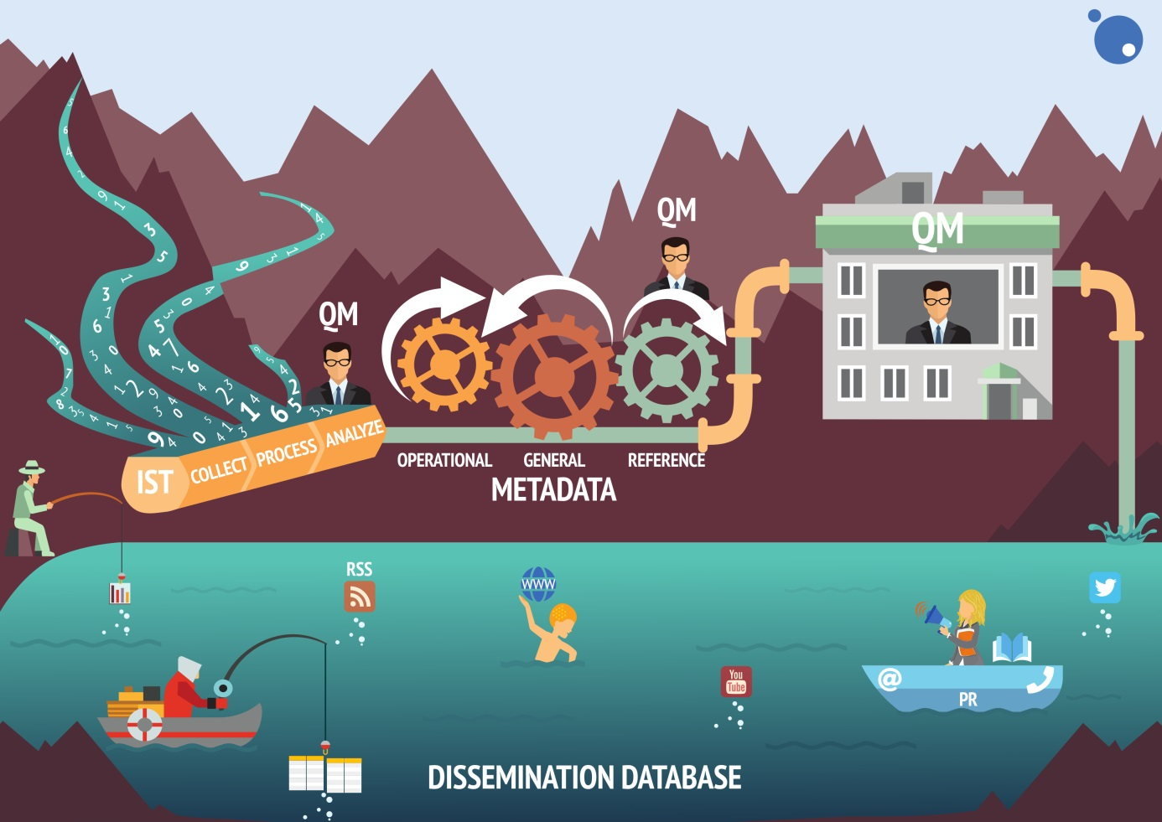
Source: Statistical Office of the Republic of Serbia

Members of the Working group for Quality management have participated in numerous workshops, seminars and study visits and have studied and analysed available quality management related documents recommended by EU as well as other countries’ best practices. Some activities recommended by the Light Peer Review team (2011) were initiated by this group. Work on quality became more transparent by promoting SORS quality orientation on the website where certain documents on quality could be found. Intranet portal for quality management dedicated to all aspects of quality management was established in 2014. Idea was to maintain and update portal in order to keep informed all employees about the available documentation, results and initiatives of the Working group for quality management.
The results achieved by this group were significant and recognised by top management as important strength of the SORS towards setting up quality management framework, methods and tools on systematic and harmonised way.
2. Measuring user and staff satisfaction
Striving to provide high quality products and services to meet users’ needs, SORS have introduced user satisfaction survey as a useful tool to identify and analyse users’ habits, attitudes and needs, in order to raise the quality of products and services in line with their satisfaction level. The survey had been introduced in 2010, and then was conducted again in 2013, 2015 and 2017. It is now conducted regularly as a web survey in two-year periodicity, and the results are made public on the SORS website. The survey results are used to improve quality of data and services provided to users in the segments where users are less satisfied. Apart from this, SORS is also monitoring and analysing comments that users leave through the website survey application „What do you think about our website?”, social networking channels or through the official e-mail address stat@stat.gov.rs.
Likewise, having in mind that staff competence, professionalism and motivation are important elements upon which the quality of statistical products and services depend, SORS introduced staff satisfaction survey in order to collect the information on their opinion and attitude regarding various issues. SORS had launched first time this survey in 2011, than conducted it again in 2014 and since then it have been carried out as a regular survey in two-year periodicity. Based on the results of the survey analysis, action plan for improving staff satisfaction is prepared.
3. Quality management documentation system
Determining the need to standardise processes and to ensure that (at least) critical processes are performed consistently the same way by all employees, Working group for quality management developed Quality management documentation system. Processes described and presented in documentation have to be uncomplicated, understandable and repeatable, respecting „keep it simple” principle. Implementation of this system started in April 2016. It is based on ISO 9001 standard, and it provides standardised and updated documentation (procedures and guidelines) in electronic form to the whole staff. This system is available on the SORS intranet portal, as a set of documents, and it is foreseen to develop an application for dealing with this documentation in the future.
4. Reference metadata and quality reporting system (RZSMETA)
Quality measurement and quality reporting is an integral part of SORS quality policy. Product quality should be regularly assessed and validated in order to provide an input for continuous improvement. Taking this into account, SORS made a significant effort during the last few years in order to develop a reference metadata system – RZSMETA. The main goal was to ensure the production of updated user and producer oriented quality reports that will be used for monitoring product quality. RZSMETA system is developed according to Single Integrated Metadata Structure v2.0 (SIMS v2.0) and its underlying reporting structures ESMS 2.0 and ESQRS 2.0, in order to meet EU requirements. The RZSMETA system consists of a repository of metadata, that is a SQLSERVER database, and a web application that enables its users to fill-in their own metadata. RZSMETA application is developed as a user-friendly application with efficient functionalities necessary for producing and disseminating user and producer oriented quality reports. User oriented quality reports (reference metadata) are made available to the public on the official SORS website, and producer oriented quality reports are published on the SORS intranet portal and will be used for monitoring product quality over time. The created files can be automatically downloaded in the SDMX format and sent to Eurostat through ESS Metadata Handler application.
Supporting documentation related to preparation of user and producer oriented quality reports was prepared and it is available on the SORS intranet portal. The Working group for quality management has organized trainings for quality reporting and use of RZSMETA application for all survey statisticians who will be responsible for the preparation of related quality documents.
Deployment of the RZSMETA is considered as SORS high priority in order to provide tool for posting user oriented quality reports on the website. That will contribute to the higher transparency and quality of the statistical activities and thus raise confidence and trust in the statistics provided by SORS as well as a better understanding of statistics in general.
5. Operational metadata: Integrated System of Data Processing (IST)
In order to process data of over 300 surveys, for many years the SORS have been using standalone applications that were developed by using different platforms (VB, C++, Java etc.). Data were stored in different places, from the servers to the local machines, in various formats, from relational databases to text files. In order to avoid this practice and improve delivering high quality statistical products and services with reduced cost, SORS have developed IST that is consisted of a .net application and a simple metabase (only six tables). These two equally important components deal with a large number of different databases containing individual and aggregated data. IST.net application is an interpreter and reads data from the IST metabase that contains descriptions of each application. Based on the read data, application generates and in real time executes each stage of statistical research or any other project, from data entry to data tabulation for more than 90% of SORS surveys. IST have provided full integration of data and IT standardization as comparative advantages that contribute to the introduction of QMS.

Figure 2. IST model
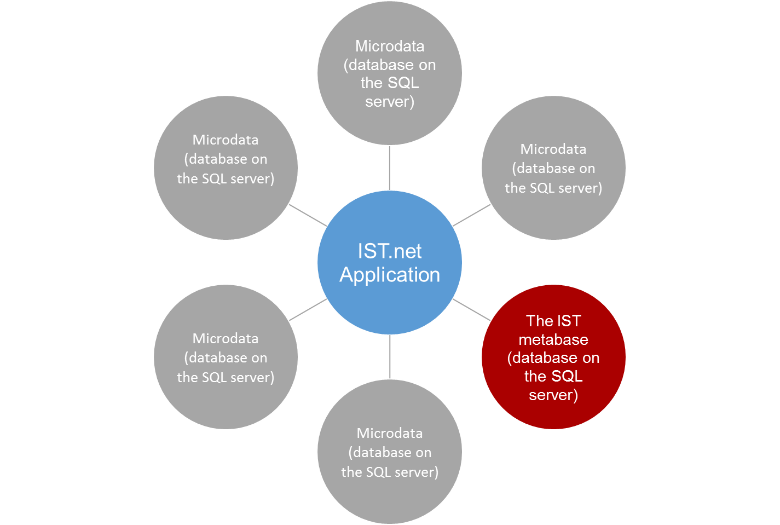
Source: Statistical Office of the Republic of Serbia

6. Linking everything: introduction of General metadata (GM)
In parallel with developing of a reference metadata system, it became clear that we lacked statistical semantics for the most central metadata pillars. This was a potential source of misunderstandings amongst people working in different subject matter areas or on different types of tasks. Furthermore, this could lead to misunderstandings and decrease of efficiency and quality when exchanging or updating data and metadata in SORS metadata or metadata-driven systems such are RZSMETA system for reference metadata and quality reporting, processing environment (IST), dissemination database etc. Therefore, SORS have started to build system of general metadata that is harmonized, simple and in transparent manner available for reuse and search. Work on codifying and linking of all components (Methods, Instruments, Documentation, etc.) to the Researches (Processes) as a central pillar of GM, is in progress.

Figure 3. GM model
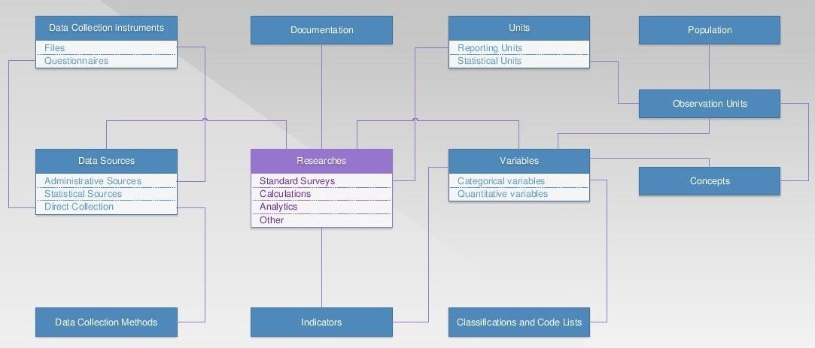
Source: Statistical Office of the Republic of Serbia

General idea is to minimize everyday (interactive) need for maintenance and to maximize automatically updating from already existing satellite systems like Electronic Library, Statistical Plan, Employees DB and Dissemination DB (machine-to-machine communication). Connection of GM with other satellite systems implies their redesign and use of standardized internal ID codes in order to integrate into centralized statistical information system. Statistical plan represents operationalization of goals of official statistics. As a legal act, plan clarifies roles and responsibilities of all producers but in the same time, it is precious source for general metadata database.
7. Future developments
Innovative practice of the SORS that could benefit to the other countries considers two successful stories: the concept and functionalities of the Integrated System of Data Processing (IST) and RZSMETA system for reference metadata and quality reporting. However, full synergetic effects of two above-mentioned successful stories can be achieved only after their linkage to the General metadata system (GM). Regarding IST, it means mapping GSBPM phases, sub-phases and activities, together with adding standardized logical layer that consolidate operational metadata according to GSIM in terms of units, variables and classifications that are used in data processing. It will have twofold benefit: enforcing and reviving GM (ensuring their harmonised use/reuse) and creation of preconditions for various standardized quality reports/indicators (i.e. on correction, validation, transformation) – directly from statistical processing. Regarding RZSMETA, connection to GM means level up in standardized reference metadata descriptions (including standard methodological documents), linking indicators with their constituent variables etc.
New web-based application solution for compilation of Statistical plan (programme) will integrate and coordinate all producers of official statistics within yearly operationalization of statistical goals. Speaking about other authorised producers of official statistics, the idea is to continue work on their education on various quality issues and to include them in more concrete quality related activities.
Further focus will be to identify and describe all processes in the statistical production chain, using GSBPM as a tool, and to set mandatory documentation necessary to provide consistent performance of processes. This would lead to higher standardisation of processes, and enable monitoring of their quality in a unique way, including implementation of quality reviews and audits as planned and regular activities.
Identifying and description of processes would also create preconditions for the introduction of a risk management system as a system for identification, assessment and prioritization of risks followed by a coordinated and cost-effective use of resources to minimize, monitor and control the probability and/or impact of adverse events. Process analysis and quality assessments are suitable "tools" for identifying risks and control activities.
Management and coordination of all successful stories described in this paper (on-going development programmes, projects and initiatives related to quality, metadata and dissemination) are responsibilities of new department established in the beginning of 2018 by decision of SORS director general. That decision is remarkably contributing to the further integration of mentioned achievements as ultimate precondition for future development of quality management system. Furthermore, if this organizational change will be followed by joint efforts and understanding of the whole institution, than SORS strategic and policy goals (towards monitoring, evaluating and improving product and process quality) together with high level of performance, will be achieved.

REFERENCES
RS, Official Statistics Law, Official Journal of the RS, No.104/09, 24/11
RS, Strategy of official statistics development in the Republic of Serbia over the period 2016 – 2020, Official Journal of the RS, No. 55/15
SORS, Quality Policy http://www.stat.gov.rs/media/2485/quality-policy.pdf

