Users’ engagement and national quality reporting at Istat
Andrea Bruni, Istat, anbruni@istat.it
Maria Francesca Loporcaro, Istat, loporcar@istat.it
Giorgia Simeoni, Istat, simeoni@istat.it
Abstract
Istat has recently re-organised the set of activities carried out to manage the relationship with users. The resulting framework is aimed at segmenting users (identification of profiles in order to classify users with different needs), collecting information needs, assessing the overall users’ satisfaction. A wide set of methods and tools are used to fulfil these objectives, ranging from traditional satisfaction surveys, to consultations on specifics topics, or indirect analysis of users’ requests and feedbacks. The paper will firstly present this new comprehensive approach as well as the tools already in use. Secondly, the focus will be shifted to the results of users’ consultation in terms of perceived quality of official statistics and metadata communication. Indeed, since 2014 the yearly Istat users’ satisfaction survey includes also two sections devoted respectively to disseminated metadata and product quality. Then, recent developments on the tools for reporting quality to users, that would also meet the users’ needs according to findings of previous analysis, will be presented. In particular, the new detailed national Quality Reports, harmonised with ESS metadata standards and oriented to expert and demanding national users, are currently being implemented. They fill a gap in the reporting for the users, that so far has been oriented to not expert ones, through the dissemination of Quality at a glance reports. They have also been developed in response to the recommendation of the last round of Peer Review on the ES Code of Practice. So far, the Istat quality reporting tools are tailored for traditional statistics based on survey and/or administrative data, however the issue of documenting the new experimental statistics is arising. A preliminary hypothesis on how to document this kind of statistics will be finally proposed, also on the basis of a review of what is already done in other statistical institutes.
Keywords: quality reports, perceived statistics quality, dialogue with users, communicating quality
1. A reference framework for the dialogue with users
Over the last years, the audience of users of official statistics has widened thanks to the development of IT technologies and social media. Users are also more and more demanding, not only in terms of statistics, but also in terms of metadata and quality information supporting data interpretation and correct use.
Istat has always recognised the central role of users in its statistical production. Already between 1995 and 2004 user satisfaction surveys were carried out, as a first attempt to study the relationship with the users.
Istat has then refined methods and tools to reinforce the relationship with users. This led to the definition of a general framework driving the dialogue with users (Table 1).
The main areas of interest have been identified, that are also mentioned in the indicators of Relevance principle of the ES Code of Practice, as: i) user profiles, ii) their information needs, and iii) their satisfaction with Istat products and services.

Table 1. Reference Framework
GOALS | ENGAGEMENT METHODS |  | CONTACT POINTS
User segmentations and user profiling | - Surveys  - Consultations |  | - Advisory bodies  - Thematic groups  - Points of access to statistical information (Statistical information centre, Library, web site)
Collect and assessment of user needs | Direct methods | - Consultations  - Focus group  - Interviews
 | Indirect methods | - Information requests analysis  - Feedback analysis  - Research strategies analysis
Satisfaction for products and services offered | User satisfaction surveys
The first step in the relationship is user segmentation: knowing who the users are is a precondition to satisfy their needs. The aim of segmentation is, indeed, identifying user profiles with different needs. Users are classified into different groups and each group has its own characteristics, such as: frequency of data consultation, purpose of data search, and affiliation.
Secondly, user information needs should be analysed. Information needs can be explicit or implicit. First ones deals with mainly consulted statistics, not satisfied requests received, etc.. Implicit needs are unstated and more difficult to be collected. In addition, not only needs regarding statistical production should be considered, but also statistics accessibility and clarity needs. In particular, all information needed to understand data.
Finally, user satisfaction should be assessed. Feedbacks from users are crucial to safeguard and continuously improve data quality.
These three areas should be analysed and regularly monitored because they change over the time. Methods mostly used to derive information on user profiles are user satisfaction surveys and/or consultations on users about specifics topics or products. Information needs could be either collected by direct methods such as surveys, focus groups and specific interviews to expert users or by indirect methods such as analysis of information requests, analysis of feedback from users and analysis of research patterns. Similar methods could be used to assess user satisfaction, together with the traditional user satisfaction surveys.
In order to implement the mentioned methods, contact points that allow access to users should be identified. They could be more or less “structured” ranging from ad-hoc groups of representatives of key users to the corporate web site. Istat, since 2011, has established an advisory body named “Commission of the users of the statistical information” (CUIS) with the purpose of collecting information needs in an organized way. CUIS represents a direct connection between users and producers, to facilitate the user involvement in user consultation and surveys.
Based on described reference framework, Istat currently organizes different activities. Since 2013, user satisfaction surveys on website product and services are carried out. Furthermore, CUIS organizes consultations of expert users on a variety of issues and the results of consultations are taken into account in the definition of National Statistical Programme. Istat also analyses user feedback and regularly collects users requests. In the following section, some important results of the last user survey will be presented.
2. Results of the last User Satisfaction Survey
In order to measure the degree to which user needs are met, Istat carries out annually a User Satisfaction Survey (USS). Last USS edition ran over the period of December 5th 2017 – February 5th 2018, with a devoted questionnaire on the institutional website. The participation to the survey was on voluntary basis, the self-selection elicited a total of 3712 replies received, still enough to draw meaningful conclusions. The survey collects information about five main areas:
- users profile;
- purpose and usage of data (why and how data are used);
- degree of confidence on Istat statistics;
- satisfaction with product and services provided via the website;
- satisfaction with both data quality and quality information.
The results presented in this paper constitute a summary of the most interesting and compelling findings, with particular reference to the last area.
Regarding users profile, table 2 reports the main groups in which respondents can be classified.

Table 2. Users profile, by type of organization, main aim of data use, and mainly consulted statistics
Type of organization |  | Main aim of data use | Mainly consulted statistics
Research Institutes (public/private), Studies centres/Universities/Scientific societies | 25% | Research | Population and households  Households economic conditions  National accounts
Private citizens | 15% | Curiosity | Population and households  Prices  Households economic conditions
Enterprises | 15% | Update of monetary values | Enterprises  Prices  Population and households
Self-employed workers, professional associations | 14% | Research | Enterprises  Population and households  Prices
Public Administration | 12% | Research | Population and households  National accounts
School and centres for vocational guidance, | 4% | Education and training | Population and households  Education and training
Trade associations, labour unions | 3% | Research | Population and households  Labour and wages  Households economic conditions
Voluntary sector/ civic organisations | 3% | Research | Population and households  Households economic conditions
Media | 3% | Journalistic activity | Population and households  Households economic conditions

Researchers represent the largest group of users (25%), followed by private citizen, enterprises, public administrations and self-employed workers (about 15% for each group). Smaller groups are users from schools, trade associations, voluntary sector and media (about 3% for each group).
“Research” is the most common aim for all users. However, the aim of statistical data usage is different among groups of respondents in order to satisfy different needs.
Most of respondents indicated that “Population and households” and “Households economic conditions” are two areas that they consulted most frequently.
Concerning frequency of data consultation (Table 3), most of respondents are occasional users (more than the half for most of groups). Researchers and Public administrations are equally distributed in all items, while trade associations result frequent users.

Table 3. Frequency of use by user groups, in percentage
 | Frequency in data consultation*
Type of organization | Occasionally | Usually | Often | Very often
Research Institutes (public/private), Studies centres/Universities/Scientific societies | 27% | 23% | 26% | 22%
Public Administration | 29% | 21% | 25% | 24%
Private citizens | 53% | 23% | 12% | 6%
Enterprises | 41% | 32% | 14% | 4%
Freelancers, professional associations | 39% | 37% | 17% | 6%
School and centres for vocational guidance, | 51% | 21% | 16% | 4%
Trade associations, labour unions | 18% | 27% | 24% | 30%
Voluntary sector/ civic organisations | 39% | 30% | 15% | 15%
Media | 24% | 24% | 29% | 22%
Total | 38% | 26% | 19% | 13%
*Occasionally: about 3-6 times per year; Usually: more and less once per month; Often: several times in a month; Very often: several times in a week.
Considering confidence and importance of statistics, it is worth noting that 94% of users state that they trust statistics, and 91% of users consider statistics important for their work.
In the last area of the questionnaire, a four-grade scale, between very satisfied and very dissatisfied, has been used to find out the level of satisfaction for the main statistical data accessed, according to the Eurostat quality criteria. Figure 1 shows that users are quite satisfied with both the data accuracy/reliability and relevance, while accessibility and, to a less extent, timeliness of statistics could be identified as areas for improvement. However, last April the new Istat website has been released, driving significant improvements to search, navigation and performance. So, it is reasonable to expect the difficulty experienced by users, when accessing and exploring data, to decrease.

Figure 1. Percentage distribution of user satisfaction by quality dimension
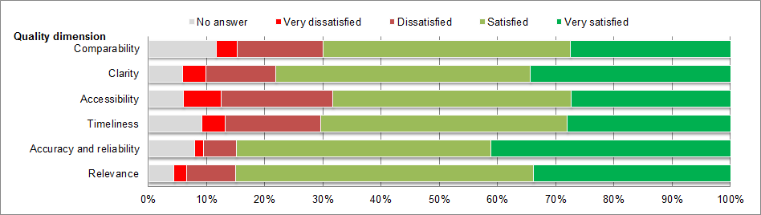
Since 2014 edition, in the USS a specific section of the questionnaire is devoted to assess the user satisfaction for available metadata and quality information.
Table 4 shows answers to the question “Which kind of metadata do you think we have to improve?” over the last 3 editions of the survey. In 2014 most users requested improvements on metadata describing the meaning and the content of the data. This percentage decreases over time, whereas the request for quality information supporting data increases.

Table 4. Metadata to develop and/or to improve, in percentage*
 | 2014 (1970 respondents) | 2015 (1189 respondents) | 2017 (1046 respondents)
Metadata describing the meaning and the content of the data | 62% | 57% | 48%
Metadata describing the underlying production process and the methodologies applied | 49% | 43% | 43%
Metadata providing information on data quality | 20% | 29% | 45%**
*Multiple choice question: this table shows “yes” responses.
** In the 2017 questionnaire there were 2 different response categories regarding quality information (Information on the error sources, Standard quality indicators) respectively with 29% and 25% of preferences. For aim of comparability, the table reports the percentage of different users that selected at least one of the 2 options.
Istat has a long-standing experience in collecting reference metadata and quality indicators. The SIDI-SIQual system (Brancato et al., 2004), implemented since 2001 and currently updated, stores harmonised documentation on Istat statistical processes and their quality. All the qualitative information is also publicly available for the users on the website http://siqual.istat.it from 2005 and a brief summary of the quality of Istat statistical processes, derived from the SIDI-SIQual system, is disseminated by means of the “Quality at a Glance” reports from 2014. The “Quality at a glance” reports are oriented to non-expert users and include also a couple of quantitative quality indicators. In addition, since 2016 the quality reports produced for Eurostat according to ESS standards and published on Eurostat database, are also published through SIDI-SIQual More detailed information can be found on Methodological notes that accompany Istat press releases, but they are available only for a subset of Istat outputs.
Users were asked to rate their level of satisfaction with some of the quality and metadata tools developed by Istat: the SIDI/SIQual system, the Methodological notes that accompany Istat press releases and the Quality at a glance reports. User satisfaction on these tools was investigated with regard to the following three aspects: i) relevance (correspondence to user needs); ii) clarity (how easy was to understand metadata) and iii) accessibility (how easy was to access metadata).

Figure 3. Percentage distribution of user satisfaction with quality tools by quality dimension.
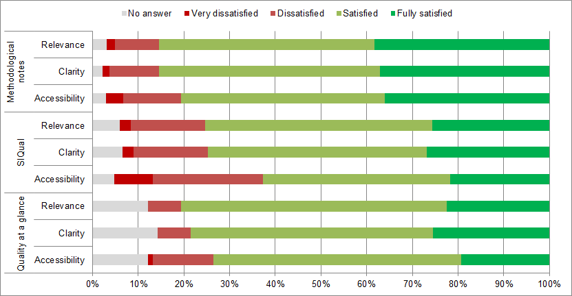
The findings indicate that users are extremely satisfied with the information provided by the methodological notes that accompany data dissemination. Also Quality at a glance summary report resulted satisfactory for a great part of users, while the SIDI/SIQual metadata system can be considered an area of improvement in particular for what concerns its accessibility. It should be mentioned that the amount of users that were asked their satisfaction level on SIDI-SIQual and on the Quality at glance reports is limited (174 and 103 respectively), due to the fact that the question was asked only to respondents that had already confirmed to have consulted such tools.
However, gathering the different results obtained, the message from the users that can be derived is that more detailed and descriptive information (similar to Methodological notes style) is appreciated, at the same time including more metadata on quality and quality indicators, and this information should be more easily accessible. Hopefully, the national quality reports that Istat has developed and whose implementation is described in the next section will satisfy this users request. In addition, it is worth mentioning that a substantial re-design of the SIDI-SIQual system is already planned in the next future.
3. Recent developments on quality reporting for national users
The results of USS highlighted that the currently available documentation leaves partially unmet information needs with regard to quality of statistics. In addition, during the last round of ESS peer review, Istat was recommended to improve accessibility of quality information and the availability of quality indicators for external users.
Indeed, Istat has not systematically disseminated standard quality indicators yet, even if they are internally collected in the SIDI-SIQual system. Thus, it has been decided to define a standard template for national quality reports, based on the ESS standard SIMS (Single integrated metadata structure) that could be automatically filled in with the information available in the internal version of SIDI-SIQual. Such a template has been approved the Presidency Committee in July 2017 and the software to produce such reports has then been developed, by reusing and adapting SIDI-SIQual subsystem for producing ESS quality reports (Simeoni, 2016).
The reports were then “generated” by the staff in charge of quality and reference metadata at Istat. Indeed, even if the compilation is automatic, a preliminary analysis of the documentation of each statistical process was deemed necessary, e.g. to define the edition of the process which the report should refer to (when referred to a short-term indicator, a report can be considered updated if the quality indicators are available for 2016 or 2017, but a structural statistic can be considered updated also if the reference year is 2015).
Once the quality reports were produced, since they include several quality indicators never disseminated before, it has been agreed, by the head of both Istat Departments, on an ad-hoc validation procedure before their dissemination. They were consequently addressed to the attention of the Heads of the Divisions of the Production department in charge of statistical process, for revision and validation. When changes or corrections were requested, they were first applied in the SIDI/SIQual system to ensure coherence, and the quality report re-generated accordingly. The validation procedure took about two months but resulted worthy because many quality indicators were updated to the following year. The final adjustments are now being implemented and the national quality reports will be disseminated by the end of June 2018. At first, national quality reports will be published in Italian language only, but also the English version will be provided next. They will be disseminated on a dedicated section of the Istat website, and not only through SIDI-SIQual, to improve their accessibility. A collaboration with the experts from the IT and from the staff of the website was set up to develop the connection between SIDI-SIQual and the website, to define where to place the new section on the website and agree on graphical issues, also considering that Istat was going to publish a new version of the website.
The next edition of the USS will then verify if the needs of users have been met.
4. Next steps on quality reporting
The quality documentation provided by Istat to users on a systematic basis refers, by now, to statistics grounded in traditional surveys and/or administrative data. However, the introduction of the so-called Experimental statistics is enhancing the statistical production, with the experimentations on the use of new sources and the application of innovative methods. The quality of such innovative products needs to be documented as well, however it should be evaluated if the time is ripe for defining how to document them in an harmonised and systematic way. To this aim, a review of what is presented on Eurostat and other National Statistical Institutes about experimental statistical was made. It resulted that every producer developed a specific section of its website, in which “what is intended by experimental statistics” is clearly explained. It is usually pointed out that there are some known limitations that users should be aware of. Indeed, these statistics have not reached full maturity in terms of harmonisation, coverage or methodology: further testing and development is underway. This is why they should be accompanied by methodological notes and/or detailed technical paper summarising the data and results. Without exception, all providers mark the estimates with clearly visible labels, or logos, in order to allow experimental data to be easily distinguished from official statistical information released. Data users are strongly encouraged to provide feedback (general impression or specific points) on new ideas and initiatives in order to further improve the robustness, and therefore also quality, of experimental statistics and help producers determine whether these experimental estimates better meet user needs. A similar dedicated area is already available also on the new Istat website released last April.
Given the variety and the complexity of these innovative statistics, it seems that, so far, detailed ad-hoc methodological notes and technical papers are needed to appropriately document their quality, so that the standardisation of such documentation will definitely be a challenge for the next future.
5. References
Brancato G., Pellegrini C., Signore M., Simeoni G., (2004), Standardising, Evaluating and Documenting Quality: the implementation of Istat Information System for Survey Documentation – SIDI. Proceedings of the European Conference on Quality and Methodology in Official Statistics (Q2004). Mainz, 24-26 May 2004.
Eurostat (2017), Report on the Eurostat 2016 user satisfaction survey.
Simeoni G. (2016). ESS standard quality reporting implementation: the point of view of a national statistical institute. European Conference on Quality in Official Statistics (Q2016), 31 May – 3 June 2016, Madrid, Spain.

https://www.istat.it/en/methods-and-tools/tools-for-data-quality/quality-at-a-glance
http://siqual.istat.it/SIQual/docQualityReport.do?ric=0&language=UK&refresh=true
http://ec.europa.eu/eurostat/web/quality/quality-reporting
The new version of the website is indeed available from 23 April 2018

