**Data exchange between the Nordic countries – supplementing education registers by qualifications completed in another Nordic country**

Kaija Ruotsalainen, Statistics Finland, kaija.ruotsalainen@stat.fi

**Abstract**

*High-quality and precise statistics production concerning the educational structure of the population usually requires a comprehensive register of qualifications that includes data on all degrees and qualifications completed by the population. An education register is the basis for producing education statistics and also important source data, for example, for population census and various survey-based statistics.*

*Nordic countries have a statistical register of education that contains data on degrees and qualifications completed by the population. The quality of the education registers is high as a rule because educational institutions are obliged to deliver data to the education registers annually. A big problem is caused, however, by the lack of data concerning qualifications attained abroad. No comprehensive register-based data source exists with data on the qualifications of immigrants attained in their home country nor on qualifications attained abroad by the original population.*

*As part of the project ”Nordic Mobility” funded by the Nordic Council of Ministers, the coverage of education registers is improved by exchanging unit-level data between Nordic statistical institutes. This is enabled by the EU Statistics Act, based on which confidential data can be released from one ESS authority to another in order to develop and produce European statistics and improve their quality.*

**Keywords:** education register, micro data exchange

**1. Background**

Both Finland and other Nordic countries have a statistical register of education that contains data on degrees and qualifications completed by the population. In Finland, the register is based on data collected with questionnaires on the educational structure of the population in the 1970 census. After this, data have been received annually from educational institutions on individual basis. The education registers in the other Nordic countries are also based on similar data collection. The quality of the education registers is high as a rule because educational institutions are obliged to deliver data to the education registers annually.

The majority of the population complete their qualifications before the age of 25. According to Statistics Finland’s Register of Completed Education and Degrees (later education register), around 16 per cent of the population aged 25 to 64 do not have post-comprehensive level qualifications: 13 per cent of those born in Finland and one-half of those born abroad. Some of them have not actually completed any post-comprehensive level qualification, but for some qualification data are missing from the register. This particularly concerns qualifications of persons born abroad. This is largely due the fact that no comprehensive register-based data source exists with data on the qualifications of immigrants attained in their home country nor on qualifications attained abroad by the original population.

Qualifications and degrees obtained abroad and by foreigners are updated yearly from two sources. Valvira, the National Supervisory Authority for Welfare and Health, provides data on health care qualifications attained abroad and licensed in Finland, and the Finnish National Board of Education on the recognition and comparability of qualifications completed abroad (Witting 2017).

Qualification data obtained from update data hardly correct the already existing and constantly growing shortage of qualifications in the register. Update data mainly concern new immigrants, are focused on tertiary degrees and depend on the person's own reporting to authorities handling qualifications (Witting 2017).

There is undercoverage in the education registers also in other Nordic countries, although the coverage of the education register has been tried to be improved with data collections directed at persons with foreign background, at least in Sweden, Norway and Denmark. This is because responding to the inquiry is voluntary, inquiries are not made annually and they are only directed at persons with foreign background.

**2. Education data as part of the Nordic Mobility project**

*2.1. Background and objectives of the project*

Nordic cooperation has been conducted on the official level ever since the 1950s. From the start, the objective has been free movement of people and enterprises between the Nordic countries. The borders of the Nordic countries are possibly one of the most open and well-functioning borders in the world, but there are no exact statistical data on activities across the borders of the countries, such as working and studying or current transfers. The aim of the project funded by the Nordic Council of Ministers is to produce statistics on these topics in cooperation with the statistical institutes of all Nordic countries.

The first objective of the project is to improve the coverage of the register of educations by exchanging unit-level data on educations completed by persons between Nordic statistical institutes. It was assumed that the data exchange will improve the coverage of the education registers of Nordic countries. At least in Finland this is likely to be visible especially in Åland where many of the population have completed their qualifications in Sweden, which means that data on completed qualifications degrees have not been included in Statistics Finland's education register.

*2.2. Preconditions for data exchange*

Micro data exchange is enabled by the EU Statistics Act 223/2009 article 21, based on which confidential data can be released from one ESS authority to another in order to develop and produce European statistics and improve their quality. This type of data exchange is likely to be the first of its kind at least in the history of Nordic statistical institutes.

Even though the EU Statistics Act gives the opportunity to exchange unit-level data, national legislation and conventions concerning data release, research use and storage of data must be considered. In order to store data permanently in the databases of another country, the practices related to further utilisation of data and releasing to third parties must be similar in the country releasing and receiving the data.

*2.3. Data exchange process*

Data are released from the register of education of each country (country A) to another Nordic country (country B) concerning persons who have sometimes lived in the country (B) concerned. The following information is released about education:

* Highest completed education, ISCED 2011 field
* Highest completed education, ISCED 2011 level
* Time of attaining the education (yyyymm)
* Country of attaining the education
* Municipality of attaining the education
* Source of education data

Because there is no common personal identity code in the Nordic countries, exchange of data is based on persons’ identification by means of name, date of birth and sex. Information needed for identification of persons:

* Date of birth
* Sex
* First names
* Last name (present)
* Last name (former)

Persons’ identification as the same person based on the above-mentioned data in two different registers (country A's register of qualifications and country B's population register) is made with SAS software that compares the sex and name data of persons born on the same day. Identified persons receive different status values depending on how complete the identification is. If persons’ all data are similar in both registers and only one person is found, the identification is total. In most cases, those who have small deviations in either registers regarding first or last names can also be considered as being 100 per cent identified.

In the first phase, all persons with data on completed education are selected from the register of qualifications of country A. The identification data of these persons including the formed serial number are sent to country B, where the person's data are compared to the data of the population living in the country. As the aim is to update data also retrospectively, comparison was made to the population having sometimes lived in country B. The serial number of identified persons was sent back to country A, where data related to completed education were added for the person. If the person had several education data, the highest completed education data were selected or in case of education of the same level the latest completed education. After this, data were sent back to country B, where the data were processed and the highest qualification was selected for the population of 2016 (Figure 1). Data on the person's highest qualification are also stored in the register of qualifications.

Figure **Data exchange process**



**3. Results**

*3.1. Results for Finland*

All in all, education data were found in the register of educations of other Nordic countries for nearly 300,000 persons having lived in Finland after 1970. The majority of these derived from the education register of Statistics Sweden, from which data were obtained for nearly 274,000 persons. This is understandable because migration between Finland and Sweden has been very lively and many Finns have lived in Sweden for different lengths of time, possibly completed a qualification there and then returned to Finland. In addition, people from Åland in particular often continue studies in Swedish universities after upper secondary school.

In Finland, Statistics Finland's education register so far includes only post-comprehensive level qualifications (ISCED 3-8), but in other Nordic countries unit-level data have also been collected on basic level qualifications. Of these 300,000 obtained qualifications, around 90,000 were basic level qualifications and at this stage, they were excluded from the examination. In future, when unit-level data on primary and pre-primary education are collected in Finland, these data can be utilised as updating data for the education register.

At the moment, the latest educational structure data of the population derive from 2016. In all, education data were found from other Nordic countries’ registers of education for around 44,000 persons living in Finland at the end of 2016. Of them, 31,000 were post-comprehensive level qualifications and 15,600 were defined as the person's highest completed education (Table 1).

**Table 1. Educations received through data exchange with Nordic countries for Finnish population**

|  |  |  |  |  |  |
| --- | --- | --- | --- | --- | --- |
| Data source | Ever lived in Finland | | Finland at the end 2016 | | |
| Total | 3 - 8 Upper secondary or higher education | Total | 3 - 8 Upper secondary or higher education | Highest education from data exchange |
| Total | 299,864 | 208,604 | 44,480 | 31,070 | 15,612 |
| Statistics Denmark | 9,460 | 7,577 | 1,805 | 1,435 | 658 |
| Statistics Iceland | 1,295 | 1,226 | 248 | 228 | 93 |
| Statistics Norway | 15,588 | 12,476 | 3,895 | 3,196 | 677 |
| Statistics Sweden | 273,521 | 187,325 | 38,532 | 26,211 | 14,184 |

It was initially assumed that through data exchange, the rise in the educational level would be visible particularly in Åland. Åland residents often go abroad to study, particularly to Sweden, when data on completed qualifications are not included in Statistics Finland's education register and the educational level appears in the statistics lower than in reality.

According to Statistics Finland’s education register, 71 per cent of the population aged 15 or over had completed at least upper secondary qualifications at the end of 2016. The educational level was highest in Pirkanmaa, where around 74 per cent had completed a qualification. According to the education register, the educational level was indeed lowest in Åland, where 63 per cent of the population aged 15 or over held an upper secondary or tertiary level qualification. This is about eight percentage points lower than the value for the whole country and the difference to the region with the second lowest educational level in the share of people with qualifications was over five percentage points. According to the education register, 23 per cent of people from Åland had completed tertiary level degrees.

On the level of the whole country, around 15,600 of the qualifications obtained from the Nordic countries’ registers of educations were accepted as the highest completed qualification. This raised the share of those with at least upper secondary qualifications by 0.3 percentage points. As assumed, the biggest change in the share of people with qualifications was in Åland. After the data exchange, the share of population aged 15 or over with educational qualifications was nearly 70 per cent. The share of those with tertiary level qualifications also rose by nearly four percentage points. The data exchange also had more effect than average in Lapland and Ostrobothnia on the share of persons with completed qualifications. In Lapland, the share of the population with qualifications rose by 0.9 percentage points and in Ostrobothnia, by 0.8 percentage points. (Figure 1.)

**Figure 1. Share of the population aged 15 or over with qualifications at the end of 2016, before and after the data exchange.**

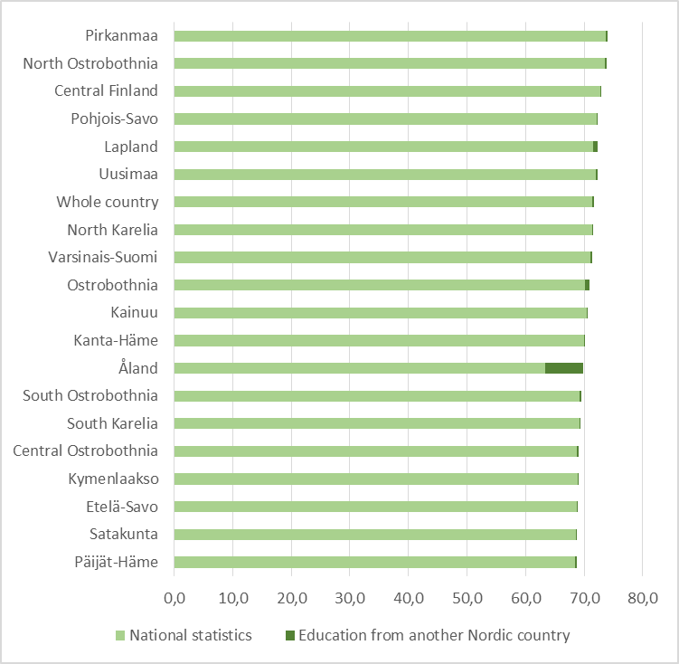

*3.2. Challenges of data exchange*

All Nordic countries have more or less similar legislation and practices on further use of statistical data and release of unit-level data outside statistical institutes. In the course of the project, certain small differences and interpretations were encountered, which at the moment still prevent data exchange between Sweden and Denmark, Sweden and Norway and partly between Statistics Sweden and Statistics Finland as well. By Swedish legislation, statistical data released to some authority are its property and the data can be released further to third parties without permission from the statistical institute. In other Nordic countries the practice is different: the ownership of statistical data remains with the statistical institute and if some other party wants to use the same data, the statistical institute grants permission to it. In addition, all data coming to the statistical institute in Sweden are considered equal pursuant to the publicity principle, so data meant to be kept temporarily can be subject to a data request by some authority. The authority must, however, have the right by law to process personal data in order to consent to the request. A solution is sought to the problem as Sweden has a very central role for all Nordic countries with respect to studying, migration and employment alike.

*3.3. Follow-up work*

Statistics Finland is at the moment contemplating how the quality and coverage of the education register could be improved as regards foreign qualifications. The intention is to carry out a similar inquiry as in other Nordic countries for the population born abroad. The inquiry will be conducted possibly next year. However, this inquiry does not cover qualifications completed by Finns abroad. Thus, the exchange of unit-level data with other statistical institutes can help to improve the coverage of data for people born in Finland as well. It has been preliminarily discussed that this type of data exchange could be included in the annual statistical production process. The number of qualifications updated in the register of qualifications is naturally smaller than in the data exchange made now. As some indication of the yearly number of qualifications obtained from other Nordic countries, around 850 of the qualifications updated to the population of 2016 were completed in 2016.

**5. References**

Regulation (EC) No 223/2009 oof the European Parliament and of the Council of 11 March 2009. Available at: <http://ec.europa.eu/eurostat/web/ess/about-us/legislation>

Witting, Mika (2017). Nuoret vailla perusasteen jälkeistä tutkintoa – eniten Uudellamaalla ja Ahvenanmaalla? Tieto&Trendit blog. Available at (only in Finnish): <http://tietotrenditblogi.stat.fi/nuoret-vailla-perusasteen-jalkeista-tutkintoa-eniten-uudellamaalla-ja-ahvenanmaalla/#_ga=2.67154834.2015047441.1525412830-1730179518.1511869250>