Global standards and national procedures – What can the ESS learn from the Programme for the International Assessment of Adult Competencies (PIAAC)
Markus Bönisch, Statistics Austria, markus.boenisch@statistik.gv.at
Abstract
The Programme for the International Assessment of Adult Competencies (PIAAC) is an international OECD survey that compares key competencies of adults (16-65 years) in 38 countries. In order to obtain high quality data and to ensure comparability between the participating countries, the international PIAAC Consortium produced an elaborate set of standards and guidelines for almost all aspects of the national implementation. In Austria, a comprehensive set of procedures was put in place for the PIAAC fieldwork. Some of the international requirements for data collection were not reasonable within the national context and required certain adaptations to accomplish a successful fieldwork.
The presentation will talk about PIAAC and its methodological background and discuss how specific measures relate to global data collection standards. Reflecting on this national experience, some of the possibilities and limitations of national compliance to global standards will be discussed.
Furthermore the multidimensional assessment of quality in PIAAC (Response Rate, Non-Response-Bias, compliance with technical standards and guidelines) will be discussed and related to national contexts. The conclusions will discuss still open issues regarding data quality in cross-national surveys and the balance between global standards for comparability and the degree of freedom to reconcile national differences. Furthermore some best practices and lessons learned will be presented which have the potential to enhance the quality of European statistics and the ESS.
Keywords: global standards, data quality, PIAAC, ESS
- The Programme for the International Assessment of Adult Competencies (PIAAC)
The Programme for the International Assessment of Adult Competencies (PIAAC) is an international survey and aims to measure key competencies of the adult population in the participating countries. These key competencies are literacy, numeracy and problem solving in technology rich environments and are considered to be relevant for the participation in the modern society.
In Round 1 of PIAAC (2008-2013) 17 EU-countries plus Australia, Japan, Korea, Canada, USA, Norway and the Russian Federation participated in the survey. Another 14 countries particpated in Round 2 and Round 3 (2012-2019; same instruments and survey procedures. So by the 2019, 38 countries will have adminstered the survey and the data of these countries will be available to the scientific community and the general public.
PIAAC was carried out as a combination of a personal interview (CAPI-background questionnaire) and a skills test (on computer or paper). The whole interview process took between 1 1/2 and 2 hours. Each country had to interview and test at least 5.000 randomly selected adults between the age of 16 and 65.
In order to obtain high quality data and to ensure comparability between the participating countries, the international PIAAC Consortium produced an elaborate set of standards and guidelines for almost all aspects of the national implementation (see also Figure 1 or OECD 2011). The following survey aspects were part of the technical standards:
- Quality assurance and quality control
- Ethics standards
- Survey planning standards
- Sample design standards
- Survey instrument standards
- Translation and adaptation standards
- Information technology standards
- Field management standards
- Data collection staff training standards
- Data collection stanards
- Data capture standards
- Data file creation standards
- Confidentiality and data security standards
- Weighting standards
- Estimation standards
- Documentation standards
Every national deviation from the international standards had to be documented and justified. The whole process was closely monitored by the international PIAAC-Consortium and the OECD.
- National measures and international standards
The international standards aimed at achieving the highest quality and comparability of data possible. But some of these standards were difficult to meet.
In Austria, a comprehensive set of procedures was put in place for the PIAAC fieldwork to follow the standards as close as possible and - if a deviation was necessary - to accomplish the aim of the standard in another way.
One standard that proved challenging to a lot of countries was the target response rate of 70%. This aim was from an Austrian point of view unrealistic, because response rates for comparable surveys are between 40% and 50% and are decreasing over time. Only 7 countries from PIAAC-Round 1 & 2 were able to reach a response rate of 70% or higher. 23 countries had response rates between 50% and 70% (including Austria with 53%). 3 countries were not able to reach a response rate of 50%, which was also defined as a minimum criteria in the technical standards. All countries were obliged to conduct a non-response-bias analysis. For countries below a response rate of 70%, the non-response-bias analysis was more extensive.
Another difficult aspect of the international technical standards were the very detailed guidelines for field work procedures (e.g. interviewer payment) and quality control (e.g. interviewer supervision and observation). These standards were to a certain extent orientated on best practices learned from household surveys in the United States and partly differing from tried-and-tested procedures in other countries. Although some of these international standards can be gate opener for new and innovative national survey procedures, also other different national ways to achieve the goal of high data quality should be taken into account. Austria for example was putting more emphasize on ongoing data checks and validation by phone. Especially because it was possible to use high quality registry data for data checks and quality control.
The last point also shows a big difference between “registry”-countries (e.g. Austria and the Nordic countries) and countries with household-sampling. Countries with high quality population registries have different opportunities for sampling, weighting and quality control than countries that do household-sampling. These opportunities can be translated in higher data quality – an aspect that was not adequately represented in the technical standards and guidelines.

- Data adjudication process
Throughout the survey process, the PIAAC-consortium closely monitored the adherence to the technical standards. The global quality of the data from each participating country was judged in a data adjudication process. This adjudication process was designed along 4 domains with different indicators (see also Table 1).

Table 1. Quality domains and associated indicators
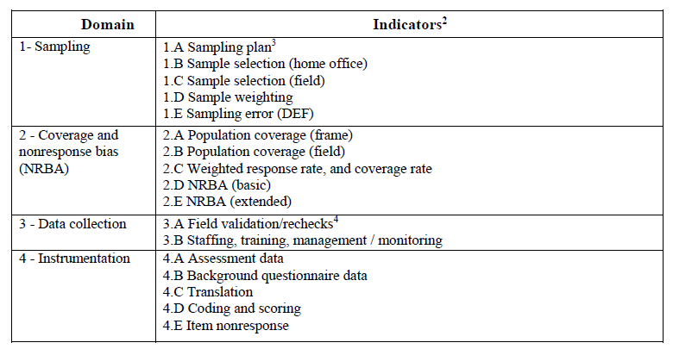
Source: OECD 2016a
In each of the four domains, the Consortium made assessed the level of performance of countries. A three-category assessment schema was used to summarize the assessments for each domain:
  - “pass”: relevant requirements completely met
  - “caution”: relevant requirements met to a reasonable extent
  - “fail”: relevant requirements generally not met
A “fail” grade in one or more domains resulted in conditions to be placed on the release of a country’s data – ranging from an annotation when reporting results to not releasing the data of the respective country. Similarly, also the receipt of a “caution” for two or more domains could lead to these conditions. Table 2 shows the data quality evaluation table for countries participating in PIAAC round 1 & 2.

Table 2. PIAAC data quality evaluation summary table
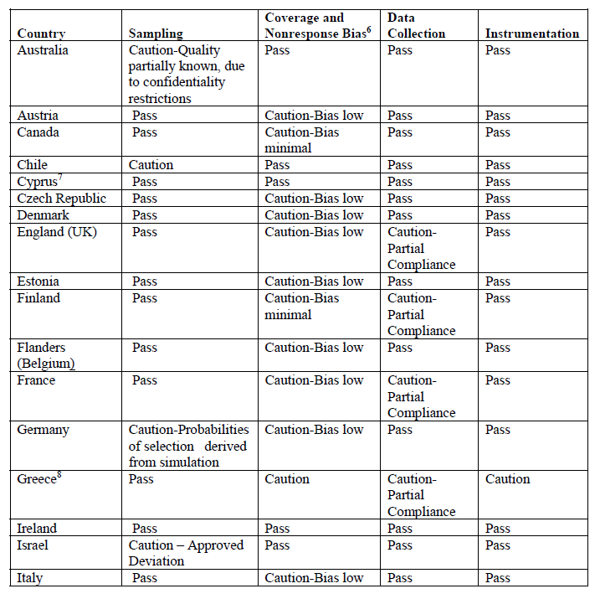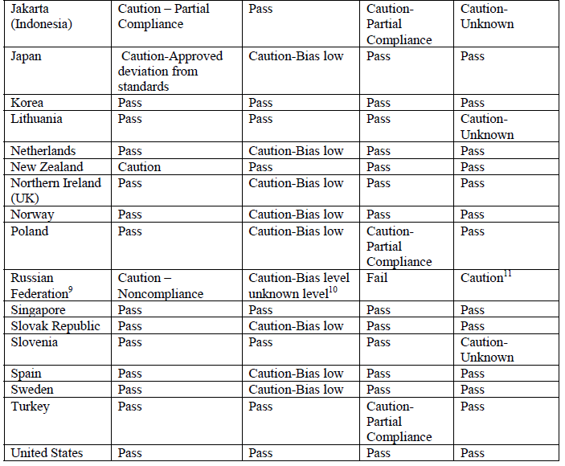
Source: OECD 2016a
At the end of the adjudication process, conditions were recommended for two countries (Greece and the Russian federation), which resulted in Notes for these two countries in the final PIAAC report of the OECD:
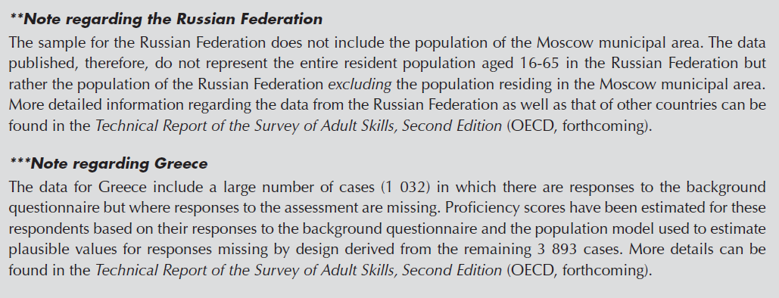
Source: OECD 2016b
When looking closer in the issues in these countries, the quality problems were mostly due to interviewers or survey organizations simplifying their tasks with different methods (e.g. faking interviews).
4. Conclusions
High international survey standards can be gate opener for new and innovative national survey procedures and are necessary for comparability and data quality, but they also have to be realistic and should reflect also different national tried-and-tested survey procedures. This could be achieved through a stronger involvement of participating countries in the process of setting standards and thus lead to a better balance between standards required for comparability and enough degree of freedom to accommodate differences between countries.
Adherence to survey standards should be closely monitored and strict sanctions should be set when a relevant deviation is obvious (e.g. because of non-documentation, simplification, falsification).

5. References
OECD. (2011). PIAAC technical standards and guidelines (December 2011).
OECD (2016a). Technical Report of the Survey of Adult Skills (PIAAC)- (2nd Edition).
OECD (2016b). Skills Matter: Further Results from the Survey of Adult Skills, OECD Skills Studies, OECD Publishing, Paris.

