Labour market characteristics of European citizens living in another European country
Georgiana Ivan, Eurostat, Aurelia-Georgiana.IVAN@ec.europa.eu
Mihaela Agafitei, Eurostat, Mihaela.Agafitei@ec.europa.eu

Abstract
Migration flows within the European labour market tend to go in specific geographic directions; some EU Member States can mostly be defined as sending countries while the others mainly as receiving ones. While the statistical characteristics of immigrant populations and their performance on the labour market is more readily available based on the European Union Labour Force Survey, the labour market portrait of European citizens residing in a country other than their own by country of origin or citizenship is less known. Eurostat’s new innovative series of products (datasets and explanatory articles) on the characteristics of European citizens residing in another European country by country of origin or citizenship fills this gap. The work is of interest at a methodological level, as the construction of these indicators implies the aggregation of sub-populations coming from different national samples of the European Union Labour Force Survey. The article discusses the main results, comparing the population living abroad with the one in the country of citizenship and also with the EU average for the total population. It also describes methodological matters: the advantages of using this method, the calculation of confidence intervals and data validation.
Keywords: emigration; intra EU labour mobility; EU-LFS; reliability limits

1. The need for data on intra EU labour mobility
Labour mobility refers to the extent to which workers move between different jobs, occupations, and geographical areas. In the European Union (EU), the freedom of movement is an individual right guaranteed by the Treaty which makes the concepts of national borders and residence less relevant and has driven important labour force movements across the EU territory. EU citizens are entitled to (1) look for a job in another EU country, (2) work there without needing a work permit, (3) reside there for that purpose, (4) stay there even after employment has finished and enjoy equal treatment with nationals in access to employment, working conditions and all other social and tax advantages. Therefore intra-EU labour mobility refers to the citizens of a member of the European Union or the European Economic Area (where the same rules apply) that reside elsewhere within the area bound by the free movement of people principle. How many EU citizens do take advantage of this right and reside and work in another EU Member State? Which are the top sending countries, both in absolute and relative terms? Which characteristics do these mobile citizens have, especially in terms of level of education and employment rate, if we compare them with the non-mobile EU citizens (those residing in their country of citizenship)? To answer these questions, policy makers need statistics to build policies that draw benefits of economic and social mobility of EU citizens and thus, creating premises for a win-win experience for all parties involved.

2. Proposing an innovative way to measure intra-EU labour mobility
The main data source for measuring labour mobility is the EU Labour Force Survey (EU-LFS), the largest EU sample survey covering the resident population aged 15 and over, living in private households and residing in the EU. It provides detailed quarterly and annual data on employment and unemployment, broken down along many dimensions. One of the major benefits of having a survey with a large sample size is to be able to study the characteristics on the labour market of the foreign-born population (i.e. persons born in a country other than her/his country of residence and whose residence period in the host country is, or is expected to be, at least 12 months). Thus, migration statistics offer an overview on the main demographical characteristics and labour outcomes of immigrant populations living in every EU Member State. They are the basis for policies and strategies in receiving countries to foster the active participation of immigrants in national labour market and, generally speaking, to maximise their integration in daily life. Integration on all layers is very important for social cohesion and having productive and effective societies.
On the other hand, sending countries also need statistics to analyse the situation of their mobile nationals residing and working elsewhere within the EU. They need to undertake comparative analysis so that they can identify which nationals leave their home-country, what are their main socio-characteristic, what are their main reasons to migrate and thus to identify possible main drawbacks of their national labour markets. For this purpose, it is necessary to shift the perspective from immigration (offering a view on the structure and composition of foreign-born population residing on the national territory) to “emigration”/ intra EU labour mobility (a view on the structure and composition of nationals residing elsewhere within the EU). This kind of statistics is not readily available for sending countries because they do not survey people residing outside their national territories. In this context, Eurostat as the provider of statistics at European level (that enable comparisons between countries and regions) has the opportunity to meet this need through a different way of using the microdata provided by EU Member States.
Therefore, the EU-LFS can be used to estimate, for each EU Member State, the number of people who are nationals of it and reside elsewhere on the EU territory as a whole and their socio-economic characteristics. This is possible through aggregating the estimates coming from EU-LFS samples of all EU Member States except that of the corresponding home-country. EU Member States were consulted through the Working Group of Labour Market Statistics (LAMAS) and gave their consent on using this approach.

3. Methodological considerations
These statistics from an emigration perspective are also subject to the availability of the data, confidentiality rules and minimum requirements for data accuracy. In doing so, statistical rules in place for confidentiality are applied and a quality rating system (with the aim at deciding whether or not the estimates are accurate enough to lead to right conclusions) is needed. The most commonly used precision measures are coefficients of variation (for totals and means of continuous variables) and standard errors (for ratios or proportions).
The general approach could be considering each reporting country as a stratum and apply methods to approximate variance for each estimate. The main breakdown is by country of citizenship (or of birth) which implies domain estimates with overlapping and complementary (covering the whole EU population) strata.
In the Working Group of Labour Market Statistics (LAMAS), EU Member States agreed that Eurostat applies analytical methods to estimate variance for a very limited set of indicators and on ad-hoc basis if a particular need arises. Several mirror checks with National Institutes of Statistics (NSI) of EU Member States were done so that it was concluded that the variance estimates produces by Eurostat are close enough to those computed by NSIs. The difference comes from the lack of information in Eurostat on data treatments, especially on calibration. Nevertheless, allowing Eurostat to estimate the variance requires from NSIs a lot of detailed sampling design information at microdata level like strata, primary and secondary sampling units, initial inclusion probabilities and sampling weights before and after calibration. This translates into an addition significant effort for NSIs to transmit data to Eurostat. "The information needed by Eurostat can be technically complex to acquire and requires sampling expertise and knowledge of details which are country-specific. This approach requires very sound statistical expertise from Eurostat and is burdensome, in terms of personnel and computing power. The average number of records in the LFS (i.e. ultimate sampling units) per quarter in 2007 was almost 1.4 million. If we take into account stratification (32 countries*country wise strata) and differences between the various element and cluster sampling designs, then any overall variance estimation experiment becomes very cumbersome." (Handbook on precision requirements and variance estimation for ESS households surveys, page 92). This approach is clearly not feasible for regular LFS data production.
Computing precision measures for migrant statistics from an emigration perspective implies an additional complexity given by considering each reporting country as an artificial stratum. The sampling design of EU-LFS is one of the most complex among social surveys. Any additional, even minor, increase of complexity makes the process even more burdensome and resource consuming (in terms of both staff and time resources). For this reason the new migration statistics on emigration perspective are disseminated using the regular flag system based on the numbers of sampling units in the sample that are used for estimates. In this case, the sample is actually a sum of national samples. The regular flag system to disseminate EU-LFS data is based on the number of reporting units used to estimate them, an overview of which can be seen in Table 1, while detailed information regarding reliability limits is available online.

Table 1. EU-LFS flag system
Flag | Label | Explanation
To disseminate without quality warning | - | All excepting the below cases
To disseminate with quality warning | Data of limited reliability | Reliability limits depend on the sample size and design in the individual Member States and refer to weighted data.
Not to disseminate | Unreliable data
 | Confidential data | Data are not disseminated if they are based on 3 or less reporting units. This typically corresponds to estimates of some 200-400 persons or less.

4. Publication
The first migration statistics on emigration perspective were created under "Labour mobility" special section within EU-LFS section of the Eurostat database. 12 datasets on this topic were published on 22.05.2018, together with a metadata file, an explanatory article and a news release. It provides demographical and labour statistics on people either born in the EU and European Free Trade Association (EFTA) area (6 datasets) or having the citizenship of an EU/EFTA country (the other 6 datasets) and residing elsewhere on the EU and EFTA territories except their country of birth/citizenship. To be included in these statistics, the people should effectively undergo a change of residence implying crossing a border has taken place, meaning they reside (or intend to do so) in another country for at least 12 months. Short term movements are therefore not taken into account.
Importantly, the focus is on the working age population, therefore the datasets only contain information on the 15-64 or 20-64 groups. The datasets contain absolute numbers for this category by country of birth or citizenship, as well as breakdowns by sex, level of education and separately employment rates of this category broken down by sex and level of educational attainment as well.

5. Examples of questions that can be answered using these new data sets
This section presents statistics on EU citizens residing elsewhere on the EU territory as a whole, except their country of citizenship. The analysis presents their number, educational skills and employment rates and compares their outcomes with those of their corresponding home countries’ resident population, as well as the EU average.

5.1 Who were the most mobile EU citizens?
In 2017, Romanian nationals of working age (20-64) residing abroad within the EU accounted for about a fifth (19.7%) of the population residing in Romania, making them by far the first largest national group among EU mobile citizens. The next five national groups accounted from 12.5% to 15.0% of their home-country resident populations: Bulgarians (12.5%), Latvians (12.9%), Portuguese (13.9%), Croats (14.0%) and Lithuanians (15.0%). The EU Member States with the smallest share of mobile nationals (out of the home-country resident population) were Germany (1.0%) and the United Kingdom (1.1%). In other eight Member States this share was 2% or less. Overall, EU mobile citizens accounted in 2017 for 3.8% of total EU resident population, which was 1.3 percent point (pp) more than in 2007. On the other hand, if we look at absolute numbers, in 2017 the most numerous national groups of mobile EU citizens aged 20-64 were those from Romania (2.366.000), Poland (1.762.100), Italy (1.099.700), Portugal (847.700) and Bulgaria (533.900).
Over the last decade, when looking at the percent increase of EU mobile citizens as a share out of their home-country resident population, Romanians remained at the forefront. This national groups’ proportion of mobile citizens increased by 13 pp followed by Latvians (10.0 pp), Lithuanians (9.5 pp) and Bulgarians (8.0 pp). On the opposite, the corresponding share of mobile Cypriot nationals in total home-country population decreased from 15.2% in 2007 to 10.8% in 2017, which is the biggest percent decrease among EU mobile citizens. They also have the biggest decrease in relative numbers (from 33.800 in 2007 to 20.100 in 2017) alongside Finish nationals who come in second (from 88.700 to 57.200). The share out of home-country population of other 16 national (13 Member States and the 3 EFTA countries) groups remained stable over the decade, with percent difference ranging from -1 pp to +1 pp. For these countries the share of mobile citizens in 2017 was also on the low side, ranging from 1.0% for Germany to 3.2%, for the Netherlands (with the exception of Ireland and Iceland with a share of 8.8% and 8.0% respectively). But 5 (Italy, Spain, France, Germany and the Netherlands) out of these 16 countries whose share of mobile nationals in total home-country population remained almost unchanged experienced an increase of over 50.000 in absolute numbers. Especially, the number of Italian citizens residing elsewhere in the EU grew by 233.100, that of Spaniards by 181.700 and the one of French citizens by 86.200.
Figure 1. EU mobile citizens of working age (20-64) by country of citizenship, % of their home-country resident population

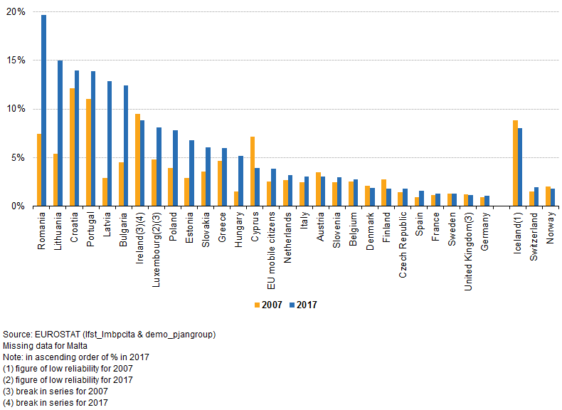

5.2 How important was the share of tertiary graduates among the EU mobile citizens, compared to the one in the home countries?
In 2017, the proportion of EU mobile citizens with tertiary education ranged from 62.5% for the French to 16.1% for the Portuguese nationals. Figure 2 indicates that those living abroad in another EU country attained in a higher proportion tertiary education level than those residing in the country of which they are nationals. This was the case for all EU nationalities with the exception of Portugal, Bulgaria, Croatia, Luxembourg and the three Baltic countries (Latvia, Estonia and Lithuania). This difference was however relatively small, almost negligible, for another series of EU nationalities (Romania, Cyprus, Poland, Greece and Slovenia). For the remaining 15 countries the difference was quite notable, ranging from 9.5 pp in the case of the United Kingdom to over 28 pp for French and German nationals (in favour of mobile citizens). There were also very large differences to be observed in the proportion of tertiary graduates within national resident population, which ranged from 42.4% in Ireland to 16.7% in Romania. This needs to be correlated with the corresponding variations among EU mobile citizens. One interesting conclusion that comes up is that tertiary graduates were generally more mobile than the rest of the population, and this was especially the case for countries that were part of the European Union before the 2004 accession (with the notable exception of Luxembourg and especially Portugal). This was also the case for the 3 EFTA countries for which data is available (Iceland, Norway and Switzerland), whose mobile citizens were also much more likely to have tertiary education than the corresponding’s home-country population.
Figure 2. Population aged 20-64 with tertiary educational attainment level (ISCED 5-8) by country of citizenship, 2017

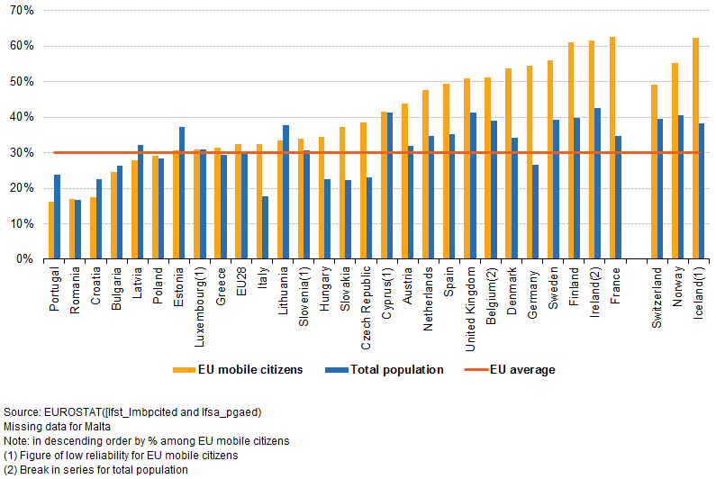

5.3 How are the employment rates of mobile EU citizens?
The employment rate of mobile EU citizens stood at 76.1% in 2017, compared to an an EU average of 72.1% overall. It ranged from 82.9% for the Slovenes to 57.9% for Luxembourgers and 68.7% for Bulgarians. Figure 3 indicates, with very few exceptions, that in most countries the employment rates of mobile EU citizens were higher than those of their home country’s resident population. The differences were important in the cases of Greek, Croat, Italian, Spanish and Polish citizens living abroad in the EU. In their case, the difference was larger than 10 pp and reached almost 20 pp for the Greek nationals. A significant difference in employment rates between the country of origin and the countries of destination (the European labour market) was probably an important pull factor. This was especially true for Greeks, Croats, Italians and Spanish nationals, for which this difference exceeded 6 pp. On the other hand, in the case of the Nordic and Benelux countries (except for Finland and Belgium), Germany, the United Kingdom and Switzerland employment rates are higher in the home countries than for the mobile citizens. This is most likely due to the fact that migration from these countries is also motivated by other reasons than seeking employment (for example family reunification, the pursuit of higher education or early retirement).
Figure 3. Employment rate of persons aged 20-64 by country of citizenship, 2017
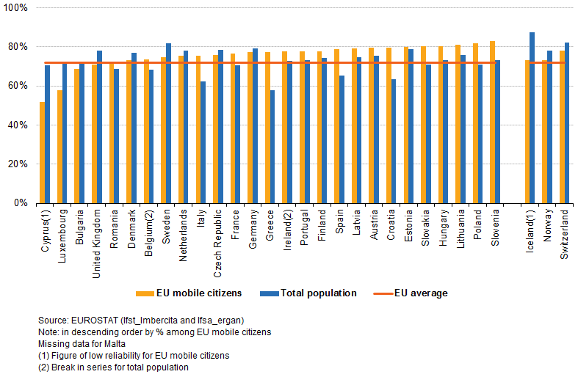

6. Conclusions

6.1 Main data conclusions
Around 3.8% of EU citizens of working age (20-64) were residing in another country than that of their citizenship in 2017. This share has slightly increased over time, as in 2007 it was standing at 3%. In 2017, the share of EU mobile citizens out of their home-country resident population also varies very much between countries, ranging from 1 % for Germany to 19.4% for Romania.
Tertiary graduates were generally more mobile than the rest of the population, and this was especially the case for countries that were part of the European Union before the 2004 accession (with the notable exception of Luxembourg and especially Portugal.
The employment rate of mobile EU citizens stood at 76.1% in 2017, compared to an EU average of 72.1% overall. It ranged from 82.9% for the Slovenes to 57.9% for Luxembourgers and 68.7% for Bulgarians. In most countries the figures were higher than the employment rates found in the corresponding country of citizenship and also than the EU average. Between 2007 and 2017 there has also been a larger increase in the employment rate of mobile EU citizens (4.1 pp) compared to the total population (2.6 pp).

6.2 Main methodological conclusions
The new Eurostat datasets on "Labour mobility" represent an innovative way to use information readily available in the EU-LFS, looked at through a new, “emigration” perspective. Their added value has been proven through a series of analysis in this paper. Therefore, Eurostat can also help EU Member States and provide them with statistics of high interest that cannot be produced differently.
Methodological challenges exist and they are mostly due to the fact that in some cases the sub-populations analysed are small and therefore the corresponding sample sizes as well, producing estimates of low reliability. External validation based on other data sources when available could be helpful in tackling these challenges.

http://ec.europa.eu/eurostat/statistics-explained/index.php?title=EU_labour_force_survey_%E2%80%93_data_and_publication#Publication_guidelines_and_thresholds
Source of data: lfst_lmbpcita

