Transition to WEB data collection in household surveys at SURS – what have we learned so far

Marta Arnež, SURS, marta.arnez@gov.si

Eva Belak, SURS, eva.belak@gov.si
Nataša Bučar, SURS, natasa.bucar2@gov.si

Mihaela Nemec, SURS, mihaela.nemec@gov.si
Katja Rutar, SURS, katja.rutar@gov.si
Luka Zupanc, SURS, luka.zupanc1@gov.si
Abstract
The Statistical Office of the Republic of Slovenia (hereinafter SURS) conducts 20 surveys of households or individuals on a regular basis. More than 100,000 persons or households are surveyed every year (5% of the population of persons and more than 10% of the population of households). The predominant data collection mode is still telephone (CATI).

An increasing number of people do not use their fixed telephones and they do not list their mobile phones in the telephone directory. Since only around 40% of the telephone numbers (fixed and mobile) are matched to the persons in the population register, the telephone survey mode alone is not a recommended practice of conducting survey data collection.

Due to huge technological development of the ICT in the last ten years and increased demand for internet-based services, and also pressure to reduce data collection costs, SURS launched a 13-month project in 2014 to set up processes and standards for WEB data collection for surveys of households and individuals.

Since 2016 several household surveys at SURS have been transferred to the WEB survey mode: Consumer Survey, ICT Usage in Households and by Individuals Survey, and Household Energy Consumption Survey.

The article aims to present some of the methodological challenges when transferring data collection to a new survey mode: questionnaire testing for WEB surveys, re-interviewing to possibly assess the measurement error, communication with the respondents who are the non-respondents in the presented WEB surveys, analysis of the costs, and impact of the WEB survey data collection on some key statistics.

Keywords: mixed mode design, web surveys, re-interviewing, paradata, measurement error, questionnaire testing, fieldwork strategy, costs
1. Introduction
Due to huge technological development of the ICT in the last ten years and increased demand for internet-based services, and also pressure to reduce data collection costs, SURS launched a 13-month project in 2014 to set up processes and standards for WEB data collection for surveys of households and individuals.
SURS has a goal to make the WEB method available for all the household surveys in the following years, but the transition is not straightforward since the introduction of the WEB mode can have a considerable impact on the published estimates (non-response bias, mode effect). It also means that data collection processes, processes of estimation as well as questionnaires have to be revised in all surveys of households and individuals.
According to the ICT survey in households in 2017, 79% of the general population aged 16 to 74 are regular internet users, and 68% are daily users. The Chart 1 presents the implementation schedule for mixed mode data collection for household surveys at SURS. The paper summarizes our experiences with WEB data collection in the past few years.

Chart 1. Implementation schedule for mixed mode data collection in household surveys at SURS

Source: SURS.

Table 1. List of mixed mode surveys at SURS using WEB as a survey mode
Name | Main statistics | Popul-ation | Sample size and sample design | Survey length; # reminders  WEB, (other mode) | Survey modes  WEB completion rate ONLY(%) | Periodicity; WEB data collection period
Consumer survey – CS | Consumer confidence indicator (CCI) | 16-84 | 3,000  stratified sample | 6 min  (5 min);  1 reminder | Consecutive  WEB -> CATI  29.0% | Monthly
Pilot Adult Education Survey – AES-P | Participation in formal, non-formal, informal (%) | 18-69 | 2,075  Two stage sample design | 1 reminder | WEB  28.5% | Pilot
Adult Education Survey – AES |  | 18-69 | 8,504  Two stage sample design | 6 min  (7 min)  2 reminders | Consecutive  WEB -> CATI, CAPI  34.6% | Every 5 years
Pilot ICT in households and by individuals – ICT | Internet usage for different purposes (%) | 16-74 | 2,504  Two stage sample design | 13 min  2 reminders | WEB  32.5% | Pilot; June 2017
ICT in households and by individuals – ICT |  | 16-74 | 2,504  Two stage sample design | 13 min  2 reminders | Consecutive  WEB -> CAPI  37.5% | Yearly, March 2018
Pilot Household Energy Consumption Survey – HECS | The total amount of consumed energy and fuels (in in energy units) by energy sources and by end-use (space heating, water heating, cooking, other) | House-holds via sele-cted person (18+) | 2,407  Stratified SRS: 2007  +  Two-stage: 400  =2,407 | 17 min  2 reminders | WEB  19.3% | Pilot;  Sept.-Oct. 2017  (regular survey every  4- years)
Source: SURS.
2. Data collection issues
2.1. Communication, contact strategy and motivation
In all SURS’s household surveys the participation is voluntary. In a consecutive mixed mode design, all selected persons received the advance letter along with the information leaflet. Besides information regarding the survey content (e.g. education of the adults), it contains also information on how to access the web questionnaire.
If the data collection period is long enough, two reminders are sent to sampled persons who have not responded. Seven days after the advance letter the first reminder is sent and then after 7 days the second reminder is sent along with the announcement of the telephone and/or face-to-face (hereinafter f2f) interview. In surveys with shorter data collection period, only one reminder is sent (Consumer Survey).
Generally we do not specify the deadline in the advance letter since the experiment in the pilot Adult Education Survey showed that in the group where we specified “please fill out the questionnaire as soon as possible” worked slightly better than the version where we set the due date.
In the advance letter and in the introduction of the questionnaires we underline that we would like to get responses also from the respondents who did not have the attribute of the survey name (e.g. from persons who do not use ICT, persons who do not travel, etc.).
We specify average or median time of filling out the questionnaire or the time span. Also a toll free telephone number and e-mail of SURS are specified in the advance letter so that respondents without the internet or without skills to fill out the WEB questionnaire have the possibility to make an appointment for a telephone interview or obtain information about our plans regarding further data collection. Namely, we announce the f2f and/or telephone interviewing in the second reminder. In case only one reminder is sent (Consumer Survey), telephone interviewing is announced in the first reminder.
The completion rate is 28% to 38% where the questionnaire is supposed to be filled out by the sampled person. In the Household Energy Consumption Survey (HECS) the WEB completion rate was only 19%. The letter was addressed to the sampled person, but in the letter it was specified that the questionnaire should be completed by a person in the household who is most knowledgeable regarding energy consumption in the household. In the case of surveys where data have to be prepared in order to answer the survey (HECS), the tables about these data were printed on the other side of the advance letter. Here there is also room for improvement.

Table 2. WEB completion rates, calls to the toll free number and remarks at the end of the questionnaire
Name | Sample size | WEB completion rate | # calls, e-mails, mails, returned mail (% of sample size) | # remarks on the questionnaire (% of WEB response)
Consumer survey – CS, | 3,000 | 858 (29.0%) | 190 (6%) | 178 (19%)
Pilot Adult Education Survey – AES-P | 2,075 | 592 (28.5%) | 101 (5%) | 112 (19%)
Adult Education Survey – AES | 8,504 | 2813 (34.6%) | 548 (6%) | 535 (19%)
Pilot ICT in households and by individuals – ICT | 2,504 | 826 (32.5%) | 326 (13%) | 92 (11%)
ICT in households and by individuals – ICT | 2,504 | 961 (37.5%) | 389 (16%) | 149 (16%)
Pilot Household Energy Consumption Survey – HECS | 2,407 | 489 (19.3%) | 339 (14%) | 73 (15%)
Source: SURS.
2.1.1. Respondents’ contacts to the office during the WEB survey
All contacts of the potential respondents are registered in the predefined table in Excel and/or Blaise. There are around 10% of the originally selected persons that call or write to SURS during WEB data collection. Mostly they called the toll-free number (around 95%). The toll-free number and the e-mail address were explicitly specified in the letter. These data are used when preparing the address list for reminders and address lists for telephone and/or f2f data collection.
As it is evident from Chart 2, there are many selected persons without computer or the internet, or they do not know how to use them. Since these persons would like to participate in the survey, it is important that they have the opportunity to cooperate and to be informed about the telephone and/or f2f interview. Persons aged 65 years or more call the number more often than others. Not only for the reason that they do not have a computer or access to the internet, but also for rejections and other reasons.
We believe it is important that a toll free telephone number is available, since they were invited to cooperate in our survey and therefore should have an opportunity to participate. In general, this kind of communication with respondents is needed, as it enables respondents a direct contact with our institution. They can get instant assistance when they are accessing the WEB questionnaire, they can schedule a telephone interview or get any other information related to the survey. Although managing calls and messages from respondents requires additional work, we believe that this is necessary when conducting a WEB survey.

Chart 2. Telephone calls, e-mails and mails to the office during WEB data collection by type of request
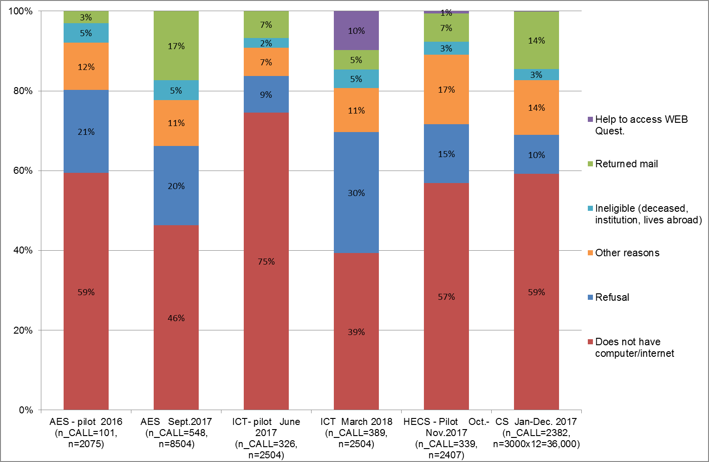
Source: SURS.
2.2. Remarks regarding the pilot WEB questionnaire
At the end of the pilot WEB questionnaire respondents were asked to comment the questionnaire. The comments/remarks were coded and the results are presented in Chart 3. The percentage of the comments of the questionnaire varies from 11% to 19% of WEB respondents in different surveys (see Table 2).
The analysis of the remarks showed that many respondents feel that the question about the household income is too personal. Therefore, we are analysing the possibility of using household income from the register data instead. Furthermore, some respondents commented the poor user experience when using their smartphone to fill out a WEB questionnaire. In the Consumer Survey in April 2018, about 15% of respondents were using a smartphone and their number is increasing quite rapidly, from around 5% at the beginning of 2016 to around 15% in April 2018. Furthermore, the dropout rate is much higher for respondents accessing the online questionnaire with a smartphone; around 10% for smartphone compared to around 2% for computer. These numbers supported by remarks of the respondents suggest that the WEB questionnaire should have responsive design, i.e. design that will look good on any device (desktop, tablet, mobile phone).
There were also suggestions from the respondents about adding a progress bar to the questionnaire. This would enable the respondents to see the progress, while it could discourage some in the case of a long questionnaire. There is also an additional problem with the progress bar when the questionnaire has lots of filters and the length of the questionnaire depends on the answers on these filter questions. For instance in the ICT survey a respondent who does not use the internet for online shopping skips many questions about online shopping. In those cases, the progress bar could be misleading rather than helpful.

Chart 3. Remarks regarding the WEB questionnaire by respondents (at the end of the questionnaire)
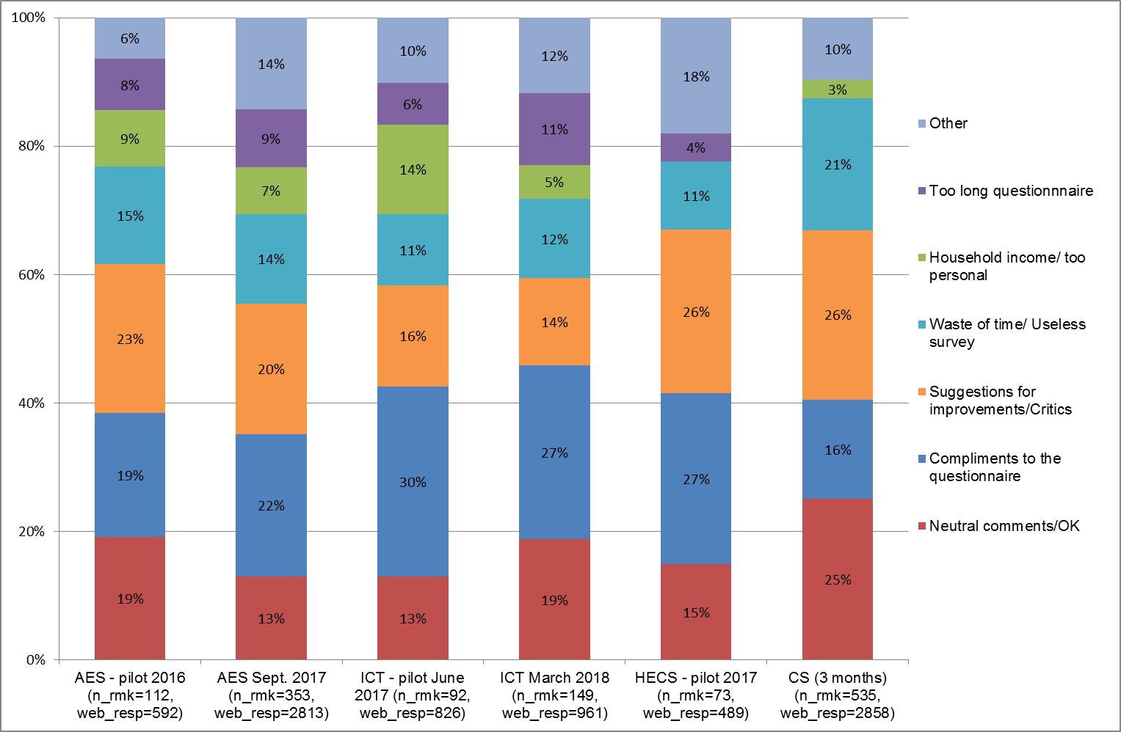
Source: SURS.

2.3. Questionnaire design and testing of the WEB questionnaires
All SURS's WEB surveys are developed in Blaise 4.8, which does not enable the responsive design. The introduction of the WEB survey mode into the survey process requires substantially more work for SURS. The questionnaire for the WEB data collection mode has to be simplified. With WEB there is no interviewer who would explain the questions to the respondents. Within the organisation it is important to set up the standards for WEB data collection and constantly update them. At the end of the questionnaire we also have the standardized open question where respondents can comment the survey, questions, etc. With this open question we detect some problems in the survey and can make improvements of the questionnaire or the survey process.
For the questionnaire design it is also very important to analyse paradata to learn on which device the questionnaire is filled out, how much time is needed for filling out the questionnaire, if and where dropout occurs. We learned that dropout typically happens with sensitive questions (e.g. year of birth and/or income) or with difficult questions. With WEB questionnaires and apps it is also very important to develop standardised usability testing of the questionnaire and/or apps. It is important to combine multiple methods of survey pretesting: cognitive (can people understand it?), usability (can people use it?) and pilot testing (how the questionnaire will work in the real world?).
In 2018 we had a question at the end of the ICT WEB questionnaire asking whether the respondent is prepared to cooperate with us in testing the questionnaires and the request for e-mail and telephone number for contact. 15% of ICT WEB respondents are prepared to cooperate with SURS in testing the questionnaires and our plan for the future is to develop online questionnaire testing. The collection of the personal information was done according to the new GDPR.
We have also learned that it is important that we have a standardised question regarding who filled out the questionnaire in order to exclude the questionnaires that were not filled out by the selected person (or in the name of the selected person) and to learn who generally fills out the questionnaires to improve communication.
At SURS we have the practice to always conduct the pilot survey before the main survey. When transforming the survey to the new mode it is important to start early enough to set up the methodology and see what can be expected from the results; are there possible differences due to different modes, assessment of non-response bias, etc.
2.4. Costs of the WEB surveys
The costs of the surveys were analysed in detail for the Adult Education Survey. The total costs of the survey were about EUR 42,000; WEB response costs (per respondent) EUR 3.4, CATI EUR 6.1 and the most expensive is f2f response, which is EUR 13.7.
WEB costs include the advance letter and the first reminder and printing costs of those two, as well as extra costs caused by coding of the questions regarding activities and education. Telephone interviewing includes costs of interviewers and costs of calling, and part of the costs of sending out the second reminder, where we announce telephone and f2f interviewing. And finally costs for f2f interviewing consist of the cost of response, non-response, travel costs, and the cost of sending out the second reminder. For the complete picture of the cost analysis it is also important to include internal cost of the employees, which were not included in the analysis (except coding). Cost analysis is important for making decisions about the design of the survey and organisation of the fieldwork and budget planning.
3. Non-response analysis and potential bias in WEB only survey
The goal of non-response analysis was to learn more about the non-response patterns in WEB surveys and whether non-response is consistent across different surveys or is survey specific. The goal was also to see whether the additional mode that follows the WEB mode improves the survey estimates. For the target statistics we took average net income of the household (which is available from the register for the respondents and the non-respondents).
3.1. Sources of data for the non-response analysis
Besides the survey data, also the following data sources were used in the analysis: Central Population Register (Ministry of the Interior), Demographic Database, Register of Households, Real Estate Register (Surveying and Mapping Authority of the Republic of Slovenia), income tax records (Financial Administration of the Republic of Slovenia) for the reference years 2014, 2015, 2016 and 2017.
3.2. Non-response analysis
In the analysis the following variables were included: sex, age, education, activity status, type of household, number of household members, number of rooms, tenure status, type of building, degree of urbanisation, assigned telephone number (telephone number for the selected person is available in the telephone directory), statistical region, type of settlement and household income. The completion rates of WEB surveys (AES, ICT, CS, HECS), reaching from 19% to 38%, were compared to the completion rate of EU-SILC survey (57%, 1st wave), which is conducted every year on the field by CAPI method. EU-SILC is used as the benchmark for the non-response distribution for a typical f2f survey conducted by SURS.
In WEB and f2f surveys women respond better than men, persons who belong to a larger household are better respondents than single-member households. Also persons who (or their household members) own the dwelling in which they live respond better than non-owners. Similarly, persons living in larger dwellings respond more likely than persons in smaller ones.
In WEB surveys younger persons cooperate significantly better (up to 61% in ICT) than other age groups. Cooperation is dropping with age. But in combination with education, we see that older respondents with higher education respond significantly better than younger ones with lower or medium education. In f2f data collection the highest response rate is with the oldest age group, the lowest is in the middle age group (30–49 years), and the youngest group are somewhere in between. With all WEB surveys the average age of the respondents is lower than the average age of non-respondents, whereas in f2f surveys the opposite is true.
If we consider education, response is higher in higher educated groups in WEB surveys (up to 53% in AES and ICT), while in f2f surveys we cannot see the differences in response. Regarding the activity status we see that in WEB students and pupils are our “best” respondents, while in f2f our “best” respondents are retired persons, but also students and pupils are responding above the average. It is also very obvious that response in WEB is increasing with income. In f2f surveys this is not the case, at least not in EU-SILC. Regarding the type of households, we see that respondents that belong to households with children are responding better than households without children. In f2f surveys couples without children have a higher response rate than couples with children. Type of building is another distinguishing variable: in f2f the response rate in multi-dwelling housing is much lower (47%) than in individual houses (63%); in WEB there is no such difference. In larger towns the response rate is lower (45%) than in smaller settlements (71%); in WEB there is no difference regarding the type of settlement.
3.3. Bias of the estimates
In Table 3 relative non-response bias (Vehovar and Zaletel, 1998: 124) was calculated for the statistics “average monthly income of the household”. For both, respondents and non-respondents, household income is obtained from the administrative sources. First we matched sampled persons and administrative household register to obtain also data on other household members. Thus we were able to designate net income to each household member and ultimately we were able to calculate household income for each sampled person. We can see that household income is overestimated if only web responses were considered in the results by 9.6% in AES (Table 3). In AES where we used additional mode (telephone or f2f) the estimate has been improved and relative bias has decreased to 3.6%. For comparison we have the estimate from EU-SILC 2017, which 1st wave, which was used for comparison, was implemented only f2f. The relative bias was only -2.4%. If the target statistics of the survey is correlated with the income, we can expect that also our final estimates will be biased, since WEB respondents tend to be younger, higher educated, have higher household income, etc.

Table 3. Relative non-response bias for AES and EU-SILC survey for average income of the household (register data)
 | Sample | WEB Non-respondents | WEB respondents (weighted*) | WEB  relative bias | Final non-respondents | All modes  (weighted**) | Final  relative bias
 | average income of the household |  |  |  | average income of the household
AES 2016 | 2134 EUR | 1966 EUR | 2280 EUR | 9.6% | 1954 EUR | 2175 EUR | 3.6%
EU-SILC 2017 | 2063 EUR |  |  |  | 2014 EUR | 1899 EUR | -2.4%
Source: SURS.
*WEB survey mode was separately weighted to obtain population estimates.
**Final weights calculated for AES.

Another example to study non-response bias is to weight separately WEB only mode and separately all modes. Analysis of the AES survey data from 2016 shows (see Chart 4) that using only the WEB mode would give us biased estimates for some of the key statistics of the survey assuming that a combination of modes is the true value.
In WEB more persons who are involved in non-formal education are responding. Response analysis shows that more educated and younger persons respond to WEB almost twice as much as less educated respondents. Using only WEB mode we would overestimate non-formal educational activities. This could be the result of the fact that persons who are engaged in the educational activities are more likely to respond to WEB than those who are not. On the other hand respondents may respond differently to interviewer than on the WEB (mode effect). One of the ways to decrease non-response bias of the „less active” respondents is to combine WEB also with other modes.

Chart 4. Participation rate in non-formal education and activities
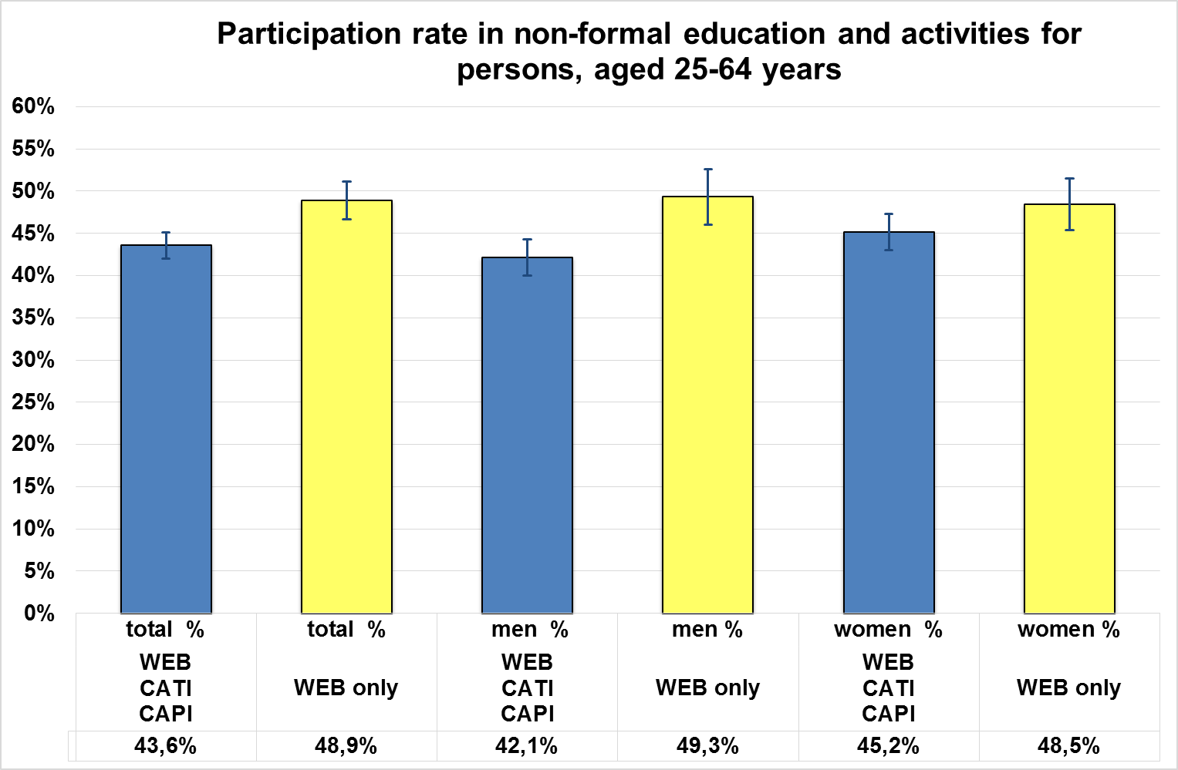
Source: SURS.

4. Conclusions and discussion
It is important that the WEB survey mode has been introduced to the respondents since the society is undergoing technological development and people demand WEB questionnaires and even apps for passive data collection. The other reason is also that some respondents are more difficult to reach in other modes, for example persons in towns respond to WEB better than f2f.
When transferring a CAPI or telephone survey into WEB, the questionnaire needs to be revised, and this takes some time. Cognitive, usability and pilot testing is important to avoid errors in the data. It is important to analyse non-response and potential errors in the data if additional modes are not included in the data collection.
Persons with lower education have a higher non-response rate on the WEB and in addition to that, those that completed the online questionnaire more often commented that the questionnaire was a waste of time. Therefore, in the leaflet sent along with the advance letter, we could try to present the survey in such a way that it would seem more important and more interesting to the general population.
For the future we would like to test whether segmented communication strategy or gifts has an effect to response. At least for short surveys such as the CS a responsive design questionnaire should be developed.
We are planning to study if the income of the household could be obtained from administrative sources (one year old data), for surveys such as AES, ICT, CS, where income is not the target variable of the survey.
For now we have an open question at the end of the questionnaire to comment the survey, questionnaire, etc. Maybe we could close the question and develop some categories so that responses would not have to be coded afterwards.
5. References
Callegaro M., Lozar Manfreda K., Vehovar V. (2015), Web Survey Methodology. London: Sage.
ESSnet DCSS (2014a) Query on Data Collection for Social Surveys. Available at: https://ec.europa.eu/eurostat/cros/content/d22-query-report_en (Accessed: 10 March 2018).
ESSnet DCSS (2014b) Report on the Definition, Identification and Analysis of Mode Effects. Available at: https://ec.europa.eu/eurostat/cros/content/d35-mode-effects_en (Accessed: 10 March 2018).

Geisen, E. and Bergstrom, J. R (2017), Usability Testing for Survey Research, 1st Edition, Morgan Kaufman.
Thomsen, I.O., Kleven, Ø., Wang, J.E. and Zhang, L.C. (2006) Coping with Decreasing Nonresponse Rates in Statistics Norway. Recommended Practice for Reducing the Effect of Nonresponse, Reports 2006/29, Statistics Norway. Available at: https://www.ssb.no/a/publikasjoner/pdf/rapp_200629/rapp_200629.pdf (Accessed: 9 March 2018).
Vehovar V. and Zaletel M. (1998), Non-response Patterns from the Matched Data, Advances in methodology and statistics (Metodološki zvezki), 14, pp. 115-127 Available at: http://dk.fdv.uni-lj.si/metodoloskizvezki/Pdfs/Mz14VehovarZaletel.pdf (Accessed: 9 March 2018).

