Nowcasting Finnish Real Economic Activity: a Machine Learning Approach
Paolo Fornaro, The Research Institute of the Finnish Economy, paolo.fornaro@etla.fi
Henri Luomaranta, Statistics Finland, henri.luomaranta@stat.fi
Abstract
We develop a nowcasting framework based on micro-level data in order to provide faster estimates of the Finnish monthly real economic activity indicator, the Trend Indicator of Output (TIO), and of quarterly GDP. In particular, we rely on firm-level turnovers, which are available shortly after the end of the reference month, to form our set of predictors. We rely on combinations of nowcasts obtained from a range of statistical models and machine learning methodologies which are able to handle high-dimensional information sets. The results of our pseudo-real-time analysis indicate that a simple nowcasts' combination based on these models provides faster estimates of the TIO and GDP, without increasing substantially the revision error. Finally, we examine the nowcasting accuracy obtained by relying on traffic data extracted from the Finnish Transport Agency website, and find that using machine learning techniques in combination with this big-data source provides competitive predictions of real economic activity
.Keywords: Nowcasting, Microdata, Big data, Machine learning, Forecast combinations
1. Introduction
We live in a data-rich world. Statistical agencies, central banks, research institutes and private businesses have access (and produce) thousands of economic and financial indicators. The list of available data is continuously growing, with the introduction of "big data" encompassing sources such as Internet search engines, social media sites, cash registry data and many more. However, this wealth of information has not been directly translated into a faster and more accurate production of important economic statistics, such as the GDP. In Finland, the first estimate of GDP provided by Statistics Finland is released 45 days after the end of the reference quarter (flash estimate), while the first "appropriate" version is released 60 days after the end of the quarter. Nowcasting and the production of economic activity indicators in real time have been the focus of a growing literature. Early works related to the tracking of economic conditions in real time are Aruoba, Diebold, and Scotti (2009), for the U.S. economy, and Altissimo, Cristadoro, Forni, Lippi, and Veronese (2010), for the Euro Area. In these studies, the authors develop econometric frameworks with the objective to create high-frequency indicators of real economic activity. On the other hand, the nowcasting literature is interested in estimating an existing economic indicator (usually quarterly GDP growth) in real-time. (see, for example: Giannone, Reichlin, and Small (2008). Usually, nowcasting models involve the use of a wide array of data from various sources and different frequencies, such as consumer surveys, financial variables and macroeconomic indicators, and use factor models or large bayesian vector autoregressions to produce predictions.
In this study, we combine micro-level datasets and machine learning techniques to provide faster estimates of Finnish real economic activity, both at the quarterly and monthly frequencies. In addition, we examine the predictive power of a novel dataset based on traffic volumes' measurements, created by combining disaggregated data obtained from the Finnish Transport Authority website. The use of novel data sources, such as firm-level data and traffic measurements, in combination with the use of a wide array of machine learning techniques provides the main contribution of our study to the nowcasting literature. The use of firm-level data in providing fast estimates of real economic activity is not unique: Matheson, Mitchell, and Silverstone (2010) rely on qualitative responses obtained from business surveys, to obtain nowcasts of New Zealand GDP growth, while Fornaro (2016) uses a similar firm-level dataset to estimate Finnish economic activity, using factor models. We expand the latter work in two main ways: firstly, we consider an additional data source, i.e. the trucks' traffic volumes, which can be interesting with respect to the use of big data in economic forecasting and nowcasting (e.g., see Baldacci, Buono, Kapetanios, Krische, Marcellino, Mazzi, and Papailias, 2016). Moreover, we consider a much larger array of statistical frameworks and machine learning techniques. We find that our approach of combining predictions obtained by using a large set of machine learning algorithms, based on both firm-level data and traffic loop data, is able to provide accurate estimates of monthly economic activity growth, producing revision errors that are in line with the ones of Statistics Finland, while shortening the publication lags by 30 days. The resulting early estimates of the monthly indicator are used to compute nowcasts of GDP year-on-year growth. We provide three early predictions of GDP: the first two are produced during the second and third month of the reference quarter (nowcasts), while the last estimate is computed 16 days after the end of the quarter (backcast). The first two nowcasts provide good accurancy, even though there are some notable revision errors. The estimates produced after the end of the quarter are very accurate, while providing a 45 days reduction in the publication lag. Moreover, the methods we use are computationally feasible and easily automatable, making them appropriate for a real-time setting.
2. Methodology
Given the large set of models we employ, an in-depth methodological description is not feasible for the scope of this report. However, we list the main categories of models we have employed, in order to handle the large dimensionality of our data.
2.1. Factor Models
The main idea underlying factor models is that a small number of constructed variables, factors, can summarize most of the information contained in a large dataset. We extract factors by PCA.
2.2. Shrinkage Models
While the factor model described in the previous subsection solves the curse of dimensionality by extracting a relatively small number of variables from our large dimensional dataset, resulting in a two-step procedure, shrinkage methodologies regularize the coefficients of the original predictors. We employ three types of shrinkage regressions, namely the ridge regression, the lasso and the elastic-net. One similarity among these models is that the predictors are included linearly
2.3. Machine learning approaches
So far, we have described methodologies that, despite being able to solve the curse of dimensionality, assume a linear relationship between the predictors and the target variables. In our study, we have examined the nowcasting ability of a large number of machine learning methods, going from tree-based models to boosting and neural networks. We are not going to offer a thorough examination of these techniques. A detailed discussion of these models can be found in Hastie, Tibshirani, and Friedman (2009).
3. Data Description
The main predictors in our nowcasting application are firm-level sales extracted from the sales inquiry, a monthly survey conducted by Statistics Finland. This dataset covers around 2,000 enterprises and encompasses different industries (services, trade, construction, manufacturing), representing ca. 70% of total turnovers. Formally, Statistics Finland imposes a deadline to the firms, which are supposed to send their data by the end of the 15th day of the month. We compute the nowcast on the 16th day. However, this deadline is not always met, thus our set of firms' sales does not cover the entire sample , and we are typically able to use only ca. 700-800 firms in the predictors set. The data accumulation is realistically simulated by using the time stamp of the reported sales.
Big data sources provide interesting possibilities for nowcasting, given that they are collected real-time, in an automated manner. We examine traffic loop data for real-time estimation purposes, and consider the predictive performance of traffic volumes records obtained by the Finnish Transport Agency website. This dataset contains the number of vehicles passing through a number of measurement points (around 500) around Finland, observed through an automatic traffic monitoring system. The data is available at hourly frequency, and it distinguishes between different types of vehicles. This dataset contains numerous missing values, due to the fact that some measurement points do not have observation for certain days or months, and it is not structured. For imputation, we rely on the regularized principal component technique illustrated in Josse and Husson (2016). For our nowcasting analysis, we collect data for trucks' traffic volumes from January 2010 (the first dataset available). Trucks' traffic presents an interesting intuitive link with aggregate economic activity. We expect that in periods of economic growth, when trade volumes are increasing, we will see more truck passages in order to move goods. In principle the traffic data we utilize allows for nowcasts during the month of interest, given their daily frequency.
The target variables in our exercise are the Trend Indicator of Output (TIO) and quarterly GDP, both measured in real-term year-on-year growth rates. The TIO is a monthly series that describes the development of the volume of produced output in the economy. The TIO is published monthly at t+45, and its value for the third month of a quarter is used to compute the flash estimate of GDP, which is also published as an early version at t+45, and updated at t+60. The t+60 version is considered as the first official and reliable estimate of GDP.
Figure 1. Target variables
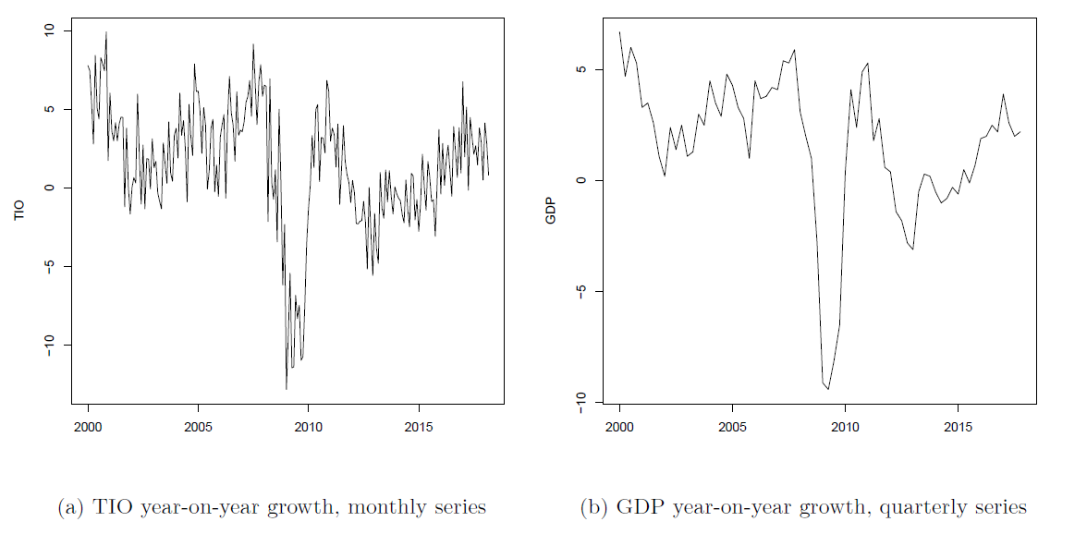
One aspects that it is important to underline is how closely related the TIO and GDP growth are. If we aggregate TIO growth to the quarterly level we obtain a series that closely tracks GDP growth (the resulting correlation coefficient is 0.99). This demonstrates that providing a good estimate of TIO leads to a greater nowcasting accuracy of GDP.
4. Nowcasting exercise formulation
In our nowcasting exercise, we are careful in terms of making a realistic representation of the available information set. When estimating quarterly GDP, we do not rely directly on the GDP series but rather use TIO, which means that we do not have problems in terms of publication lag. Fortunately, we are able to realistically simulate the accumulation of firm-level data, because Statistics Finland records that date on which the firms send their sales reports. Our quarterly estimate of GDP are entirely based on TIO, both the released version and our nowcasts. We compute the GDP nowcasts differently, depending on the month in which we make the estimate. In our setting, the nowcasts for a given quarter are computed three times: during the second month of the quarter, during the third month and 16 days after the end of the quarter. For example, If we compute the GDP nowcast during the third month, we would use the first TIO estimate made by Statistics Finland for the first month, then use our nowcast of TIO growth for the second month and then compute the 1-step ahead forecast for the third month. Notice that this procedure is rather similar to the one of bridge regression, which links quarterly and monthly variables via simple linear models. We estimate more than 150 nowcasting models, some of which are computationally burdensome. We then average these nowcasts using simple combination schemes such as unweighted average or using weights which depend on historical nowcasting performance (already Stock and Watson, 2004, point out that these schemes outperform more complex ones). We have tried different criteria in order to trim the original nowcasting models and found that keeping the models with lowest mean error (i.e. the ones producing unbiased nowcasts of TIO) tend to produce the best TIO and GDP estimates, once combined. Once we have produced the fast estimate of the indicator of interest, we re-evaluate the whole set of models to make sure that the performance with respect to the latest months does not alter the best set of models. This implies that, in principle, the models which are going to be included in the estimate can change over time.
5. Empirical results
We report the results of the individual models which provide the lowest root mean squared error (RMSE), the lowest mean error (ME), mean absolute error (MAE), and finally for the model with the lowest maximum absolute error (MaxE). In addition, we report the results for the simple forecast combination consisting of the unweighted average of the nowcasts provided by the 20 models with lowest MEs. This choice is driven by the high importance, for the statistical institute, of having unbiased flash estimates. We plot the nowcasts obtained from the forecast combination, against the first published version of TIO.
Figure 1. TIO & Nowcast (%-points)
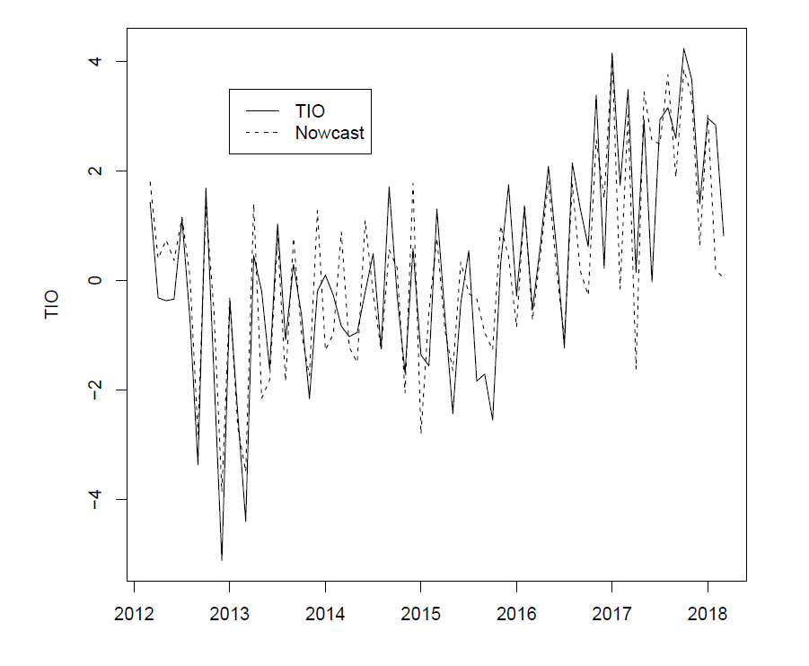
The nowcasts track fairly well the monthly original series, except for a fairly large mistake in April 2017, while they provide a substantial gain in terms of publication lag (around 30 days). Next, we provide some numerical indicators of the nowcasting performance, for the models described at the beginning of this subsection.
Table 1: Nowcasting performance of model combinations and individual models (%-points)
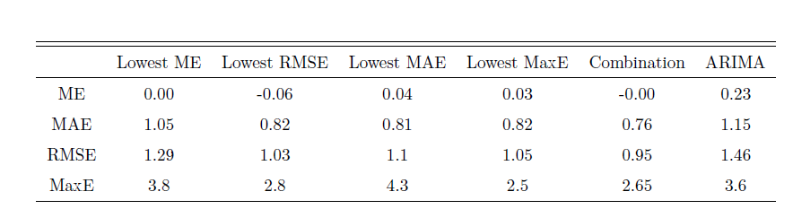
ME, MAE, RMSE and MaxE for different nowcasting models. Lowest ME, RMSE, MAE and MaxE indicate the models with the lowest mean error, root mean squared error, mean absolute error and max error, respectively. The Combination column contains performance measures for the simple nowcast combination based on the unweighted average of our models. The set of predictors is based on firm-level turnovers. The nowcasting performance of our selected models is far better than the one of an automated ARIMA procedure. Moreover, the simple nowcast combination provides the best estimates, in terms of ME, RMSE and MAE. In our case, nowcast combinations seem to be the most desirable approach, also in the light of being less prone to possible structural breaks in a model's performance.
We present next the results of the quarterly GDP nowcasts

Figure 2. GDP t+60 & Nowcast obtained at t-45,t-15,t+16, using firm-level data (%-points)
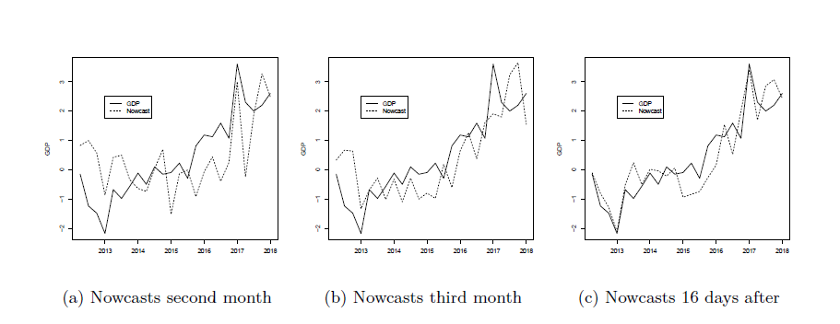
The nowcasts of the monthly indicator translate to a very good performance at t+16, where the nowcast captures also the large turning points in the economy. The estimates at t-45 and t-15 are less accurate, but improve as more data accumulates.
Table 2: Nowcasting performance at different time periods compared to the t+60 GDP publication, using firm-level data (%-points)
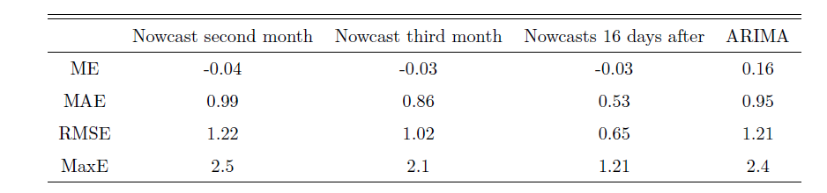
The accuracy measures indicated, that the t-15 day nowcast outperform the ARIMA benchmark, and is already quite accurate. The nowcast at t+16 days is very accurate and contains the same information in the statistical sense than the publication of Statistics Finland 45 days later. In other words, the estimate is unbiased and accurate. Let’s look at the traffic loop data performance next, after following similar process.
Table 3: Nowcasting performance at different time periods compared to the t+60 GDP publication, using traffic loop data (%-points)
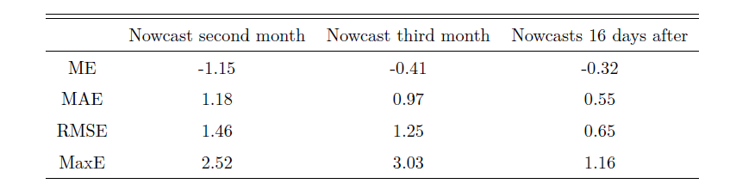
The traffic loop data provides a very good performance, roughly the same accuracy as the predictions based on firm level data. RMSE is exactly the same, and the maximum error is even lower. This is a surprising result, given how peculiar data source we are dealing with. This is a clear indication that the traffic loop data (a typical example of smart meters generating big data) is useful in economic forecasting and nowcasting.
6. Conclusions
In this report, we have examined the potential of large micro-level datasets, in combination with statistical models and machine learning techniques that are able to handle high-dimensional information sets, for the production of faster estimates of real economic activity indicators, both at the monthly and at the quarterly frequency. In particular, we have examined the nowcasting performance of firm-level data, and of trucks’ traffic volumes measurements. We find that a simple combination of the nowcasts obtained from a large set of machine learning techniques and large dimensional statistical models is able to produce accurate estimates of monthly real economic activity, or at least estimates that do not lead to a much larger revision error compared to the current official publications. While the revision errors do not increase substantially, our approach based on both firm-level data and traffic loop data allows for a reduction in the publication lag of roughly 30 days, when considering the monthly indicator. Turning to the results related to quarterly GDP, we find that our nowcasts would produce fairly accurate estimates of GDP growth during the third months of the reference quarter, even though there are few large errors. On the other hand, the nowcasts computed at t + 16 are accurate and do not show large revisions, and the revisions are compatible with the ones of Statistics Finland’s official publications. Even though these estimates would be produced after the end of the quarter, they would still allow for more than a month reduction of the publication lag. Finally, it is important to underline the satisfactory performance of traffic measurements data. The potential of this source of information should be explored further, given its real-time availability.
6. References
S. Boragan Aruoba, Francis X. Diebold, and Chiara Scotti (2009), Real-Time Measurement of Business Conditions. Journal of Business & Economic Statistics, 27(4):417–427

Filippo Altissimo, Riccardo Cristadoro, Mario Forni, Marco Lippi, and Giovanni
Veronese. (2010), New Eurocoin: Tracking Economic Growth in Real Time. The Review of Economics and Statistics, 92(4):1024–1034

Domenico Giannone, Lucrezia Reichlin, and David Small (2008). Nowcasting: The real-time informational content of macroeconomic data. Journal of Monetary Economics, 55 (4):665–676.

Julie Josse and François Husson (2016). missmda: A package for handling missing values in
multivariate data analysis. Journal of Statistical Software, Articles, 70(1):1–31,
ISSN 1548-7660.

James H. Stock and Mark W. Watson. Combination forecasts of output growth in a seven-country data set. Journal of Forecasting, 23(6):405–430, 2004. ISSN 1099-131X.doi: 10.1002/for.928. URL http://dx.doi.org/10.1002/for.928.

Martin D. D. Evans. Where Are We Now? (2005), Real-Time Estimates of the Macroeconomy. International Journal of Central Banking, 1(2), September 2005.
Paolo Fornaro (2016). Predicting Finnish economic activity using firm-level data. International Journal of Forecasting, 32(1):10–19, 2016.
Troy D. Matheson, James Mitchell, and Brian Silverstone (2010). Nowcasting and predicting data revisions using panel survey data. Journal of Forecasting, 29(3):313–330, 2010. doi: 10.1002/for.1127.
Trevor Hastie, Robert Tibshirani, and Jerome Friedman (2009). The elements of statistical learning: data mining, inference and prediction. Springer, 2 edition, 2009.

This set of models includes specifications from the regressions trees class, random forests, regression splines, k-nearest neighbors, boosting, neural networks, and others.
The data is available at https://aineistot.liikennevirasto.fi/lam/reports/LAM/
This best set of most accurate (by mean of errors) includes specifications from the regressions trees class, random forests, factor models, ridge regression, regression splines and k-nearest neighbors.

