The method of harmonised Labour Market Areas in Europe
Valeriya ANGELOVA-TOSHEVA, Eurostat, Valeriya.ANGELOVA-TOSHEVA@ec.europa.eu
Teodora BRANDMUELLER, Eurostat, Teodora.BRANDMUELLER@ec.europa.eu
Dario BUONO, Eurostat, Dario.BUONO@ec.europa.eu
Abstract
The Labour Market Area (LMA) is a well-established and discussed concept in regional geography and statistics. The concept of LMAs has existed for almost 30 years, based on different definitions and known under various names.
The need for functional geographies in the statistical practice is indisputable. Administrative boundaries often break up single LMAs. Commuting across NUTS and country boundaries can lead to significant differences between total employment (job-place-based) in a region and resident working population (domestic employment) in the same region.
For the last ten years, Eurostat has intensively worked on the EU-wide harmonisation of the LMAs concept starting with a study together with the research community to investigate the value assed, feasibility and best practices in the EU. The approach for delineation of LMAs proposed to the Member States is a simple, transparent, reproducible, consistent, and policy independent bottom-up method that needs only commuting flows as input. The algorithm operates with set of four parameters (minimum and target size of the employment and minimum and target self-containment). This article describes the method and provides visualisations of the obtained LMAs using the examples of Bulgaria and Portugal.
Keywords: Functional geographies, LMAs, harmonisation, open source software, self-containment, grid cells
1. Introduction
The European Union has defined far-reaching policy development objectives in the context of the Cohesion Policy, the Commission priorities and more recently within the context of the Sustainable Development Goals. These political initiatives share the challenge to provide adequate, statistical information on which to base the necessary policy actions. In order to implement the policy initiatives in the European context, there is a growing need for not only higher geographical detail and references related to administrative units, but also for information, that reflects the inherent structure of the social and economic reality at which European decisions and projects need to be targeted. As such, the structuring of information according to functional areas is complementary to the established administrative areas and regions. The concept of the Labour Market Areas (LMAs) has the potential to play a role in the economic analysis of territories both on European and also on national scale.
The LMA is a well-established and discussed concept in regional geography and statistics. The concept of LMAs has existed for almost 30 years, based on different definitions and known under various names (Labour Market Regions, Employment Zones, Commuting Zones, Travel-To-Work-Areas, Daily Urban Systems, Working Catchment Areas etc.).
The need for functional geographies in the statistical practice is indisputable. Administrative boundaries often break up single LMAs. Commuting across NUTS and country boundaries can lead to significant differences between total employment (job-place-based) in a region and resident working population (domestic employment) in the same region. Indicators such as GDP per inhabitant will be affected in regions with asymmetric commuting patterns. Luxembourg, the NUTS regions of Inner London and Brussels are only a few examples of territories where employment and GDP data are distorted when presented as divided by inhabitants.
LMAs can be defined as a geographic area designed for the purposes of compiling, reporting, and evaluating employment, unemployment, workforce availability and related topics. It is a statistically defined, economically integrated territory, where the majority of people live and work.
For the last ten years, Eurostat has intensively worked on the EU-wide harmonisation of the LMAs concept starting with a study together with the research community to investigate the value added, feasibility and best practices in the EU. The subject has been intensively studied in the Working Group on Regional, Urban and Rural Development Statistics, both in a specific Task Force and in a range of EU grants. The approach for delineation of LMAs proposed to the Member States is a simple, transparent, reproducible, consistent, and policy independent bottom-up method that needs only commuting flows as input. Furthermore, a script based on open-source software (R package) supported the IT implementation of the method. The algorithm operates with set of four parameters (minimum and target size of the employment and minimum and target self-containment). In the frames of a grant programme, several countries tested the IT tool and proved the feasibility of implementing the proposed harmonised method.
This article aims to present the method in detail and its applicability to analyse rural functional areas or urban-rural linkages within a functional area on the example of Portugal and Bulgaria.
2. The method
The aim of the method is to aggregate neighbouring Local Administrative Units (LAUs) to LMAs, satisfying a particular validity condition (internal cohesion and external separation principles), based on functional relationships, namely the commuting flows.
The EU (TTWA) method operates with two properties: (1) self-containment and (2) number of workers (persons employed). The self-containment is the proportion of the labour force that lives and work in the area. For both properties, minimum and target values have to be defined to run the algorithm. Consequently, four parameters (with values between 0..1 set the constraints to define what is considered to be a LMA:
1. minimum self-containment (minSC),
2. target self-containment (tarSC),
3. minimum number of workers (minSZ),
4. target number of workers (tarSZ).
The parameter tarSC is always greater than minSC. The default values for tarSC are between 0.75 and 0.8 but in specific situations higher values can also be selected. For the parameter minSC, the default values are between 0.6 and 0.6667. In other words, 0.8 self-containment means that only one out of 5 residents is commuting out of the LMA, 0.75 means that three out of four residents work inside the LMA, 0.6667 corresponds to two out of three, 0.6 to three out of five. The parameters could be changed based on expert decision to better reflect on the reality.
Self-containment is measured for both the supply and the demand side. Supply side self-containment (SSC) is the number of people living and working in an area divided by the number of workers in the area. Demand side self-containment (DSC) is the number of people living and working in an area divided by the number of jobs (taken by resident and non-resident workers) in the area.
The method considers a cluster of municipalities to be an LMA if the validity condition is fulfilled:
$$\frac{minSC}{tarSC}≤\left(1-\left(1-\frac{minSC}{tarSC}\right)∙MAX\left(\frac{tarSZ - SZ}{tarSZ - minSZ},0\right)\right)∙\left(\frac{MIN(SC, tarSC)}{tarSC}\right)$$
As regards SC, the condition has to be fulfilled by both supply and demand side self-containment.
In practice, the algorithm starts with assessing every municipality/Statistical Building Block (SBB) against the validity condition above. If a SBB does not fulfil the condition, the SBB that gives the lowest value for the right-hand side of the condition is selected. This SBB_{A} is then assessed against all other SBBs to find the one SBB_{B}, which has the most important commuting flows according to the following formula:
$$MAX\frac{Commuters{({SBB}_{A}→{SBB}_{B})}^{2}}{{Workers}_{{SBB}_{A}}∙{ Jobs}_{{SBB}_{B}}}+\frac{Commuters{({SBB}_{B}→{SBB}_{A})}^{2}}{{Workers}_{{SBB}_{B}}∙{ Jobs}_{{SBB}_{A}}}$$
where: ‘Commuters’ stands for the commuting flow,
‘Workers’ stands for the residents employed in the municipality and
‘Jobs’ stands for the population employed in a municipality (residents and non-residents together).
The SBB_{B} is the one with the most important commuting links to SBB_{A}. Therefore, SBB_{A} and SBB_{B} are grouped. The grouping of SBB_{A} and SBB_{B} (SBB_{AB}) is now considered as one entity and the joined commuting flows to the other SBBs will be recalculated.
Then the procedure restarts, with the SBBs and groupings of SBBs (e.g. SBB_{AB}) being treated equally.
However, in case in the ranking of SBBs that do not fulfil the validity condition, a grouping of SBBs gives the lowest value for the right-hand side of the validity condition, the grouping of SBBs is dismembered and each SBB is re-grouped.
The sequence of the re-grouping follows the ranking according to the right-hand side of the validity condition starting with SBB_{Z} with the lowest value.
SBB_{Z} is then re-grouped with another SBB or grouping of SBBs according to the formula above expressing the relationships between commuters, workers and jobs, unless – because of the merge with SBB_{Z} – the new grouping fails the validity condition. In such a case, SBB_{Z} will be put in a reserve list, as SBB_{Z} cannot be re-grouped to a SBB in its previous group.
SBB_{X,} previously identified having the second lowest value of the right-hand side of the validity condition, is re-grouped next, and so on, until all the SBBs have been re-grouped. Once such a regrouping is finalised, the commuting flows have to be recalculated before the procedure can restart.
The process stops when all SBBs or groupings of SBBs fulfil the validity condition.
The output of the algorithm is not the final solution. The fine-tuning procedure is designed to check for contiguity and deals with enclaves/exclaves.
3. Illustration of the results on LMAs obtained by two Member States
Bulgaria and Portugal are two of the countries that have produced LMAs based on the harmonised method described above. The results obtained by the two countries have been communicated to national stakeholders, who have accepted the LMAs as meaningful, and reflecting the reality of the local labour market and the observed commuting patterns. Furthermore, we checked whether the LMAs capture the rurality. Maps one and two show the share of population by individual LMA living in high density and urban clusters and demonstrate how the LMAs reflect the rurality. It is interesting to see that the rural LMAs in Bulgaria are generally smaller while the rural LMAs in Portugal are rather bigger as a size, both countries having settlements asymmetries. The area of the Bulgarian LMAs with a median of 907.9 sq. km varies from 174.8 sq. km in a rural LMA located at the border with Greece to 4210.4 sq. km in the LMA of the capital city of Sofia. On the other hand, the area of the Portuguese LMAs with a median of 2795 sq. km varies from 794 sq. km in the second largest city of Porto to 8543 in the rural LMA of Beja.
Maps three and four go deeper showing the distribution of the population by different type of density clusters visualising also the clusters.
Map 1. Share of population by LMA living in high density and urban clusters in Bulgaria (2011 population grid data)
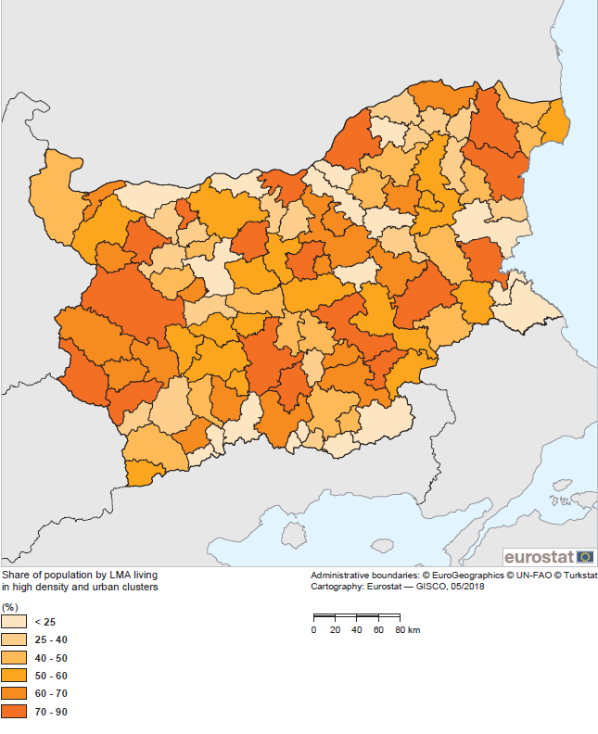
We observe that the rural and the unlived grid cells follow the elevation of the two countries. The elevation has an impact on the transport connections; hence, on the distance which people are whiling to travel to work Although the scale does not allow us to zoom into the maps presenting the clusters, it gives an idea of the analytical power of the grid statistics combined with functional geographies such as the LMAs. The 2011 Census population grid is available on the Eurostat's webpage.
Map 2. Share of population by LMA living in high density and urban clusters in Portugal (2011 population grid data)
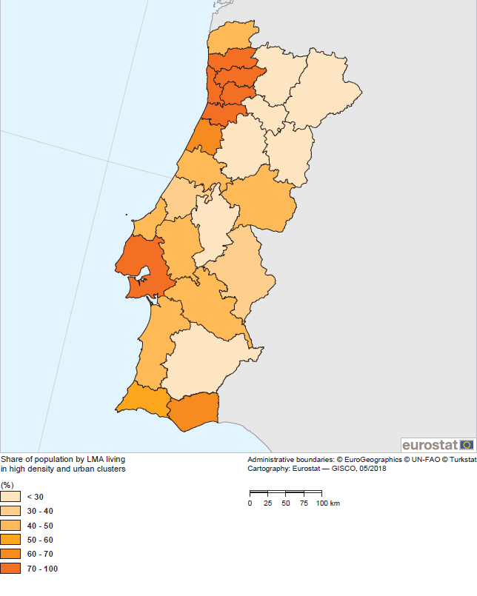
Map 3. Distribution of the population by different type of density clusters in Bulgaria (2011 population grid data)
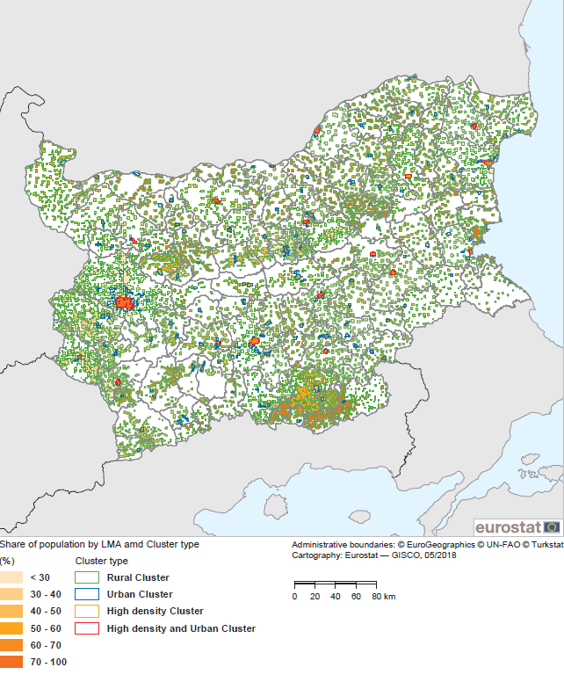

Map 4. Distribution of the population by different type of density clusters in Portugal (2011 population grid data)
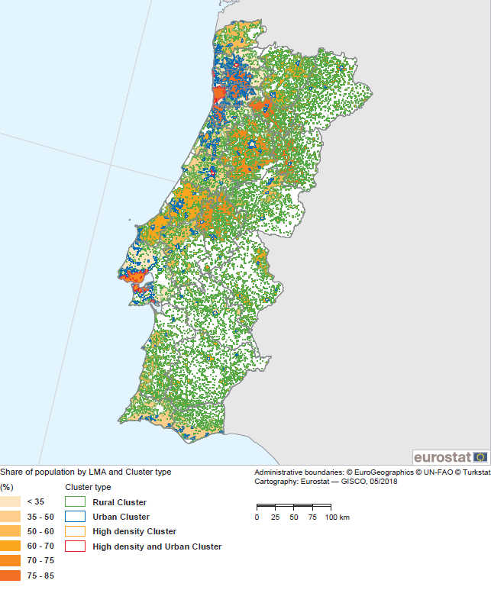
4. References
Coombes, M., Casado-Diaz, J.M., Martinez-Bernabeu, L., Carausu, F. (2012). Study on comparable Labour Market Areas, Final research report, Luxembourg. Available at: https://ec.europa.eu/eurostat/cros/content/study-comparable-labour-market-areas_en
ISTAT (2015), La nuova geografia dei sistemi locali, Roma. Available at: https://ec.europa.eu/eurostat/cros/content/new-geography-local-systems_en

https://ec.europa.eu/eurostat/cros/content/it-tools_en
http://ec.europa.eu/regional_policy/sources/docgener/work/2014_01_new_urban.pdf
http://ec.europa.eu/eurostat/web/gisco/geodata/reference-data/population-distribution-demography/geostat

