**An empirical study of**

**nonresponse bias. The Norwegian**

**National Election Survey 1969-2017**

Øyvin Kleven, Statistics Norway. [KLE@SSB.NO](mailto:KLE@SSB.NO)

Ib Thomsen, Statistics Norway.

Li-Chun Zhang, University of Southampton & Statistics Norway. [L.Zhang@soton.ac.uk](mailto:L.Zhang@soton.ac.uk) or [li.chun.zhang@ssb.no](mailto:li.chun.zhang@ssb.no)

**Abstract**

*Response rates have decreased steadily in household surveys across many countries, despite the increasing effort and resource being spent to deal with the problem. The associated nonresponse errors have received considerable attention in the past decades, as they can cause bias and are critical to the accuracy of survey based statistics. Some authors have published papers claiming that estimates of sufficient quality can be produced based on response rates as low as 5 percent (e.g Hellevik 2015), while practitioners and users of survey data often argue that “high” response rates are necessary for god quality. In this empirical study we focus on the Norwegian Election Survey data over nearly 50 years, combined with linked administrative sources, which provide additional data of Electoral Turnout and population demographic characteristics. The nonresponse rate has increased steadily from 10 percent in 1969 to 45 percent in 2017. But how has nonresponse bias evolved over the same period? Can another indicator better capture the nonresponse bias, such as the R-indicator that has received much attention in the recent years? Is it possible to devise other simple but more useful bias indicators? We take a closer look at the absolute deviation of the response rates as an alternative to the squared deviation used in the R-indicator. How would the nonresponse bias evolve, based on extrapolation of the trend of nonresponse rate and other factors that determine the nonresponse bias? What would be the likely nonresponse bias if the nonresponse rate either becomes very high or very low? Is there an “acceptable’ range of nonresponse rate in practical surveys? These are some of the questions we investigate based on the historical material at our disposal.*

**Keywords:** Survey nonresponse, Bias, Indicator, Historical data

## Decreasing response rates in Norway

Response rates have decreased steadily in household surveys across many countries, despite the increasing effort and resource being spent to deal with the problem. The associated nonresponse errors have received considerable attention in the past decades, as they can cause bias and are critical to the accuracy of survey based statistics. In Norway the response rates have decreased from an average of 80 percent in the 1970s to 60-50 percent in the last years (figure 1). Several handbooks and articles dealing with the problem have been published by practitioners and researchers in Norway (e.g. Thomsen et al. 2006, Zhang et al. 2012, Hellevik 2015). In 1966 a division and a permanent interviewer corps was established in Statistics Norway. The first survey was the Consumer expenditure survey in 1967. In 1972 the Labour Force survey started. In 1973 the Level of living was established. In the 1970-ties a whole series of survey-programmes was established. The Norwegian electoral programme started in 1957, in 1977 Statistics Norway and the Norwegian Electoral programme agreed to collaborate (the 1969 and 1973 election surveys conducted by Statistics Norway is not part of the Norwegian Electoral programme).

**Figure 1. Responserates (per cent) in some of Statistics Norway’s household surveys 1967-2017.** 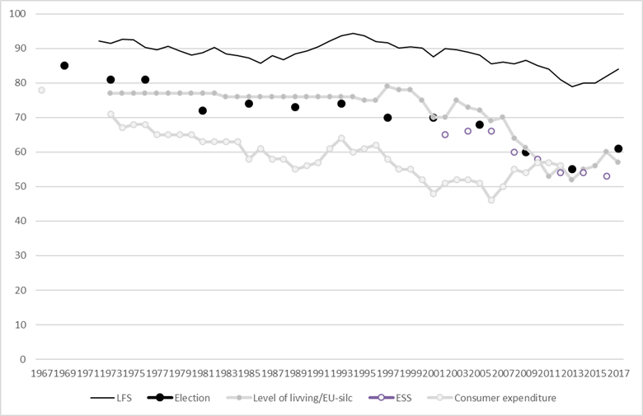

**A register based statistical system**

During the last 50 years Statistics Norway has made systematic efforts to integrate various administrative data for statistical purpose (Nordbotten 2010). Today a substantial part of official statistics in Norway are either directly produced from the register system or otherwise benefit from it. Official statistics on electoral turnout by background variables like gender, age and level of education is today mainly estimated by Statistics Norway based on register data provided to Statistics Norway from the government institution responsible for the election (The Norwegian Directorate of Elections). Every person living in Norway have a unique identifier a ‘National ID number’. All prospective voters must be included with their full name, address and their national ID number in ‘the electoral register’. The electoral register is a list of all those who are entitled to vote in a municipality. The Statistics Act of Norway states that Statistics Norway shall have access to all registers in Norway. Also, worth mentioning is that the Election Act of Norway states that the electoral register should be used for election research and governmental planning (without breaking anonymity for the persons listed). For Statistics Norway today, it is an easy task to merge data from the ‘the electoral register’ with other registers we have access to. When Statistics Norway performed their first National Election Survey in 1969 the national id number was in place, so when the sample for the survey was drawn it was drawn directly from ‘the electoral register’. Since then all the election surveys are drawn directly from the ‘the electoral register’. The register also contained information on gender, age and place of residence for the whole sample, but the sources of other relevant register information was much poorer compared to today. In 1969 a very important tradition started; the whole sample in the survey was sent to the local election committees in the municipality and then the local committee checked if each person in the sample had voted in the election. The local election committee need to have a register of each person entitled to vote in the municipality and they ned to register that each person have voted (merely to avoid that one person vote several times). Then the local election committee sends back the list from Statistics Norway, and Statistics Norway can transform that into a variable in the dataset from the survey. For most municipalities in the latest elections this is all done electronically in an electronically administrative election system.

From 1969 to 1993 we only have access to information from the documentation for the survey. Based on this we can recrate the aggregate distribution in the gross sample for electoral turnout, gender fixed agegroup and place of residence by region. For some variables it is also possible to combine them. From 1969-2017 we use timeseries including electoral turnout, gender and the age group 18-19, 20-24, 25-29, 30-49, 50-69 and 70-79. From 1997 we have anonymised complete datasets for the gross sample, including level of education place of residence.

**Separating different error sources**

A purpose of official statistics is to produce estimates of unknown values of quantifiable characteristics of a target population. Estimates are not equal to the true values because of variability (the statistics change from implementation to implementation of the statistical process due to random effects) and bias (the average of the possible values of statistics from implementation to implementation is not equal to the true value due to systematic effects; the bias of an estimator equals the difference between its expected value and the true value). It is common to separate between sampling errors and non-sampling errors. *Sampling errors*, which apply only to sample surveys; are due to the fact that only a subset of the population is selected. *Non-sampling errors*, which apply to all statistical processes is often categorised as coverage errors, non-response errors, processing errors and measurement errors. Coverage errors (or frame errors) are due to divergences between the frame population and the target population. Nonresponse is the failure of a sample survey (or a census) to collect data for all data items in the survey questionnaire from all the population units designated for data collection. Nonresponse error is the difference between the statistics computed from the collected data and those that would be computed if there where no missing values. Between data collection and the beginning of statistical analysis, data must undergo processing comprising data entry, data editing, often coding and imputation. Errors introduced in these stages are called processing errors. Measurement errors are errors that occur during data collection and cause the recorded values of variables to be different from the true ones. (ESS Handbook for Quality Reports). If we compare an estimate from a survey with a known population parameter in the whole population, that estimate will be exposed to both sampling errors and non-sampling errors. If we are studying the effect of nonresponse on the estimate we must insure that we can control and separate the different error sources. In election surveys we know from previous research that there can be measurement errors in questions on political behaviour like turnout and party preference. In this study we can analyse the direct nonresponse effect on turnout from our register variables.

**Non response bias in background variables**

As earlier mentioned the responserate in the election surveys have decreased over the years. It was 90 percent in 1969, it was around 70 per cent from 1981 until 2005. In the last three surveys its average is about 60 per cent, 2013 shows the lowest responserate 55 per cent. Table 1 shows responserates by age and gender. The general picture is that the responserate decreases among both males and females and among different age groups.

**Table 1. Responserate in election surveys by gender and age. 1969-2017. Per cent**

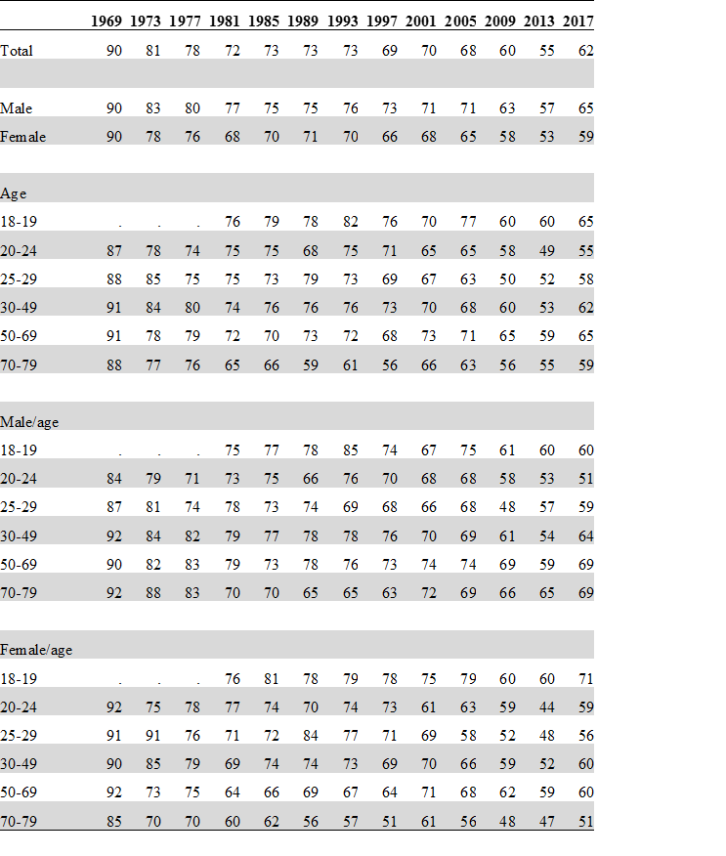

Source: Statistics Norway and Institute for Social Research, Norwegian National Election Surveys

**Bias indicator conditioning on the combination of the *X*s - *BIX***

It is common to denote background variables as *X* (independent variable)and the variables of interest we denote *Y* (dependent variable). If we want to look into the structure of bias in the background variables caused by non response, and we want to know the details tables like table 2 can be used, and we then normally extend the number of *Xs* Table like that has always been an important part of survey fieldwork management because they are easy to explain and easy to produce. But we also want a simple indicator to sum up the bias. It is easy to add together the differences in each category of the two *Xs* Gender and age group for each year. This gives a combination 2x5, 10 cells. This is merely males/age group and females/age group. Of course if we just add this 10 numbers in any given year this will be zero. Therefor we take the absolute numbers. We remove the + and – (can easily be done by multiply each value in each cell with the same value and extract the square root). Theoretically a given combination of the *Xs* where the response rate is 100 in half of the cells, and the response rate is 0 in the other half this value will actually be 100 (or 1). Hence the bias conditioning on the combination is 100 per cent. And correspondingly if the response rate is the same in each cell the value will be 0. Then there is no imbalance or bias in the given *Xs.* The value of this indicator is dependent on the *Xs* used and the combination of the *Xs.* For instance, the age interval used will produce slightly different values off the indicator. In statistical production we try to keep things in a standardised way, we are not necessarily interested in any given bias caused by non-response by some obscure variable. It is the bias caused by an important background variable we try to measure.

In statistical production it is also important to give something a distinct name so the survey managers, fieldwork staff and the users of the statistics understand the same thing. We call this very simple (and far from new or original) indicator for *Bias indicator conditioning on the combination of the Xs.* In short *BIX.*

**Table 2. Responserate in election surveys by gender*age. 1969-2017. Per cent**



Source: Statistics Norway and Institute for Social Research, Norwegian National Election Surveys

**Bias in electoral turnout**

Over the years the deviation between the mean turnout in the gross sample and the net sample have slightly increased. In Figure 2 we show the development in nonresponserate, the bias in background variables (*Xs*) and the target variable electoral turnout (*Y*).

**Figure 2. Nonresponse bias in Xs (BIXgender*age) and Y (electoral turnout).**

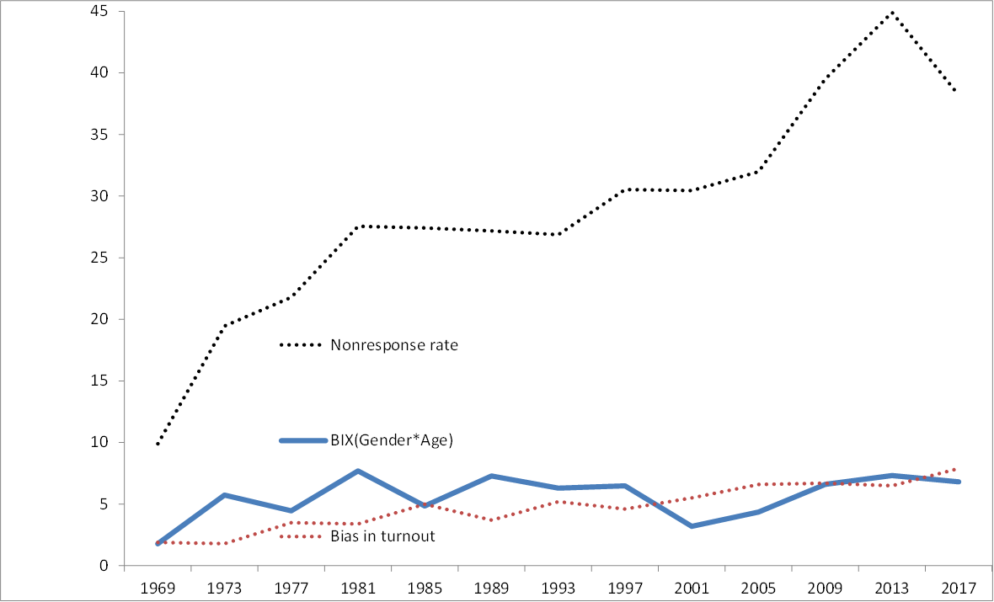

Source: Statistics Norway and Institute for Social Research, Norwegian National Election Surveys

**Extending the *X*s 1997- 2017**

From 1997 we can extend the *Xs.* We now also include level of education which often is an important background variable in social statistics. Also place of residence can be included we collapse place of residence into urban Oslo area and other big city, and the rest in rural. Level of education has a clear association with non response, people with low education participate less than people with middle or high education . In the later analysis we want to combine these variables so in order to keep the number of stratums within reason we collapse age into three. 1-34, 35-5- and 60-79. This give us 36 strata’s. Figure 3 shows nonresponserate, development in the R-indicator, the BIX and Bias in turnout from 1997. The trend shows that when the nonresponse rate increase the bias also increase. The R-indicator and the BIX shows the same trend.

**Figure 3. 1997-2017, bias in Xs BIXgender*age*education*urban and Y (electoral turnout).**

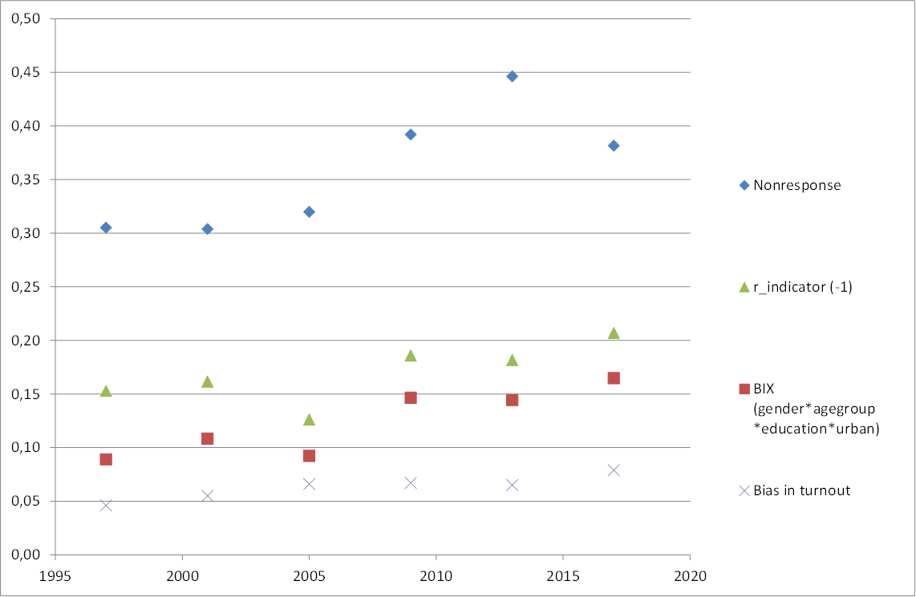

Source: Statistics Norway and Institute for Social Research, Norwegian National Election Surveys

**Non response under different scenarios**

Previously in other articles, reports and papers we have used paradata and simulated non response error for electoral turnout based on characteristics by the respondents, initial respondents (easy-to-get) and reluctant respondents who only participate due to extensively follow upp strategies from the field organisation. Now we extend this analysis from every year from 1997. Instead of characteristics of the respondents we simulate the non response effect if we have a response rate of 25 per cent, 50 percent and over 50 percent. For some survey variables like voted in the election we see that there is a severe non response bias, and that bias is reduced if the response rate increases. This non response error is reduced if we re-weight the estimate by auxiliary variables, but the non response error in electoral turnout is increased when the non response increases (table 3). To remove the bias we will ned higher response rates than 70 percent, and remember that in 1969 even a response rate of 90 percent did not remove the non response bias in this variable.

**Table 3. Electoral turnout in different scenarios of responserate. Simulations**

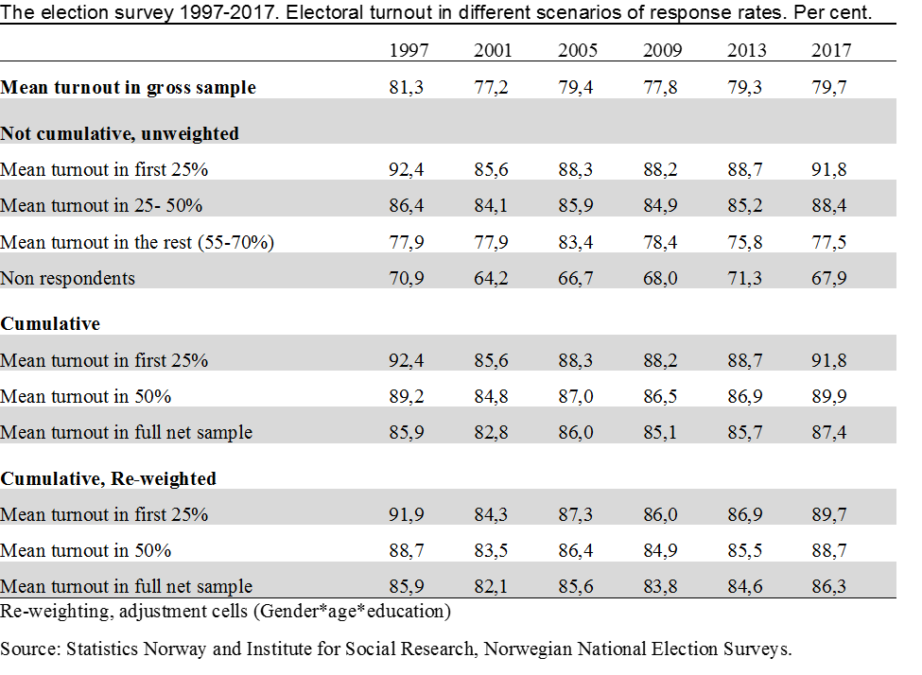

In 2017 we have moved from one election survey to an election survey programme. We conduct one high class expensive survey with a sample of 3 200 and we try to maximise the response rate within reason and budget. In addition, we have also other election surveys collected only through web and receive a response rate of about 45 per cent. In this surveys we can simulate non response bias given shorter fieldwork periods and lower responserates. We now look at several attitude variables, and for most of them the picture is not as clear as in the previous example with electoral turnout. In fact, there is no close connection between nonresponse rates and bias in the variables under investigations even when controlling for background variables. Below we show an example, the question is whether you feel that it should be easer or harder for immigrants to be allowed into Norway.

*Then there is the question of* *Norwegian immigration policy. The value 0 expresses the view that we should make it easier for immigrants to enter Norway; while the value 10 expresses the opinion that the number of immigrants coming to Norway should be restricted to an even greater extent than at present. Where would you place yourself on this scale?*

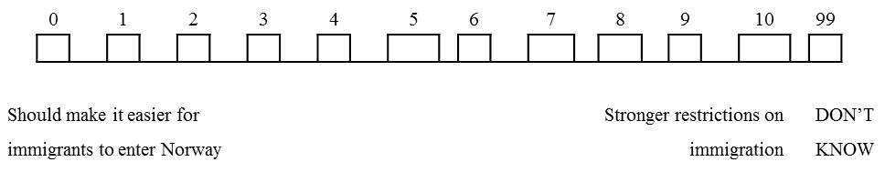

**Table 4. Distribution of the answers to question on Norwegian immigration policy. Under different scenarios of responserate. Percent**

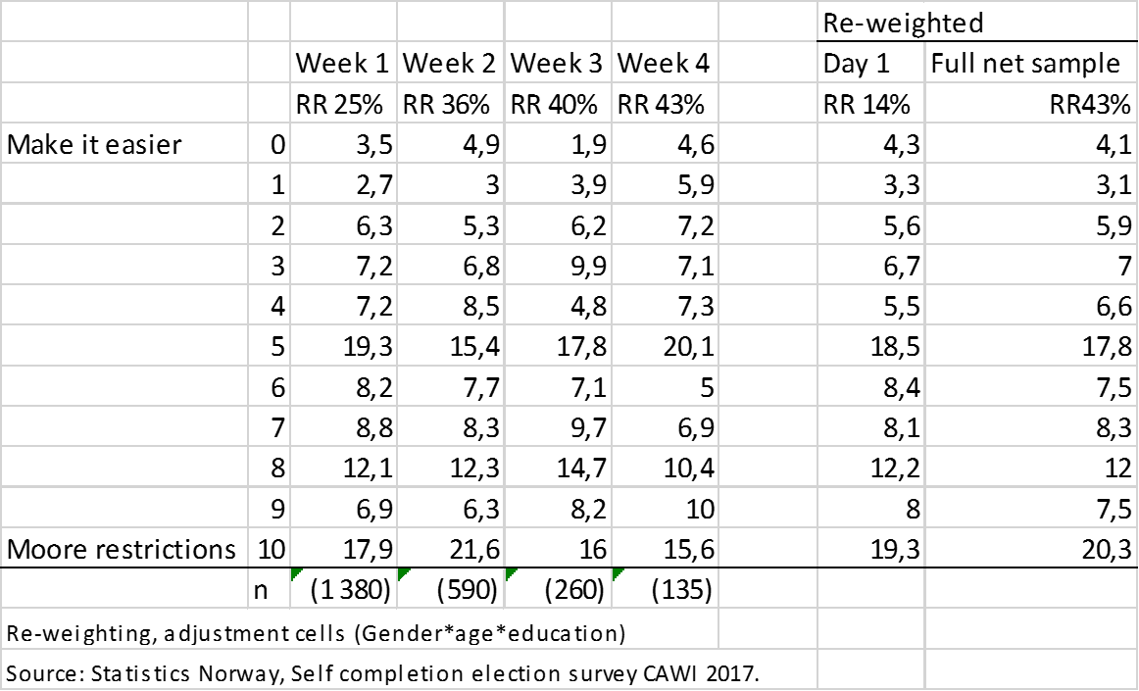

**5. References**

Hellevik, Ottar (2015). Extreme nonresponse and response bias: A “worst case” analysis. In Quality & Quantity: International Journal of Methodology.

Eurostat (2009) *ESS Handbook for Quality Reports.* Luxembourg: Office for Official Publications of the European Communities.

Nordbotten, S. (2010):The Use of Administrative Data in Official Statistics – Past, Present, and Future – With Special Reference to the Nordic Countries, Official Statistics – Methodology and Applications in Honour of Daniel Thorburn, pp. 205-225.

Thomsen, I., Kleven, Ø., Wang, J. H. & Zhang, L.-C. (2006). Coping with decreasing response rates in Statistics Norway. Statistics Norway (Reports 2006/29).

Zhang, L.-C. (2012). Topics of statistical theory for register-based statistics and data integration. Statistica Neerlandica, vol. 66, pp. 41-63.

Zhang, Li-Chun, Ib Thomsen and Øyvin Kleven (2013) “On the Use of Auxiliary and Paradata for Dealing With Non-sampling Errors in Household Surveys” in International Statistical Review (2013)