Targeting a wider public – storytelling with statistical data
Zsolt Czinkos, Hungarian Central Statistical Office, zsolt.czinkos@ksh.hu
Abstract
Reaching a wider public with statistical data is difficult. Smartphones and increasing mobile bandwidth are changing user expectations. Statistical visualizations should meet the standards of current user experience. The Hungarian Central Statistical Office has started to create interactive storytelling infographics and data visualizations to highlight interesting facts, to explain terms, to show results – to improve statistical literacy. Creating customised story visualizations is challenging. It requires cooperation between people from different domains: software development, statistics, communication, management, visualization. It also needs software tools. Publishing to both mobile and desktop environment requires responsive design and cross-browser compatibility. Tools exist, but development is expensive. Is it worth it? Number of visitors should be measured, feedback should be received. This presentation offers insight into the development process of a published interactive storytelling visualization highlighting technical details.
Keywords: data visualization, storytelling
0. Why?
Statistical literacy is important – we keep saying that. It is our mantra. But how could we reach people who never visit our website and never buy any of our publications? As a minimum we are targeting those who read news sites, assuming statistics could be interesting for them if it is served properly. We need to find a channel where this properly is possible.
1. A couple of seconds
In these days the main communication channel is the web, having a website is a must, but: Is it searchable? Does it have a modern look and provide good user experience? Does it have an intuitive interface (familiar buttons, control elements on the page)? Is it fast enough? Is this website accessible via mobile devices?
More and more users use mobile devices. They have a very short attention span, focusing on something is hard. Just think about constantly beeping notifications, alerts, instant messages! One of the most important word here is: instant. If you are really interested in something, you will probably wait for longer, but – and this is our case – if you are just browsing around you will not. According to an Akamai survey1 it is only a couple of seconds (3-4) after 50% of the users bounce if the page is not loaded yet.
In the micro-universe of our devices we have a different perception of time.
2. “Come on, I won’t read that!”
Reading a book or preparing for an exam could take hours. Reading an article could take minutes. Reading an online article… not too many minutes. Language says it all: we are not readers of a website, we are visitors or users (if interaction is possible).
How should we grab these visitors’ attention if they are not addicted to statistics? We need to show something appealing. Is a long text or table full of numbers appealing on a mobile device? Probably not and we have only seconds to keep attention. Let’s show them some colourful pictures and only a few sentences.
Remembering our mission – improving statistical literacy – we can’t use photos about cute puppies. We have data and visual representation of data (charts, maps, visualizations), and since it is not always obvious what a chart is about, we need to write a couple of sentences to explain it. Be aware! In one of our survey a university student – seeing that there are four sentences in a chart – told us: “Come on, I won’t read that!”
3. Tell me a story… and give me data!
Visualizing data is a common practice at statistical offices. We publish bar charts, pie charts, maps regularly. But now we would like to explain the data, the phenomenon behind the data, to a wider public who might think charts are boring or too complex to understand. What if we build up a hopefully appealing visualization in a couple of steps making it easier to understand? With 2-3 sentences in each step.
What is a story? – statisticians may ask. In our case a story is visual representation of data for a phenomenon – built up in a few steps – that makes our visitors feel or think something. For example: ‘Aha, I see now!’, ‘God, 1.2 million tons of apple? I love apple!’, ‘Only 1.1% of women had university degree in Hungary 60 years ago. What!?’
The story can for example explain a statistical term (e.g. ageing index), present results of a census or support marketing campaigns.
4. Development of ‘Fruit production in Hungary’
4.1. How to visualize data?
After having the data the quest for the proper visualization type begins. Storytelling should not be a slideshow with different types of charts loosely connecting to each other. It should be a couple of steps building up
Visualization should not be too complex. If our visitors are not familiar with it (like a chord diagram) or it takes too long to get the picture, they might leave.
Our ‘Fruit production in Hungary’ visualization project (see Figure 1) started with an excel file containing a couple of bar and line charts. It had geographic data, prices, harvested quantity. How can we display prices, quantity and timeline in one chart? Fruits are colourful round objects, so let’s use bubbles – a bubble chart. Let X axis = time, Y axis = harvested quantity, bubble size = price. But we have both procurement and marketing prices. Put them on top of each other! Good. The result is colourful, everything is in place. But. (This project is full of ‘but’.) Too much apple was harvested in the 1980s. Linear scale does not work, we should use logarithmic scale to keep dots representing apple on the screen.
Looks good, developer is happy, the last step of the storytelling is ready.
4.2. Platforms
After developing the steps and the transitions between them, it is time to test on other devices. If we want to reach a wider public, our software should work in the main browsers (Chrome, Firefox, Explorer/Edge) on both desktop and mobile operating systems. One part of this problem is programming, we should use JavaScript libraries and write code that has proper browser support. The other part of the problem is the screen size and orientation. Our chart should have responsive design, so it can adapt to the actual screen.

4.3. Coding
We are standing on the shoulders of giants. The development of the software would take much longer without existing open source JavaScript libraries. We use D3.js2 for visualization, and React3 for controlling the page components and handling events (e.g. buttons).
Even with such good libraries software development is risky. Modern development environments are complex and have a lot of dependencies. Some changes (e.g. an update) work, some do not. Have you ever heard from a developer: ‘What the hell happened? It worked yesterday.’ It can take a day to find a simple typo in the code.
In our project the developer was very happy with the colourful dots representing fruits, because it is much easier to handle colliding circles in a coordinate system than for example pentagons. It would have taken much more time to develop that version.
Sometimes code decides. If it is easier to code, it is cheaper.
4.4. Lower your expectation (deadline is coming)
At the beginning the developer had many ideas how to move the dots around, implementing useless bouncing balls and watching them for a couple of hours (remember: software development is risky and expensive), but deadline was coming and the fun was over. We had to define the minimum viable product4.
5. Publishing
Since our visualization is responsive (adapts to current screen size) it can be easily embedded in other webpages. We published it on our website, of course, but the main purpose of this project was reaching a wider public. The basic idea was that if it is extremely easy to put it into an online article (copy-paste) then journalists get a good looking illustration for free and we get publicity. Win-win.

6. Is it worth it?
Developing custom storytelling visualization takes time (remember the developer), and it is expensive (need many resources).
We had a survey and storytelling visualization seems to be popular among students (remember: ‘I won’t read that!’) It is promising.
We also have analytics about the page visits which shows that if our storytelling visualization is embedded in a popular site, then – for a period of time – we can reach a wider public.

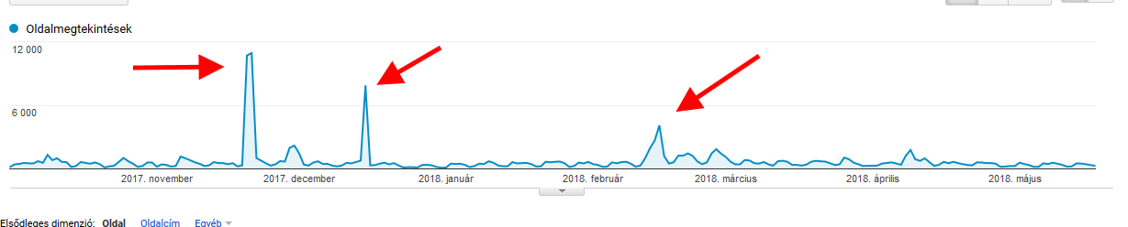

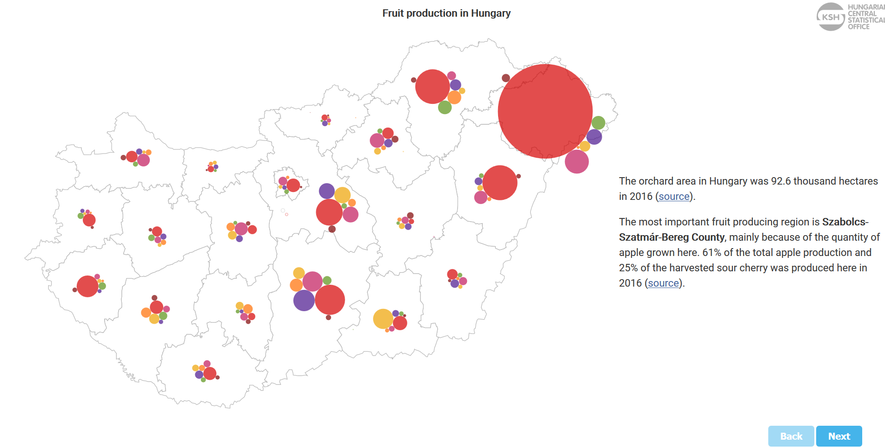  1. | 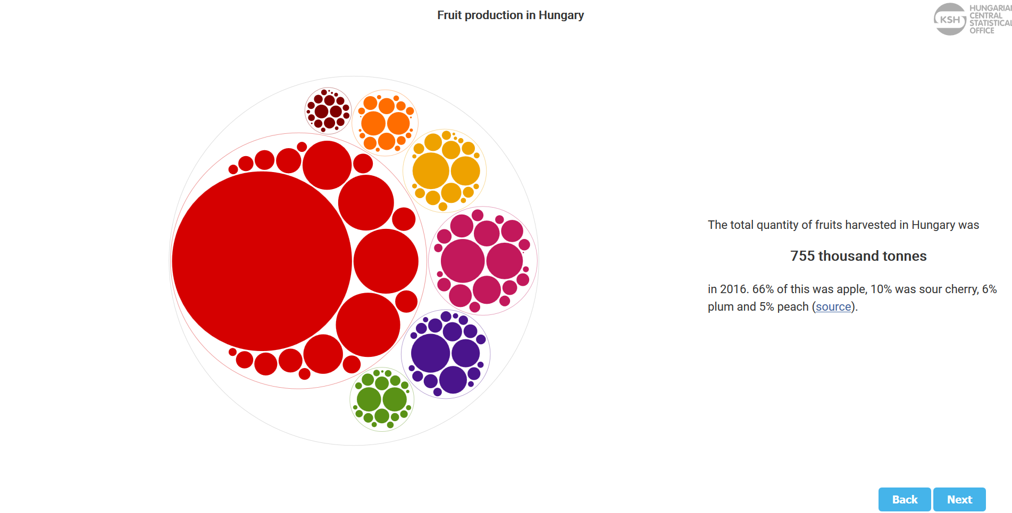  2.
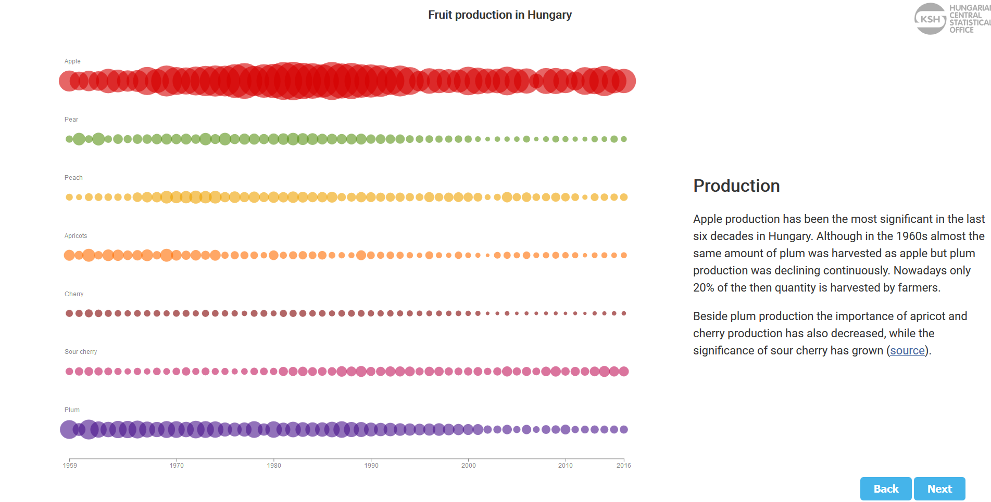  3. | 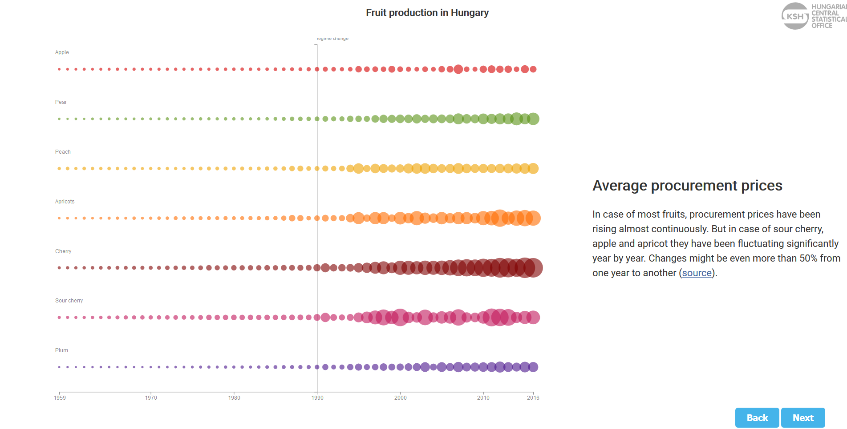  4.
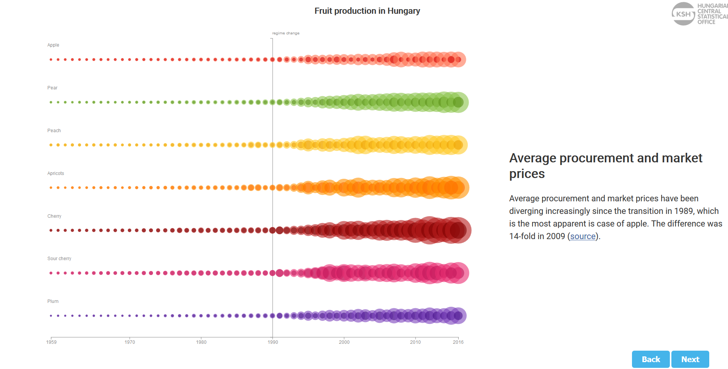  5. | 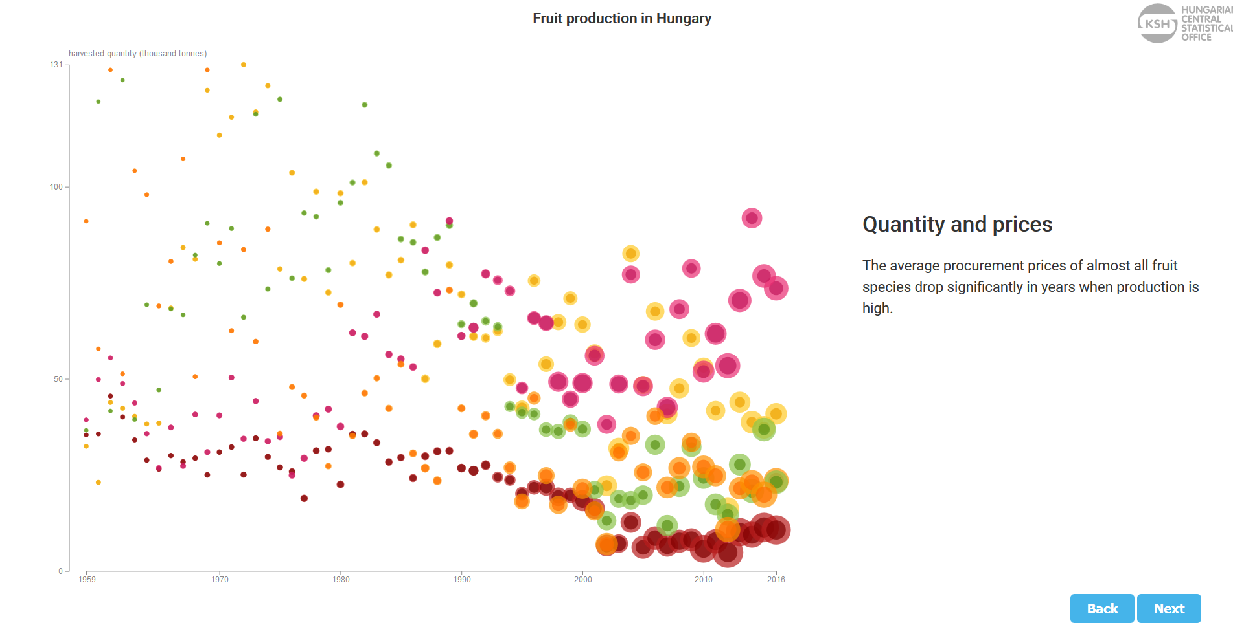  6.
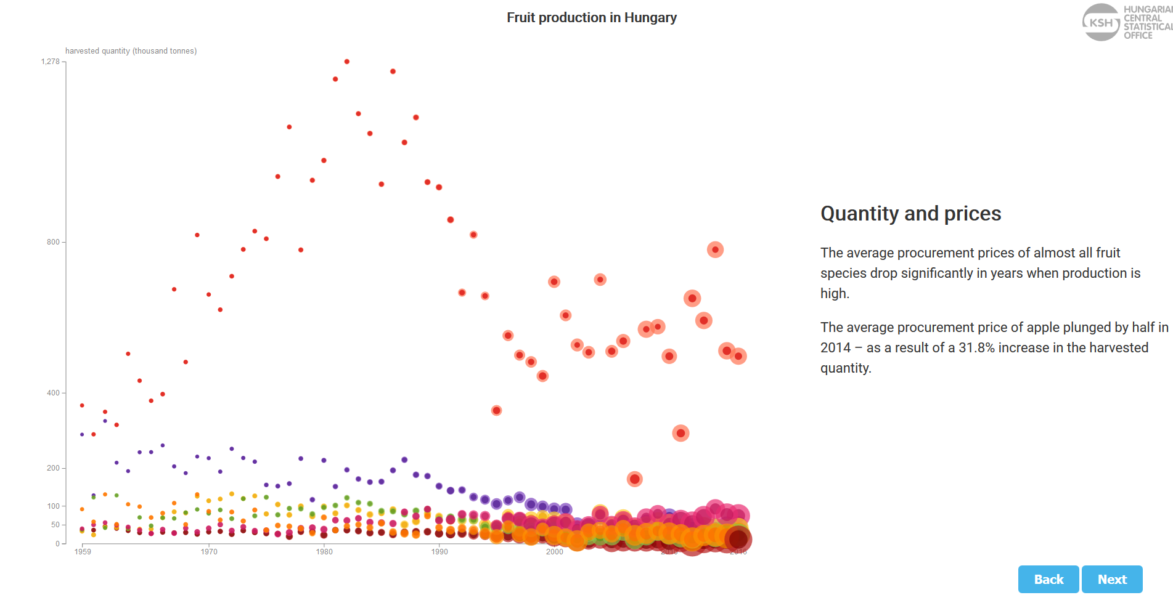  7. | 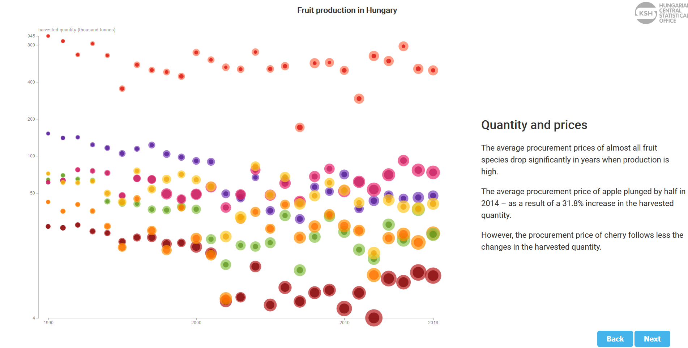  8.
1. Building chart and story step-by-step
https://www.ksh.hu/interaktiv/storytelling/gyumolcs/index.html?lang=en

1 https://www.akamai.com/uk/en/about/news/press/2017-press/akamai-releases-spring-2017-state-of-online-retail-performance-report.jsp
2 https://d3js.org/
3 https://reactjs.org/
4 https://en.wikipedia.org/wiki/Minimum_viable_product

