Bring Data to life with Data Visualization
Neal, Chen Zhihan, Ministry of Manpower Singapore, Chen_Zhihan@mom.gov.sg
Goh Jia Ying, Ministry of Manpower Singapore, Eugenia_Goh@mom.gov.sg
Heng Wei Jing, Ministry of Manpower Singapore, Jeremy_Heng@mom.gov.sg
Abstract
In today’s data-rich environment where users are overloaded with vast amounts of information, data visualization is essential in capturing a viewer’s attention and retaining it through storytelling. When data and visuals are weaved together into a story, it is able to resonate with the users on both an intellectual and emotional level. The human mind is able to grasp information better through data visualization tools instead of pouring over complex data in spreadsheets or reports. Although static visualization has long been used in storytelling, technological advancements have made the creation of interactive visualization easily accessible to the masses. Focusing on the users’ experience as the centerpiece of our design, Ministry of Manpower (MOM) of Singapore has developed an Integrated Manpower Analytics System (iMAS) which offers a wide array of statistical products such as infographics, videographics and interactive dashboards. This paper examines how MOM integrates data visualization into our statistical production process to provide users with a unique and customized narrative experience.
Keywords: Data Visualization; Technology; Storytelling; Design

1. Introduction
Visuals have been used since ancient times to facilitate the understanding of information among readers. This comes in forms of geometric diagrams, celestial charting and maps for navigation and exploration. One of the earliest examples of visualization was the idea of coordinates used by ancient Egyptian in town planning and depiction of location in a concept that is similar to longitude and latitude (Michael Friendly, 2006).
Research suggests that people tend to understand and grasp information better in visual forms as compared to texts. This is a phenomenon known as the Picture Superiority Effect. This effect can be seen clearly in memory related tasks where pictures create a more lasting effect as compared to words.
The data visualization concept and technology has advanced at an exponential rate. What was once started off as cave paints, stone carvings, static visualization on paper and Microsoft tools such as Excel and Powerpoint had evolved into the modern interactive visualization where users can tailor make their own stories through dashboard manipulation with the simple clicks of a few buttons. This allows users for quick access to relevant statistical insights which help them better understand the data to identify trends rapidly and allow for more in-depth analysis.
The Manpower Research and Statistics Department (MRSD) of Singapore conducts numerous national surveys per year. To tackle the ever increasing number and complexity of data items requested, MRSD leverages on data visualization tools extensively in different stages of the statistical production cycle to help to improve productivity and produce relevant data for the data users.
The paper seeks to take readers on a journey on how MRSD assimilates data visualization into each step of the statistical production process as part of our continuous effort for innovation.

2. Survey planning and optimisation
MRSD is the national manpower statistical agency of Singapore. Our core business spans across the full spectrum of the statistical production cycle which includes data collection, data processing, research and analysis and data dissemination. The value chain begins with survey planning. After deciding the sampling frame for each survey, the information will be ported to a survey planning dashboard which allows users to see the survey respondents’ location at one glance (Cartogram 1).
Cartogram 1: Survey planning dashboard
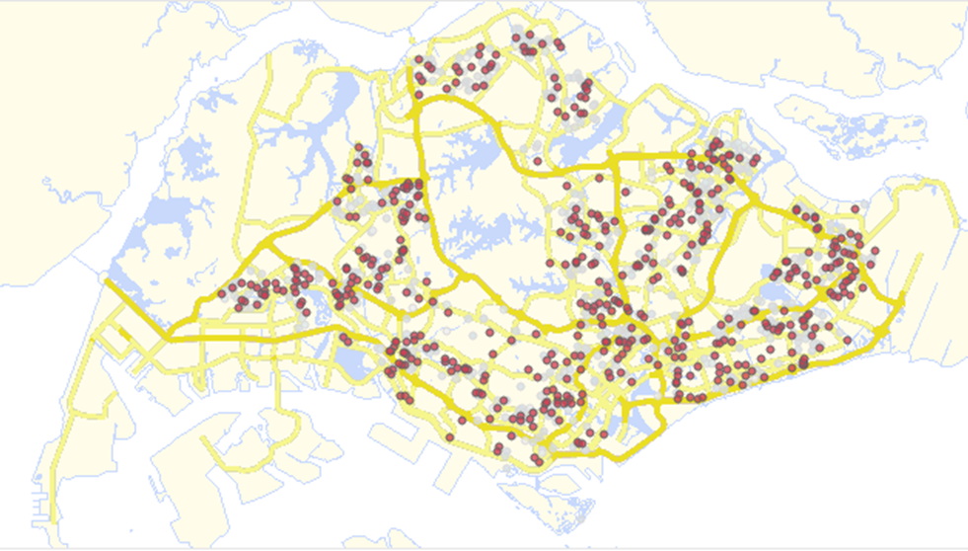
Source: Manpower Research & Statistics Department, Ministry of Manpower, Singapore
The dashboard is used during survey planning to determine the number of interviewers required for the survey and for the assignment of cases to the interviewers. The system will highlight cases which are of close proximity to the start-point of the field visit after inputting the postal code/ Longitude and Latitude of the location and allows the survey supervisors to zoom into specific regions to brief their interviewers on the area which they will be handling.
Cartogram 2: Survey route optimization dashboard 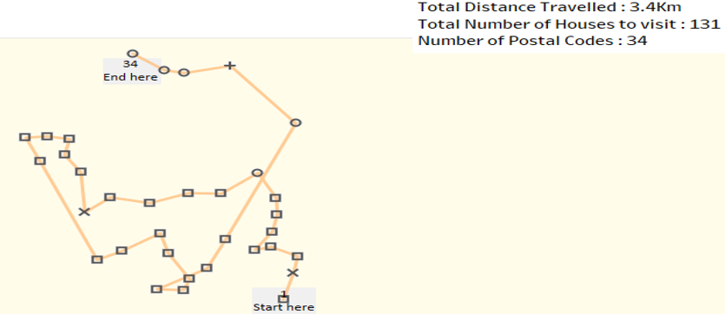
Source: Manpower Research & Statistics Department, Ministry of Manpower, Singapore
The dashboard also has the capability to suggest the best optimal route to be taken when conducting face-to-face surveys (Cartogram 2). The distances between each location is computed using the “Haversine” formula with longitude and latitude as inputs variables.
(1)
$$\text{hav}\left(\frac{\text{d}}{\text{r}}\right)\text{=}\text{hav}\left(\text{φ}\text{2 }\text{- }\text{φ}\text{1}\right)\text{ +}\text{cos}\left(\text{φ}\text{1}\right)\text{cos}\left(\text{φ}\text{2}\right)\text{hav}\left(\text{λ}\text{2 - }\text{λ}\text{1}\right)$$
where
- hav is the haversine function: $hav(θ) = sin^2(\frac{θ}{2}) = \frac{1-\cos\left(θ\right)}{2}$
- d is the distance between the two points
- r is the radius of the sphere
- $\text{φ}\text{1}$, $\text{φ}\text{2}$: latitude of point 1 and latitude of point 2, in radians
- λ₁, λ₂: longitude of point 1 and longitude of point 2, in radians

Previously, officers were required to access mapping websites to manually plot the location before they embarked on the interviews. This is a tedious process. Through the use of this tool, the time saved has allowed our interviewers to complete more cases and provide higher quality service to our respondents which has enabled us to implement new statistical programmes without increasing the amount of resources required.
3. Performance management and Data validation
In order to deliver robust and reliable data in a timely manner, data visualization is used to monitor the performance of the interviewers and identify their key strengths. This can be seen by the profile and type of cases that are assigned to the interviewers and their completion rate. For instance, interviewers who have performed exceptionally well for cases with residents living in certain areas comprising of certain housing type will be assigned cases of similar nature for future surveys to leverage on their strength. The dashboard also shows team performance with the ability to drill down into the performance of each individual interviewer which will allow the survey manager to make operational decisions and interventions easily.
Figure 1. Survey performance dashboard
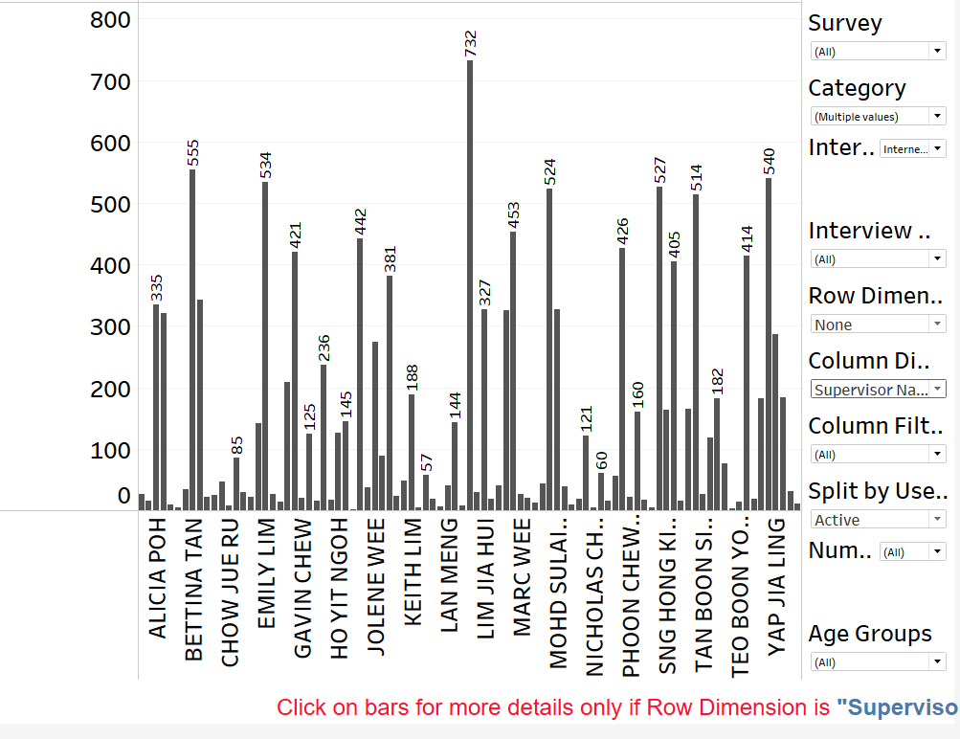
Source: Manpower Research & Statistics Department, Ministry of Manpower, Singapore

Data validation plays a pivotal role in the statistical production cycle. Stringent data validation is required to ensure the robustness and reliability of the data collected. MRSD uses a proprietary data cleaning system which links multiple datasets (both survey and administrative data) to run multi-dimensional checks on survey returns. Therefore, validation dashboards were created to assist the survey interviewers by giving them an overview of the cases with anomalies and prompting them on potential areas of concern. This will also allow the survey supervisors to assess the quality of the data collected by the respective interviewer and intervene if a certain interviewer is not meticulous in the data collection process.
Figure 2. Data validation dashboard
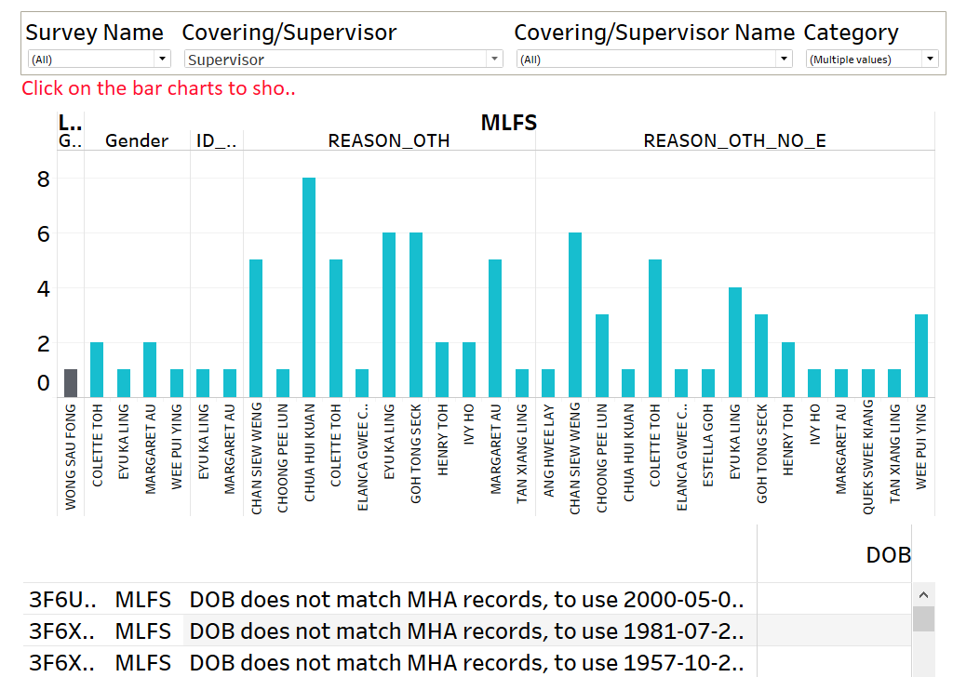
Source: Manpower Research & Statistics Department, Ministry of Manpower, Singapore
4. Data Dissemination
The traditional methods of presenting data are no longer relevant in today’s fast paced lifestyle and data saturated society. Data users expect to obtain the required information in a quick and easily understood manner. With this as our main consideration, MRSD has produced a vast array of data products to supplement the traditional statistical reports and tables. Infographics highlighting areas of interest in each report is customised and designed to suit the theme of the report. The icons and figures are designed to give data users the key highlights of the indicator which they represent in a quick glance. Through the introduction of infographics, animations and user friendly data dashboards, viewership and interest for our statistical products have increased over the years.
Figure 3. Condition of Employment 2016 infographic
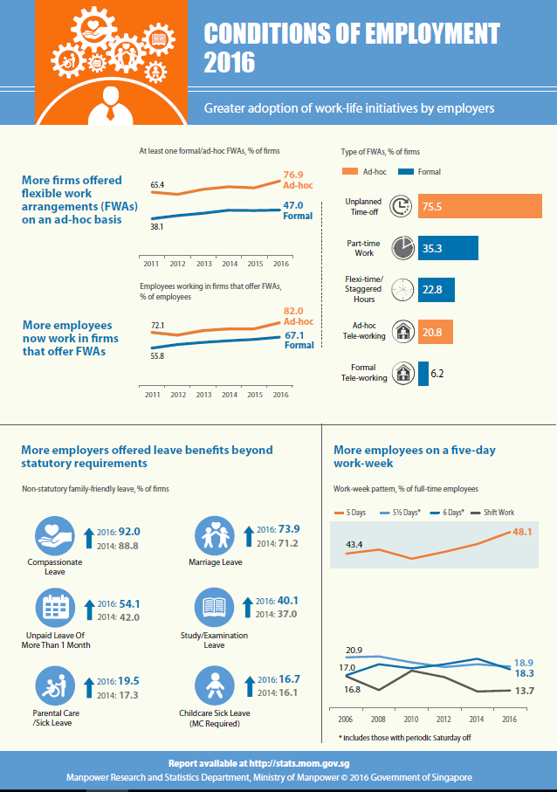
Source: Manpower Research & Statistics Department, Ministry of Manpower, Singapore

5. Conclusion
Data visualization is a valuable tool that can enhance several business processes which can improve productivity. It also bridges the demand for fast and easy-to-understand statistics to the mass public. Although there are several benefits of using data visualization, organisations need to bear in mind the need to create tools that can be easily updated and edited. This is to ensure that the effort put into producing these tools and products does not outweigh the benefits which they provide.
6. References
Michael Friendly (2006), A Brief History of Data Visualization, Handbook of Computational Statistics: Data Visualization

The Power of Visual Communication, PwC’s The Difference, http://www.commslab2017.com/CreativeComms_WhitePaper_Apr17.pdf
Haversine formula, Wikipedia, https://en.wikipedia.org/wiki/Haversine_formula

