Development of activities based on customer experiences and feedback
Reija Helenius, Statistics Finland, reija.helenius@stat.fi

Abstract
The strategic objective of increasingly many organisations is customer orientation and development of activities through customer feedback. This paper presents how listening to customers and collection and processing of customer feedback can be systematised and included in the continuous improvement procedure. Systematic processing of customer feedback, emphasising the customer voice, can be supported in various ways in an organisation. Examples of this are year planner models for customer feedback processing and collection and introduction of indicators for customer effectiveness. Monitoring of customer feedback and experiences can be made by means of both conventional studies and inquiries, as well as through new methods. Online think tanks, validation of telephone calls and email services and studying of search engine use introduce new viewpoints. By collecting together the feedback received from all different channels we gain an extensive image of customer feedback and needs. This equally includes monitoring of the use of web services and social media channels, media monitoring and data supplier feedback received. The paper presents practical tools and describes experiences of using various methods. As a case example, it is illustrated how the aims of listening to the customer in Statistics Finland's strategy have been advanced in practice. A key question in taking the strategy forward has been how the customer strategy is to be implemented in the whole organisation and its different levels. The paper produces an overall image of how customers are listened to, what ought to be measured and how to react to the feedback received. In addition, how the collection and utilisation of customer data can be coordinated comprehensively in an organisation is discussed. The customer concept is considered to comprise stakeholders, data suppliers, data users and paying customers alike.
Keywords: customer feedback, customer strategy, continuous improvement
1. Introduction
Recognition of customer needs is a key strategic objective both in international and national statistical communities. One of the five key areas of the European Statistical System (ESS) vision 2020 is called ”Focus on users” (Eurostat, 2014). User-orientation is promoted for example with the Digicom project (The project for digital communication, User analytics and Innovative products) (Eurostat, 2016). The key idea is that innovative product development is based on customers’ needs that are systematically charted by promoting continuous dialogue with customers.

Statistics Finland's strategy for 2016 to 2019 also puts the customer in the central ring (see Figure 1). Here, listening to the customer and recognising their needs, as well as development of activities and services based on this, plays a key role (Statistics Finland, 2016).

FIGURE 1. Statistics Finland's strategic goals 2016 to 2019
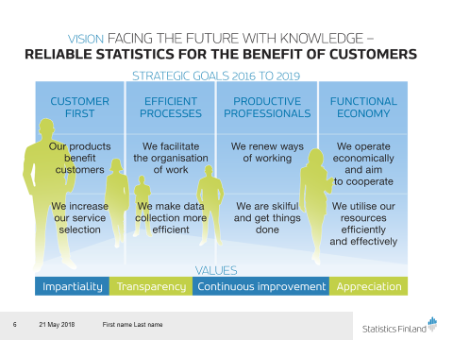
Source: Statistics Finland
2. Feedback can be collected in many ways
Statistics Finland has collected customer feedback and information on customers’ needs for several years in different ways (see Table 1). Feedback and data are, in general, collected by product and customer group by analysing web service customers. Data suppliers also give feedback. This also includes feedback received by information services, the results of feedback, media and social media monitoring, as well as direct contacts and meetings with stakeholder groups and feedback received from these (see Table 1). Statistics Finland has defined the customer as: “Customers are those who benefit from Statistics Finland´s output regardless of the output being chargeable or budget funded. Respondents are also customers.” (Hellman-Ketola, 2017).

The development challenge is further development of activities so that customer feedback is collected, reviewed and reported as a whole and the realisation of presented development targets is monitored systematically and regularly.

Table 1. Statistics Finland's customer feedback systems and corporate image/customer surveys
Procedure | Target group(s) | Objective(s) | Frequency
1. Extensive external stakeholder studies
1a. Corporate image survey | Finns (aged 15 to 79), sample survey | - Familiarity with Statistics Finland and its activities and products among Finns  - Finns views on the quality of statistics produced by Statistics Finland and how it handles its basic task  - Finns views on the usefulness and necessity of Statistics Finland. | Every second year
1b. Customer satisfaction survey | Customers and key stakeholders. Sample is drawn from CRM | - General questions  - Customers’ views, in general, on the quality and usefulness of statistics/products/services (taking CoP criteria into account)  - Customers’ views on materialisation of service principles  B. Special themes/targeted questions  - Collect feedback to develop selected products/services (e.g. open data, social media services)  - Evaluate the success and implementation of selected development objects | Every second year
1c. Surveys and reports carried out in connection with various projects, strategies, etc. as well as other targeted customer and stakeholder group studies | Desired sample/selection from stakeholder groups | The targets arise from the role of each stakeholder group and its relation to the development needs of the activity. E.g.  - Feedback for developing activities, statistics and products  - Development of stakeholder cooperation and communication  - Strengthening of partnerships | As required  Objective: Planned annually in connection with the planning of activities
1d. User panels and similar | Determined on a case-by-case basis | Development of a particular product/activity/service | As required
1e. General business image surveys carried out by others | Determined on a case-by-case basis. What will be acquired by the agency | The objectives vary between surveys, e.g.  - VIP public image survey: decision-makers’ views on the activities of various organisations.  - Business communications survey: media’s views on the activities of various organisations. | As required
1f. Other possible | Customers and key stakeholders, sample | For example, in 2016 to 2017, an online think tank where customers evaluated, e.g. how their work and data needs would change. | As required
2. Direct systematic customer feedback | Customers of charged assignments | Feedback on the practical functionality of the customer service process | Any time an assignment is completed, the service request is sent automatically from the CRM system.
3. Course evaluations | Course participants | Immediate feedback on the usefulness of the course and the functionality of the customer service process | Every course is evaluated
4. Stakeholder and customer contacts: meetings with customers, events, cooperation group meeting, etc. | Separately defined target group, e.g.  - events participants  - Group members/strategic key customers  OR “random meetings”, e.g. customer contacts, meetings at trade fairs | - Receiving direct feedback and development suggestions  - Creating interactive relationships with various stakeholder groups  - Building partnerships and supporting management | Unsystematic  Aim is to input all feedback into the CRM system
6. Media monitoring | Media | - Monitoring of the media visibility of Statistics Finland and the data it produces (incl. “the quality” of the visibility).  - Enables quick reaction to incorrect data interpretations or other similar situations  - Recognition of trends in the operational environment, as well as weak and strong signals and anticipation of data needs | Continuous, monitoring and reporting by monitoring period
7. Monitoring and quality of web services
7 a. Online feedback channel | All customers | Offer customers a channel for giving feedback and wishes, as well as development proposals | Continuous
7 b. Google analytics monitoring | Web service users | Data on web service use, user profiles and service development needs | Continuous basic monitoring
7 c. “Quality control” of web services | Testing of the internal process | Information on the punctuality of web service updates and web service accessibility | Continuous
7 d. Ad hoc surveys | Sample of web service users | Feedback on the quality, usability and development needs of web services | As required
7 e. Usability testing | Sample of web service users | Feedback on the usability of the service  Supports development measures in connection with projects and reforms | As required
8. Data supplier feedback | Data suppliers | Receive feedback from data suppliers and develop services for data suppliers
9. Other feedback and evaluations
9 a. Assessments by the EU |  | E.g. CoP | At regular intervals
9 b. Other external activity assessments, audits, etc. |  | Concerns various statistics, products and services | At regular intervals

Source: Statistics Finland
3. Organisation of reporting and customer feedback communication
Statistics Finland has developed year clocks for collecting and monitoring customer feedback. A feedback summary (see Figure 2) is made three times per year and it is presented to the Management Group with possible proposed measures. At the same time, a summary is made of how previously agreed on development measures have progressed. After Statistics Finland's Management Group process, the recommendation is that the feedback summary is discussed by the Departments' management groups under the item customer first, which has been made a standard item on the agenda of Departments' management group meetings.
The feedback summary is also presented on the Intranet and included on the feedback page, where all customer surveys and feedback can be reviewed by the entire personnel. In addition, the feedback received by the joint web service email is reported monthly on the Intranet. Every feedback is responded to if the customer has given his/her contact information. Automatic feedback collection on chargeable assignments through the CRM system enables departments to get immediate customer feedback on chargeable assignments concerning them.

FIGURE 2. Year clock for customer feedback
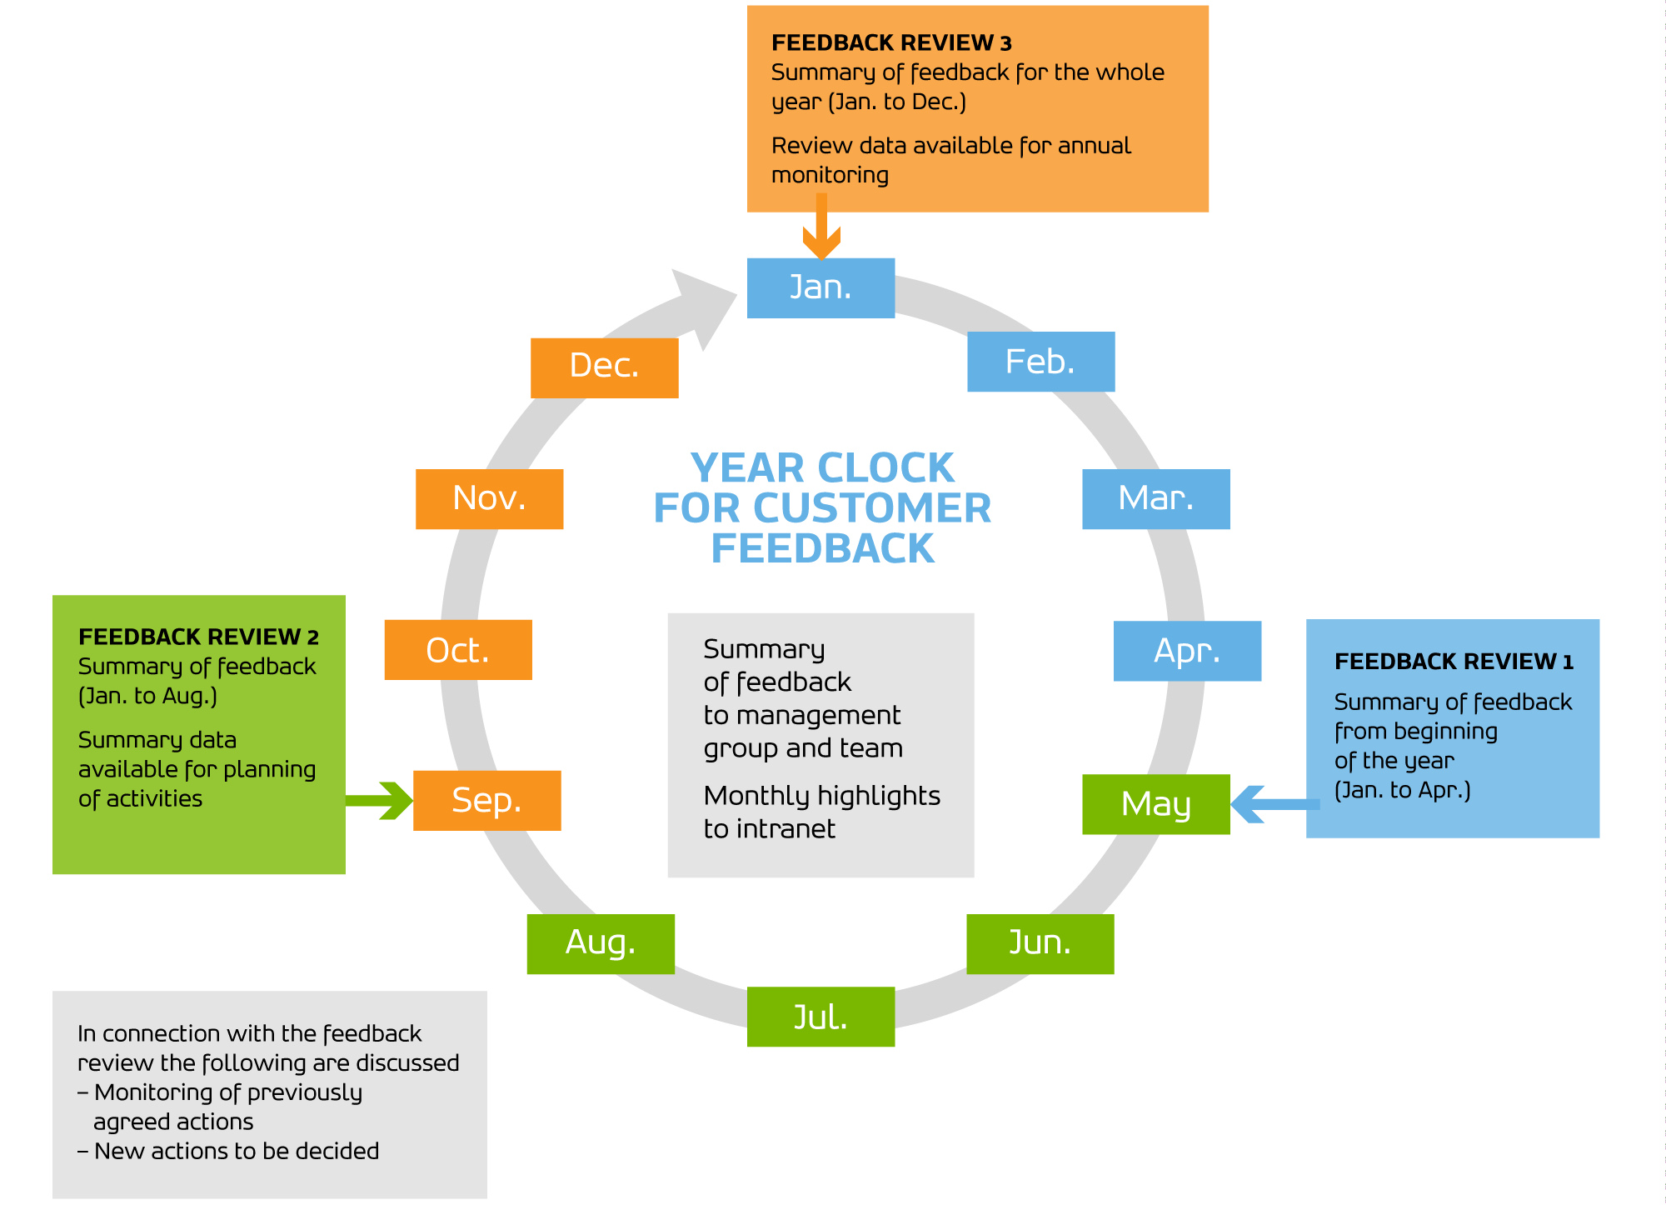
Source: Statistics Finland

Reporting, collection and monitoring of customer feedback is organised by the Communication and Information Services Department (excl. feedback from data suppliers). More extensive reports are produced regularly as agreed and are monitored by, e.g. Statistics Finland and the Ministry of Finance. Such reports include, e.g. the image and data user surveys. In addition, other product and service specific reports and surveys are carried out. We are increasingly adopting proactive examination of customer needs already at the start of the project so that customer needs can be considered already at the product development stage and not retrospectively.

FIGURE 3. Year clock for collecting customer feedback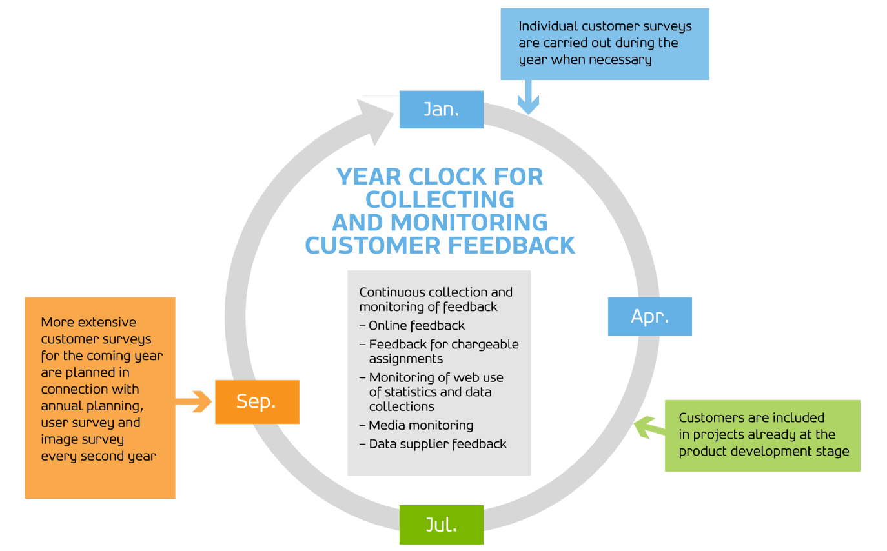
Source: Statistics Finland
4. Measuring progress
Statistics Finland has developed various communication indicators. When designing indicators, it is important to consider what measured information is needed on, how the information is available and with what kind of input. Indicators are a tool for developing activities. Indicators should be examined against the organisation's strategic goals and they must meet separately defined criteria (see e.g. SMART criteria). At Statistics Finland, the development of indicators started under the guidance of an external consultant, Elisa Juholin (see more Juholin, 2010/2013).
Table 2 describes the objectives, means and indicators separated into indicators already in use and new indicators.

Table 2. The table shows the present indicators and in addition to them, the proposed new indicators (Ukkonen, 2017).
Target | Strategic aims | What is monitored | Current indicators | Proposed new indicators
Customer commitment and responding to their expectations | Customer first | Business image surveys, data user surveys, separate product-specific surveys, course evaluations | School grade for chargeable assignments,  satisfaction with customer training | Familiarity, reliability, impartiality, intelligibility of information, recommendation of chargeable assignments’ data
Public visibility and effectiveness | Customer first | Publicity analysis, web pages, social media channels | Editorial mentions in printed media, blog posts, subscribers to newsletter | Articles, expert interviews, experts’ Twitter accounts, experts’ presentations in international meetings

Indicators for social media have also been developed (see Table 3).

Table 3. The table bellows presents the objectives, target groups and indicators of social media channels (Ukkonen, 2017).
Channel | Objectives | Target groups | Indicators from the beginning of 2017
Facebook | To reach and activate new data users and make Statistics Finland's data known. | New users of statistics, potential customers of services and products. | Weekly: successes of posts. Once a month: the number of followers, visits to web pages. Every 3 months: content evaluation.
Twitter | To reach and activate data users, bring forth Statistics Finland’s experts and present topical views to discussion. | Media, experts, decision-makers. | Weekly: successes of tweets. Once a month: followers, shares, likes, information service questions, visits to web pages. Every 3 months: content evaluation, Statistics Finland's experts on Twitter.
LinkedIn | To network professionally, to develop the employer image. | Potential job applicants | Once a month: number of followers. Every 3 months: shares of recruitment ads.
Instagram | To raise familiarity among young people, give a visually interesting image of Statistics Finland, an image of a living workplace. | Young potential job applicants. | Once a month: number of followers. Every 3 months: number of likes and comments.

Now indicators for databases are being developed, both in terms of developing the quality of their content and monitor usage. We want to develop easy to use reporting systems to monitor databases like Internet services with the help of which, the personnel can themselves monitor the services, products or statistics they want to follow, as well as their use.
5. References
AMEC Integrated Evaluation Framework. Available at: http://www. instituteforpr.org/wp-content/uploads/Barcelona-Principles-2.0.pdf (Accessed: 14 May 2018).
Eurostat (2014). Available at: http://ec.europa.eu/eurostat/web/ess/about-us/ess-vision-2020/key-areas (Accessed: 14 May 2018).
Eurostat (2016). Available at: Eurostat (2014). Available at: http://ec.europa.eu/eurostat/web/ess/digicom (Accessed: 14 May 2018).
Hellman-Ketola, S. (2017). CRM at Statistics Finland – platform for stakeholder data and relationship management. Paper presented at: UNECE Workshop on Statistical Data Dissemination and Communication 28 - 30 June 2017, Geneve. Available at: https://www.unece.org/index.php?id=44218 (Accessed: 14 May 2018).
Juholin, E. (2018). Arvioi ja paranna – Viestinnän mittaamisen opas. Helsinki, Infor/Talentum).
Statistics Finland (2016). Strategy document of Statistics Finland 2016-2019. Available at: http://tilastokeskus.fi/org/tilastokeskus/strategia_en.html (Accessed: 14 May 2018).
Ukkonen, M. (2017). Measurement of Communication at Statistics Finland. Paper presented at: UNECE Workshop on Statistical Data Dissemination and Communication 28 - 30 June 2017, Geneve. Available at: https://www.unece.org/index.php?id=44218 (Accessed: 14 May 2018).

SMART = Specific, Measurable, Attainable, Relevant, Time-bound (AMEC, 2018).

