Why consistency matters –
The impact of the consistency debate on increased accuracy and coordination within the national accounts and between the EU national accounts and balance of payments statistics
Robert Obrzut, Eurostat, robert.obrzut@ec.europa.eu
Francesca Tartamella, Eurostat, francesca.tartamella@ec.europa.eu
Abstract
In the international concept of data quality, accuracy and reliability are a major quality dimension. The quality assurance framework of the European Statistical System suggests in this context the critical assessment of data sources, statistical techniques and revision practices as well as the assessment and validation of intermediate data and statistical outputs. These point at underlying statistical compilation processes that involve the use of primary data sources and statistics in order to obtain a finalised statistical product. As a prominent example in macroeconomic statistics, the national accounts and balance of payments statistics complement each other in such a manner. This sequential concept, however, hardly reflects the realities of statistical compilation practices, where statistical products are often released in parallel, playing a role both as data source and final statistical product. It is argued that statistical compilation rather has to be perceived as a twinning process which is usually conducted by more than one compiling institution and obliges compilers to introduce only data sources and estimation practices which they can directly control for the sake of timeliness of their statistical products. In such situations a critical assessment as demanded by the international framework is conducted by each compiler autonomously. In the EU this has resulted in about half of its Member States still releasing national accounts and balance of payments statistics with either high or moderate inconsistencies due to the autonomous use of data sources and compilation practices, although the methodological standards would require full consistency. Different deadlines in the transmission program and limited resources of national statistical institutes can lead to inconsistencies across tables also within the same domain (national accounts), even when the compilation is carried out by the same institution. Sector accounts data should be consistently reflected in the other tables of the accounting framework. But this is not always the case as relevant variables often show disturbing inconsistencies in both the annual and the quarterly tables. This paper will combine data evidence about inconsistencies across the tables of national accounts and between the external accounts and balance of payments and concludes that there is a distinct need for increased coordination of the underlying compilation processes and their use of data sources at both national and international level. Although being criticised for being one-dimensional, it is argued that the consistency debate can effectively contribute towards higher levels of accuracy when broadly applied, by bringing up organisational issues related to the underlying compilation processes and emphasising the significant resource impact of coordination. As a consequence, consistency can be seen as a concrete step forward towards higher accuracy in statistics.
Keywords: national accounts; balance of payments; cross-domain consistency; international comparability
1. Introduction
In the Quality Assurance Framework of the European Statistical System (ESS) Coherence and Comparability is a prominent dimension in assessing the statistical output, and relates to the concept of statistical consistency. The European System of Accounts 2010 (ESA2010) and the Balance of Payments and International Investment Position Manual in its 6th edition (BPM6) are the current methodological standards applied to the compilation of European National Accounts and Balance of Payments (BOP) statistics. They request a high degree of consistency between BOP and the external account of National Accounts (Rest-of-the-world account). As a consequence the dimension of coherence and comparability has received more prominence in current quality analyses and reports than before, including the requirements on cross-domain/cross-table consistency in the National Accounts (NA). Altogether the statistical standards emphasise the integrated nature of the accounts with a significant impact on the underlying compilation processes.
2. Basic concepts and dimensions of consistency
This analysis covers both elements of different but related statistics (NA and BOP statistics) and selected tables of the NA accounting framework (NA tables/domains). While the three domains of main aggregates, sector accounts and government finance statistics (GFS) are directly related to the same accounting framework and its transmission programme, BOP statistics is a separate domain, although with a high degree of methodological consistency to the NA. The understanding that BOP statistics respects its own accounting framework and statistical purposes (although with comparable results to NA) has fostered different and partly historically grown autonomous compilation approaches. The guiding principle is however the comparability of 5 data dimensions involving the respective domains, where the sector accounts firm as the “anchor” for the comparison due to elements being reflected in all other domains – the external aspect of the sector accounts (ROW sector) against BOP, and the internal aspect of the sector accounts against the NA main aggregates and GFS.
Figure 1. Dimensions of consistency
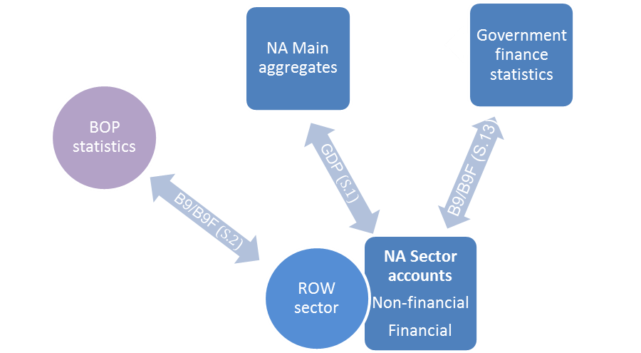
Note: GDP=Gross Domestic Product at market prices; B9=Net lending/Net borrowing of the non-financial accounts; B9F=net lending/net borrowing of the financial accounts; S.1=total sectors; S.13=General Government sector; S.2=ROW sector.
GDP and B9/B9F are indicators at the most aggregate level, which are positioned in the centre of public interest and policy analysis. Any inconsistencies occurring to them could considerably challenge the public view on reliability of these measures.
3. The overall picture – a synoptic view on the accounts
From an overall view the measured differences in the country statistics of the EU-28 were highest in the BOP-ROW comparison and particularly in the financial accounts. Differences between the sector accounts and the NA main aggregates on the other hand appeared minor in absolute terms. In relation to GDP BOP-ROW differences were 0.6% and 1.3% respectively in their multiannual averages for 2010-2016, but below 0.1% across the NA domains.
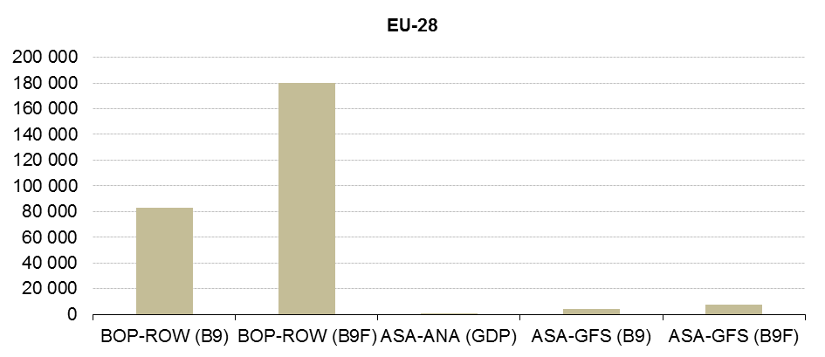
Figure 2. Mean average differences in GDP or balancing items B9/B9F of the accounts, sum of EU-28 Member States, 2010-2016 (EUR million)
Source: Eurostat – BOP-ROW: differences in gross transactions of current account/net transactions of capital account/net transactions in assets/liabilities; ASA-ANA: differences in Annual Sector Accounts (ASA) and annual main aggregates (ANA); ASA-GFS: differences in Annual Sector Accounts (ASA) and GFS for non-financial and financial accounts. Mean absolute differences are based on multiannual averages 2010-2016 in country statistics and summed up to EU-28 total. Data as of October 2017.
However, as the presented multiannual averages reflect the evolution since 2010, the risk for importing “historical” effects is high due to the differences in revision practices in BOP and NA statistics.
4. The external aspect of consistency between BOP and NA
Both BOP and the ROW sector statistics refer to a closed accounting framework which allows for the balancing items to be directly comparable. In the non-financial accounts these are the balances of the BOP current plus capital account (CKA) and the net lending/net borrowing (B9) of the ROW sector. A comparison of the two items can thus give a rough indication about the comparability of both statistics in the country data. The extent of deviation over a multiannual period can be measured by the mean average percentage deviation (MAPD). In the recent production series of the non-financial accounts 4 Member States show measures above 1.0, which alert for significant deviations in the balancing items of their statistics, and another 7 Member States record elevated deviations (between 0.5 and 1.0) – whereas 14 Member States have little or no deviations (0.0 to 0.2).
Figure 3. Mean average percentage deviation of balancing item B9, non-financial accounts, EU-28 Member States, 2014-2016 (mean absolute percentage deviation) 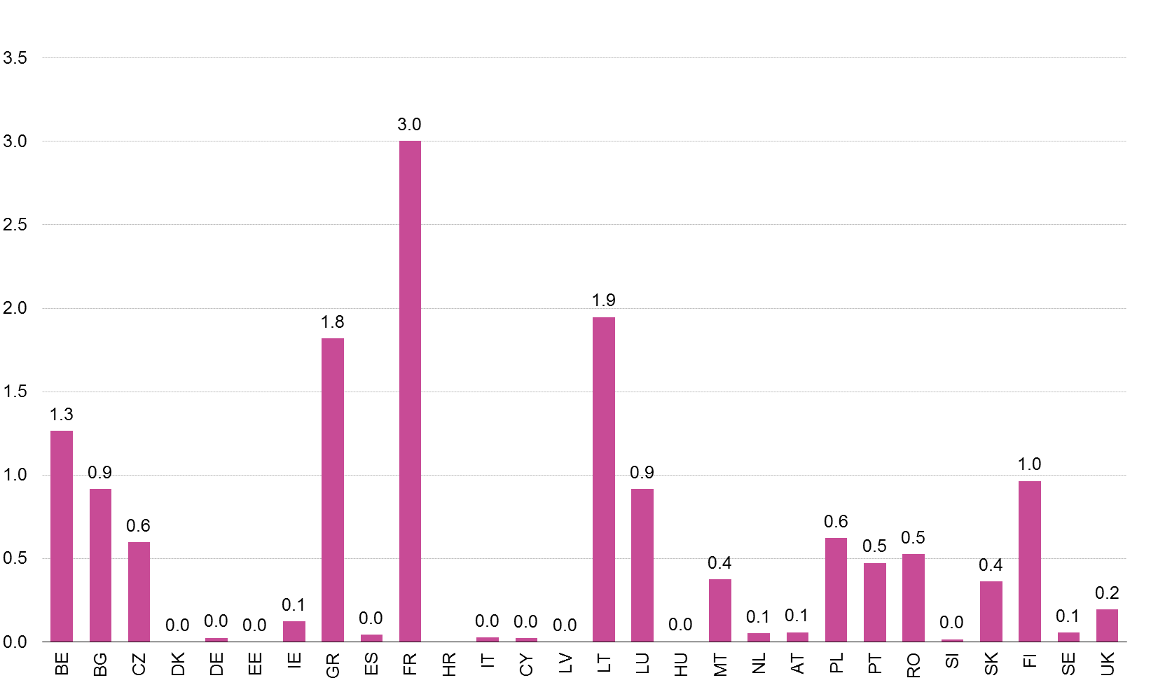
Source: Eurostat – Balancing items: BOP Balance of Current and Capital Account (CKA), ROW balance of net lending/net borrowing (B9); Croatia: QSA data missing for 2014-2016, Malta: QSA data missing for 2016; United Kingdom: QSA data were not updated, there is a risk for a vintage effect. – MAPD is calculated as deviation of the ROW value from the BOP value. MAPD value of 0.0 indicates full identity. Data as of April 2018.
As for the financial accounts the extent of deviations appears generally higher than in the non-financial accounts, but shows similar geographical patterns. Earlier analyses by Eurostat have shown that the observed BOP-ROW discrepancies in the non-financial accounts predominantly are related to services – and to some further extent to goods and primary income. The profile of inconsistencies across Member States is very heterogeneous, with directional inconsistencies in the component balances occurring as a result. Balances in components should generally show the same sign in both statistics, thus conveying conclusive information to users about an economy’s transactions with the ROW. However this is not always the case.
5. The internal aspect – measuring cross-domain consistency in NA
The European System of National and Regional Accounts (ESA2010) is the current standard of the EU accounting framework. It is defined in Regulation (EU) No. 549/2013 and includes a detailed transmission programme, which describes the scope of national accounts statistics in the EU. Among the 22 tables, transmission tables 1, 2, 6 and 8 represent the statistical domains of the NA main aggregates, GFS and the financial and non-financial sector accounts in quarterly and annual statistics respectively. Given the fact that the mentioned tables provide an important input to political and strategic decision-making as well as the fiscal monitoring of the EU Member States, potential inconsistencies could rightfully or not, jeopardise the reliability of the data. Although at a lower level than BOP-ROW inconsistencies, cross-domain inconsistencies of the sector accounts with the other NA domains appear generally elevated only with GFS and only for a few countries.
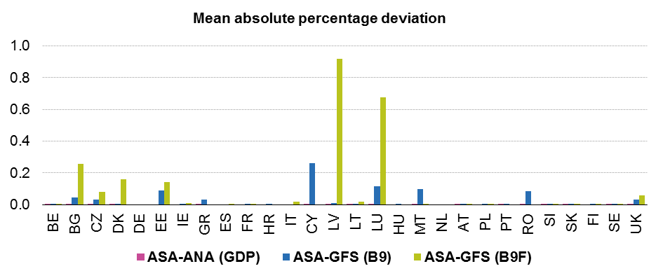
Figure 4. Cross-domain inconsistencies of the annual sector accounts, EU-28 Member States, 2010-2016 (mean absolute percentage deviation, EUR million)
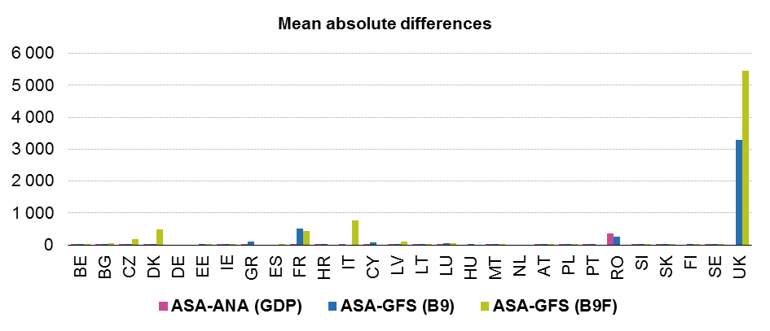
Source: Eurostat – mean absolute differences indicate average differences over the period. Data as of October 2017.
While sector accounts and main aggregates appear consistent in most Member States (pink bars), higher exposure was measured for a few Member States with GFS (blue bars – non-financial accounts, green bars – financial accounts).
Finally it has to be emphasised that consistency is also expected in the annual and quarterly sector accounts tables, following the general accounting rules (uses=resources, main items=sum of sub items, total economy=sum of sectors). Forcing external constraints from tables 1 and 2 without a globally consistent system will trigger cross-table inconsistencies also between annual and quarterly sector accounts tables, even when full alignment of all tables should be achieved through annual revisions.
6. When are inconsistencies critical?
In order to assess whether measured inconsistencies are critical, no scientific justification can be given and thus relative measures appear arbitrary. Zero deviations (i.e. full identity of data sets) can most likely be achieved from fully integrated statistical production systems, while smaller discrepancies could occur from vintage or revision effects in the analysis. In the light of the heterogeneity of production systems in the EU-28 Eurostat derived indicative thresholds for cross-domain inconsistencies in NA as criterion for criticality from sensitivity analysis and data evidence.
For GDP with fixed thresholds of 0.1% (blue line) the number of Member States with discrepancies in at least one quarter ranges from 5 in July 2015 to 9 in January 2018, while a fixed threshold of 1% (green line) would reduce these numbers to 2 and 3 Member States for the same periods. Similarly for B9 the number of Member States with discrepancies in at least one quarter in April 2017 reached a maximum of 21 with a threshold of 0.1%, and 12 with 1% of GDP. Sensitivity analysis with other threshold levels confirmed that for B9 the number of publishable countries does not vary much when the threshold is moved from 0.1% to 0.15% or 0.2%, but increases considerably when moving to 0.3%, especially in more recent years.

Figure 5. Number of Member States with discrepancies in quarterly time-series above threshold, GDP and net lending/net borrowing (B9) in comparison
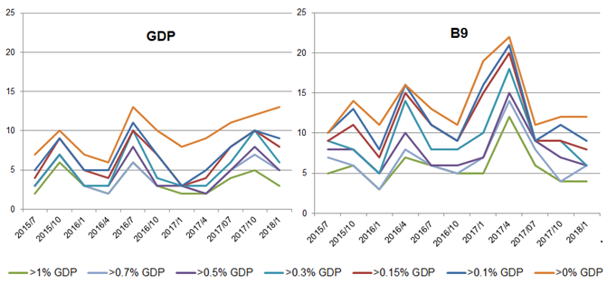Source: Eurostat – Thresholds refer to extent of measured discrepancies in % of GDP.
For GDP instead, the number of publishable countries varies most when the threshold is moved from 0 to 0.1%. Moving the threshold above 0.5% does not increase the number of publishable countries significantly. It has also been noticed that for any chosen threshold critical discrepancies affect only a few quarters (the most recent ones) both for GDP and B9. Following this analysis, 0.3% of GDP was concluded to be an adequate critical threshold for consistency, in order to combine quality requirements with the practicalities of the production processes.
7. Understanding measured inconsistencies – a step forward
Eurostat’s compiler surveys about the causes for BOP-ROW inconsistencies helped to understand their nature and identified a few methodological deviations of the statistical standards, although the main causes relate to the organisational set-up of the underlying compilation processes. Countries with integrated production systems and/or a high degree of coordinated business processes tend to be more insulated against the risk for inconsistencies, while the major outliers were detected in the statistics of countries with decentralised production systems and coordination issues. In the consistency debate organisational and institutional aspects are so far regarded as parameters, at the same time the challenges of capturing economic transactions by residents in a globalised world can hardly be tackled without a critical view on the organisation model of compilation processes. Decentralised compilations do not necessarily have to be centralised, as long as they are embedded in a cooperative institutional framework with high degree of coordination and task sharing. Centralised solutions may however prevail to harvest economies of scale in countries where extremely scarce administrative resources exist. The coordination of compilation processes is challenged by the conceptual closeness of the underlying statistics with each other, where production processes are of twinning rather than sequential character. As a consequence twinning processes require additionally also a high degree of data sharing, as production takes place in parallel. The organisational/institutional aspect is substantially a “structural issue”, of which revision work alone has so far not proven sufficient to eliminate inconsistencies.
8. Conclusions and outlook
Since the last revision of the standards in BOP and NA statistics, inconsistencies due to different methodologies can no longer be justified. However, data evidence has shown that inconsistencies in the EU-28 country statistics still persist, although to a different degree and concentrated around a few countries only. Studies in the causes of inconsistencies have further revealed that structural issues relate to the organisational set-up and the nature of underlying statistical compilation processes as twinning processes. This can only be done by the consequent sharing of tasks and micro data, thus benefiting from economies-of-scales more effectively. The case of the Irish National Accounts has illustrated that highly consistent BOP-ROW accounts alone cannot tackle the challenges of globalisation, but countries with consistent statistics have successfully gone through the processes of national coordination and seem therefore better in position to adapt to a changing environment. The successful examples of the past have also shown that the provision of common access to reference databases from micro data (CSDB) can contribute to more harmonised (financial) statistics. Initiatives in attaining a higher degree of international standardisation of enterprise identifiers and common access to business registers also appear promising, although comprehensive coverage is still an obstacle for a breakthrough. International quality initiatives such as the establishment of an FDI Network have emphasised the prominence of international coordination for the sake of more symmetric statistics on international transactions. In the light of the above the following obstacles have hampered progress and will prominently remain on statisticians’ agenda during the oncoming years – institutional autonomies and strategic rationales, resource restrictions on human/IT capacities, the need for flexibility in adjustment practices among compilers, and strict confidentiality regimes present in some jurisdictions.
References
Central Statistics Office (2016) – Ireland’s Economic Growth Figures 2015, Press Release 12th July 2016, Cork, Ireland
Eurostat (2016) – Consistency between national accounts and balance of payments, Working Papers, Luxembourg 2016
Obrzut R. (2017) – Consistency between national accounts and balance of payments – an updated view on the non-financial accounts, Statistical Papers, Luxembourg 2017
Obrzut R. (2016) – Consistency between national accounts and balance of payments statistics, in: EURONA, Luxembourg 2016
Pérez Cornejo A. and Huerga J. (2015) – The Centralised Securities Database (CSDB): Standardised micro data for financial stability purposes, BIS Working Papers, Basle 2015
Stapel-Weber S. and Verrinder J. (2016) – Globalisation at work in statistics: Questions arising from the ‘Irish case’, in: EURONA, Luxembourg 2016
BPM6 – Balance of Payments and International Investment Position Manual, Sixth edition, IMF, Washington DC 2009
ESA2010 – European System of Accounts, Eurostat, Luxembourg 2013
Eurostat (2011) – Quality Assurance Framework of the European Statistical System, Version 1.2, Luxembourg 2011

Eurostat (2015), Quality Assurance Framework of the ESS, version 2.1
BPM6 Appendix 7, ESA2010 Chapter 18
In European statistics the ESA2010
Transactions of the ROW sector are directly comparable with the external transactions of BOP statistics in both non-financial and financial accounts. For detailed explanations, see Obrzut (2016).
We apply the underlying concept of “primary” consistency in our analysis, where it is assumed that inconsistent components can be detected in the balancing items or aggregates. In contrast inconsistent components could also cancel each other out and cannot be detected in the balancing items/aggregates (“secondary consistency”). Nevertheless, secondary inconsistency should not be neglected: users expect to find the same values across all tables for any given transaction code, whose content and estimation method is uniquely defined in ESA2010. However, secondary consistency is harder to be achieved due to its more rigid consistency requirements of the sub items.
While the sector accounts foresee complete revisions of the entire time-series, the BOP revision calendars usually are limited to the more recent years, roughly covering the observations of the past 3 years.
For a broader discussion see Obrzut R. (2016), Chapter 6.3 – Studying measures of comparability, p. 125
For an updated view refer to the Eurostat website “Statistics Explained” http://ec.europa.eu/eurostat/statistics-explained/index.php/Consistency_between_national_accounts_and_balance_of_payments_statistics
The recent 2016-vintage shows directional inconsistencies in the non-financial balances for France (services), Poland (secondary income) and Germany (capital account), and in the financial balances for Finland and Sweden.
Published in Eurostat’s publication database eurobase http://ec.europa.eu/eurostat/data/database
Based on the annual statistics of the 2017 production cycle (t+9 months), when vintage effects were considered minimal in all mentioned NA domains; quarterly measures would distort the picture with vintage effects and would not lead to any new conclusions.
Full consistency was detected only in 11 of those 27 Member States sending both quarterly and annual tables.
For a more detailed description of the survey and its results, see Eurostat (2016) and Obrzut (2017)
Stapel-Weber/Verrinder (2016)
In sequential processes the final product of one process can be used as input to the other processes. Twinning processes require production activities in parallel, because the final product of one process is not timely available to the others (parallel processing).
Central Statistics Office, Ireland (2016): http://www.cso.ie/en/media/csoie/newsevents/documents/IrelandEconomicGrowthFigures.pdf
Centralised Securities Database, Pérez/Huerga (2015)
Legal Entity Identifier (LEI): https://www.gleif.org/en
https://www.imf.org/external/pubs/ft/bop/2014/pdf/14-20.pdf

