Common Quality Reporting System for Official Statistics of Finland
Outi Ahti-Miettinen, Statistics Finland, outi.ahti-miettinen@stat.fi
Kari Djerf, Statistics Finland, kari.djerf@stat.fi
Abstract
Statistics Finland, in cooperation with Finnish Customs and Natural Resources Institute Finland, designed and built a common quality reporting system for all organizations producing Official Statistics of Finland. System was developed for collecting, storing and disseminating quality reporting using Single Integrated Metadata Structure (SIMS) v 2.0 endorsed by the ESSC in November 2015. System was constructed using Service Oriented Architecture and all producers of official statistics will be invited to use the system through internet interface.
We will present main contents and general technical solutions of the new quality reporting system as well as its properties and links to general dissemination portal.
Keywords: Quality reporting system, Official Statistics, SIMS v 2.0, Coordination, Cooperation
1. Objective of the Project
Objective of the Development of quality reporting and metadata systems project was to build the service to editing, storing and disseminating of new quality reports in Finland. Furthermore, the objective of this project was to unify the structure and quality of the quality reports in all the Official Statistics of Finland. The project started officially on 8 December 2015 by the participating organisations, i.e. Statistics Finland (StatFi), Natural Resources Institute Finland (Luke) and Finnish Customs (Tulli). The project was financed partially by the Eurostat grant on quality reporting which all participating organisations thankfully acknowledge.
The project group made first the content analysis of existing needs, metadata repositories and their sources as well as discussed with various statistical domains.
Based on the existing situation and the ultimate goal of a user-friendly reporting structure fully compliant with the SIMS v. 2 structure the project was launched out.
This presentation describes the main outcome of the product, its component as well as its user-friendliness.

2. Background, existing situation
Currently the quality descriptions (i.e. quality reports) of both Statistics Finland as well as other organisations belonging to Official Statistics of Finland follow the original EU quality report standard no. 1 (see Djerf 2014 and Eurostat 2003). Djerf (2014) described the overall evaluation of the existing quality reports. After the evaluation and necessary measures to correct for the most emerging problems it became clear that a major revision has to be carried out because the new metadata structure (SIMS) was already accepted as the main reporting structure in the future.

3. Project phases
The project was divided into two phases: Initial planning project and the project aiming at fulfilling the needs. The rather small-scale planning project worked 6 months and outlined many targets for the realization. The actual project group started the constructions of the new quality reporting system in the autumn 2016. It was given a Eurostat grant finance which was to cover up to 70 per cent of project costs.
The project started working late 2016 and kept regular meetings every second week ever since. Each party carried out their own duties between the meetings. The project steering group had eight meetings. In between, some plans were approved by e-mail procedure. In addition, the project manager presented the results to the Advisory Board of the Official Statistics in Finland as well as the Management Group of Statistics Finland
Firstly there was a lot to do with initial description of concepts, possible data sources, element-level planning detailed enough for realization etc. After finishing the initial descriptions the real project planning was carried out. And that phase lasted until the end project because many practical issues made it impossible to write out a simple plan for the data architecture.

4. Cooperation within the Advisory Board of the Official Statistics in Finland
The mission of Statistics Finland says that she develops the national statistical service in cooperation with other Government officials. One way to achive in this goal we have made developing projects in cooperation with Other National Autohorities within statistics (ONAs). The ONAs belong the Advisory Board so the Board became a proper way to collect feedback from the other ONAs who were not co-partners in the project. By presenting our work already in the early stage of the development and to listen other’s needs, we hope to be able to build more suitable services to the statistical system as a whole.
5. Content analysis
The contents analysis of the current Common Structure for Statistical Information (CoSSI) at Statistics Finland and contents analysis of the metadata structures of co-partners with respect to contents of SIMS 2.0 were completed as planned in December 2015 to February 2016. In Statistics Finland it based on the SIMS 2.0 standard. All metadata elements of two existing forms of the standard (based on the technical MSD definition v. 3.0) have been combined into one content description. As the co-partners did not have specific metadata structures the work concentrated in the SIMS structure. The use of existing metadata elements to be retrieved from various administrative and other sources was completed and the so-called master sources have been identified from February 2016 to end of May 2016. At the to-be stage of the process in Statistics Finland majority of the fields would be filled automatically to the quality report. The fields to be filled to the quality report are in accordance with the SIMS 2.0 model. It was clarified which sources of the contents can be found from the databases of Statistics Finland. Furthermore, it was decided what is the so-called master-data of the information. It also was surveyed if an element which corresponds to the element of the SIMS model is found in the CoSSI model of Statistics Finland.
6. Technical service structure
Description of business cases for entering and maintaining metadata was made from March 2016 to end of November 2016. Different user stories to fill in metadata and quality reports were collected and combined as they form basic requirements for the IT definitions. Two focus group interviews to future users of the service were held and studied. Database definition and the required process control solutions were developed. Team Foundation Server was selected to serve as application lifetime management (ALM) tool. It was used e.g. to trace the requirements, versions and changes of program codes as well as testing and reporting over the time span of the whole system.
System was decided to build in the Statistics Finland and as all new systems in SF using a service oriented architecture (SOA). New internet user interface and underlying quality engine service were built. Also tow data warehouses were created, one for incomplete reports and another for archiving reports.

Figure 1. The new quality reporting system architecture
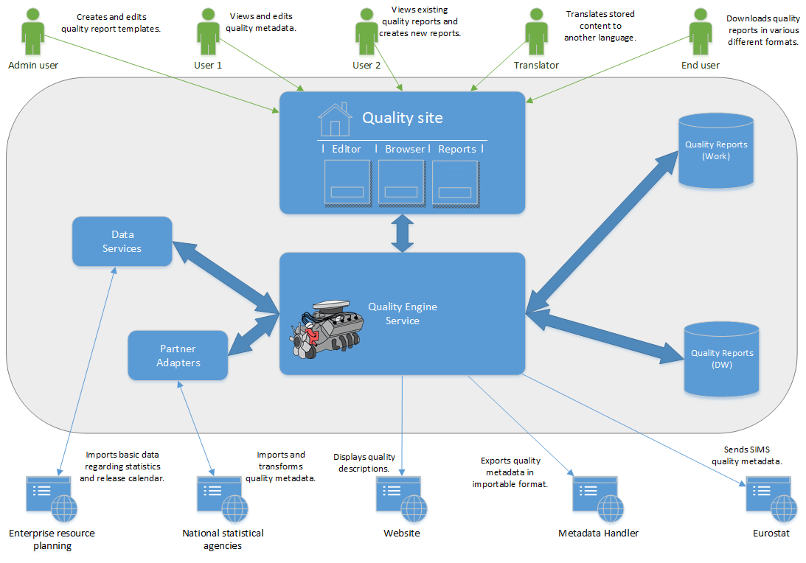
Users can access, find and edit quality reports from a single internet interface. Users are able to search for all reports stored in the system and edit ones they have rights to write. When a report is marked as ready it can be published and it is automatically archived in the warehouse.

Figure 2. Users use the quality reporting system via single internet interface
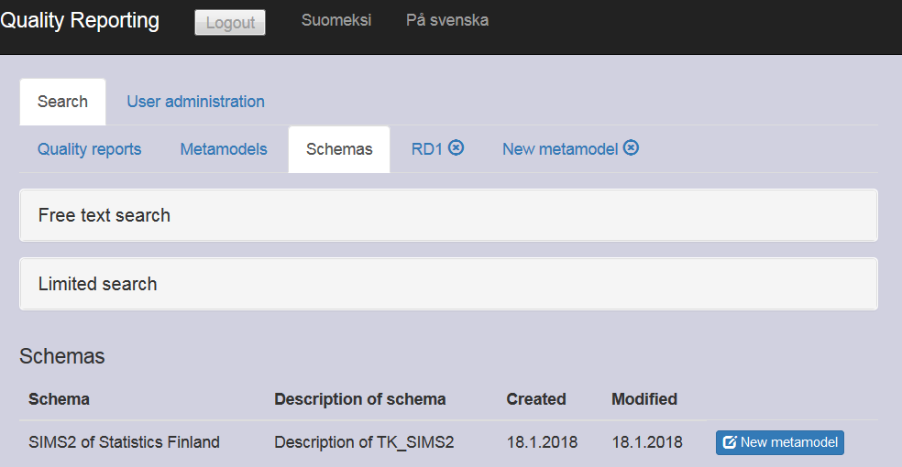

Each statistics using the system first defines their own metadata model from their organisation’s schema, by choosing all relevant elements for the report. Old quality reports can then be used as a base information for new report. After the first report quality reports are made by just updating the elements in need. All reports are stored as a json-file format in a database where all users can read them. Structural json format make various use of the data possible.
Figure 3. The new quality reporting system’s data structure is based on the second version of Single Integrated Metadata Structure (SIMS v 2.0)
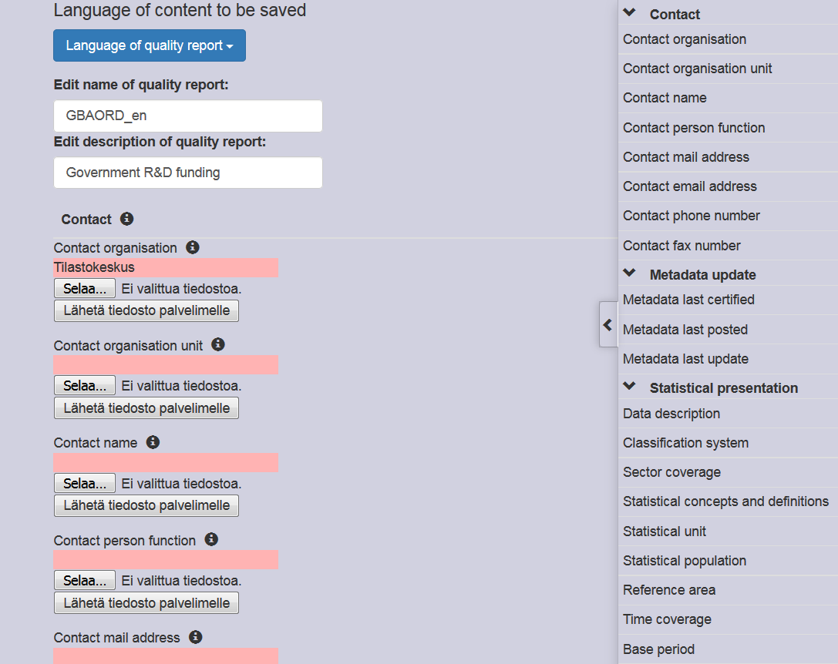

7. Conclusions
SIMS v2.0 worked well as bases of the quality reporting system. It is sufficient scope for standardising the quality reporting. More detailed information should be disseminated in the methodological descriptions. During the project, the development of the new system faced some problems due to very different quality reporting requirements. Thus finding a common data contents is a challenge and probably some statistics with very special requirements (based on acts or agreements) might not be able to use the common database framework. Unifying the quality reporting in all Official Statistics of Finland is challenging and will take some time, but it still is an important improvement for the users of statistics.

8. References

Djerf, K. (2014). A Review of Statistics Finland Quality Descriptions. Paper presented
in the Q2014 Conference in Vienna, Austria. See http://www.q2014.at/fileadmin/user_upload/Djerf.pdf (accessed in 28 28 May, 2018)

Eurostat (2003). Standard Quality Report. Methodological Documents, Working Group “Assessment of Quality in Statistics”. Luxembourg.

Eurostat. (2015), Single Integrated Metadata Structure v 2.0 (SIMS v2.0) and Its Underlying Reporting Structures the ESS Quality and Reference Metadata Reporting Standards ESMS 2.0 and ESQRS 2.0. Available at: http://ec.europa.eu/eurostat/documents/ (Accessed: 15 May 2018).

Grant no No 11152.2015.001-2015.248

