**QUALITY HANDBOOK AND QUALITY PRINCIPLES – PROGRESS AND LESSONS LEARNED**

Mirko Herzner, Statistisches Bundesamt, [mirko.herzner@destatis.de](mailto:mirko.herzner@destatis.de)

**Abstract**

*The development of Quality Principles for each part of the statistical production process according to the GSBPM is a result of an internal analysis concerning Destatis’ fulfilment of the ESS Quality Assurance Framework and was further strengthened by the latest Peer Review. A strategy for the implementation and monitoring of the Quality Principles has recently been developed and tested.*

*After the approval of the Quality Handbook (comprising the above mentioned Quality Principles) in March 2017 by the highest decision-making level of the Statistical Offices of the Federation and the Länder, six pilots have been conducted to assess the compliance with the Quality Principles in different subject matter statistics. A number of improvements have been made to the checklist used for the assessment (like the introduction of filter criteria to limit the total number of items to be answered for the individual statistics or the assignment of Code of Practice principles that are influenced by each of the 342 Quality Principles of our checklist).*

*The lessons learnt cover a wide range of issues including the optimal setup for the assessment workshops (at least two people with good knowledge of the GSBPM) and issues with individual Quality Principles (not all of them are of equal importance; what does “documentation” involve?).*

*The basic facts concerning the development and design of the Quality Handbook have already been presented at the Quality Conference in 2016 (Q2016). This paper is focussing on the progress made and the lessons learnt.*

**Keywords:** Process quality, GSBPM, quality assurance

**1. Introduction: Quality Handbook and Quality Principles**

The Quality Handbook of the Statistical Offices of the Federation and the Länder – as approved by the highest decision-making level of the Statistical Offices of the Federation and the Länder in March 2017 – describes the framework for safeguarding a high quality of data in the German official statistics. It aims to inform the users of statistical data (e. g. in ministries, associations, the sciences or the general public) about managing the quality assurance of statistical results, but also to serve as a guide to the staff of the Statistical Offices of the Federation and the Länder, as well as other authorities in Germany that produce official statistics.

Chapter 5 of the Quality Handbook provides practical descriptions of key cross-statistical Quality Principles which should be adhered to during the production of all statistics. This chapter is aimed mainly at the staff of the Statistical Offices of the Federation and the Länder.

The Quality Principles are a collection of concrete quality assurance procedures, methods and instruments for each of the 44 GSBPM sub-processes which are closely related to the quality of statistical products and the underlying processes. This comprises not only comprehensively used measures like the production and dissemination of quality reports for each of our statistics. Many of the tools and activities listed constitute ambitious development goals for the majority of our subject matter areas. They are to be implemented and initiated by the specialised unit responsible for the set of statistics in question within the Statistical Offices of the Federation and the Länder. The Quality Principles are also available as a separate document in the form of a checklist for practical use in specialised statistics.

**Figure 1. Example of Quality Principles**

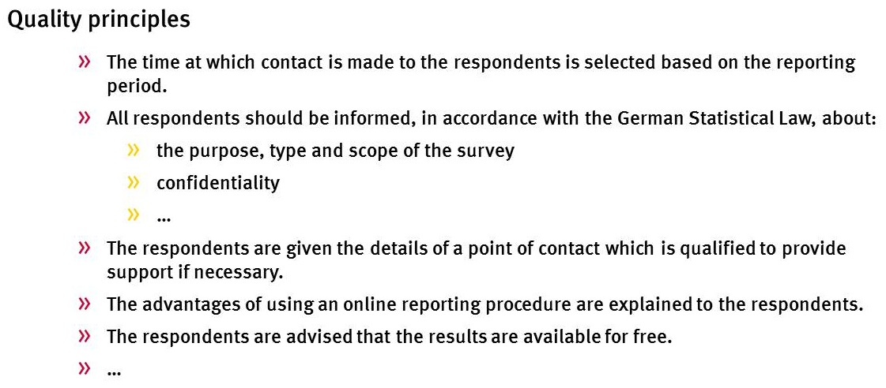

Figure 1 shows an example of five Quality Principles for GSBPM sub-process 4.3 “Run collection”. Please note that the illustration is abbreviated. In the Quality Handbook the principles are being described in more detail. The current version of the handbook features a total of 16 Quality Principles for this sub-process.

**2. What happened since 2016?**

The basic facts concerning the development and design of the Quality Handbook have already been presented at the Quality Conference in 2016 (Q2016).

In 2016/2017 a pilot exercise has been conducted aimed at testing the use of the Quality Principles in the form of the above mentioned checklist for the stocktaking of the fulfilment of the Quality Principles in six subject matter statistics. These covered a wide range of different statistics from the huge External Trade Statistics to the miniscule Statistics on Edible Mushrooms.

To limit the number of Quality Principles to be dealt with by each of the subject matter statistics we introduced more than 30 filter criteria. This results in an average of 250 Quality Principles to be considered from the total number of 342. Two examples for these filter criteria: Quality Principles dealing with sampling issues have no use for censuses, while Quality Principles dealing with questionnaire design and testing should not be answered by statistics based on administrative data.

For each of the remaining principles the subject matter experts had to state if the principle is relevant for their statistics and if yes, if they fulfil the principle. If they answered “not relevant” or “not fulfilled” they had to provide a short explanation.

**Figure 2. Extract from the checklist used**



In general the pilot exercise is considered a success. The piloting has essentially confirmed that the procedure proposed so far can be implemented for the stocktaking in all subject matter statistics. Various minor adjustments were made in the Quality Handbook, the checklist and the implementation concept.

**3. Results, lessons learned and further development**

*3.1. Main results concerning the fulfilment of the Quality Principles*

The overall results of the stocktaking exercises conducted by six subject matter statistics are quite positive. The overall fulfilment rate for all relevant Quality Principles is between 78 and 92 percent. It should be noted that the fulfilment rates for the individual phases of the GSBPM vary to a much larger extent: For the individual phases we found fulfilment rates of as high as 100 percent to as low as 38 percent. While phase 1 “Specify needs” and phase 5 “Collect” with on average more than 90 percent compliance can be considered strengths of German official statistics, phase 8 “Evaluate” with an average of only 61 percent can be considered an area for improvement.

*3.2. Lessons leaned*

According to our pilot concept there should always be more than one person answering the checklist. This makes for a better stocktaking because misunderstandings can more easily be sorted out. It also enhances objectivity when diverging views need to be discussed and a consensus is to be sought. This setup proved successful and will thus be maintained also for the wider application of the stocktaking.

It is also beneficial if each participant has a good knowledge of the GSBPM process model which forms the processual basis for the stocktaking as this helps the understanding why a certain Quality Principle is covered in this particular position and why some aspects reoccur at a later stage – sometimes with only a slightly different wording.

The pilot exercise confirmed strongly with our expectations concerning the time spent to answer each Quality Principle: On average it is possible to answer one Quality Principle per minute – even including some clarifying discussions where necessary.

*3.3. Further development*

*3.3.1. E-learning module*

The planned implementation of the stocktaking in all statistics means a significant workload for the subject matter departments. It is therefore essential to make the implementation process as smooth as possible. One important issue here will be the optimal preparation of the subject matter statisticians starting the stocktaking for their statistics.

We are therefore currently developing an e-learning module aimed specifically at subject matter experts imminently facing stocktaking. In addition to explaining the stocktaking process, the e-learning module will also address a number of issues where further clarification might be needed.

One such issue is the question of relevance – when is a Quality Principle relevant for a statistics or not. We ask for absolute relevance, i. e. the question of whether the implementation of a Quality Principle would be useful for the statistics in question at all. Cost or effort reasons are no valid criterion for a rejection here. Neither is the question of whether a principle could realistically be implemented at the moment or not. A good reason for answering “not relevant” would be “Not useful because of a very small number of survey units” while “Does not apply” would be a bad explanation.

A similar issue to be dealt with in the e-learning is the question of fulfilment of a Quality Principle. The possible choices of "yes" or "no" do not allow any gradations in the sense of "partially implemented". The decisive factor is: Can you say in good conscience that the Quality Principle has been implemented?

One final aspect to address in the e-learning module is the question of when can a documentation be considered adequate as many of the Quality Principles ask for some kind of documentation. Only for a few of these cases (e. g. for the quality report) have fixed templates been developed specifying the concrete form and content of the documentation. It is not sensible and affordable to develop a corresponding template for each documentation required. Rather, as in the implementation of the Quality Principle as a whole, the assessment of the subject matter experts is crucial. The e-learning provides a number of key questions when deciding whether adequate documentation is available and a corresponding Quality Principle is met:

* Is the documentation accessible and known to all persons involved in the relevant process step?
* Is the documentation available in a way that is understood by all persons involved in the corresponding process step (e. g. with regard to required background knowledge)?
* Is it clear how old the documentation is and whether it is the current version? Does it correspond to actual practice? Is the documentation checked regularly and updated if necessary?

*3.3.2. Classification of the Quality Principles*

When pilot testing the Quality Principles with six subject matter areas one unsurprising insight emerged: Not all Quality Principles are of equal importance. Furthermore they deal with different aspects of statistical quality management.

We are therefore currently working on a classification of the Quality Principles to allow for better controlling of quality measures by the top management and to help subject matter statisticians prioritising improvement activities. The classification will only be used when compiling reports and prioritising improvements – it will be omitted from the actual stocktaking as it might influence the answers given on certain items.

The classification will consist of two components. Firstly we will determine an importance from 1 (normal) to 3 (very high) for each Quality Principle. In trying to be as objective as possible we define these three levels as follows:

* 3 (very high) means that defects due to non-implementation of the principle may directly impact data users or respondents,
* 2 (high) are Quality Principles that constitute basic requirements for statistics with a sound production process,
* 1 (normal) are Quality Principles that are to be considered advanced and that would usually only be implemented once a sound production process is ensured.

The second component consists of assigning each Quality Principle to one or more thematic areas addressed by the principle:

* Further development of statistics/continual improvement: The implementation of these principle can provide valuable foundations or information for improving the statistics or the statistical production process,
* Efficiency of statistics: The implementation of these principles can provide valuable basics or information for increasing the efficiency of the statistics or contribute directly to an increase in efficiency,
* Documentation: The implementation of these principles serves to document important aspects of statistical production,
* Other.

**Figure 3. Example for classifying the Quality Principles**



**4. Conclusion and outlook**

The implementation of the Quality Handbook with the Quality Principles has been an important step to further develop a systematic data quality management in German official statistics. Pilot testing the Quality Principles proved their worth for a systematic stocktaking of quality management activities. They will contribute to further development and improvement of quality assurance in all steps of the production process.

The pilot exercise also led to a number of lessons learned and improvements to be made to both the content of the Quality Principles as well as the stocktaking process. Communication and training are central when promoting the use of the principles and rolling out the stocktaking to a wide range of statistics.

A first round of the stocktaking for all federal statistics will start later this year. We plan to conduct the systematic stocktaking within a four year period ending in 2021. Annual reports will summarise the findings for the management and general staff.

An IT-solution is currently being developed to facilitate both the stocktaking and the reporting.