Assessing the quality of the geographical dimension in macro-economic statistics through mirror data
Tjeerd Jellema, European Central Bank, Tjeerd.Jellema@ecb.europa.eu
Fausto Pastoris, European Central Bank, Fausto.Pastoris@ecb.europa.eu
Carmen Picón Aguilar, European Central Bank, Carmen.Picon_Aguilar@ecb.europa.eu
Abstract
The quality of the geographical breakdown in the balance of payments and related statistics such as international trade in goods, trade in services and FDI statistics can best be assessed by means of comparisons with mirror data, to assess bilateral asymmetries. Such checks form a natural complement to the validation of consistency between balance of payments and the national accounts external account. Although such comparisons are performed regularly, they tend to focus on pairs of countries, and do not provide sufficient guidance to assess which of the countries involved has relatively better data, nor do they provide an indication of the level of quality achieved in specifying the geographical dimension. This paper describes three synthetic indicators developed to provide for a group of countries, and specifically in the context of an economic union external account, an assessment of the quality of the geographical breakdowns by country and the relevance of a country to the aggregate asymmetry of that group of countries. The indicators are applied in the context of euro area and the EU foreign direct investment statistics.
Keywords: Asymmetries, mirror data, balance of payments, foreign direct investment
1. Introduction
The main principles and elements guiding the production of euro area statistics compiled by the ECB are contained in the Statistics Quality Framework (SQF) and quality assurance procedures, published on the ECB’s website. On that account, quality analysis of the statistical output is regularly carried out, covering the elements of: methodological soundness, compliance with timeliness, reliability and stability, internal consistency and external consistency/coherence with other comparable statistical domains. In particular, the quality of the geographical breakdown is fundamental to produce reliable balance of payments (b.o.p.) and international investment position (i.i.p.) statistics and can be inter alia assessed by means of comparisons with mirror data. A typical feature of statistics where the geography of the counterparty is captured (e.g. b.o.p./i.i.p., trade in goods, trade in services, FDI statistics) is that they in principle provide for two independent observations of the same phenomenon under observation. When the information is not the same an asymmetry arises.
Significant bilateral asymmetries adversely affect the quality of official statistics and their usability as a basis for sound policy advice. It has occurred that the data reported by partner countries describes a contradictory economic relation between them. Traditionally, measures of asymmetries focus on pairs of countries, analysing the magnitude and the direction of the bilateral differences between geographical partners. Such bilateral comparisons often do not lead to a resolution of the problem, as they do not provide information on which number is likely to be more reliable. The follow up to large bilateral asymmetries typically involves sharing micro-data and metadata information on a case-by-case basis, between partners to try to reconcile the recording of the most important cross-border transactions and positions.
The measures proposed in this paper go beyond conventional measures of bilateral asymmetries as they assess the recurrent or structural dimension of asymmetries between a country and its counterparties. They provide a synthetic overview of how well the geographical breakdown provided by that country is matched by the overall available mirror information. These measures can be applied to any dataset where mirror data is available and to any grouping of countries (e.g. intra euro area, intra EU, regional groupings or global selections, such as G20). This paper describes the application of these measures to the euro area foreign direct investment transactions due to their relevance for FDI asymmetries to the euro area balance of payments as well as bilateral data availability considerations.
2. Proposed quality measures for geographical breakdowns
2.1. Synthetic indicators
The approach behind the proposed measures is to overcome the difficulty in assessing where the problem lies for any given single bilateral asymmetry. It considers that a comparison with the full set of mirror data from the partner countries would provide an indication whether either the reporting country or the countries providing the mirror data should investigate the quality of their (bilateral) data. The rich information set thus obtained results in indicators summarising the quality of the geographical breakdown of a particular country. The indicators provide synthetic values for each country involved in the exercise and for each of the periods taken into consideration. The resulting indicators are clearly interpretable, and have a defined minimum and maximum.
We propose three synthetic measures based on this approach, each captures a different aspect of the quality of the geographical breakdown provided by countries:
- Internal Country Geographical Quality Indicator (ICGQ): a measure that provides information on the accuracy of the bilateral geographical classification.
- External Country Geographical Quality Indicator (XCGQ): a measure that provides information on the accuracy of the allocation between intra/extra group by a country vis-à-vis the same allocation obtained through mirror data.
- Relevance Indicator (RELV): a measure that relates the total of bilateral asymmetries involving a country to the total asymmetry of the group of countries providing bilateral data.
Given the following notation, the formulas for the three measures are listed below:
i is the country to which the quality index applies, c is the counterpart country , w is a predefined weight that applies to all countries, that by default is equal to 0.5, reflecting that our synthetic indicators give the same weights to asymmetries in the reported-assets and reported-liabilities side. $\sum_{c}{|A_{i,c}|}$ reflects the sum of absolute values of the assets reported by country i vis-a-vis all the c countries present in the group analysed. Likewise $\sum_{c}{|L_{i,c}|}$ reflects the sum of the absolute values of the liabilities reported by country i vis-a-vis all the c countries present in the group analysed. $\sum_{c}{|A_{i,c}-L_{c,i}|}$ measures the sum of absolute bilateral asymmetries of the assets of country i vis-à-vis its counterparts, and $\sum_{c}{|L_{i,c}-A_{c,i}|}$ represents the sum of absolute bilateral asymmetries of the liabilities of the same country i vis-à-vis its counterparts.
The three measures are all constrained to be within the range [0, 1].
The ICGQ is expressed as follows:
$${ICGQ}_{i}=\left[w.\frac{\sum_{c}{\left|A_{i,c}-L_{c,i}\right|}}{\sum_{c}{\left|A_{i,c}\right|+\sum_{c}{\left|L_{c,i}\right|}}}+ \left(1-w\right).\frac{\sum_{c}{\left|L_{i,c}-A_{c,i}\right|}}{\sum_{c}{\left|L_{i,c}\right|+\sum_{C}{\left|A_{c,i}\right|}}}\right]$$

It assesses the quality of the geographical breakdown of country i vis-à-vis each of the counterpart countries also providing geographical information. It measures the accuracy of the geographic classification within the sample of countries where bilateral data is provided by aggregating the absolute bilateral asymmetries. It shows high values when a country has particular problems in matching the mirror data of most of its counterpart countries, either through bilateral misallocation or through under or overestimation.
The XCGQ is expressed as follows:
$${XCGQ}_{i}=\left[w.\frac{\left|\sum_{c}{A_{i,c}-\sum_{c}{L_{c,i}}}\right|}{\sum_{c}{\left|A_{i,c}\right|+\sum_{c}{|L_{c,i}|}}}+ \left(1-w\right).\frac{\left|\sum_{c}{L_{i,c}-\sum_{C}{A_{c,i}}}\right|}{\sum_{c}{\left|L_{i,c}\right|+\sum_{C}{\left|A_{c,i}\right|}}}\right]$$

It measures the absolute difference between the total sum of the intra-country group values reported by the country i and the total sum of the mirror data. It provides an indication of over/under-reporting by the country under consideration vis-à-vis the group of its counterparties that highlights problems with regards the overall intra/extra group geographical allocation, or a more general problem of coverage.
The RELV is expressed as follows:
$$R_{i}=\frac{\sum_{c}{\left|A_{i,c}-L_{c,i}\right|+}\sum_{c}{\left|L_{i,c}-A_{c,i}\right|}}{\sum_{i}{\sum_{c}{\left|A_{i,c}-L_{c,i}\right|}}}$$

The relevance indicator places the findings of the first two indicators in context, as it measures each country’s impact to the overall intra group asymmetry. It is intended to complement the first two measures and to summarize which countries have the highest impact on the measured bilateral asymmetries. For example, in the case of the euro area, the relevance indicator would provide an assessment of the weight of a country to the intra euro area asymmetry, and thus directly to the quality of the corresponding EA balance of payments item.
2.2 Numerical example
A stylised numerical example is presented here to illustrate the behaviour of the three measures. We consider 5 countries (C1, C2, C3, C4, and C5) which are part of a specific regional grouping (G5). We construct a dataset that includes bilateral transactions in assets and liabilities as reported by each of the 5 countries vis-à-vis their 4 respective counterparts.
We focus on the perspective of country C1 and we calculate the ICGQ, XCGQ and RELV for this country, under 3 different assumed cases, in order to highlight the complementarity nature of these measures for analysing different quality issues of the geographic breakdown of macro-economic statistics.

Table 1. 3 Possible scenarios for country C1
 | Counterpart | C1- Case 1 |  |  | C1-Case 2 |  |  | C1-Case 3
Assets |  | Rep. | Mirr. | |asym| | Rep. | Mirr. | |asym| | Rep. | Mirr. | |asym|
 | C2 | 200 | 300 | 100 | -300 | 300 | 600 | -300 | 300 | 600
 | C3 | -55 | -70 | 15 | 70 | -70 | 140 | 3700 | -70 | 3770
 | C4 | 3400 | 3700 | 300 | -3700 | 3700 | 7400 | -3000 | 3700 | 6700
 | C5 | 30 | 30 | 0 | -30 | 30 | 60 | -30 | 30 | 60
 | Total G5 | 3575 | 3960 | 415 | -3960 | 3960 | 8200 | 370 | 3960 | 11130
Liabilities |  | Rep. | Mirr. | |asym| | Rep. | Mirr. | |asym| | Rep. | Mirr. | |asym|
 | C2 | 1200 | 1300 | 100 | -1300 | 1300 | 2600 | -1000 | 1300 | 2300
 | C3 | -25 | -40 | 15 | 40 | -40 | 80 | 2500 | -40 | 2540
 | C4 | 1000 | 1300 | 300 | -1300 | 1300 | 2600 | -1200 | 1300 | 2500
 | C5 | 10 | 10 | 0 | -10 | 10 | 20 | -10 | 10 | 20
 | Total G5 | 2185 | 2570 | 415 | -2570 | 2570 | 5300 | 290 | 2570 | 7360
 | ICGQ | 0.07 |  |  | 1.00 |  |  | 0.99
 | XCGQ | 0.06 |  |  | 0.97 |  |  | 0.31
 | RELV | 0.33 |  |  | 0.89 |  |  | 0.92

Source: ECB calculations

The results are summarised in Table 1, which is organised as follows. The blue column lists the counterparty country. Then for each of the 3 cases, the first column shows the data reported by C1 vis-à-vis each of the counterpart countries; the second column shows the mirror data reported by each counterparty vis-à-vis C1; the third column calculates the absolute bilateral asymmetries. In the top half of the table, the reported assets-side of C1 is considered; while the bottom half includes the reported liabilities-side of C1. Please note that the remaining bilateral data from the dataset are assumed to be constant under the 3 cases, and have values in the interval +/- 500. This means that the bilateral flows not involving C1 either as a reporting country or as counterparty, but referring to the bilateral relationships between the remaining 4 countries are the same under the 3 scenarios and they cause the same amount of asymmetries in the 3 cases.
As regards Case 1, we can observe that the individual bilateral asymmetries involving C1 and its group asymmetry total are modest with respect to the overall size of the data reported by C1. The geographical distribution obtained from C1 and from mirror data match quite well. Consequently both the ICGQ and the XCGQ indicate relatively good results. The RELV indicator 0.33 tells us instead that the asymmetries involving C1 are relevant but do not dominate the total intra-G5 asymmetries. (The sum of intra-G5 absolute bilateral asymmetries in Case 1 amounts to 2490).
In Case 2, we can see that C1 fails to match any of the counterparty data, by the simple expedient of being of the same size, but of opposite sign. The ICGQ therefore reaches its maximum level (1.00) indicating that C1 has an extreme problem matching its counterparties’ bilateral data that deserves a deeper analysis. The total value obtained summing up the bilateral data for the total intra-G5 group has also the same size but the opposite sign for C1 and its partner countries. The XCGQ value is therefore close to 1 indicating the very large discrepancy in the total intra-G5 data. The RELV indicator at 0.89 now reaches a very high value, indicating the high contribution of C1 to intragroup asymmetries. (The sum of intra-G5 absolute bilateral asymmetries now amounts to 15100).
As regards Case 3, we see that the situation for the bilateral asymmetries is quite similar to that of Scenario 2. C1 again achieves almost perfect bilateral mismatches with its partners’ data by construction, with the total amount of bilateral asymmetries almost the same size of the sum of the absolute reported and partner data, producing an ICGQ very close to 1. The XCGQ measure however now yields a good result as the discrepancies between the reported and mirror total intra-G5 are relatively small compared to the absolute amounts reported. Case 3 would captures a situation where C1 has cannot obtain a the correct bilateral geographical allocation of its data (compared to its counterparties information) but manages to achieve intra-group totals are not far away from the totals obtained from the counterparties bilateral information, implying that the C1 intra/extra group breakdown does not seem to have severe quality issues. Still, the RELV indicator indicates that C1 remains highly relevant (with a value of 0.92) as it contributes to a very large degree to intra group bilateral asymmetries. (In case 3, the sum of intra-G5 absolute bilateral asymmetries amounts to 20130).
3. Application: FDI data
3.1. Intra euro area asymmetries
A key element for compiling reliable b.o.p. statistics is the accuracy of the geographical distribution. This element becomes crucial when compiling euro area aggregates based on the contributions from the member states. The correct identification of the counterpart of a b.o.p. transaction, for example whether a transaction made by an Italian resident has as counterparty a resident in Germany or a resident in Switzerland, is fundamental for the compilation of the euro area b.o.p., but also for the analysis of the euro area (financial) integration. This analysis is based on intra-euro area transactions that should be equal to 0 after consolidation, i.e. the intra-euro area credits and debits should be equal, as well as the intra-euro area assets and liabilities. A wrong geographical allocation may generate large errors and omissions (statistical discrepancies) and also indicators of (financial) integration difficult to interpret and justify.
This analysis of asymmetries is one of the available tools to assess and improve the quality of the geographical distribution of transactions and positions; therefore the ECB, as the euro area b.o.p. compiler, devotes continuing efforts to this analysis and its follow-up.

Chart 1. Intra EA asymmetries in the financial account

Source: ECB calculations
Considering the breakdown by functional category of the intra-euro area asymmetries in the financial account (see Chart 1), it is evident that the asymmetries in direct investment are recurrently the most relevant component. This may be explained by the difficulty for national compilers to disentangle the geography of transactions occurring within complex enterprises group structures. The application of the synthetic indicators to the FDI transactions may guide national compilers to the identification of transient and structural problems in the geographic quality of FDI transactions.
3.2. Assumption of the exercise
The main challenge in the application of the synthetic indicators is the need for comprehensive bilateral data for all the countries belonging to the euro area. For this exercise, bilateral data for 17 out of the 19 euro area countries were available to us; only Greece and Slovakia are missing in the sample but due to their low weight in the total euro area FDI, we consider their potential contribution to the intra euro area asymmetries negligible.
Before calculating the indicators a simple validation check is performed. The calculated total of the bilateral transactions should account for at least 80% of the reported total intra euro area transactions, if this is not the case the indicators are supressed for the given country and period where this occurs.
3.3. Results
Charts 2 to 4 summarise the results for the 3 indicators by means of box-plots indicating for each country the median (red line) and the dispersion for quarterly calculations from Q1 2015 to Q4 2017. The box-plots are ordered by the median value for each country in an ascending order.

Chart 2. ICGQ – FDI transactions
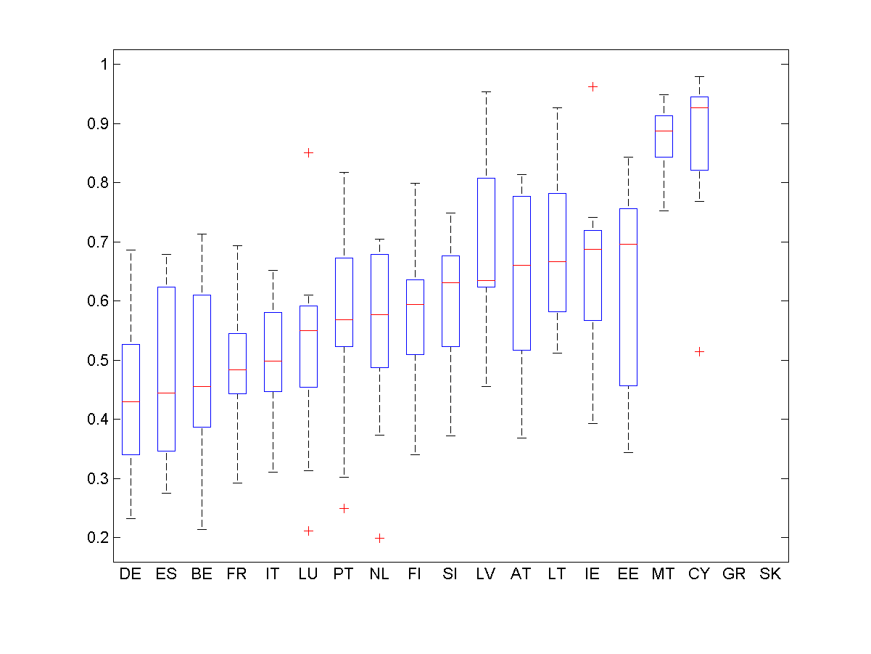
Chart 3. XCGQ – FDI transactions
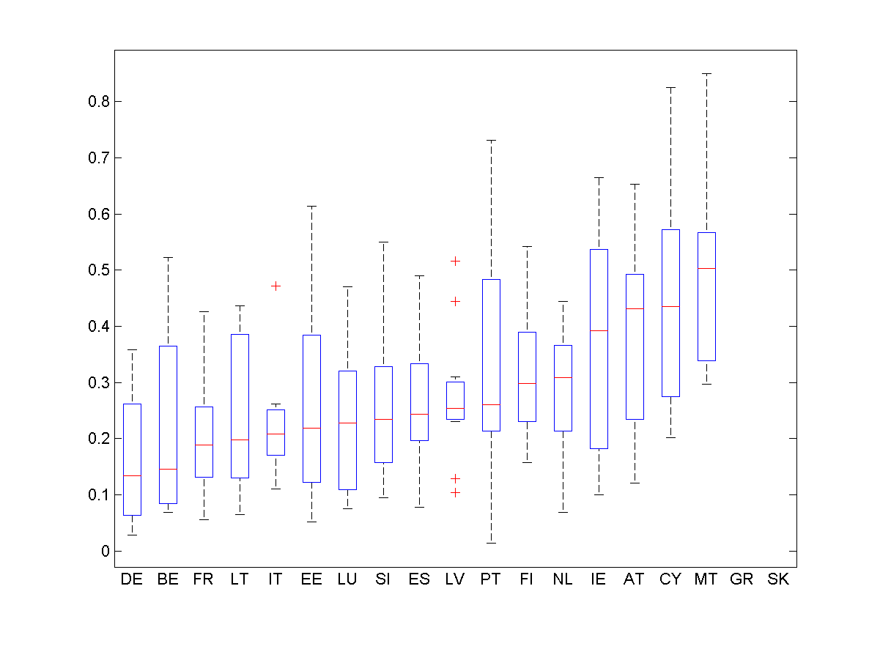
Chart 4. RELV – FDI transactions
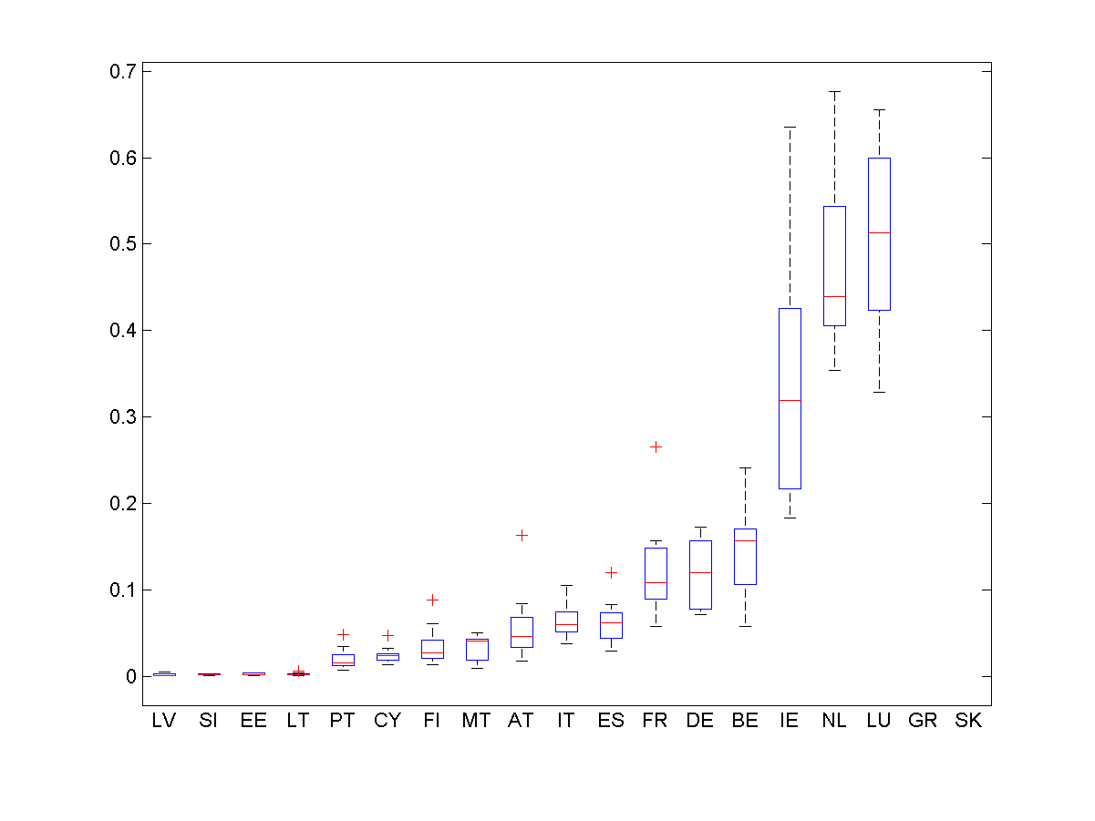
Source: ECB calculations
Generally euro area countries face difficulties in matching individual counterparties’ data, while they seem to face a lesser problem in matching the intra euro area totals. This can be inferred from the median values, where most of the countries show an ICGQ median exceeding 0.5, while the XCGQ is lower than 0.5 for all countries.
It is, however, important to note that the focus on median values only provides a partial view of the complexity of the phenomenon. Most countries show a high dispersion of the results over time in both ICGQ and XCGQ indicators, indicating a high variability over time and suggesting sensitivity to large transactions.
Another interesting result is that, in terms of the median values showing at the same time low dispersion, the most adverse results for both ICGQ and XCGQ are shown by Malta and Cyprus, related to problems experienced by these countries in capturing resident SPE’s. As a result they have a higher score of the relevance indicator than expected based on the relative size of their economy.
The relevance indicator (RELV) results emphasise however that a limited number of countries concentrating large intra EA FDI transactions, namely the Netherlands, Luxembourg and Ireland, are disproportionately relevant to the euro area FDI transactions asymmetries, which can be traced back to the operations of large multinational corporations having simultaneously specialised subsidiaries in these countries.

4. Conclusion
The analysis of asymmetries is fundamental to improve the quality of statistics based on a geographical dimension, such as b.o.p. and i.i.p. statistics. The synthetic indicators presented and applied in this paper go beyond conventional measures of bilateral asymmetries and contribute to a better understanding of regional asymmetries in macroeconomic data.
As the numerical examples and the application to euro area quarterly FDI data showed, a combined analysis of the three indicators helps summarising the different aspects of geographical quality of bilateral data and allows country-specific follow-up strategies to be formulated.
5. References
Angulo E. and Hierro A. (2017), Asymmetries in the Coordinated Direct Investment Survey: What Lies Behind?, IMF Working Paper No.17/261
ECB and Eurostat (2014), European Networking Exercises: The FDI Network, Twenty-Seventh Meeting of the IMF Committee on Balance of Payments Statistics
Eurostat (2006), Asymmetries in EU current account data, Working Papers and Studies, Eurostat, 2006
Javorsek M. (2016), Asymmetries in international merchandise trade statistics: A case study of selected countries in Asia and the Pacific”, ARTNeT Working Paper
Ortolani G. and Rucaj E. (2009), Improving the quality of remittance statistics through the analysis of bilateral asymmetries, Technical Meeting on Measuring Remittances

The ECB’s Statistics Quality Framework (SQF) and quality assurance procedures is available at: http://www.ecb.europa.eu/stats/html/sqf.en.html
See the experience of the FDI network available: https://www.imf.org/external/pubs/ft/bop/2014/pdf/14-20.pdf
These indicators could also be used to measure asymmetries for the current account, and then A will show the credits and L will represent the debits.
Another possibility of achieving the extreme value of 1 is that C1 would report zero flows vis-á-vis all its counterparties.
Also as observed through the available mirror data.
The guideline of the ECB of 9 December 2011 on the statistical reporting requirements of the ECB in the field of external statistics is available at: http://www.ecb.europa.eu/ecb/legal/1005/1022/html/index.en.html
For example, the indicators of Malta are calculated only for 5 out of 12 quarters.

