GSBPM AND ISO: AS QUALITY MANAGEMENT SYSTEM TOOLS IN OFFICIAL STATISTICS (AZERBAIJAN EXPERIENCE)
Yusif Yusifov, Deputy Chairman of the State Statistical Committee of the Republic of Azerbaijan
yusify@azstat.org
Vugar Mammadalizade, Head of department, State Statistical Committee of the Republic of Azerbaijan
vugarm@azstat.org
Abstract
Quality statistical production depends on standardization and quality management of the current statistical system processes.
Recent years the application of ISO 9001 international standard along with GSBPM for improvement of activity among statistical institutions incurs certain conflicts and discordance. Several statistical institutions put forward application of ISO and some of them the GSBPM, and cannot identify the more consistent one.
State Statistical Committee of the Republic of Azerbaijan follows in its activity the application of GSBPM for systematic management of statistical processes towards delivery quality statistical product to users, and ISO 9001 standard for identification and observance of requirements of quality management system towards obtaining of the quality product.
Due to application of GSBPM the creating flexible tool for identification and explanation of processes required for production of official statistics, standardization of management of current statistical processes, and the process mapping was achieved, whereas through the application of ISO 9001 standard the observance of current guidelines and manuals, the application of PDCA cycle in improvement of outputs was gained, as well as appropriate actions were taken to prevent potential inconsistencies by risk-based thinking. Furthermore significant achievements were gained in the field of implementation of monitoring and improvement measures through conduction of internal audits for completion of GSBPM assessment stage.
In our opinion, GSBPM and ISO 9001 standard should not be coincided, on the contrary, they have to be applied in parallel and thus improving quality of official statistics and increasing users’ trust should be gained. It is more logical to implement quality and metadata management on the stages and sub-processes of statistical processes through the application of GSBPM. Due to application of ISO 9001 standard the management by the administration becomes easier, furthermore it enables to monitor at what extent the current requirements are followed based on “process approach”.
Keywords: GSBPM, ISO 9001, quality management, international standard

Brief history of establishing QMS in Azerbaijan. Establishment of QMS in the State Statistical Committee has been launched after the Global Assessment of the National Statistical System of Azerbaijan implemented by such important international organizations like Eurostat and OECD in 2010.
- Quality policy and objectives have been declared;
- measures on application of quality management system are envisaged in the “State Program of Improvement of Official Statistics” approved at the highest level by the President of the country;
- representative of the administration on quality who is directly subordinated to the Chairman of the Committee and has authorization on ensuring completion of the development of quality management system, preparing the certification of quality management system and its maintenance and etc., has been assigned;
- Coordination Council for Quality for decision-making has been established.
Initial standard approaches. Studying and application of ISO 9001 international standard of quality management system has been initially launched in Azerbaijan as a country having no experience in this field. Why ISO 9001?
- While talking of quality management system we referred to ISO 9001;
- Practical guidelines were available;
- Companies suggested their services for trainings;
- There was an interest in a controlling the application and implementation of generic rules and standards;
- One of objectives was to receive certification of international compliance of statistical processes and data quality.
What we did for ISO 9001 standards requirements? Wide-scale measures based “Action Plan for establishment of quality management and metadata system in the State Statistical Committee” were taken to assure subsequence and consistency of works done.
Theoretical and methodological frameworks
- Quality Guideline determining the theoretic aspects of quality management, document management, issues of analysis by the administration, has been developed. The Quality Guideline clearly explains the documented procedures “Document management”, “Records management”, “Internal audits”, “Unconformities management”, “Management of organizational and early measures”, “Analysis by administration”; process maps for each department of the Administration have been developed. Moreover, the followings have been developed:
- “Rules on submission of microdata to users for research purposes”;
- “Rules on responding to inquiries from international organizations”;
- “Rules on correction of errors in official statistical data published and disseminated”;
- “Rules on classifying and elimination of errors in report data”;
- “Standards and recommendations on quality assessment report”;
- “Conception of metadata, standards, models and registers” ;
- “Statistical metadata in corporative context”;
- “Methodological recommendations on inclusion of information on metadata structure into database”;
- “Methodology and questionnaire for conduction of the survey on satisfaction of users’ needs related with statistical activity and data quality”;
- National version of Generic Statistical Business Process Model;
- Methodological recommendations on assessment of statistical data quality;
- “Methodology on integrating metadata system into statistical database”, etc.

Practical steps
- Previously the national standards, since 2012 the Joint UNECE/Eurostat/OECD, Generic Statistical Business Process Model, Version 4.0, 2009 have been implemented for management of statistical processes;
- realization of control on application and implementation of the identified general rules and standards;
- organization of documentation works in the system of statistics according to quality management system standards;
- provision of the process of documents management;
- coordination of reporting information to assure primary data quality;
- organization of internal audits in the structural subdivisions of the Committee;
- preparation of quality reports on statistical data quality assessment;
- coordination of the published main macro indicators, carrying out the comparative analysis and revealing of inconsistencies;
- observance of rules on formation, use and maintenance of database archives;
- conduction of the survey on satisfaction of users’ needs related with statistical activity and data quality;
- determination and organization of metadata system standards on official statistical report forms, indicators and statistical processes;
- receiving certification of international compliance of statistical processes and data quality and etc.
Moreover, for the purpose to control the establishment of quality management system in the State Statistical Committee the internal audits have been organized and afterwards complex analysis of the results have been implemented by the administration. Generally, audit has become an effective tool for revealing shortages, weaknesses and strengths. Audit consultations have also enabled sharing experience, the works in departments have been better arranged, and the level of execution of requirements has been improved.
As a key factor the user opinion in quality management system took an important place in the planning of further development. In this view, the results of surveys on satisfaction of users’ needs related with statistical activity and data quality conducted in 2010 and 2013 were analyzed and used as feedback in further improvements.
The indicated practical works created good possibilities for carrying out the outside certification audit in all departments of the Committee and despite the less time passed since the establishment of quality management system the “Bureau Veritas” company issued a certificate of international compliance of QMS with ISO 9001:2008 standards.

What we learned from ISO 9001 standard?

And how application of GSBPM has been launched? Application of GSBPM in the State Statistical Committee has been launched in 2012 and the first national version has been developed; GSBPM Azerbaijan version has been improved several times in accordance with internal requirements and GSBPM international version. The last improvement has been carried out in 2017 as a result of cooperation with experts of statistical systems of Azerbaijan, Bulgaria, Germany and Slovenia in the framework of Twinning project “Support to the State Statistical Committee in harmonisation of the National Statistics System of the Republic of Azerbaijan in line with European standards” within Component of “Statistical quality management”.
GSBPM national version covers the standards for implementation of statistical production activity of the SSC consists of 8 stages, 44 sub sub-processes and 108 sub sub-processes. Main difference of GSBPM national version from the international one is that each sub-process has sub sub-processes and for better understanding of these sub sub-processes the explanations for each item have been developed (https://www.stat.gov.az/menu/2/quality/en/00_2_en.pdf). As an example, it could be noted that 4 sub-processes of the stage of data collection has 15 sub sub-processes (4.1. Create frame and select sample has 3 sub sub-processes, 4.2. Set up collection – 5 sub sub-processes, 4.3. Run collection – 5 sub sub-processes, 4.4. Finalize collection – 2 sub sub-processes).
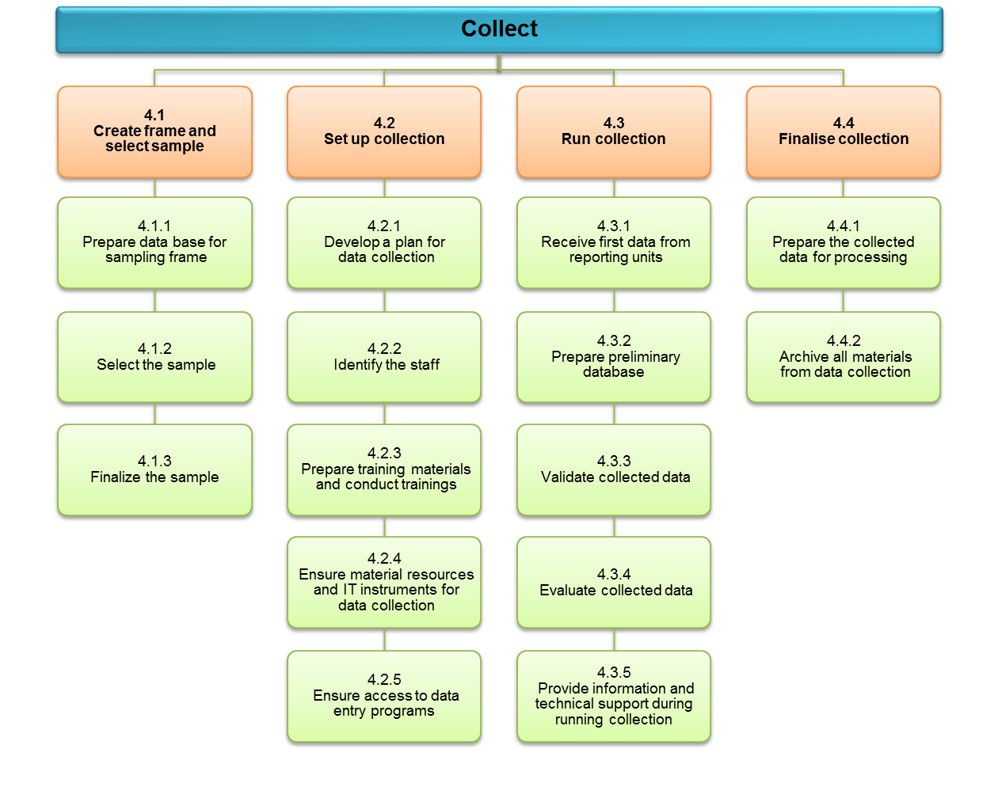
Joint application of GSBPM and ISO 9001 international standards: application of GSBPM is important for getting quality statistical product and systematic management of statistical processes, and application of ISO 9001 international standard is a key to observe the defined requirements for getting quality product.
The followings have been achieved in the SSC:
- through the application of GSBPM the creation of flexible tool for identification and explanation of processes required for production of official statistics;
- standardization of management of current statistical processes, and the process mapping;
- through the application of ISO 9001 standard the observance of current guidelines and manuals;
- the application of PDCA (“Plan – Do – Check – Act”) cycle in improvement of outputs, as well as implementation of appropriate actions to prevent potential inconsistencies by risk-based thinking;
- implementation of monitoring and improvement measures through conduction of internal audits for completion of GSBPM assessment stage;
- control of the extent of observance of measures taken in the system of statistics relating to GSBPM stages.
Through implementation of internal audits in accordance with ISO 9001 standard it defined whether consistencies in application of the adopted rules exist or not. As it is indicated in the below table major stages of GSBPM complement the requirements of ISO 9001 standard.
Moreover, there are similar activities in GSBPM and ISO standards:
 | GSBPM |  | ISO 9001:2015
1 | Specify needs | 4.2 | Understanding the needs and expectations of interested parties
2 | Design | 8.3 | Design and development of products and services
3 | Build | 6.  6.1  6.2  6.3 | Planning  Actions to address risks and opportunities  Quality objectives and planning to achieve them  Planning of changes
4  5  6 | Collect  Process  Analyse | 7.  7.1  7.1.6  7.2  7.3  7.4  7.5 | Support  Resources (human resources, material resources)  Organizational knowledge  Competence  Awareness  Communication  Documented information
7 | Disseminate | 8.2.1 | Customer communication
8 | Evaluate | 9.1.3  9.2 | Analysis and evaluation  Internal audit

Effective work distribution in accordance with ISO 9001:2015 international standard, item 9.1.1 b (audit, measurement, analyse and assessment methods required for assurance of reliable output), calculation of workload for increasing the quality of final results and carrying out an appropriate analyse are implemented through application of both models. Thus, the requirement comes from ISO 9001:2015 standard and distribution of work by processes is implemented on the base of GSBPM.

Harmonisation of ISO and GSBPM and its effect (an example). According to ISO requirements the State Statistical Committee has implemented analysis on workload by first quarter of 2018 based on GSBP model and the outputs are as follows:
From 56896 man-hour
- 4921 man-hour (8.6 %) was spent to specifying needs,
- 1040 man-hour (1.8 %) - designing,
- 631 man-hour (1.1 %) - building of production system,
- 13406 man-hour (23.6 %) - data collection,
- 10939 man-hour (19.2 %) - data processing,
- 11340 man-hour (20.0 %) - data analysis,
- 8573 man-hour (15.1 %) - data dissemination,
- 6046 man-hour (10.7 %) - other activities.

Distribution of works done on GSBPM stages and other activities, %
Specify needs

8.6
Design

1.8
Build

1.1
Collect

23.6
Process

19.2
Analyse

20.0
Dissemi-nate

15.1
Other activities

10.6

Benefits of ISO standards’ principles for quality management. Due to application of ISO 9001 international standards the State Statistical Committee could achieve standardization of actions related with consideration of needs and expectations of the interested parties, more observance of user-oriented principles, formation of quality policy, risks and opportunities assessment, quality objectives and planning to achieve them, planning of changes, improvement of human and financial resources, ensuring access to organizational knowledge for all and documentation of information and received certification of compliance with ISO 9001 international standard in the field of “Official statistics production and dissemination” awarded by Bureau Veritas company of France for the first time in 2013 and by SGS company of Switzerland for the second time in 2017.
Through application of ISO 9001 standard the quality control tables are used for measuring the quality of statistical product to reveal and prevent inconsistencies in report data. The main objective to use quality control tables is to reveal in time the errors in primary data of statistical units and eliminate them. The software has been developed by the State Statistical Committee and quality control tables enabling comparison of indicators cover 26 official statistical reporting forms relating with several domains of statistics and classify such inconsistencies like inaccurate indication of measurement units, the coordination of reporting data, data distortion, presenting not required data, serious deviations between primary and précised data and delays in reporting data.
For systematization of the works done due to application of ISO 9001 standard the statistical process maps have been developed for all departments, the section “Metadata” has been created in the official web-page of the Committee, where metadata of statistical indicators has been developed in the ESMS structure, and the quality reports on statistical indicators have been developed in ESQRS structure.
The national version of DESAP self-assessment survey has been developed. In national version of GSBPM the comparison of explanations of sub-processes of GSBPM stages with sub-processes of DESAP stages has been presented in the table and it has a supplementary function for implementation of self-assessment.
Self-assessment is implemented in the SSC on the base of DESAP self-assessment survey and initially “Household Budget Survey”, afterwards Form No 1-labour (Report on labour) and pilot survey on statistics of “Incomes and living conditions” (EU SILK) have been implemented and correspondingly, the assessment diagram has been obtained on each statistical observation.

We came to the following conclusion:
- GSBPM processes standardizes the way how to manage ISO processes;
- Processes in GSBPM are implemented in not linear form; in ISO it is implemented based on PDCA cycle.
- GSBPM serves for increasing data quality and ISO – for data quality assessment;
- GSBPM gives general view of production process, ISO assesses the general production process;
- GSBPM considers risks in production process, ISO estimates the risks;
- Both models, GSBPM and ISO, standardize quality process management.

