The Swiss Federal Statistical Office quality, process and risk management system
Milos Schaer, Swiss Federal Statistical Office, milos.schaer@bfs.admin.ch
Abstract
The proposed abstract by Switzerland focuses on the new quality, process and risk management system of the Swiss Federal Statistical Office (FSO) introduced in 2016 as well as lessons learned and next steps in this context.

Quality, process and risk management are crucial activities for any organisation, especially for statistical offices that have to face many challenges in terms of resources and budget, user needs and technological development. Aware of this reality, the FSO undertook a major revision of its quality management system between 2014 and 2016. During this work, it was also decided to integrate process and risk management into the same system because they are considered as complementary approaches.

The main goal of the system is to support and stimulate continuous improvement of FSO activities and products and ensure compliance with national or international requirements. This system is now operational and through a simple and pragmatic mechanism allows a better coordination of activities in these three areas as well as a better communication of these topics within the hierarchical line. International standards and tools such as the European Statistics Code of Practice (CoP), the Eurostat Quality Assurance Framework (QAF) or the Generic Statistical Business Process Model (GSBPM) have played a central role in the creation of this new system.

This system is itself subject to a constant need for continuous improvement. The use of the Generic Activities Model for Statistical Offices (GAMSO) and other good practices are two examples of development measures that the FSO intends to take into account for the future.
Keywords: quality management, process management, risk management, continuous improvement, quality assurance
1. Context
The Swiss federal statistical office (FSO) is Switzerland’s main producer of official statistics. This organisation has around 800 staff members (650 FTEs) splitted in 7 departments (5 production departments, 1 support and 1 strategy department). Until the introduction of its revised quality, process and risk management system in 2016, the FSO had had no clearly structured and centralised quality management system since 2004. The execution of quality assurance and continuous improvement activities was decentralised and came under the responsibility of each unit, making it difficult to obtain an overview of issues and views towards this domain. To address this problem, the FSO set up a project to review its quality management system, also including questions concerning process documentation and risk management. This project enabled the implementation of a quality, process and risk management system called the QPR system, so that these topics could be better coordinated, centralised and regulated within the FSO. This system now belongs to the FSO’s everyday activities and it is possible to assess how well it is meeting expectations and what the next developments should be.
2. Purpose of the QPR system
The main purposes of the QPR system are:
- Provide staff with simple and pragmatic tools for quality, process and risk management;
- Strengthen the standardisation, coordinated management and governance of activities in these areas;
- Encourage continued improvement of the FSO’s activities
3. Presentation of the QPR system
3.1. Overview
In essence, the QPR system is a set of principles, requirements and tools as well as a process aiming to strengthen the coordination of FSO activities with regard to quality, process and risk management. This system is coordinated by the quality and process management unit (QP) and the risk manager. The QP unit is comprised of two people who are responsible for quality and process management. The risk manager is attached to the financial management unit. These two units belong to the “Resources” department which also includes human resources, IT, statistical methods and project management.
3.2 The QPR principles
The FSO QPR principles are the following
- Principle 1 / Commitment to quality: the FSO strives to ensure that all of its statistics are of high quality.
- Principle 2 / Improving the FSO on an ongoing basis: the FSO is committed to continuously improving its statistical production and other activities.
- Principle 3 / Quality assurance for statistical production: the FSO is committed to producing statistics that comply with national and international constraints and best practices applicable.
- Principle 4 / Clear work regulations: the FSO strives to offer clear regulations regarding the allocation of tasks and responsibilities.
- Principle 5 / Conformity with the CoP: the FSO strives to respect the requirements of the CoP, particularly through regular monitoring of the improvement plan defined in the scope of the peer review of the 2014/15 European statistical system.
- Principle 6 / Documentation of processes: the FSO is committed to documenting the processes of its main activities.
- Principle 7 / Managing the FSO’s main risks: the FSO is committed to and actively uses risk management as a tool to establish the main risks and potential challenges it faces and implements measures to reduce these.
3.3. The main QPR management tools
The tools available within the QPR system can be illustrated in a 5-tier diagram ranging from the most strategic to the most operational level:
- 1st tier: the FSO’s quality policy, which outlines the FSO's commitment and principles with regard to quality, process and risk management. The policy is available on the FSO’s website.
- 2nd tier: the FSO's QPR management handbook which provides an overview of the tools and processes in place to ensure centralised management of quality, processes and risks;
- 3rd tier: the tools and standards used to support the QPR management system, enabling it to successfully carry out its activities. Among these tools, the quality assurance handbook for statistical production has been completely revised. The current document is structured according to the GSBPM phases and incorporates the quality requirements of the QAF. For each stage, there is a description, a list of quality requirements as well as information about the unit that can be contacted by staff members if they have question.
- 4th tier: the activities carried out within the QPR system such as internal quality reviews of FSO’s activities, risk analyses and process documentation;
- 5th tier: the results produced by the QPR management system such as improvement measures definied during quality reviews, a process documentation library and a risk catalogue.

Figure. 1 Overview of FSO QPR management tools
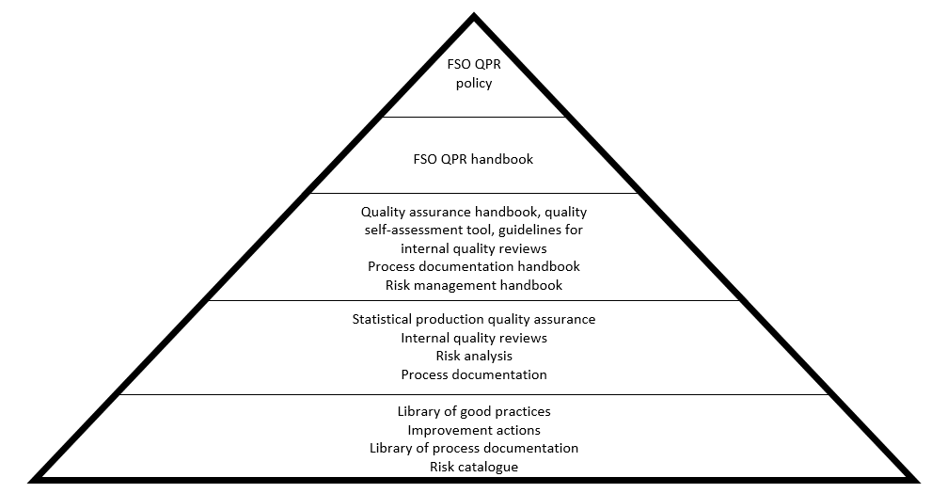
Source: Schaer M. and Baumann M. (2016), The FSO Quality, Process and Risk Management System Presentation Handbook, Swiss Federal Statistical Office, Neuchâtel.

3.4. The QPR process
The diagram below shows the annual QPR process.

Figure 2. QPR management process
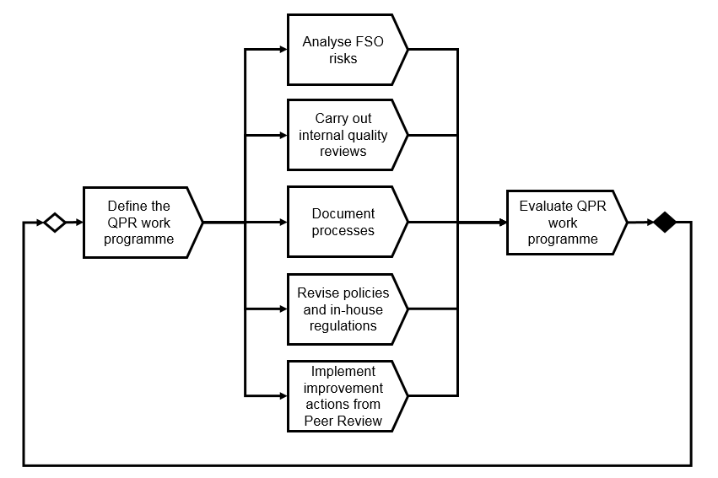
Source: Schaer M. and Baumann M. (2016), The FSO Quality, Process and Risk Management System Presentation Handbook, Swiss Federal Statistical Office, Neuchâtel.

3.5. Definition of the annual work programme
The first activity in the QPR process is to define the needs. This usually takes place in November each year. The QP unit contacts each department (7 departements) to identify their needs. These needs concern:
- The internal quality reviews to be carried out (1 evaluation per department and per year, i.e. 7 in total);
- The processes to be documented (1 process to be documented per department and per year, so 7 in total);
- In-house policies and regulations in need of revision or creation;
- The follow-up from the Peer Review of the European statistical system 2014/15;
- The follow-up of the main risks;
For each of these areas, a discussion is held between the QP unit and the different units concerned. The input collected is then discussed with the QPR committee. The QPR committee is comprised of 8 people who represent different hierarchical and thematic levels (production and support). The purpose of this working group is to provide a platform for dialogue on QPR issues, and to validate the content of discussions before they are submitted to the board of management. The committee gives its opinion on the work programme which can be adapted or added to. Once it has been validated by the committee, the programme is presented to the board of management who then discuss it. This discussion serves to inform top managers about the planned work programme and to ensure that the priorities defined are the correct ones but also to ensure the support of top management in the programme’s implementation. When the programme has been approved by the board of management, the QP unit contacts the different units concerned to organise and plan the work envisaged.
3.6. Implementation of work programme
Based on the programme that has been established, the QP unit carries out throughout the year the different activities planned in cooperation with the units concerned.

The internal quality reviews are monitored by the QP unit but the discussion on the potential improvements of the evaluated activities is held by the persons responsible for these activities. The evaluations are carried out in 3 steps:
- an initial, preparatory phase using a self-assessment tool (based on the requirement set out in the quality assurance handbook);
- the actual review which is a discussion with participants on the strengths and weaknesses of the assessed activity. This meeting lasts about 3 hours.
- the creation of an improvement actions plan by the QP unit. The unit responsible for the activity notifies the QP unit once it has approved this plan;

The process documentation is compiled by the persons responsible for the activities concerned with the help of the QP unit. The production processes are modelled on the basis of the GSBPM and according to the BPMN standard. The process diagrams are then usually pasted into a Word document and explanatory texts are added. Once the document is complete, it is added to the FSO’s process documentation library where it can be consulted by all FSO staff.

Internal policies and regulations are created or revised by the units in charge of them. The QP unit also provides its support for this task if necessary. Guidelines on the content and the process for creating or revising a policy are also available to the members of staff concerned.

With regard to the follow-up of the Peer Review, each improvement action has been attributed to a unit that is responsible for its implementation. The QP unit monitors progress on these improvement actions twice a year.

The risk management side is being developed and will primarily enable an overview of the risks facing the FSO and steps implemented to limit them. Once this overview will be produced, focus will be placed on monitoring and achieving the planned measures. Current work is focused on risks that could have a financial impact and on the topic of Business Continuity Management.
3.7. Evaluation of work programme
Usually in October of each year, the QP unit evaluates the work programme. The main purpose of this evaluation is to inform the board of management about the progress of work and to initiate a dialogue on these topics. It also ensures monitoring of the improvement actions defined in the internal quality reviews of previous years, ascertains whether there are any transversal improvement actions (which have an effect on the entire statistical production or on the FSO) or improvement actions of the QPR system. This evaluation is first discussed and adjusted by the QPR committee and then by the board of management. The most important elements identified during this phase can serve as a base for the preparation of the following year’s work programme.

4. Future developments
4.1. Risk management
The risk management is not yet completely implemented and is awaiting finalisation - mainly the creation of a catalogue of the FSO’s risks. This catalogue will be an important element in prioritising the QPR annual work programme. This tool will help identify statistical production activities (but also support or management activities) requiring an evaluation or for which a process documentation should be compiled.
4.2. Library of good practices
A library of good practices identified during the internal quality reviews is also being created and will be available in 2018. This library will be structured according to the GSBPM and accessible on the FSO’s intranet so that all FSO members of staff can have access to it.
4.3. Internal quality reviews
The QPR committee and the board of management will also discuss at the end of 2018 the current way quality reviews are carried. The focus of these discussions will be the participants in these reviews. At the moment, it is mainly the teams responsible for activities and the QP unit who participate in this exercise. In the future it may be possible to include representatives working in the area of support. IT management, statistical methods or dissemination unit could also take part; they would bring a new perspective to the strengths and weaknesses identified, making the reviews more objective. A pilot phase is already taking place on this subject. Furthermore, the quality reviews of support activities are also being intensified.
4.4. Use of GAMSO
The FSO is currently establishing a mapping between its own activities and the GAMSO model. As a first step, this exercise will provide an overview of the main activities, documents, risks, projects and improvement measures of the FSO, categorized according to the GAMSO framework. This will in particular facilitate discussions with managers on current and future priorities and developments within the FSO. In a second step, proposals for an overall evaluation mechanism of the FSO based on this framework will be presented and discussed with the board of management. This evaluation mechanism should better support the FSO in its reflections on the continuous improvement of all its tasks and not only on its production process, thus tending towards a more comprehensive and coordinated quality management system.
5. Lessons learned
5.1. QPR committee
The introduction and implementation of the QPR system relies to a large extent on the people who support it and who understand its added value. For this reason, an exchange and dialogue platform such as the QPR committee is important as it enables middle and top management to be aware of the operational reality facing FSO staff. Special effort has been made to identify key persons who are motivated to be part of this committee. They make it possible to take a critical look at the QPR system and any future developments but also play an important “sponsor” role, by supporting the system during discussions with the production teams or the board of management.
5.2. Understanding the needs of the organisation
Understanding the different needs and expectations of FSO in-house users is a time-consuming exercise but it ensures that the QPR system brings the expected value-added to the organisation in the long term. Finding a balance between the expectations of all FSO users (which are sometimes conflicting) is key in ensuring a cross-disciplinary solution such as a quality management system makes sense and can become an invaluable tool. Alongside the meetings with the QPR committee, the QP unit organises discussion workshops with FSO staff in order to better understand their needs and to discuss with them what can be done to help.
5.3. Communication
The creation of tools and instruments, even ones that have been well thought out and carefully developed, is not enough to strengthen quality management. All members of staff also have to be aware of them and be able to adapt them to their needs. To this end, the QP unit organises quality management and process documentation training courses once or twice a year. These inform staff about the tools available and how they can use them but also helps the QP unit to understand their everyday problems and to be able to develop these tools further.
5.4. Use of national and international standards
There are already many national and international standards governing many areas of management, in particular in quality management. The creation of the QPR system and its different tools is largely based on tools developed by Eurostat and the United Nations or on practices observed in other countries. It is important for the FSO to continue to follow developments made in other organisations and to evaluate periodically to what extent these developments could be adopted, even partially.

