Quality and Risk Management at IBGE: a short report of a work in progress
Ana Cristina Martins Bruno, Brazilian Institute of Geography and Statistics, ana.bruno@ibge.gov.br
Abstract
The paper aims to present and discuss risk management (RM) integrated to quality management (QM) under construction at the Brazilian Institute of Geography and Statistics (IBGE). QM and RM are strategic issues, part of the modernization program linked to the institutional strategic plan 2017-2027. In Brazil, RM has been strongly recommended by the Federal Court of Accounts (TCU), which has developed a model for assessing organizational maturity in RM based on best international practices such as COSO, ISO 31000 and British Orange Book. The model proposed by the TCU will be used for risk-based external audits and will evaluate management in four dimensions: capacity, translated in terms of leadership, policies and strategies; preparation of people in risk management; application of these capabilities to processes and partnerships; and evaluation of results. The model will be adopted by IBGE as a self-evaluation reference to identify realistic targets for improvements and produce action plans for developing or enhancing risk capabilities. The work has been carried out by the Governance, Conformity and Risks Committee together with Quality Committee, that is responsible for the implementation of quality policy and process management, based on generic models GSBPM (Generic Statistical Business Process Model) and GAMSO (Generic Activity Model for Statistical Organizations). Although the project is in the initial phase and has not yet generated effective demonstrable results, it is intended to present the model as a position paper, portraying a short report of work in progress under the Brazilian Institute.
Keywords: Risk management Risk management maturity
1. Introduction
In many Brazilian public organizations, risk management (RM), in a structured and systematic way, is a recent activity. Regulatory documents published in recent years, with deadlines for organizations to set up a formal RM system, have gradually mobilized organizations. The Federal Court of Accounts (TCU) has an important role in this process by means of diagnoses governance, controls and RM in public administration, followed by reports with recommendations to participating bodies and awareness lectures. External audits based on risk, from an own model developed to assess maturity in RM, complement the actions to drive change. (BRASIL, 2017).
In the Brazilian Institute of Geography and Statistics (IBGE), RM implementation was mainly motivated by three aspects: first, due to the need to comply with legal and regulatory requirements; second, to respond to changes and pressures from the external environment such as budgets constraints, changing expectations, demands for new products, increasing costs, more agile and flexible deliveries, more efficiency and many other challenges that statistical organizations all around the world are facing. Due to more frequent changes, statistical organizations are facing new types of risks. So, last but not least, RM was perceived by top management as a useful managerial tool that can contribute to objectives achievement, to support planning process and provide a reliable basis for decision making, leading to a more proactive management.
This paper is organized into four sections. Section 2 presents how IBGE has organized itself to structure its RM process and how it contributes to and integrates with Quality Management (QM) and Planning. Section 3 describes the RM Maturity Assessment Model developed by TCU for risk-based external audits and it will be adopted by IBGE as a self-assessment reference for improvements on RM process. The last section presents some lessons learned so far and future developments intended.
2. Quality and Risk Management at IBGE
Strategic Plan of IBGE (2017-2027) brought new challenges to the Institution, presented opportunities for modernization and revealed internal pressures for governance and management improvements. QM and RM are strategic decisions considered as priorities aimed at strengthening the institutional management model. Figure 1 presents the strategic map of IBGE, part of the institutional strategic plan, with a set of nineteen strategic objectives established for the next ten years.
To implement the strategy and its deployment to tactical and operational levels, projects and initiatives have been planned and are being implemented. Although quality and risks are treated by distinct Committees (RM is a responsibility of Governance, Compliance and Risk Committee, composed by Deputy Directors of all Organization Units; and Institutional Quality Committee is in charge of QM System), these two issues are complementary and benefit each other. For this reason, an integrated implementation approach is being planned. The adoption of GSBPM (Generic Statistical Business Process Model) and GAMSO (Generic Activity Model for Statistical Organizations) and the existence of processes already mapped, for example, contribute to RM implementation. At the same way, preventive approach and reinforcement of the internal controls resulting from RM process contribute to QM and the implementation of preventive controls, including quality gates.
Figure 1. IBGE´s Strategic Map – 2017-2027
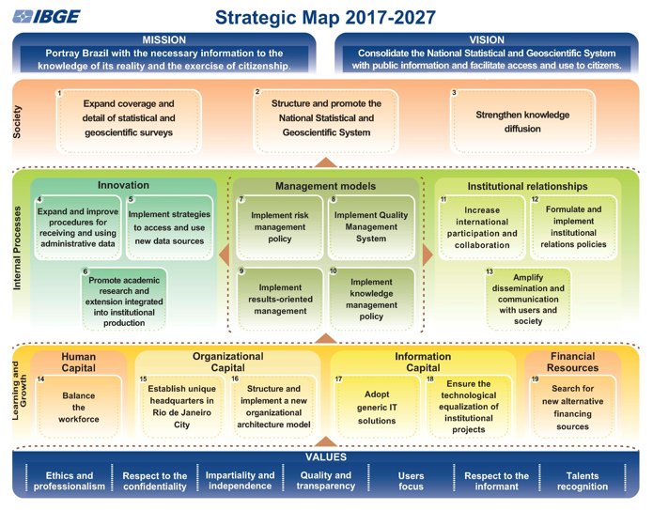
Source: IBGE, 2017
The strategy deploys and materializes through strategic and tactical projects and the execution of business and corporate processes. Processes need to be continually improved to ensure quality of regular production and mission fulfilment. Projects need to be established to provide innovation, change and modernization, leading the organization towards its future vision. Although the structured and formal system of RM is recent, in the last years there have been several activities conducted for the gradual strengthening of institutional management. Some exemples are:
- Quality Improvement Program, based on the criteria of Public Management Excellence Model (BRASIL, 2014) resulted in relevant improvement projects, including the start of business process management in the institution;
- The institutional value chain documented management, business and support macro-processes and its unfolding in second and third level processes;
- Managers and technicians from different organizational units were trained in process management and process mapping tool (firstly, ARIS; nowadays, the free BIZAGI tool is been adopted);
- The first version of methodology and language convention for process mapping was published in 2010, when approximately 130 corporate support processes were mapped, some of which were automated;
- In 2013 the IBGE´s Code of Practice for Statistics was published and more structured and formal actions for QM system implementation were started;
- In 2014, a Departmental Quality Committee was formalized in the Geosciences Department (DGC) and a self-assessment was carried out, with the principles of QM as a reference (ISO, 2015), resulting in the identification of opportunities for improvement and the implementation of improvement projects on 2015.
More recent initiatives underway focus on quality and risk identification in statistical production and in corporate management and support processes using GSBPM and GAMSO. The value chain will be revised this year based on GAMSO.
In 2017, Institutional Quality Committee and Governance, Compliance and Risk Committee were formally created, both are subordinated to IBGE´s Board of Directors. Quality Policy and RM Policy are in final stage of approval and will be published in the first half of 2018. These documents are complementary and aligned, with quality and risk issues integrated. RM follows ISO 31000 (ISO, 2018) and QM system follows ISO 9001 (ISO, 2015). The framework aims to integrate these two international standards and integrate RM and QM into GSBPM and GAMSO.
The Committees represent a good way to develop quality and risk systems. In these spaces of interaction and regular meetings, the policies were elaborated and the roles and responsibilities were discussed. The next steps include the definition of methodologies and artefacts, as well as the proposal of implementation from an experimental phase of pilot testing to consolidate knowledge and methodology and deepen its adaptation to different processes in a successive wave motion.
Although still in the initial phase, there are already initiatives to map processes with identification of quality improvements opportunities and risks, and a pilot project started in the statistical production of economic research.
Introducing changes creates additional risks. But although there are risks associated with change, even bigger risk is not changing at all. The risk is present in formulation of strategies, prioritization and implementation of portfolio, fulfillment of work plan, conducting business processes and executing activities and corporate support processes. RM, therefore, has a prominent importance from strategy definition and execution to organizational performance management.
Risks can be caused by the most diverse sources: people, processes, systems, organizational structure, infrastructure, equipment and technologies are among the most common sources that, if present vulnerabilities, can lead to events of risks. In turn, risks, if materialized, may have consequences that can affect institutional performance and deliveries, work environment and safety, may impact budget and incur in unnecessary costs, impact institutional image and reputation or legal aspects and compliance. To increase the probability of achieving the objectives, risks must be managed in a systematic way, which means acting on potential causes (sources of risks and their vulnerabilities) through effective preventive controls, while acting on the impacts and consequences considering the risk materialization (Figure 2).
In a simplified way, RM process includes risks identification, risks analysis (crossing impact of each effect with the probability of occurrence of each cause and reaching the level of risk, as predicted in the risk matrix) and risk evaluation (compare level of risk found in the process with level of tolerable risk). When the current risk level is greater than tolerable risk level, the organization is exposed to risks, current controls are not sufficient and a risk treatment plan should be prepared, including new preventive controls to avoid the causes and new detective and corrective measures to deal with impacts and consequences in case of risks incidents happen. Risk assessment and treatment support strategic planning, strategy execution and decision making and ensure that projects and processes are more likely to achieve desired goals.
Figure 2 summarizes IBGE RM process, integrated with QM and planning. QM involves compare compliance with requirements and standards and in case of nonconformities implement correction measures (focus on effect) and corrective actions (focus on root cause) to ensure that the same error does not occur again for the same cause. QM system also involves preventive actions to address potential nonconformities and potential causes to prevent errors from occurring. At this point, QM and RM meet and grow stronger.
Figure 2: Integration between planning, RM and QM in IBGE
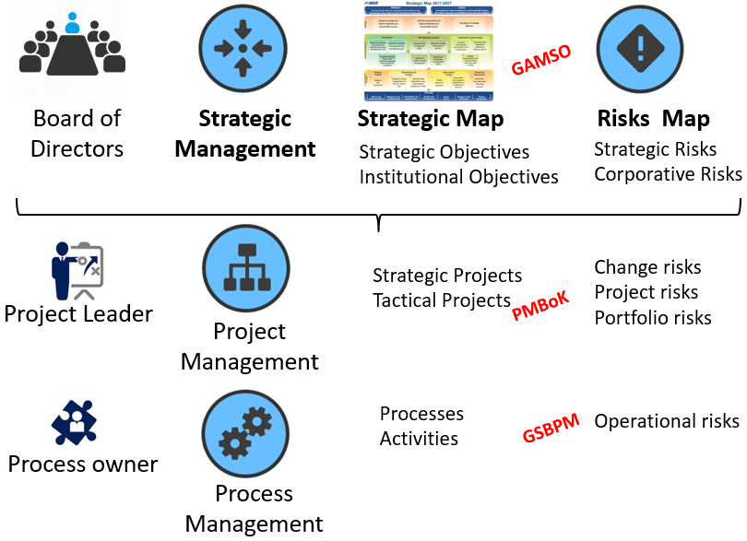
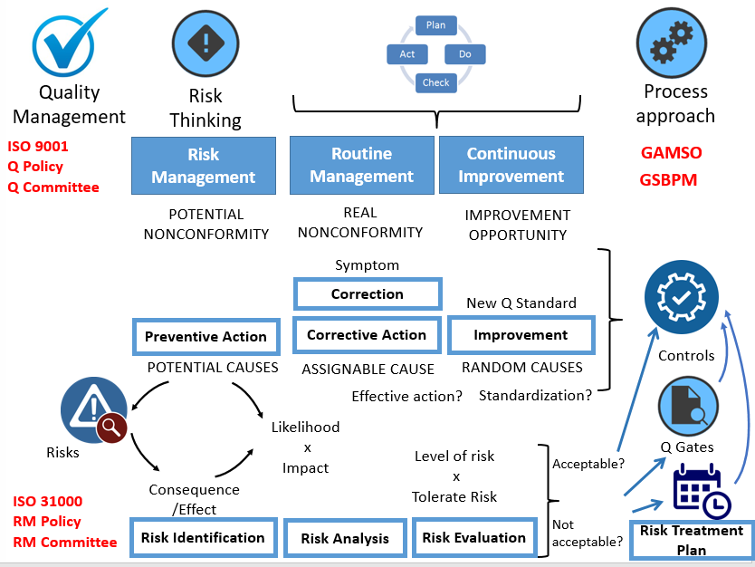Source: the author
3. The maturity model for RM proposed by the Federal Court of Accounts (TCU)
Self-assessment is a comprehensive and systematic critical analysis of activities, results and performance, from the comparison with reference and evolutionary stages of maturity. IBGE intends to use RM maturity self-assessment to identify its current position and determine directions and future improvement priorities. As the main reference, we will use RM Maturity Assessment Model developed by TCU for external audit purposes. The maturity index was also adopted as a monitoring indicator of the strategic objective achievement # 7 (See Figure 1). Model elaborated by TCU is based on international reference models, especially COSO ERM and ISO 31000 and is composed by grouped items in four fundamental dimensions of analysis presented in Figure 3. (BRASIL, 2017, BRASIL, 2013).
Figure 3. A Model to assess risks management maturity in Brazilian public organizations
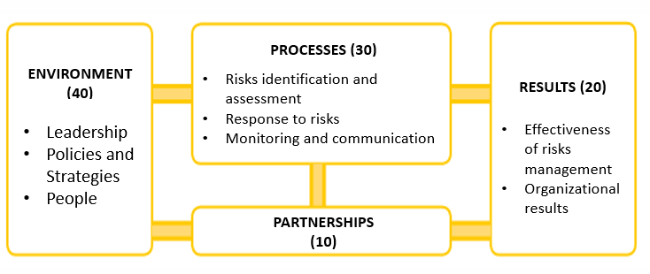
Source: BRASIL, 2017
ENVIRONMENT dimension is related to culture, risk governance and to take into consideration the risks when defining strategy and objectives at all levels. The dimension includes leadership (to what extent do managers and senior management carry out their risk governance responsibilities, making a strong and sustained commitment, and overseeing commitment to RM at all levels of the organization); policies and strategies (to what extent does the organization have RM policies and strategies defined, communicated and put into practice); people (the extent to which people in the organization are informed, empowered to exercise their roles and responsibilities in managing risks and controls, understand those roles and the limits of their responsibilities, and how their positions fit into the management structure and internal control of the organization). PROCESSES dimension includes assessing to what extent the organization has established a formal process with defined standards and criteria for risk identification, analysis, evaluation and responses, monitoring and communication. PARTNERSHIP dimension includes any arrangements established to enable a collaborative relationship between parties, aiming at achievement of objectives of common interest, including definition on which risks will be managed and by whom, how the information will be exchanged to ensure a common understanding of risks and their management. RESULTS dimension addresses aspects related to the effects of RM practices, assess the extent to which RM has been effective in improving governance and management processes and the results of RM have contributed to the related objectives the efficiency of operations, the quality of products and services, transparency and accountability, and compliance with laws and regulations. The questionnaire to assess maturity is composed of 55 questions and addresses different themes in each dimension (BRASIL, 2017).
Maturity of each dimension and the global level of maturity can be calculated. The calculation of maturity index for each aspect of RM is performed by assigning four points to the integral and consolidated presence of the practice and one, two or three, when the presence is partial, according to its intensity, and zero point to total absence, according to scale for evaluation of evidence. In case of questions that admit yes/no answers, four points is assigned to 'yes' and zero point to 'no'. The maturity index of each dimension is calculated by the sum of points of the set of questions that compose each dimension and calculating the ratio between the score achieved and the maximum possible score, expressing this quotient with a number between 0% and 100%. The overall maturity index of RM is obtained by the weighted average of the maturity indexes of the dimensions, considering the weights presented in Table 1. The derived global index allows classifying the level of maturity in one of the five scoring scales shown in Table 2.

Table 1. Dimensions and weights
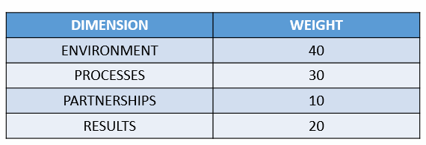
Source: BRASIL, 2013
Table 2. Maturity Level
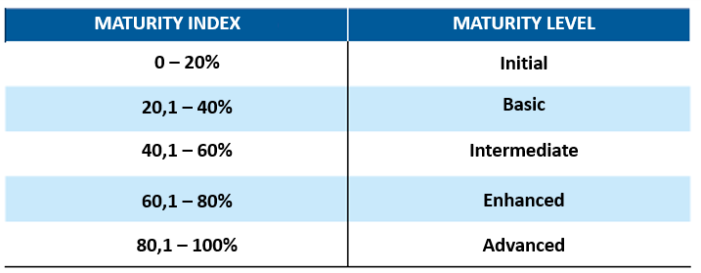
Source: BRASIL, 2013

Conducting self-assessment of RM will contribute to providing a global and systemic view of the process's performance and maturity, identifying strengths that need to be disseminated and shared, and points that require attention, improvements and priorities for subsequent actions, as well as contribute to organizational learning.
4. Conclusion
Risk, because it is directly associated with acceptance of reality permeated by the uncertainties inherent in institutional actions, may offer greater awareness challenges and efforts to change organizational behaviour. To accept the productive reality as organic, subject to uncertainties, is essential for construction of institutional management model. The main challenge for IBGE is to transform management style, which requires a new organizational behaviour, emphasizes actions crossing the organizational structure and privileges interactions between teams of different areas, joint decisions and progresses management. Maturity implies methodological domain and its assimilation in the organizational culture.
Some elements are required:
- Commitment to management model transformation;
- Sharing of perceptions, prioritization, decisions and changes in collegiate bodies (Committees), maintaining vertical and horizontal communication;
- Active engagement of Committee members and risk managers for operational integration, dissemination of methodologies and connection of knowledge;
- Comprehensive training in management, including project management, process management, QM, RM. Leaders and managers should be empowered to sustain continuous improvement;
- Clear commitment and support by Board of Directors: meet at each two months to discuss risks and use information on risks to take decisions.
QM has as one of the fundamental pillars the continuous improvement and RM has the implementation and monitoring of internal controls as a central element. Strengthening these pillars from an experimental phase of pilot test is important to consolidate knowledge and methodology and deepen its adaptation to other processes in a successive wave motion.
Next steps include:
- Publish quality policy and RM policy and provide broad communication and visibility to such documents;
- Publish RM methodology and establish formal training of managers;
- Identify the risks and gradually register the Risk Map of IBGE, including the risks treatment plan, with deadlines and persons in charge and starts an effective risk treatment monitoring and improving controls;
- Conduct self-assessment based on the maturity model developed by the Federal Court of Accounts and set performance targets for the coming years;
- Seek cooperation with Internal Audit Unit.
We are on a journey of continuous and growing transformation. In the last years, IBGE has been achieving management maturity and progress is already significant. There are opportunities and challenges but not all challenges are just technical. As work progresses and everyone can be engaged, including strong leadership for change, a gradual new organizational culture will turn possible a major transformation in the way we produce statistics.
5. References
Brasil (2017). Tribunal de Contas da União. Roteiro de Auditoria de Gestão de Riscos, Brasília: TCU, Secretaria de Métodos e Suporte ao Controle Externo, 164 p. available at: http://portal.tcu.gov.br/lumis/portal/file/fileDownload.jsp?fileId=8A8182A15EAB92B3015F2F41DB870250 (Accessed: 19 May 2018).
Brasil (2014). Ministério do Planejamento, Orçamento e Gestão. Secretaria de Gestão Pública. Programa GESPÚBLICA, Modelo de Excelência em Gestão Pública, Brasília; MP, SEGEP, 2014. Versão 1/2014. Available at: http://www.gespublica.gov.br/sites/default/files/documentos/modelodeexcelenciaemgestaopublica2014.pdf (Accessed: 19 May 2018).
BRASIL (2013). Acórdão nº 2467/2013-TCU-Plenário. Ata 35, Sessão de 11/09/2013. Levantamento de auditoria para elaboração de indicador para medir o grau de maturidade de entidades públicas na gestão de riscos. Brasília.
IBGE (2017). Plano Estratégico do IBGE 2017-2027. Rio de Janeiro, 1ª edição. Available at: https://www.ibge.gov.br/np_download/novoportal/documentos_institucionais/Plano_Estrategico_2017_2027.pdf (Accessed: 19 May 2018).
ISO (2018), ISO 31000 – Risk Management – Guidelines. International Organization for Standardization, Geneva.
ISO 9001 (2015), Quality Management systems – Requirements. International Organization for Standardization, Geneva.

