Documentation System STATDOK – a cornerstone for efficient management of statistical surveys
Petra Blažič, Statistical Office of the Republic of Slovenia, petra.blazic@gov.si
Barbara Kutin Slatnar, Statistical Office of the Republic of Slovenia, barbara.kutin@gov.si
Tina Osvald, Statistical Office of the Republic of Slovenia, tina.osvald@gov.si
Abstract
Systematic and exhaustive documentation of the statistical surveys is one of the challenges that national statistical offices have been facing in the recent years. The widely accepted Generic Statistical Business Process Model (GSBPM) provides a very useful tool to accomplish this task in a standardized manner.
The Statistical Office of the Republic of Slovenia accepted the adjusted GSBPM model as the general process model in 2012, which was updated in 2017. On the basis of this model, detailed quality guidelines for proper implementation of each of the phases were prepared. This was the basis for preparing the standardized framework of the internal Documentation System of Statistical Surveys, called STATDOK. It is a response to the needs that arise from the desire for more effective management, transparency of the statistical survey implementation, comparison of surveys and the needs of employees for continuous learning.
The paper describes the conceptual framework of the internal Documentation System of Statistical Surveys - STATDOK, implementation of the system and its functionalities. It also presents how the Documentation System will be upgraded in the future.

Keywords: Documentation System of Statistical Survey‘s Implementation, process standardization, GSBPM
1. Introduction: The need for documentation of statistical surveys
The regulation of the documentation of statistical surveys has been an important challenge for the Statistical Office of the Republic of Slovenia (hereinafter SURS) for many years. Therefore, in 2006 the document entitled 'Documentation of Statistical Surveys at SURS' was created, but the situation did not change in practice. Despite the fact that certain framework standards for the regulation of individual parts of the documentation had always existed, management of the entire documentation was very diverse: for each statistical survey the documentation was managed in its own way, and the documents were stored in different locations. The consequences of the unregulated conditions regarding the documentation of statistical surveys were lack of transparency and poor accessibility, the possibility of losing important information and a very different quality (diverse structure of the content, different details and informativeness). Also, unregulated documentation caused difficult organization of work in cases of changes or absence of employees. Therefore, in 2011, a decision was made that it is necessary to standardize the management and content of the documentation and to regulate the uniform location for the storage of documentation of statistical surveys.
First of all, the actual situation of the existing documentation by the surveys was analysed: the use and purpose of the existing documentation, the structure of the existing documentation, and the location where the documentation of the statistical surveys was kept. After the status review, a special working group was established, which has been active since 2011. Its main tasks were: preparation of a meaningful content structure of the documentation of statistical surveys, and preparation of a proposal for further organization of the management of the documentation of statistical surveys at SURS. After the first two tasks, the working group continued its work on the preparation of a new, modern technical environment and software solutions for further management of the documentation of statistical surveys at SURS.
1.1. How to do it?
The working group set the following objectives as the starting point for work: the solution must be reasonable in terms of the input of work and maintenance of the system, and at the same time consistent with other SURS’s longer-term goals and strategies. As much as possible, it is necessary to avoid duplication of collecting the same information in various ways. At the same time, the working group was looking for an answer to the question 'Why did the previous attempts to systematically manage the documentation in practice not work?'
A review of past practices of the document management showed that the key reasons for the failure of the system were the vague responsibility for preparing documentation and the poor use value of the whole system (mainly because of the incomparable structure between surveys, different quality and fragmentation, and different locations of storage).
The answer to the findings was the design and implementation of a new system for documentation of statistical surveys, called STATDOK, that establishes one place for storing documentation for all statistical surveys, environment and management that prevents the loss of documents, and comparability between surveys (the structure of content of the system follows the SURS process model based on the GSBPM model, since it provides a comparable structure between different surveys), which provides analytical value. At the same time, the preparation of the documentation should become a planned part of the survey implementation and obtain its wider internally usable value through the guaranteed functionalities of the new system. According to the diversity of different survey methodologies and different user needs for information from this system, it was reasonable to establish a multi-level system that systematically combines general/basic and detailed/implementation information.
In designing the solution, the working group focused on the organizational and user aspects of the new system. With the new organizational model of document management of the statistical surveys, the group established a new division of responsibilities for quality and up-to-date documentation preparation. This is crucial for higher flexibility in an employee’s management system. With the new multi-level structure and standard content of the documentation, the new solution responds to the needs of various users of information from this system. The important advantages are that the system provides a quick insight into the critical points of the implementation of each survey, allows a comparison between similar surveys and represents the information base as a basis for continuous learning and planning of improvements of individual phases of a process.
2. Description of the documentation management system at SURS (STATDOK)
What is the STATDOK system? STATDOK is the single entry point to the documentation of the implementation of a statistical survey - it is a system of related documents, information that builds the documentation of a statistical survey or a group of surveys. The system is designed as a multi-level structure of related documents and other information, as shown in Figure 1.

Figure 1. Multi-level STATDOK system
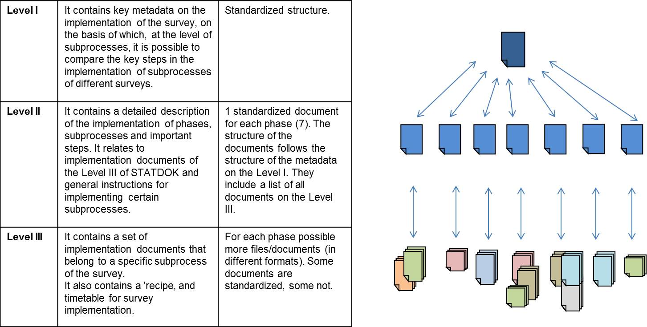
Source: SURS
One of the basic SURS’s policies is the commitment to constantly monitor and improve the quality of statistical processes and products. A comprehensive description and guidelines for correct implementation of individual phases are given in Guidelines for Quality Assurance. This is also the basis for the content structure of the STATDOK. The general framework for any monitoring (also for the STATDOK system) of the implementation of processes at SURS is the adapted Process Model based on the GSBPM model and is shown in Figure 2.

Figure 2. Process Model of the Statistical Office of the Republic of Slovenia
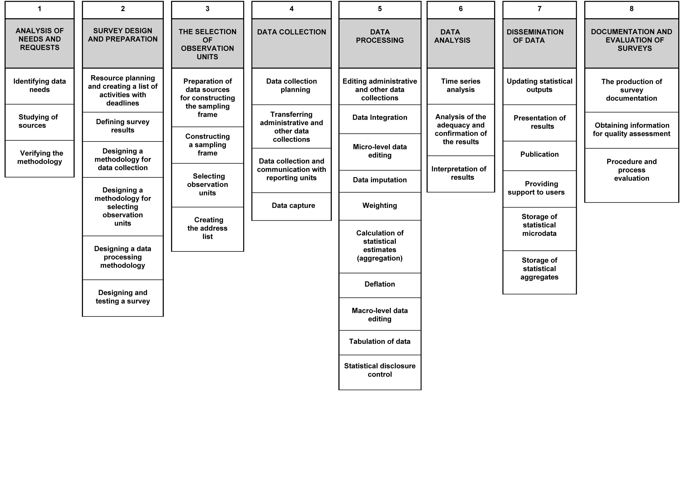
Source: SURS
3. Organizational aspects of the STATDOK system
One of the main objectives of implementing the STATDOK system is comparison and monitoring of the conglomerate of different surveys and statistical processes at SURS. To follow these needs the organisational structure has to be simple and efficient. STATDOK offers transparency, easier communication between different levels of employees, comparability between statistical surveys and insight into process’s implementation.
3.1. Goals
Development of the STATDOK system was a consequence of many different factors, several of them connected to the organisational aspects of managing statistical surveys implementation. In the first phase of establishing the unified documentation system the main goals were to change the attitude towards documentation in the organisation and to emphasise not only the value of data production but also the value of accompanying metadata.
3.2. Structure of responsibility
The systematic management, updating and monitoring of documentation is the key to successfully follow the directions in line with the Process Model. The responsibility is shared among different actors involved in SURS’s processes. The structure of responsibility goes in various directions:
- Hierarchically from the survey methodologist (who is responsible for preparing documentation in time, its frequent updating and publishing) to head of section (who is responsible for optimal management of employees and transparent survey implementation), head of division and finally to the top management
- Owners of phases and sub-processes (offer support to survey methodologists concerning documentation of the specific phases and sub-processes)
- Division’s STATDOK coordinators (guarantee support to the survey methodologists and are a link between the survey methodologist and the STATDOK working group)
- STATDOK working group, watching over the system, upgrading and updating it.
Each of the responsible persons has a role in fulfilling the prepared annual plan regarding the preparation or updating of documentation. The structure of responsibility and the communication flow of the documentation system are shown in Figure 3.

Figure 3. Organisational scheme of completing the annual survey documentation plan
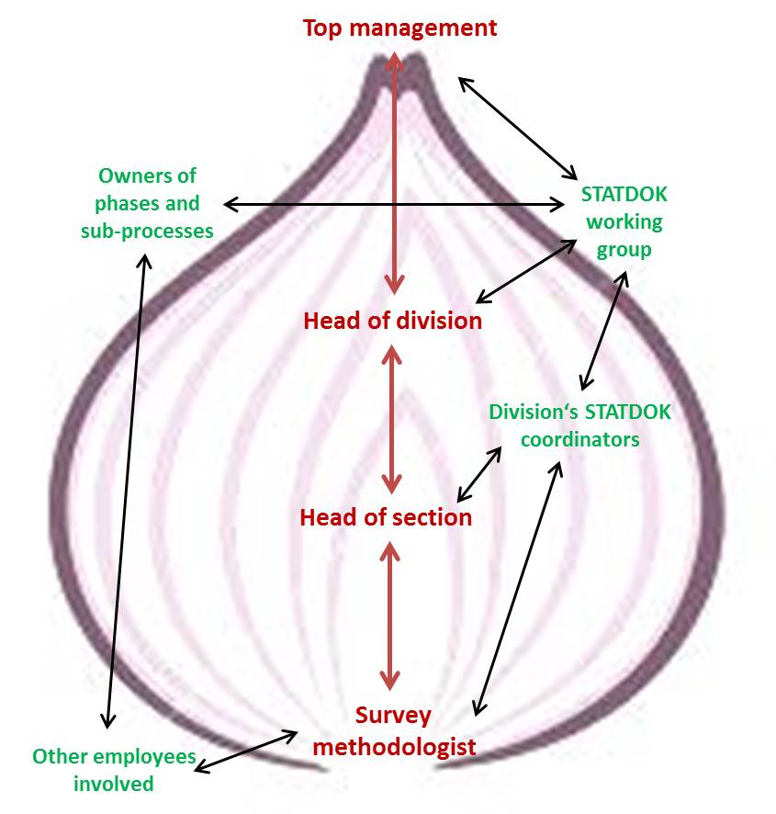
Source: SURS
The implementation of the new STATDOK system required presentations and workshops for the employees using and preparing documentation as well as for management staff. First, general presentations were held by the STATDOK working group members. Advantages of the STATDOK system, its main functionalities and new technical solutions were presented to all employees, while survey methodologists responsible for the preparation of documentation participated in user workshops. They were actively enrolled in these workshops as there were possibilities of expressing main issues and main questions regarding STATDOK and specific cases in different statistical surveys. Workshops give important feedback for further development of a user-friendly documentation system at SURS as constant quality control, monitoring and updating is a key to useful documentation.
4. Purpose and use of the STATDOK system
The main purpose of the SATATDOK system is the quality of metadata and thus higher quality of the whole process of statistical surveys at SURS. The STATDOK system was developed to ease the procedures of standardisation of statistical surveys as well as statistical processes carried out within the Process Model. The established STATDOK system serves its purpose at three levels of the organisational structure. The main benefits of STATDOK for survey methodologists are the availability of centralised platform to gather all metadata needed for the survey, easier planning and knowledge transfer to new colleagues as well as the possibility to compare their own survey to other similar surveys. The latter is of great significance as it means that the system of documentation offers transparency along with the exchange of good practices and thus improves the survey process.
The second level to benefit from the use of the STATDOK system is the heads of individual organisational units (e.g. head of section). With comprehensive information on the statistical surveys within their units they can effectively manage the work of their employees and have a tool to help them replace or compensate for the missing employee (e.g. due to annual, sick or family leave) and to compare their procedures to others.
Finally, the STATDOK system serves the decision-makers or the top management of the organisation as well as those who are responsible for the individual phases or sub-processes (according to the Process Model). It offers the coherent and standardised insight into the organisation of phases and statistical surveys. Therefore, the comparative aspect of the STATDOK system could be used to further standardise and optimise sub-processes which are the main bottlenecks.
5. Technical support to the STATDOK system
One of the objectives of setting up the documentation system at SURS is the preparation of documentation in a standardized manner in a uniform environment. In the past, the documentation was kept in various forms in different places and therefore did not serve the purpose of comparability between surveys. By establishing standardized documents at the first and second level, the content part of the introduction of the STATDOK system was taken care of, and a temporary technical solution was prepared. In this way, a new system was introduced, survey methodologists learned through training courses and workshops to prepare internal documentation of surveys in a standardized way. Thus, the content was checked, possible uncertainties were clarified, and the prepared survey documentation was analysed. We wanted to consider the results in the next more stable technical solution. Temporary technical environment for uploading documentation is an intranet site made in the Share Point environment, where already more than 180 STATDOKs have been uploaded. Documents (with the exception of confidential) in this system are stored in the same way and accessible to all employees. Extensive research and feedback of survey methodologists was taken into account in preparing a new technical solution - the STATDOK application, which is currently in the testing phase. It is prepared in a more stable environment, reading / writing / editing rights are arranged according to different users, it will be able to fulfil metadata, upload files, disseminate documentation in the system, edit documentation with automatic versioning of files, historical overview, search engine, views according to different metadata. The application will enable user help in the form of a user manual and a database of frequently asked questions with answers.
The database for the new technical solution was created on Microsoft Sql Server. There are more than a hundred data tables in the database (186), about 90 of them code lists.
The STATDOK application was created in the C # programming language, and with the help of the Asp.Net MVC 5 framework. Libraries Jquery and Bootstrap were also used. Domain authentication is used to log into the system.
6. Conclusions
To avoid the consequences of unregulated conditions of the documentation of statistical surveys and lack of transparency, poor accessibility, the possibility of losing important information and a very different quality, it is necessary to standardize the management and content of the documentation and to regulate the uniform location for the storage of documentation of statistical surveys. SURS developed the solution, the new internal Documentation System of Statistical Surveys, called STATDOK. The system provides one place for storing documentation of all statistical surveys, environment and management that prevents the loss of documents, and comparability between surveys, which provides analytical value. The documentation became a planned part of the survey implementation and gained its wider internally usable value through the guaranteed functionalities of the new system.
The STATDOK system provides standardized documents at different levels from general/basic to detailed/implementation information, a uniform technical environment which ensures that the documentation of all surveys is available from a single entry point and allows comparison between surveys according to different parameters. In the new documentation system the following aspects are very important: the organizational aspect (participation of different levels of organisation and different groups, shared responsibility), change in general opinion or in the preparation of surveys (documentation is an important part of survey preparation, it is planned like other sub-processes), the long-term vision of the project (regular planning of updating documentation), education and user workshops for all employees.
SURS made a big step forward in the area of internal documentation. So far documentation for more than 180 surveys has been prepared in the STATDOK system and most importantly, the documentation is regularly updated, the preparation and updating of documentation has become part of the regular survey planning process.
We still have a number of challenges for the future. Some of them are: implementation of the application in the production, preparation and implementation of the training for the application users, encourage improvement and content supplementation of some implementation documents, standardize documents for certain sub-processes, stimulate analysis and comparison between surveys in order to improve quality. In the survey processing, due to changes in technologies and tools, modes of implementation of individual sub-processes are changed, so changes in practice must be followed and taken into account also in the system of documentation of statistical surveys.
7. References
SURS. (2017) Guideliness for Quality Assurance. Available at: http://www.stat.si/StatWeb/File/DocSysFile/9694/guidelines-for-quality-assurance-2nd.docx (Accessed: 7 May 2018).

