Title of Paper: Centred alignment, bolded, Arial 24 points; normal
John Doe, affiliation, email address
Jane Doe, affiliation, email address
Abstract
Lorem ipsum dolor sit amet, consectetur adipiscing elit, sed do eiusmod tempor incididunt ut labore et dolore magna aliqua. Ut enim ad minim veniam, quis nostrud exercitation ullamco laboris nisi ut aliquip ex ea commodo consequat. Duis aute irure dolor in reprehenderit in voluptate velit esse cillum dolore eu fugiat nulla pariatur. Excepteur sint occaecat cupidatat non proident, sunt in culpa qui officia deserunt mollit anim id est laborum. Lorem ipsum dolor sit amet, consectetur adipiscing elit, sed do eiusmod tempor incididunt ut labore et dolore magna aliqua. Ut enim ad minim veniam, quis nostrud exercitation ullamco laboris nisi ut aliquip ex ea commodo consequat. Duis aute irure dolor in reprehenderit in voluptate velit esse cillum dolore eu fugiat nulla pariatur. Excepteur sint occaecat cupidatat non proident, sunt in culpa qui officia deserunt mollit anim id est laborum. Lorem ipsum dolor sit amet, consectetur adipiscing elit, sed do eiusmod tempor incididunt ut labore et dolore magna aliqua. Ut enim ad minim veniam, quis nostrud exercitation ullamco laboris nisi ut aliquip ex ea commodo consequat. Duis aute irure dolor in reprehenderit in voluptate velit esse cillum dolore eu fugiat nulla pariatur. Excepteur sint occaecat cupidatat non proident, sunt in culpa qui officia deserunt mollit anim id est laborum. Lorem ipsum dolor sit amet, consectetur adipiscing elit, sed do eiusmod tempor incididunt ut labore et dolore magna aliqua. Ut enim ad minim veniam, quis nostrud exercitation ullamco laboris nisi ut aliquip ex ea commodo consequat. Duis aute irure dolor in reprehenderit in voluptate velit esse cillum dolore eu fugiat nulla pariatur. Excepteur sint occaecat cupidatat non proident, sunt in culpa qui officia deserunt mollit anim id est laborum.
Keywords: Lorem, ipsum, dolor, sit, amet
1. Length of Paper
The papers are expected to be not less than 5 pages and not more than 10 pages in length. This is calculated for the printed format, with 1.5 line spacing and font size 12 pts. The whole text must be written in English, in Microsoft Word format file.
2. Layout
The font type is Arial. In title of the papers please use 24 pts and centre the title. In main text please use 12 pts. The main headings should be in bold, subheadings should be in Italics. Please use 1.5 line spacing, paragraph line spacing 6 pts before, 0 pts after. In the abstracts, footnotes, signatures of figure etc. please use 10 pts. The abstract should be in Italics. The sections should be consecutively numbered by Arabic numerals (not by Roman numerals or capital letters).
Main sections should have 1 digit designation (1. , 2. , etc.); subsections 2 digit (1.1, 1.2, etc.). All headings (section titles) should be aligned to the left, paragraph spacing 18 pts before, 0 pts.
3. Equations, Figures and Tables
3.1. Equations
The equations should be centred, 6 pts space above and below the text. Equation numbers should be aligned to the right. Please use Equation Editor to create equations. Please follow the example below:
(1)
$$x=\frac{-b±\sqrt{b^{2}-4ac}}{2a}$$
3.2. Tables, Figures & Cartograms
The tables, figures and cartograms should be included directly in the files you submit. They should be at high resolution. All tables, figures and cartograms must be numbered consecutively using Arabic numerals in bold (e.g. Figure 1, etc.). The size of a figure/table should be proportional to the amount and value of the information the figure has to convey. Do not assemble figures at the back of your paper, but place them as close as possible to where they are mentioned in the main text.

Table 1. Lorem ipsum dolor sit amet, consectetur adipiscing elit
Lorem | ipsum | dolor | sit
1 | 2 | 3 | 4
5 | 6 | 7 | 8
9 | 10 | 11 | 12
Source:

Figure 1. Lorem ipsum dolor sit amet
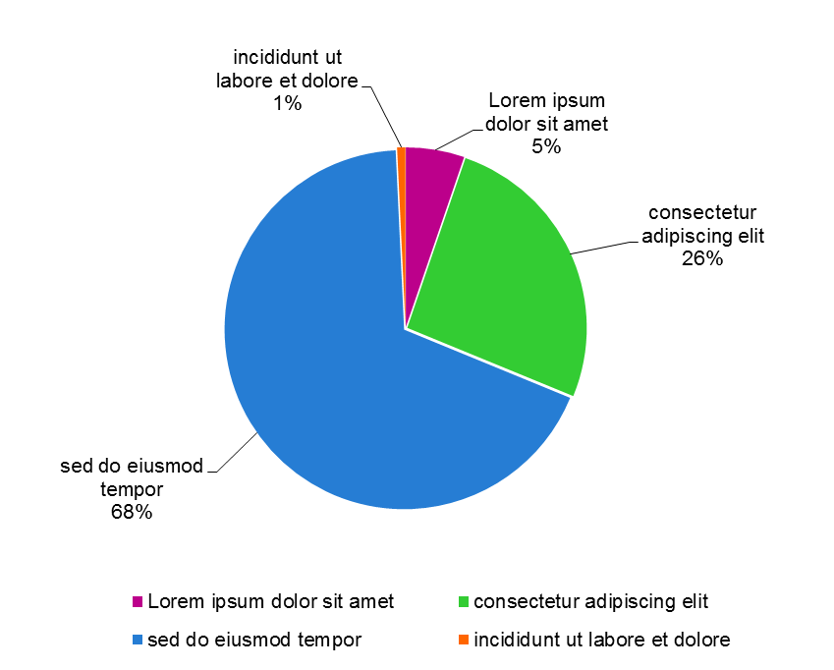
Source:

Cartogram 1. Lorem ipsum dolor sit amet
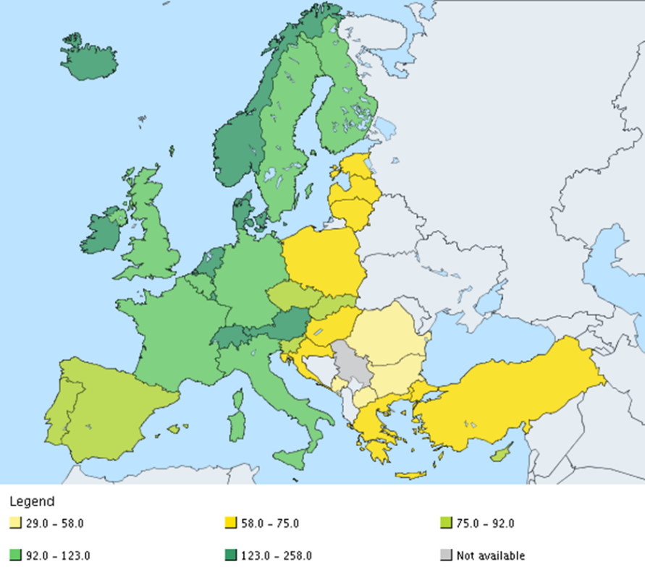
Source:
4. Footnotes
If needed, use footnotes placed at the bottom of a page, use Arial 10 pts.
5. References
References and citations should follow the Harvard System Convention (Autor, date). Please follow the example:
Biemer P. and Lyberg L. (2003), Introduction to Survey Quality, J.Wiley, N.Y.
Little, R. J. A. (1988), Missing-Data Adjustments in Large Surveys, Journal of Business and Economic Statistics, 6, pp. 287-296.
Kimber, R. (2013) Richard Kimber’s Political Science Resources. Available at: http://www.politicsresources.net/ (Accessed: 28 May 2014).

Footnotes.

